  Year 5 · Place value · Step 10  Comparing and ordering numbers up to 100,000 | 
  Year 5 · Place value · Step 10
  Comparing and ordering numbers up to 100,000
  1 | Write the number shown in each place value chart. Then write <, > or = to compare them.  Chart A  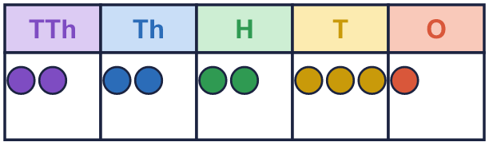  Chart B  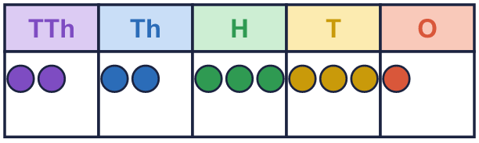
    A |  | B
  1 | Write the number shown in each place value chart. Then write <, > or = to compare them.  Chart A  Chart B
    A |  | B
  2 | Write <, > or = in each box.  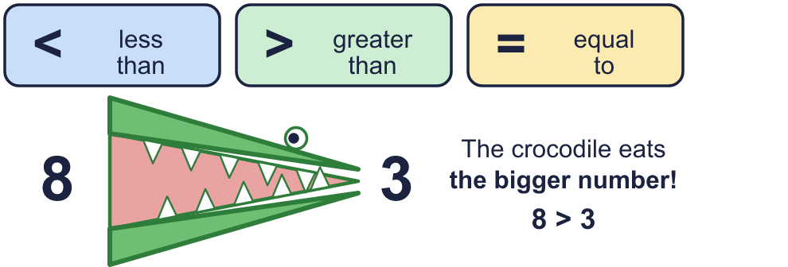
    a) | 147 |  | 148
    b) | 39,535 |  | 39,335
    c) | 6,131 |  | 5,831
  2 | Write <, > or = in each box.
    a) | 147 |  | 148
    b) | 39,535 |  | 39,335
    c) | 6,131 |  | 5,831
  3 | Circle the greater number in each pair. Write it.  a) 40,000 or 5,000  b) 8,374 or 8,384  c) 26,492 or 26,392  d) 18,999 or 4,404
  3 | Circle the greater number in each pair. Write it.  a) 40,000 or 5,000  b) 8,374 or 8,384  c) 26,492 or 26,392  d) 18,999 or 4,404
  4 | Write the numbers in order.  a) smallest first: 52,390 5,293 5,239 52,930  b) largest first: 5,293 52,930 3,925 39,250
  4 | Write the numbers in order.  a) smallest first: 52,390 5,293 5,239 52,930  b) largest first: 5,293 52,930 3,925 39,250
  5 | Write a digit in each box to make the statement correct. There may be more than one answer.
    a) | 1 |  | 8 | > | 158
    b) | 4,2 |  | 2 | < | 4,241
    c) |  | 1,643 | > | 31,643
  5 | Write a digit in each box to make the statement correct. There may be more than one answer.
    a) | 1 |  | 8 | > | 158
    b) | 4,2 |  | 2 | < | 4,241
    c) |  | 1,643 | > | 31,643
  6 | Work out the left side. Then write <, > or = in each box.
    a) | 50,000 + 3,000 + 25
    53,025
    b) | 99,999 + 1 |  | 100,000
  6 | Work out the left side. Then write <, > or = in each box.
    a) | 50,000 + 3,000 + 25
    53,025
    b) | 99,999 + 1 |  | 100,000
  7 | 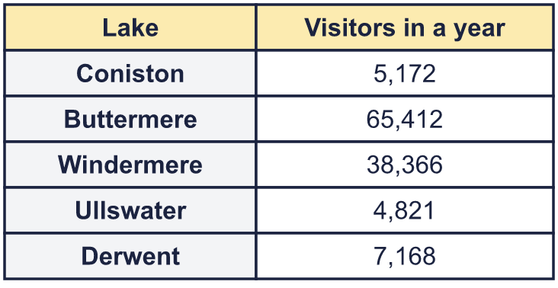  a) Write the lakes in order, fewest visitors first.  b) Which lake had the most visitors?
  7 | a) Write the lakes in order, fewest visitors first.  b) Which lake had the most visitors?
  8 | Write <, > or = in each box.
    a) | LIII |  | 50
    b) | XXV |  | 25
    c) | XVI |  | 8
  8 | Write <, > or = in each box.
    a) | LIII |  | 50
    b) | XXV |  | 25
    c) | XVI |  | 8

  9 | 342 25,196 9,719 53,054  Is Boba correct? Circle yes or no.  Yes / No  Explain how you know.
     | 
  9 | 342 25,196 9,719 53,054  Is Boba correct? Circle yes or no.  Yes / No  Explain how you know.
  10 | Write three numbers that could go in the middle, in order.
     | 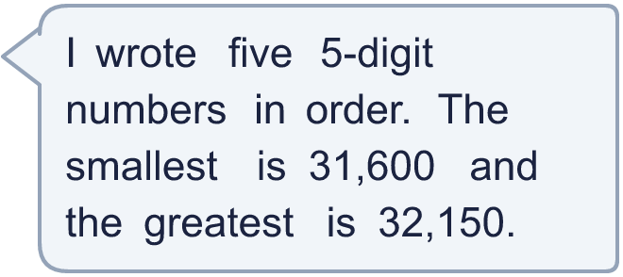
  10 | Write three numbers that could go in the middle, in order.
  11 | Look at the two place value charts.  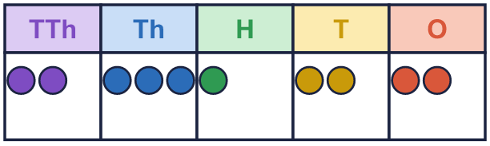  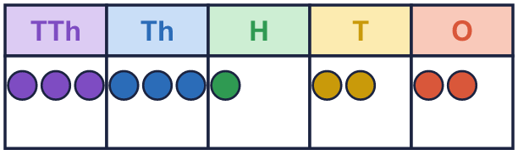  a) Which chart shows the greater number? Write A or B.  b) How much greater is it?
  11 | Look at the two place value charts.  a) Which chart shows the greater number? Write A or B.  b) How much greater is it?
  12 | 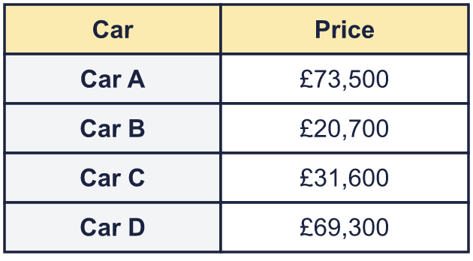  a) Write the cars in order, most expensive first.  b) How much more is the most expensive car than the cheapest?
     | 
  12 | a) Write the cars in order, most expensive first.  b) How much more is the most expensive car than the cheapest?
  13 | 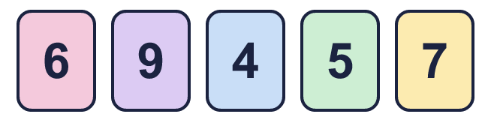  a) How many different 5-digit numbers between 50,000 and 55,000 can you make?  b) Write them in order, largest first.
    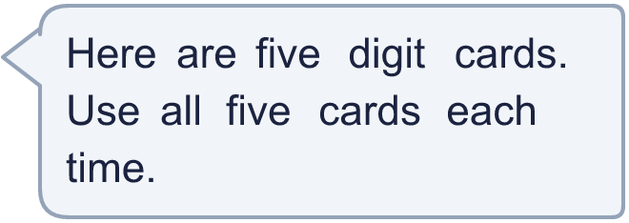
  13 | a) How many different 5-digit numbers between 50,000 and 55,000 can you make?  b) Write them in order, largest first.
  14 | Use five counters to make four different numbers in a place value chart. Write your numbers in order, smallest first.  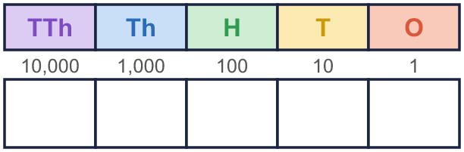
  14 | Use five counters to make four different numbers in a place value chart. Write your numbers in order, smallest first.

Year 5 · Place value · Step 10
Comparing and ordering numbers up to 100,000
Answers (teacher copy)

  1 | Write the number shown in each place value chart. Then write <, > or = to compare them.  Chart A  Chart B  A = 22,231 B = 22,331  A < B
  2 | Write <, > or = in each box.  a) 147 < 148  b) 39,535 > 39,335  c) 6,131 > 5,831
  3 | Circle the greater number in each pair. Write it.  a) 40,000 or 5,000 40,000  b) 8,374 or 8,384 8,384  c) 26,492 or 26,392 26,492  d) 18,999 or 4,404 18,999
  4 | Write the numbers in order.  a) smallest first: 52,390 5,293 5,239 52,930  5,239, 5,293, 52,390, 52,930  b) largest first: 5,293 52,930 3,925 39,250  52,930, 39,250, 5,293, 3,925
  5 | Write a digit in each box to make the statement correct. There may be more than one answer.  a) 1 6, 7, 8, 9 8 > 158  b) 4,2 0, 1, 2, 3 2 < 4,241  c) 4, 5, 6, 7, 8, 9 1,643 > 31,643
  6 | Work out the left side. Then write <, > or = in each box.  a) 50,000 + 3,000 + 25 = 53,025  b) 99,999 + 1 = 100,000
  7 | a) Write the lakes in order, fewest visitors first. Ullswater, Coniston, Derwent, Windermere, Buttermere  b) Which lake had the most visitors? Buttermere
  8 | Write <, > or = in each box.  a) LIII > 50  b) XXV = 25  c) XVI > 8
  9 | 342 25,196 9,719 53,054  Is Boba correct? Circle yes or no.  Yes / No  Explain how you know.  25,196 is bigger than 9,719, so it should come after it. The numbers should be: 342, 9,719, 25,196, 53,054.
  10 | Write three numbers that could go in the middle, in order.  Any three numbers between 31,600 and 32,150 in order, for example 31,740, 31,880, 32,010
  11 | Look at the two place value charts.  a) Which chart shows the greater number? Write A or B. B  b) How much greater is it? 10,000
  12 | a) Write the cars in order, most expensive first. Car A, Car D, Car C, Car B  b) How much more is the most expensive car than the cheapest? £52,800
  13 | a) How many different 5-digit numbers between 50,000 and 55,000 can you make? 6  b) Write them in order, largest first. 54,976, 54,967, 54,796, 54,769, 54,697, 54,679
  14 | Use five counters to make four different numbers in a place value chart. Write your numbers in order, smallest first.  Any four different numbers whose digits add up to 5, for example 5, 2,030, 10,004, 11,111

