  Year 5 · Multiply and divide A · Step 6  Square numbers | 
  Year 5 · Multiply and divide A · Step 6
  Square numbers
  1 | Work out each square number. For example, 3² = 3 × 3 = 9.  a) 3² =  b) 6² =  c) 7² =  d) 10² =
  1 | Work out each square number. For example, 3² = 3 × 3 = 9.  a) 3² =  b) 6² =  c) 7² =  d) 10² =
  2 | Circle the square numbers. Write them below.  8 49 25 64 18 36 10 15
  2 | Circle the square numbers. Write them below.  8 49 25 64 18 36 10 15
  3 | Write the missing number.
    a) |  | ² = 36
    b) |  | ² = 49
    c) |  | ² = 25
  3 | Write the missing number.
    a) |  | ² = 36
    b) |  | ² = 49
    c) |  | ² = 25
  4 | Work out each calculation.  a) 5 squared =  b) 6 squared =  c) 7 squared =  d) 11 squared =
  4 | Work out each calculation.  a) 5 squared =  b) 6 squared =  c) 7 squared =  d) 11 squared =
  5 | Here is a sequence of square numbers: 1, 4, 9, 16, ...  Write the next four numbers in the sequence.
  5 | Here is a sequence of square numbers: 1, 4, 9, 16, ...  Write the next four numbers in the sequence.
  6 | Write <, > or = in each box.
    a) | 3² |  | 4 + 5
    b) | 8² |  | 60 + 5
    c) | 2² |  | 1 × 4
    d) | 6² |  | 5 × 7
  6 | Write <, > or = in each box.
    a) | 3² |  | 4 + 5
    b) | 8² |  | 60 + 5
    c) | 2² |  | 1 × 4
    d) | 6² |  | 5 × 7
  7 | List all the square numbers between 10 and 50.
  7 | List all the square numbers between 10 and 50.
  8 | Work out each calculation.  a) 2² + 6² =  b) 7² − 5² =  c) 4² + 3² =
  8 | Work out each calculation.  a) 2² + 6² =  b) 7² − 5² =  c) 4² + 3² =

  9 | Is Boba correct? Circle yes or no.  Yes / No  Explain how you know.
     | 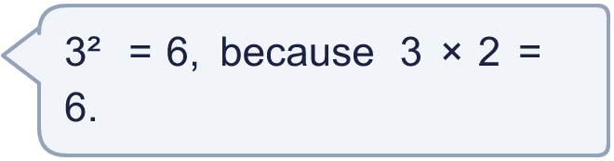
  9 | Is Boba correct? Circle yes or no.  Yes / No  Explain how you know.
  10 | Is Boba correct? Circle yes or no.  Yes / No  Explain the mistake.
     | 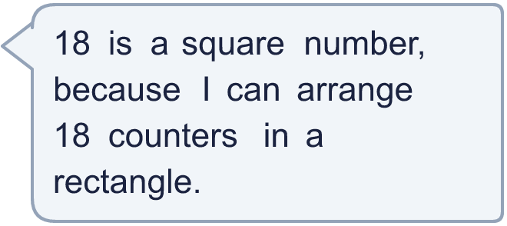
  10 | Is Boba correct? Circle yes or no.  Yes / No  Explain the mistake.
  11 | Dani is thinking of a square number with two digits. The digits add together to make another square number.  What could Dani's number be? Write all the answers.
  11 | Dani is thinking of a square number with two digits. The digits add together to make another square number.  What could Dani's number be? Write all the answers.
  12 | Dr Trent is celebrating his birthday. His age is a square number. Last year his age was a multiple of 5. Next year his age will be a multiple of 2. He is younger than 100.  How old is Dr Trent?
  12 | Dr Trent is celebrating his birthday. His age is a square number. Last year his age was a multiple of 5. Next year his age will be a multiple of 2. He is younger than 100.  How old is Dr Trent?
  13 | Write three different even square numbers between 20 and 300.
  13 | Write three different even square numbers between 20 and 300.
  14 | Two square numbers have a difference of 11.  What are the two square numbers?
  14 | Two square numbers have a difference of 11.  What are the two square numbers?

Year 5 · Multiply and divide A · Step 6
Square numbers
Answers (teacher copy)

  1 | Work out each square number. For example, 3² = 3 × 3 = 9.  a) 3² = 9  b) 6² = 36  c) 7² = 49  d) 10² = 100
  2 | Circle the square numbers. Write them below.  8 49 25 64 18 36 10 15  25, 36, 49, 64
  3 | Write the missing number.  a) 6 ² = 36  b) 7 ² = 49  c) 5 ² = 25
  4 | Work out each calculation.  a) 5 squared = 25  b) 6 squared = 36  c) 7 squared = 49  d) 11 squared = 121
  5 | Here is a sequence of square numbers: 1, 4, 9, 16, ...  Write the next four numbers in the sequence. 25, 36, 49, 64
  6 | Write <, > or = in each box.  a) 3² = 4 + 5  b) 8² < 60 + 5  c) 2² = 1 × 4  d) 6² > 5 × 7
  7 | List all the square numbers between 10 and 50.  16, 25, 36, 49
  8 | Work out each calculation.  a) 2² + 6² = 40  b) 7² − 5² = 24  c) 4² + 3² = 25
  9 | Is Boba correct? Circle yes or no.  Yes / No  Explain how you know.  3² means 3 × 3, which is 9, not 6.
  10 | Is Boba correct? Circle yes or no.  Yes / No  Explain the mistake.  18 is not a square number. 16 = 4 × 4 and 25 = 5 × 5, and 18 is between them. A square array has the same number of rows and columns.
  11 | Dani is thinking of a square number with two digits. The digits add together to make another square number.  What could Dani's number be? Write all the answers. 36, 81
  12 | Dr Trent is celebrating his birthday. His age is a square number. Last year his age was a multiple of 5. Next year his age will be a multiple of 2. He is younger than 100.  How old is Dr Trent? 81
  13 | Write three different even square numbers between 20 and 300.  Any three even square numbers between 20 and 300, for example 36, 64, 100
  14 | Two square numbers have a difference of 11.  What are the two square numbers? 25 and 36

