  Year 5 · Multiply and divide A · Step 5  Prime numbers | 
  Year 5 · Multiply and divide A · Step 5
  Prime numbers
  1 | Write the prime numbers in each list.  a) 9 10 4 5 7 2 6  b) 17 21 9 11 13 15 23
  1 | Write the prime numbers in each list.  a) 9 10 4 5 7 2 6  b) 17 21 9 11 13 15 23
  2 | Write all the factors of each number. Which numbers are prime?  a) 5:  b) 14:  c) 19:
  2 | Write all the factors of each number. Which numbers are prime?  a) 5:  b) 14:  c) 19:
  3 | Write how many factors each number has. A prime number has exactly two.  a) 9:  b) 1:  c) 7:  d) 11:
  3 | Write how many factors each number has. A prime number has exactly two.  a) 9:  b) 1:  c) 7:  d) 11:
  4 | List all the prime numbers between 10 and 30.
  4 | List all the prime numbers between 10 and 30.
  5 | These are consecutive prime numbers. Complete the sequence.  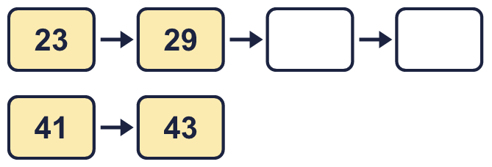
  5 | These are consecutive prime numbers. Complete the sequence.
  6 | List all the prime numbers between 60 and 90.
  6 | List all the prime numbers between 60 and 90.
  7 | Is each number prime? Write yes or no.  a) 34:  b) 53:  c) 46:
  7 | Is each number prime? Write yes or no.  a) 34:  b) 53:  c) 46:
  8 | Write the prime numbers in each list.  a) 47 33 31 45 43 39  b) 69 63 61 57 59 67
  8 | Write the prime numbers in each list.  a) 47 33 31 45 43 39  b) 69 63 61 57 59 67

  9 | Is Boba correct? Circle yes or no.  Yes / No  Explain your answer.
     | 
  9 | Is Boba correct? Circle yes or no.  Yes / No  Explain your answer.
  10 | 5,619 2,470 1,910 2,756 8,416  Is Boba correct? Circle yes or no.  Yes / No  Explain how Boba knows.
     | 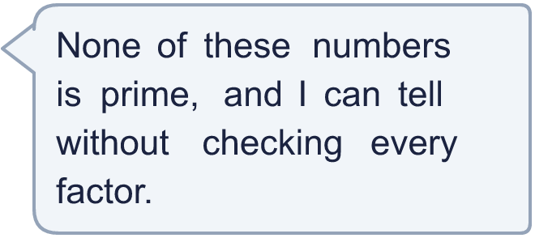
  10 | 5,619 2,470 1,910 2,756 8,416  Is Boba correct? Circle yes or no.  Yes / No  Explain how Boba knows.
  11 | What number am I thinking of?
     | 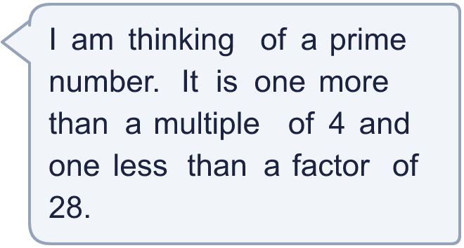
  11 | What number am I thinking of?
  12 | Write five consecutive numbers. Exactly three of them must be prime numbers.
  12 | Write five consecutive numbers. Exactly three of them must be prime numbers.
  13 | Is Boba correct? Circle yes or no.  Yes / No  Explain how you know.
    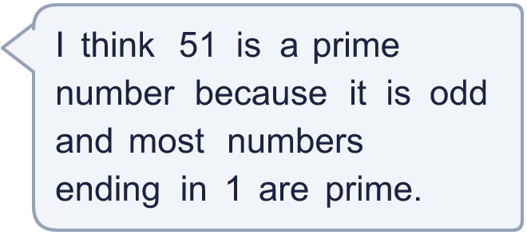
  13 | Is Boba correct? Circle yes or no.  Yes / No  Explain how you know.
  14 | Write 87 as a product of two numbers that are both bigger than 1.
    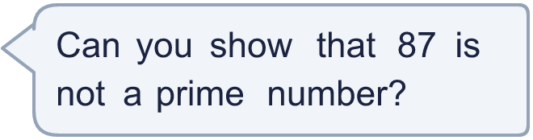
  14 | Write 87 as a product of two numbers that are both bigger than 1.

Year 5 · Multiply and divide A · Step 5
Prime numbers
Answers (teacher copy)

  1 | Write the prime numbers in each list.  a) 9 10 4 5 7 2 6 5, 7, 2  b) 17 21 9 11 13 15 23 17, 11, 13, 23
  2 | Write all the factors of each number. Which numbers are prime?  a) 5: 1, 5  b) 14: 1, 2, 7, 14  c) 19: 1, 19
  3 | Write how many factors each number has. A prime number has exactly two.  a) 9: 3  b) 1: 1  c) 7: 2  d) 11: 2
  4 | List all the prime numbers between 10 and 30.  11, 13, 17, 19, 23, 29
  5 | These are consecutive prime numbers. Complete the sequence.  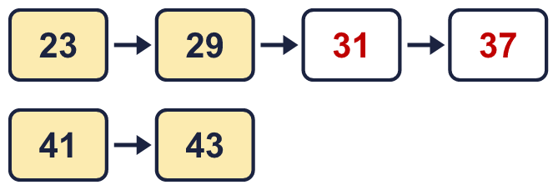
  6 | List all the prime numbers between 60 and 90.  61, 67, 71, 73, 79, 83, 89
  7 | Is each number prime? Write yes or no.  a) 34: No  b) 53: Yes  c) 46: No
  8 | Write the prime numbers in each list.  a) 47 33 31 45 43 39 47, 31, 43  b) 69 63 61 57 59 67 61, 59, 67
  9 | Is Boba correct? Circle yes or no.  Yes / No  Explain your answer.  No. 2 is a prime number and it is even. It only has the factors 1 and 2.
  10 | 5,619 2,470 1,910 2,756 8,416  Is Boba correct? Circle yes or no.  Yes / No  Explain how Boba knows.  Yes. Every number is divisible by 2, 3 or 5, so each one has a factor other than 1 and itself.
  11 | What number am I thinking of? 13
  12 | Write five consecutive numbers. Exactly three of them must be prime numbers.  for example 2, 3, 4, 5, 6 and 3, 4, 5, 6, 7
  13 | Is Boba correct? Circle yes or no.  Yes / No  Explain how you know.  51 is not prime: 51 ÷ 3 = 17, so 3 × 17 = 51. It has more than two factors.
  14 | Write 87 as a product of two numbers that are both bigger than 1. 3 × 29

