  Year 5 · Multiply and divide A · Step 3  Factors | 
  Year 5 · Multiply and divide A · Step 3
  Factors
  1 | Write all the factors of each number.  a) 24:  b) 40:
  1 | Write all the factors of each number.  a) 24:  b) 40:
  2 | Complete the factor pairs of 24.
    a) | 1 × |  | = 24
    b) | 2 × |  | = 24
    c) | 3 × |  | = 24
    d) | 4 × |  | = 24
  2 | Complete the factor pairs of 24.
    a) | 1 × |  | = 24
    b) | 2 × |  | = 24
    c) | 3 × |  | = 24
    d) | 4 × |  | = 24
  3 | Circle the factors of 30. Write them below.  15 2 36 37 52 1 30 22 9
  3 | Circle the factors of 30. Write them below.  15 2 36 37 52 1 30 22 9
  4 | Is the first number a factor of the second? Write yes or no.  a) Is 20 a factor of 180?  b) Is 3 a factor of 177?  c) Is 12 a factor of 144?
  4 | Is the first number a factor of the second? Write yes or no.  a) Is 20 a factor of 180?  b) Is 3 a factor of 177?  c) Is 12 a factor of 144?
  5 | Write how many factors each number has.  a) 12:  b) 16:  c) 6:  d) 28:
  5 | Write how many factors each number has.  a) 12:  b) 16:  c) 6:  d) 28:
  6 | Which number has more factors? Write the number.  72 64
  6 | Which number has more factors? Write the number.  72 64
  7 | List all the factors of 50. How can you check that you have found them all?
  7 | List all the factors of 50. How can you check that you have found them all?
  8 | Whitney bakes 40 cakes. Boxes can hold 2, 3, 4, 5, 6, 8 or 10 cakes. She wants to fill every box.  Which boxes could she use with no cakes left over?
  8 | Whitney bakes 40 cakes. Boxes can hold 2, 3, 4, 5, 6, 8 or 10 cakes. She wants to fill every box.  Which boxes could she use with no cakes left over?

  9 | Is Boba correct? Circle yes or no.  Yes / No  Explain your answer.
     | 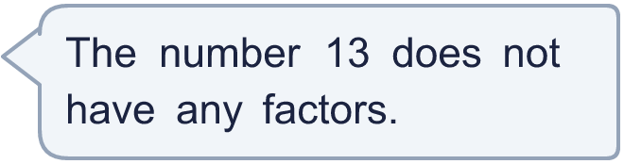
  9 | Is Boba correct? Circle yes or no.  Yes / No  Explain your answer.
  10 | What number am I thinking of?
    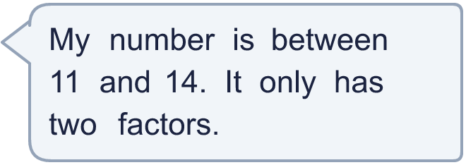
  10 | What number am I thinking of?
  11 | Is Boba correct? Circle yes or no.  Yes / No  Explain the mistake.
     | 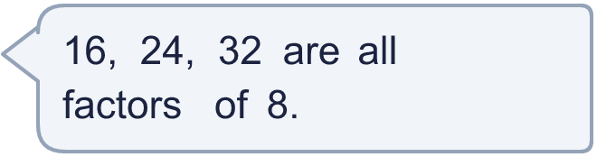
  11 | Is Boba correct? Circle yes or no.  Yes / No  Explain the mistake.
  12 | Is the statement always, sometimes or never true?  A square number has an odd number of factors.  Always, sometimes or never?  Explain your answer.
  12 | Is the statement always, sometimes or never true?  A square number has an odd number of factors.  Always, sometimes or never?  Explain your answer.
  13 | • It has exactly 4 factors.  • It is an odd number.  • It is a factor of 132.  What is my number?
     | 
  13 | • It has exactly 4 factors.  • It is an odd number.  • It is a factor of 132.  What is my number?
  14 | Write three different numbers between 30 and 60 that have exactly 4 factors.
  14 | Write three different numbers between 30 and 60 that have exactly 4 factors.

Year 5 · Multiply and divide A · Step 3
Factors
Answers (teacher copy)

  1 | Write all the factors of each number.  a) 24: 1, 2, 3, 4, 6, 8, 12, 24  b) 40: 1, 2, 4, 5, 8, 10, 20, 40
  2 | Complete the factor pairs of 24.  a) 1 × 24 = 24  b) 2 × 12 = 24  c) 3 × 8 = 24  d) 4 × 6 = 24
  3 | Circle the factors of 30. Write them below.  15 2 36 37 52 1 30 22 9  1, 2, 15, 30
  4 | Is the first number a factor of the second? Write yes or no.  a) Is 20 a factor of 180? Yes  b) Is 3 a factor of 177? Yes  c) Is 12 a factor of 144? Yes
  5 | Write how many factors each number has.  a) 12: 6  b) 16: 5  c) 6: 4  d) 28: 6
  6 | Which number has more factors? Write the number.  72 64  72
  7 | List all the factors of 50. How can you check that you have found them all?  1, 2, 5, 10, 25, 50
  8 | Whitney bakes 40 cakes. Boxes can hold 2, 3, 4, 5, 6, 8 or 10 cakes. She wants to fill every box.  Which boxes could she use with no cakes left over? 2, 4, 5, 8, 10
  9 | Is Boba correct? Circle yes or no.  Yes / No  Explain your answer.  13 has the factors 1 and 13. Every number has at least these two factors.
  10 | What number am I thinking of? 13
  11 | Is Boba correct? Circle yes or no.  Yes / No  Explain the mistake.  16, 24, 32 are multiples of 8, not factors. The factors of 8 are 1, 2, 4, 8.
  12 | Is the statement always, sometimes or never true?  A square number has an odd number of factors.  Always, sometimes or never? Always  Explain your answer.  16 has 5 factors (1, 2, 4, 8 and 16) and 25 has 3 factors (1, 5 and 25). The factor pair of a square number that uses the same number twice only counts once.
  13 | • It has exactly 4 factors.  • It is an odd number.  • It is a factor of 132.  What is my number? 33
  14 | Write three different numbers between 30 and 60 that have exactly 4 factors.  for example 39, 46, 51

