  Year 5 · Multiply and divide A · Step 2  Common multiples | 
  Year 5 · Multiply and divide A · Step 2
  Common multiples
  1 | Write the first 8 multiples of each number. Circle the numbers that are in both lists.  a) 2:  b) 5:
  1 | Write the first 8 multiples of each number. Circle the numbers that are in both lists.  a) 2:  b) 5:
  2 | Sort the numbers into the diagram. Write each group.  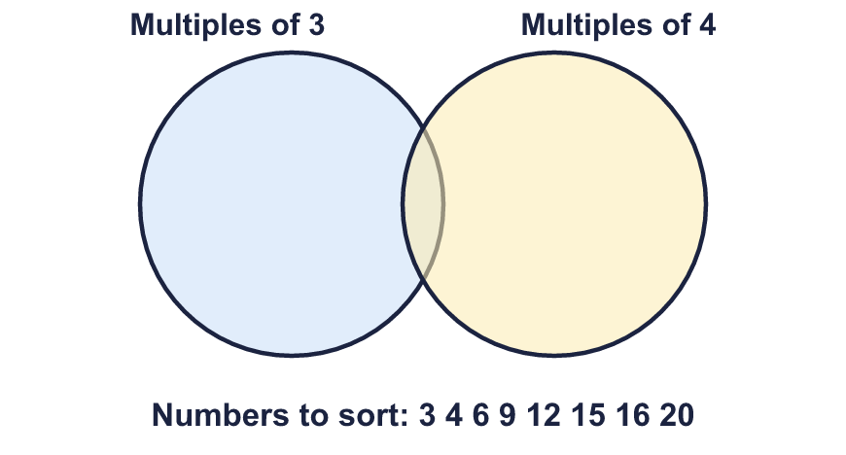  Multiples of 3 only:  Multiples of both:  Multiples of 4 only:  Neither:
  2 | Sort the numbers into the diagram. Write each group.  Multiples of 3 only:  Multiples of both:  Multiples of 4 only:  Neither:
  3 | Write the first three common multiples of each pair.  a) 2 and 7:  b) 3 and 4:  c) 2 and 4:
  3 | Write the first three common multiples of each pair.  a) 2 and 7:  b) 3 and 4:  c) 2 and 4:
  4 | Find the first common multiple of each pair.  a) 6 and 9:  b) 4 and 6:  c) 4 and 10:
  4 | Find the first common multiple of each pair.  a) 6 and 9:  b) 4 and 6:  c) 4 and 10:
  5 | Circle the common multiples of 3 and 4. Write them below.  12 15 18 20 24 40 45
  5 | Circle the common multiples of 3 and 4. Write them below.  12 15 18 20 24 40 45
  6 | List all the common multiples of 2 and 3 that are more than 10 and less than 50.
  6 | List all the common multiples of 2 and 3 that are more than 10 and less than 50.
  7 | List the common multiples of 5 and 6 that are more than 10 and less than 100. Use a hundred square to help you.
  7 | List the common multiples of 5 and 6 that are more than 10 and less than 100. Use a hundred square to help you.
  8 | Mason plays tennis every 4 days. Gill plays tennis every 7 days. They both played today.  In how many days will they next both play on the same day?
  8 | Mason plays tennis every 4 days. Gill plays tennis every 7 days. They both played today.  In how many days will they next both play on the same day?

  9 | a) Will both lights flash together at 1,140 seconds? Write yes or no.  b) After how many seconds will they next flash together?
    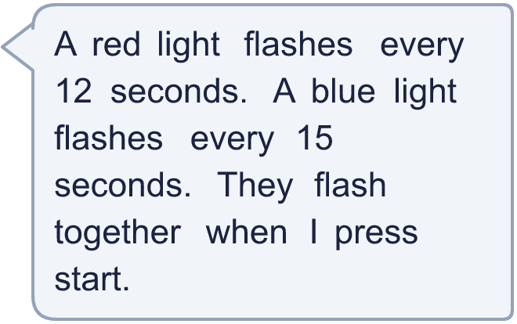
  9 | a) Will both lights flash together at 1,140 seconds? Write yes or no.  b) After how many seconds will they next flash together?
  10 | Is Boba correct? Circle yes or no.  Yes / No  Explain how you know.
     | 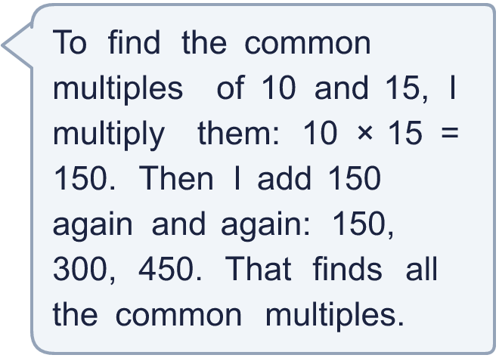
  10 | Is Boba correct? Circle yes or no.  Yes / No  Explain how you know.
  11 | Use these methods to circle the common multiples of 3 and 4. Write them below.  60 68 75 90 100 108
     | 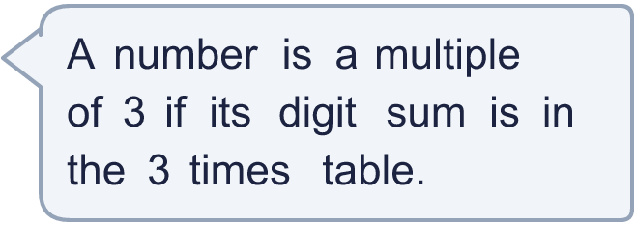
     | 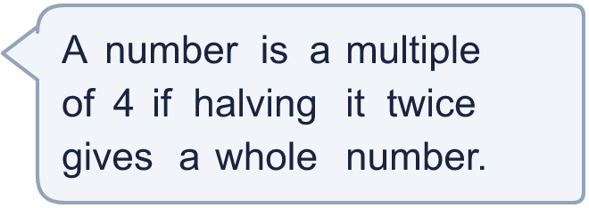
  11 | Use these methods to circle the common multiples of 3 and 4. Write them below.  60 68 75 90 100 108
  12 | Annie runs in the park every 4 days. Ron runs in the park every 6 days. They both ran today.  How many more times will they run on the same day in the next 60 days?
  12 | Annie runs in the park every 4 days. Ron runs in the park every 6 days. They both ran today.  How many more times will they run on the same day in the next 60 days?
  13 | Filip lists some common multiples of 3 and 5: 15, 30, 45, 60.  a) What is the difference between each common multiple and the next one?  b) Write the next three common multiples.
  13 | Filip lists some common multiples of 3 and 5: 15, 30, 45, 60.  a) What is the difference between each common multiple and the next one?  b) Write the next three common multiples.
  14 | Write three different numbers between 100 and 200 that are common multiples of 6 and 9.
  14 | Write three different numbers between 100 and 200 that are common multiples of 6 and 9.

Year 5 · Multiply and divide A · Step 2
Common multiples
Answers (teacher copy)

  1 | Write the first 8 multiples of each number. Circle the numbers that are in both lists.  a) 2: 2, 4, 6, 8, 10, 12, 14, 16  b) 5: 5, 10, 15, 20, 25, 30, 35, 40
  2 | Sort the numbers into the diagram. Write each group.  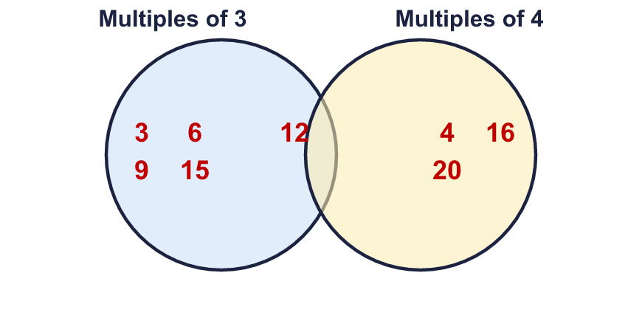  Multiples of 3 only: 3, 6, 9, 15  Multiples of both: 12  Multiples of 4 only: 4, 16, 20  Neither: none
  3 | Write the first three common multiples of each pair.  a) 2 and 7: 14, 28, 42  b) 3 and 4: 12, 24, 36  c) 2 and 4: 4, 8, 12
  4 | Find the first common multiple of each pair.  a) 6 and 9: 18  b) 4 and 6: 12  c) 4 and 10: 20
  5 | Circle the common multiples of 3 and 4. Write them below.  12 15 18 20 24 40 45  12, 24
  6 | List all the common multiples of 2 and 3 that are more than 10 and less than 50.  12, 18, 24, 30, 36, 42, 48
  7 | List the common multiples of 5 and 6 that are more than 10 and less than 100. Use a hundred square to help you.  30, 60, 90
  8 | Mason plays tennis every 4 days. Gill plays tennis every 7 days. They both played today.  In how many days will they next both play on the same day? 28
  9 | a) Will both lights flash together at 1,140 seconds? Write yes or no. Yes  b) After how many seconds will they next flash together? 60
  10 | Is Boba correct? Circle yes or no.  Yes / No  Explain how you know.  30 is a common multiple of 10 and 15 that Boba misses, because 30 is less than 150. 30 ÷ 10 = 3 and 30 ÷ 15 = 2.
  11 | Use these methods to circle the common multiples of 3 and 4. Write them below.  60 68 75 90 100 108  60, 108
  12 | Annie runs in the park every 4 days. Ron runs in the park every 6 days. They both ran today.  How many more times will they run on the same day in the next 60 days? 5
  13 | Filip lists some common multiples of 3 and 5: 15, 30, 45, 60.  a) What is the difference between each common multiple and the next one? 15  b) Write the next three common multiples. 75, 90, 105
  14 | Write three different numbers between 100 and 200 that are common multiples of 6 and 9.  Any three of the common multiples of 6 and 9 between 100 and 200, for example 108, 126, 144

