  Year 5 · Fractions A · Step 7  Ordering fractions less than 1 | 
  Year 5 · Fractions A · Step 7
  Ordering fractions less than 1
  1 | Write the fractions in order.  a) ⁶⁄₈ ⁴⁄₈ ³⁄₈ ²⁄₈  b) ³⁄₁₀ ⁹⁄₁₀ ⁸⁄₁₀ ¹⁄₁₀ ²⁄₁₀
  1 | Write the fractions in order.  a) ⁶⁄₈ ⁴⁄₈ ³⁄₈ ²⁄₈  b) ³⁄₁₀ ⁹⁄₁₀ ⁸⁄₁₀ ¹⁄₁₀ ²⁄₁₀
  2 | Write the fractions in order.  a) ³⁄₇ ³⁄₆ ³⁄₈ ³⁄₄  b) ³⁄₁₀ ³⁄₁₂ ³⁄₆ ³⁄₅
  2 | Write the fractions in order.  a) ³⁄₇ ³⁄₆ ³⁄₈ ³⁄₄  b) ³⁄₁₀ ³⁄₁₂ ³⁄₆ ³⁄₅
  3 | Write the fractions in order. Change them so they all have the same denominator.  a) ²⁄₄ ¹⁄₄ ²⁄₅  b) ¹⁄₅ ¹⁄₂₀ ³⁄₅
  3 | Write the fractions in order. Change them so they all have the same denominator.  a) ²⁄₄ ¹⁄₄ ²⁄₅  b) ¹⁄₅ ¹⁄₂₀ ³⁄₅
  4 | Find the smallest and the greatest fraction.  ⁴⁄₅ ⁵⁄₆ ⁶⁄₁₂ ¹⁄₆
  4 | Find the smallest and the greatest fraction.  ⁴⁄₅ ⁵⁄₆ ⁶⁄₁₂ ¹⁄₆
  5 | Which is the greatest fraction?  ²⁄₄ ⁴⁄₅ ¹⁄₆ ¹⁄₈
  5 | Which is the greatest fraction?  ²⁄₄ ⁴⁄₅ ¹⁄₆ ¹⁄₈
  6 | Write the fractions in order, starting with the smallest.  a) ²⁄₃ ⁵⁄₁₂ ¹⁄₃ ³⁄₄
  6 | Write the fractions in order, starting with the smallest.  a) ²⁄₃ ⁵⁄₁₂ ¹⁄₃ ³⁄₄
  7 | Write the fractions in order, starting with the greatest.  a) ³⁄₈ ⁷⁄₈ ²⁄₄ ²⁄₆
  7 | Write the fractions in order, starting with the greatest.  a) ³⁄₈ ⁷⁄₈ ²⁄₄ ²⁄₆
  8 | Write the fractions in order.  a) ¹²⁄₂₀ ⁵⁄₁₀ ⁷⁄₁₀ ¹⁄₅ ⁸⁄₁₀  b) ⁹⁄₁₂ ¹¹⁄₁₂ ¹⁄₁₂ ⁷⁄₁₂
  8 | Write the fractions in order.  a) ¹²⁄₂₀ ⁵⁄₁₀ ⁷⁄₁₀ ¹⁄₅ ⁸⁄₁₀  b) ⁹⁄₁₂ ¹¹⁄₁₂ ¹⁄₁₂ ⁷⁄₁₂

  9 | Write the names in order, starting with the person who ran the furthest.
     | 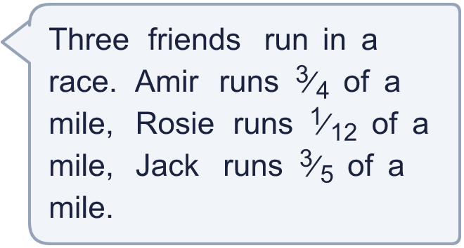
  9 | Write the names in order, starting with the person who ran the furthest.
  10 | Is Boba correct? Circle yes or no.  Yes / No  Explain your answer.
     | 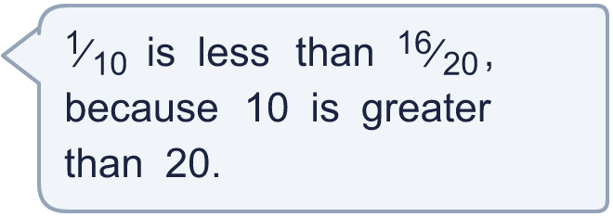
  10 | Is Boba correct? Circle yes or no.  Yes / No  Explain your answer.
  11 | Write all the whole numbers that make this correct.  ³⁄₅ < ?⁄₁₀ < ⁵⁄₅
  11 | Write all the whole numbers that make this correct.  ³⁄₅ < ?⁄₁₀ < ⁵⁄₅
  12 | Write two fractions that are between ¹⁄₄ and ⁴⁄₅.
  12 | Write two fractions that are between ¹⁄₄ and ⁴⁄₅.
  13 | Write the fractions in order, starting with the smallest. Explain your method to a partner.  a) ⁸⁄₁₂ ⁵⁄₆ ²⁄₈ ³⁄₄ ³⁄₅
  13 | Write the fractions in order, starting with the smallest. Explain your method to a partner.  a) ⁸⁄₁₂ ⁵⁄₆ ²⁄₈ ³⁄₄ ³⁄₅
  14 | Write the fractions in order, starting with the greatest.  a) ³⁄₅ ⁷⁄₁₀ ⁵⁄₁₀
  14 | Write the fractions in order, starting with the greatest.  a) ³⁄₅ ⁷⁄₁₀ ⁵⁄₁₀

Year 5 · Fractions A · Step 7
Ordering fractions less than 1
Answers (teacher copy)

  1 | Write the fractions in order.  a) ⁶⁄₈ ⁴⁄₈ ³⁄₈ ²⁄₈  smallest first: ²⁄₈, ³⁄₈, ⁴⁄₈, ⁶⁄₈  b) ³⁄₁₀ ⁹⁄₁₀ ⁸⁄₁₀ ¹⁄₁₀ ²⁄₁₀  greatest first: ⁹⁄₁₀, ⁸⁄₁₀, ³⁄₁₀, ²⁄₁₀, ¹⁄₁₀
  2 | Write the fractions in order.  a) ³⁄₇ ³⁄₆ ³⁄₈ ³⁄₄  smallest first: ³⁄₈, ³⁄₇, ³⁄₆, ³⁄₄  b) ³⁄₁₀ ³⁄₁₂ ³⁄₆ ³⁄₅  greatest first: ³⁄₅, ³⁄₆, ³⁄₁₀, ³⁄₁₂
  3 | Write the fractions in order. Change them so they all have the same denominator.  a) ²⁄₄ ¹⁄₄ ²⁄₅  smallest first: ¹⁄₄, ²⁄₅, ²⁄₄  b) ¹⁄₅ ¹⁄₂₀ ³⁄₅  greatest first: ³⁄₅, ¹⁄₅, ¹⁄₂₀
  4 | Find the smallest and the greatest fraction.  ⁴⁄₅ ⁵⁄₆ ⁶⁄₁₂ ¹⁄₆  Smallest: ¹⁄₆, ⁵⁄₆ Greatest:
  5 | Which is the greatest fraction?  ²⁄₄ ⁴⁄₅ ¹⁄₆ ¹⁄₈  ⁴⁄₅
  6 | Write the fractions in order, starting with the smallest.  a) ²⁄₃ ⁵⁄₁₂ ¹⁄₃ ³⁄₄  smallest first: ¹⁄₃, ⁵⁄₁₂, ²⁄₃, ³⁄₄
  7 | Write the fractions in order, starting with the greatest.  a) ³⁄₈ ⁷⁄₈ ²⁄₄ ²⁄₆  greatest first: ⁷⁄₈, ²⁄₄, ³⁄₈, ²⁄₆
  8 | Write the fractions in order.  a) ¹²⁄₂₀ ⁵⁄₁₀ ⁷⁄₁₀ ¹⁄₅ ⁸⁄₁₀  smallest first: ¹⁄₅, ⁵⁄₁₀, ¹²⁄₂₀, ⁷⁄₁₀, ⁸⁄₁₀  b) ⁹⁄₁₂ ¹¹⁄₁₂ ¹⁄₁₂ ⁷⁄₁₂  greatest first: ¹¹⁄₁₂, ⁹⁄₁₂, ⁷⁄₁₂, ¹⁄₁₂
  9 | Write the names in order, starting with the person who ran the furthest. Amir, Jack, Rosie
  10 | Is Boba correct? Circle yes or no.  Yes / No  Explain your answer.  Yes. ¹⁄₁₀ = ²⁄₂₀, and ¹⁶⁄₂₀ is greater than ¹⁄₁₀.
  11 | Write all the whole numbers that make this correct.  ³⁄₅ < ?⁄₁₀ < ⁵⁄₅ 7, 8, 9
  12 | Write two fractions that are between ¹⁄₄ and ⁴⁄₅.  for example ¹⁄₂ and ³⁄₅
  13 | Write the fractions in order, starting with the smallest. Explain your method to a partner.  a) ⁸⁄₁₂ ⁵⁄₆ ²⁄₈ ³⁄₄ ³⁄₅  smallest first: ²⁄₈, ³⁄₅, ⁸⁄₁₂, ³⁄₄, ⁵⁄₆
  14 | Write the fractions in order, starting with the greatest.  a) ³⁄₅ ⁷⁄₁₀ ⁵⁄₁₀  greatest first: ⁷⁄₁₀, ³⁄₅, ⁵⁄₁₀

