  Year 5 · Fractions A · Step 1  Fractions equivalent to a unit fraction | 
  Year 5 · Fractions A · Step 1
  Fractions equivalent to a unit fraction
  1 | Each bar is the same length. Use the bars to find the missing numerators.  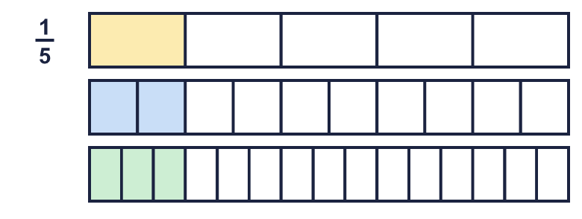  a) ¹⁄₅ = ?⁄₁₀  b) ¹⁄₅ = ?⁄₁₅
  1 | Each bar is the same length. Use the bars to find the missing numerators.  a) ¹⁄₅ = ?⁄₁₀  b) ¹⁄₅ = ?⁄₁₅
  2 | Write the missing numerator in each pair of equal fractions.  a) ¹⁄₅ = ?⁄₁₀  b) ¹⁄₈ = ?⁄₂₄  c) ¹⁄₆ = ?⁄₂₄
  2 | Write the missing numerator in each pair of equal fractions.  a) ¹⁄₅ = ?⁄₁₀  b) ¹⁄₈ = ?⁄₂₄  c) ¹⁄₆ = ?⁄₂₄
  3 | Write the missing denominator in each pair of equal fractions.  a) ¹⁄₅ = ⁵⁄?  b) ¹⁄₄ = ³⁄?  c) ¹⁄₉ = ⁴⁄?
  3 | Write the missing denominator in each pair of equal fractions.  a) ¹⁄₅ = ⁵⁄?  b) ¹⁄₄ = ³⁄?  c) ¹⁄₉ = ⁴⁄?
  4 | Write the missing denominator in each pair of equal fractions.  a) ⁴⁄₁₂ = ¹⁄?  b) ⁵⁄₂₅ = ¹⁄?  c) ³⁄₁₂ = ¹⁄?
  4 | Write the missing denominator in each pair of equal fractions.  a) ⁴⁄₁₂ = ¹⁄?  b) ⁵⁄₂₅ = ¹⁄?  c) ³⁄₁₂ = ¹⁄?
  5 | Write the missing number in each pair of equal fractions.  a) ¹⁄₉ = ?⁄₅₄  b) ¹⁄₁₀ = ?⁄₁₀₀  c) ¹⁄₅ = ?⁄₄₅  d) ¹⁄₄ = ?⁄₃₂
  5 | Write the missing number in each pair of equal fractions.  a) ¹⁄₉ = ?⁄₅₄  b) ¹⁄₁₀ = ?⁄₁₀₀  c) ¹⁄₅ = ?⁄₄₅  d) ¹⁄₄ = ?⁄₃₂
  6 | Three of these fractions are equal to ¹⁄₆. Write the fraction that is not.  ⁶⁄₃₆ ⁵⁄₃₀ ²⁄₁₈ ²⁄₁₂
  6 | Three of these fractions are equal to ¹⁄₆. Write the fraction that is not.  ⁶⁄₃₆ ⁵⁄₃₀ ²⁄₁₈ ²⁄₁₂
  7 | Write each fraction as a unit fraction.  a) ⁵⁄₁₅ =  b) ²⁄₁₄ =  c) ⁷⁄₆₃ =  d) ⁶⁄₃₆ =
  7 | Write each fraction as a unit fraction.  a) ⁵⁄₁₅ =  b) ²⁄₁₄ =  c) ⁷⁄₆₃ =  d) ⁶⁄₃₆ =
  8 | Write the missing number in each pair of equal fractions.  a) ¹⁄₁₀ = ?⁄₁₂₀  b) ¹⁄₅ = ?⁄₁₀₀  c) ¹⁄₆ = ?⁄₉₀
  8 | Write the missing number in each pair of equal fractions.  a) ¹⁄₁₀ = ?⁄₁₂₀  b) ¹⁄₅ = ?⁄₁₀₀  c) ¹⁄₆ = ?⁄₉₀

  9 | Is Boba correct? Circle yes or no.  Yes / No  Explain your answer.
     | 
  9 | Is Boba correct? Circle yes or no.  Yes / No  Explain your answer.
  10 | Is Boba correct? Circle yes or no.  Yes / No  Explain the mistake.
     | 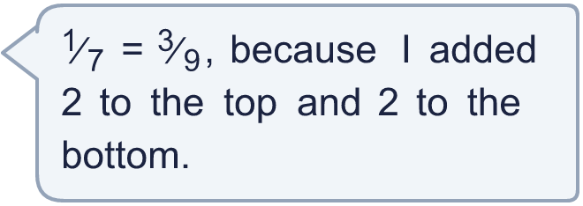
  10 | Is Boba correct? Circle yes or no.  Yes / No  Explain the mistake.
  11 | Write three different fractions that are equal to ¹⁄₅.  All the denominators must be multiples of 2.
  11 | Write three different fractions that are equal to ¹⁄₅.  All the denominators must be multiples of 2.
  12 | What fraction am I?
    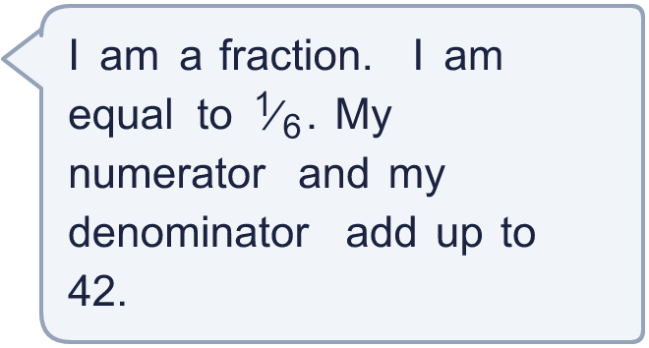
  12 | What fraction am I?
  13 | What fraction am I?
     | 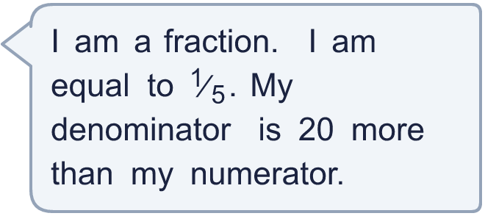
  13 | What fraction am I?
  14 | Ben eats ¹⁄₃ of a pizza. Cal eats ²⁄₆ of an identical pizza.  Who eats more pizza? Explain how you know.
  14 | Ben eats ¹⁄₃ of a pizza. Cal eats ²⁄₆ of an identical pizza.  Who eats more pizza? Explain how you know.

Year 5 · Fractions A · Step 1
Fractions equivalent to a unit fraction
Answers (teacher copy)

  1 | Each bar is the same length. Use the bars to find the missing numerators.  a) ¹⁄₅ = ?⁄₁₀ 2  b) ¹⁄₅ = ?⁄₁₅ 3
  2 | Write the missing numerator in each pair of equal fractions.  a) ¹⁄₅ = ?⁄₁₀ 2  b) ¹⁄₈ = ?⁄₂₄ 3  c) ¹⁄₆ = ?⁄₂₄ 4
  3 | Write the missing denominator in each pair of equal fractions.  a) ¹⁄₅ = ⁵⁄? 25  b) ¹⁄₄ = ³⁄? 12  c) ¹⁄₉ = ⁴⁄? 36
  4 | Write the missing denominator in each pair of equal fractions.  a) ⁴⁄₁₂ = ¹⁄? 3  b) ⁵⁄₂₅ = ¹⁄? 5  c) ³⁄₁₂ = ¹⁄? 4
  5 | Write the missing number in each pair of equal fractions.  a) ¹⁄₉ = ?⁄₅₄ 6  b) ¹⁄₁₀ = ?⁄₁₀₀ 10  c) ¹⁄₅ = ?⁄₄₅ 9  d) ¹⁄₄ = ?⁄₃₂ 8
  6 | Three of these fractions are equal to ¹⁄₆. Write the fraction that is not.  ⁶⁄₃₆ ⁵⁄₃₀ ²⁄₁₈ ²⁄₁₂  ²⁄₁₈
  7 | Write each fraction as a unit fraction.  a) ⁵⁄₁₅ = ¹⁄₃  b) ²⁄₁₄ = ¹⁄₇  c) ⁷⁄₆₃ = ¹⁄₉  d) ⁶⁄₃₆ = ¹⁄₆
  8 | Write the missing number in each pair of equal fractions.  a) ¹⁄₁₀ = ?⁄₁₂₀ 12  b) ¹⁄₅ = ?⁄₁₀₀ 20  c) ¹⁄₆ = ?⁄₉₀ 15
  9 | Is Boba correct? Circle yes or no.  Yes / No  Explain your answer.  No. ¹⁄₆ is equal to ²⁄₁₂, not ²⁄₁₃. ²⁄₁₃ is not a unit fraction in disguise.
  10 | Is Boba correct? Circle yes or no.  Yes / No  Explain the mistake.  No. ¹⁄₇ and ³⁄₉ are not equal. To find an equal fraction you multiply the top and the bottom by the same number, for example ²⁄₁₄.
  11 | Write three different fractions that are equal to ¹⁄₅.  All the denominators must be multiples of 2.  for example ²⁄₁₀, ⁴⁄₂₀, ⁶⁄₃₀
  12 | What fraction am I?  ⁶⁄₃₆
  13 | What fraction am I?  ⁵⁄₂₅
  14 | Ben eats ¹⁄₃ of a pizza. Cal eats ²⁄₆ of an identical pizza.  Who eats more pizza? Explain how you know.  Neither. They eat the same amount. ²⁄₆ = ¹⁄₃.

