  Year 5 · Fractions A · Step 2  Fractions equivalent to a non-unit fraction | 
  Year 5 · Fractions A · Step 2
  Fractions equivalent to a non-unit fraction
  1 | Each bar is the same length. Use the bars to find the missing numerators.  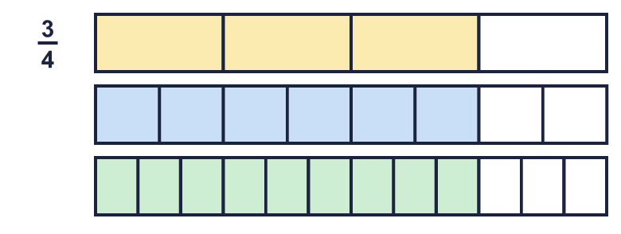  a) ³⁄₄ = ?⁄₈  b) ³⁄₄ = ?⁄₁₂
  1 | Each bar is the same length. Use the bars to find the missing numerators.  a) ³⁄₄ = ?⁄₈  b) ³⁄₄ = ?⁄₁₂
  2 | Write the missing numerator in each pair of equal fractions.  a) ²⁄₃ = ?⁄₁₂  b) ³⁄₇ = ?⁄₂₈  c) ²⁄₅ = ?⁄₁₀
  2 | Write the missing numerator in each pair of equal fractions.  a) ²⁄₃ = ?⁄₁₂  b) ³⁄₇ = ?⁄₂₈  c) ²⁄₅ = ?⁄₁₀
  3 | Write the missing denominator in each pair of equal fractions.  a) ²⁄₃ = ⁴⁄?  b) ⁴⁄₇ = ¹⁶⁄?  c) ²⁄₉ = ⁸⁄?
  3 | Write the missing denominator in each pair of equal fractions.  a) ²⁄₃ = ⁴⁄?  b) ⁴⁄₇ = ¹⁶⁄?  c) ²⁄₉ = ⁸⁄?
  4 | Write the missing numerator in each pair of equal fractions.  a) ¹²⁄₂₁ = ?⁄₇  b) ²¹⁄₂₄ = ?⁄₈  c) ²⁵⁄₃₅ = ?⁄₇
  4 | Write the missing numerator in each pair of equal fractions.  a) ¹²⁄₂₁ = ?⁄₇  b) ²¹⁄₂₄ = ?⁄₈  c) ²⁵⁄₃₅ = ?⁄₇
  5 | Write the missing denominator in each pair of equal fractions.  a) ²⁵⁄₄₀ = ⁵⁄?  b) ⁶⁄₉ = ²⁄?  c) ¹²⁄₁₅ = ⁴⁄?
  5 | Write the missing denominator in each pair of equal fractions.  a) ²⁵⁄₄₀ = ⁵⁄?  b) ⁶⁄₉ = ²⁄?  c) ¹²⁄₁₅ = ⁴⁄?
  6 | Three of these fractions are equal to ²⁄₃. Write the fraction that is not.  ⁸⁄₁₂ ¹⁰⁄₁₅ ⁵⁄₉ ⁴⁄₆
  6 | Three of these fractions are equal to ²⁄₃. Write the fraction that is not.  ⁸⁄₁₂ ¹⁰⁄₁₅ ⁵⁄₉ ⁴⁄₆
  7 | Write each fraction in its simplest form.  a) ²⁴⁄₅₄ =  b) ³⁰⁄₃₅ =  c) ¹⁶⁄₃₆ =  d) ⁸⁄₁₀ =
  7 | Write each fraction in its simplest form.  a) ²⁴⁄₅₄ =  b) ³⁰⁄₃₅ =  c) ¹⁶⁄₃₆ =  d) ⁸⁄₁₀ =
  8 | Write the missing numerator. The denominators are all 100.  a) ⁹⁄₂₅ = ?⁄₁₀₀  b) ¹⁄₄ = ?⁄₁₀₀  c) ¹⁄₂ = ?⁄₁₀₀
  8 | Write the missing numerator. The denominators are all 100.  a) ⁹⁄₂₅ = ?⁄₁₀₀  b) ¹⁄₄ = ?⁄₁₀₀  c) ¹⁄₂ = ?⁄₁₀₀

  9 | Is Boba correct? Circle yes or no.  Yes / No  Explain the mistake.
     | 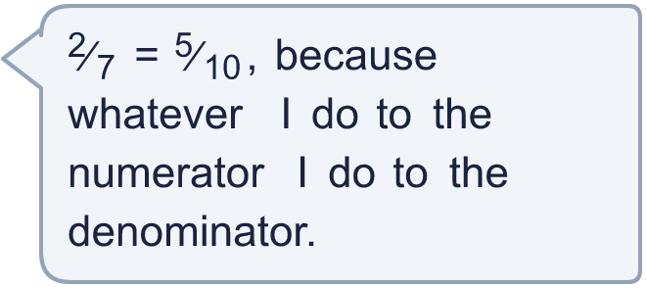
  9 | Is Boba correct? Circle yes or no.  Yes / No  Explain the mistake.
  10 | Eva simplifies ²⁰⁄₃₀. Eva divides the numerator by 5 and the denominator by 2, and gets ⁴⁄₁₅.  What mistake did Eva make? Write the correct answer.
  10 | Eva simplifies ²⁰⁄₃₀. Eva divides the numerator by 5 and the denominator by 2, and gets ⁴⁄₁₅.  What mistake did Eva make? Write the correct answer.
  11 | Write three different fractions that are equal to ⁴⁄₇.  All the denominators must be multiples of 3.
  11 | Write three different fractions that are equal to ⁴⁄₇.  All the denominators must be multiples of 3.
  12 | What fraction am I?
    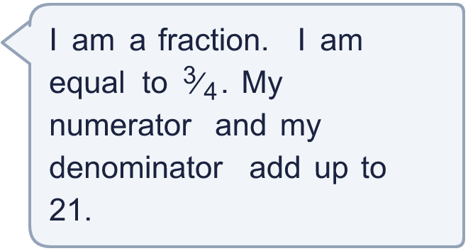
  12 | What fraction am I?
  13 | What fraction am I?
     | 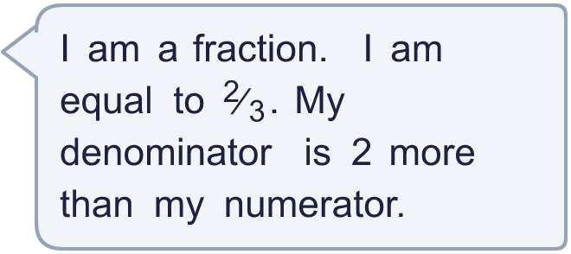
  13 | What fraction am I?
  14 | Ana eats ⁶⁄₉ of a pizza. Eli eats ⁸⁄₁₂ of an identical pizza.  Who eats more pizza? Explain how you know.
  14 | Ana eats ⁶⁄₉ of a pizza. Eli eats ⁸⁄₁₂ of an identical pizza.  Who eats more pizza? Explain how you know.

Year 5 · Fractions A · Step 2
Fractions equivalent to a non-unit fraction
Answers (teacher copy)

  1 | Each bar is the same length. Use the bars to find the missing numerators.  a) ³⁄₄ = ?⁄₈ 6  b) ³⁄₄ = ?⁄₁₂ 9
  2 | Write the missing numerator in each pair of equal fractions.  a) ²⁄₃ = ?⁄₁₂ 8  b) ³⁄₇ = ?⁄₂₈ 12  c) ²⁄₅ = ?⁄₁₀ 4
  3 | Write the missing denominator in each pair of equal fractions.  a) ²⁄₃ = ⁴⁄? 6  b) ⁴⁄₇ = ¹⁶⁄? 28  c) ²⁄₉ = ⁸⁄? 36
  4 | Write the missing numerator in each pair of equal fractions.  a) ¹²⁄₂₁ = ?⁄₇ 4  b) ²¹⁄₂₄ = ?⁄₈ 7  c) ²⁵⁄₃₅ = ?⁄₇ 5
  5 | Write the missing denominator in each pair of equal fractions.  a) ²⁵⁄₄₀ = ⁵⁄? 8  b) ⁶⁄₉ = ²⁄? 3  c) ¹²⁄₁₅ = ⁴⁄? 5
  6 | Three of these fractions are equal to ²⁄₃. Write the fraction that is not.  ⁸⁄₁₂ ¹⁰⁄₁₅ ⁵⁄₉ ⁴⁄₆  ⁵⁄₉
  7 | Write each fraction in its simplest form.  a) ²⁴⁄₅₄ = ⁴⁄₉  b) ³⁰⁄₃₅ = ⁶⁄₇  c) ¹⁶⁄₃₆ = ⁴⁄₉  d) ⁸⁄₁₀ = ⁴⁄₅
  8 | Write the missing numerator. The denominators are all 100.  a) ⁹⁄₂₅ = ?⁄₁₀₀ 36  b) ¹⁄₄ = ?⁄₁₀₀ 25  c) ¹⁄₂ = ?⁄₁₀₀ 50
  9 | Is Boba correct? Circle yes or no.  Yes / No  Explain the mistake.  No. Boba added 3 to the top and the bottom. ²⁄₇ and ⁵⁄₁₀ are not equal. You must multiply the top and the bottom by the same number, for example ⁶⁄₂₁.
  10 | Eva simplifies ²⁰⁄₃₀. Eva divides the numerator by 5 and the denominator by 2, and gets ⁴⁄₁₅.  What mistake did Eva make? Write the correct answer.  Eva divided the top and the bottom by different numbers. You must divide both by the same number. ²⁰⁄₃₀ = ²⁄₃.
  11 | Write three different fractions that are equal to ⁴⁄₇.  All the denominators must be multiples of 3.  for example ¹²⁄₂₁, ²⁴⁄₄₂, ³⁶⁄₆₃
  12 | What fraction am I?  ⁹⁄₁₂
  13 | What fraction am I?  ⁴⁄₆
  14 | Ana eats ⁶⁄₉ of a pizza. Eli eats ⁸⁄₁₂ of an identical pizza.  Who eats more pizza? Explain how you know.  Neither. They eat the same amount. ⁶⁄₉ = ²⁄₃ and ⁸⁄₁₂ = ²⁄₃.

