  Year 5 · Addition and subtraction · Step 3  Subtracting large whole numbers | 
  Year 5 · Addition and subtraction · Step 3
  Subtracting large whole numbers
  1 | Complete the column subtraction. Write the missing digits in the answer.  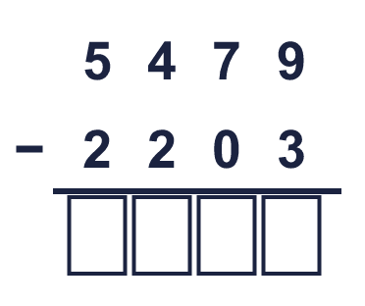
  1 | Complete the column subtraction. Write the missing digits in the answer.
  2 | Use the column method to work out the subtractions.  a) 6,875 − 437 =  b) 5,940 − 2,968 =  c) 6,492 − 1,694 =
  2 | Use the column method to work out the subtractions.  a) 6,875 − 437 =  b) 5,940 − 2,968 =  c) 6,492 − 1,694 =
  3 | Use the column method to work out the subtractions.  a) 98,320 − 9,455 =  b) 80,733 − 21,088 =  c) 331,909 − 44,644 =
  3 | Use the column method to work out the subtractions.  a) 98,320 − 9,455 =  b) 80,733 − 21,088 =  c) 331,909 − 44,644 =
  4 | Use the column method to work out the subtractions. Write the units in your answer.  a) £94,768 − £6,917 =  b) 93,634 g − 248 g =  c) £36,719 − £26,160 =
  4 | Use the column method to work out the subtractions. Write the units in your answer.  a) £94,768 − £6,917 =  b) 93,634 g − 248 g =  c) £36,719 − £26,160 =
  5 | Work out the subtractions. They all start with 9,589.  a) 9,589 − 1,323 =  b) 9,589 − 2,694 =  c) 9,589 − 5,652 =  d) 9,589 − 611 =
  5 | Work out the subtractions. They all start with 9,589.  a) 9,589 − 1,323 =  b) 9,589 − 2,694 =  c) 9,589 − 5,652 =  d) 9,589 − 611 =
  6 | Work out the subtractions. Take care with the zeros.  a) 10,009 − 9,993 =  b) 10,000 − 9,236 =  c) 100,000 − 89,684 =  d) 80,005 − 9,994 =
  6 | Work out the subtractions. Take care with the zeros.  a) 10,009 − 9,993 =  b) 10,000 − 9,236 =  c) 100,000 − 89,684 =  d) 80,005 − 9,994 =
  7 | A family has £25,343 in the bank. They spend £6,800 on a holiday.  a) How much money do they have left?  Sydney is 10,771 miles from London and 9,997 miles from New York.  b) How much further is Sydney from London than from New York?
  7 | A family has £25,343 in the bank. They spend £6,800 on a holiday.  a) How much money do they have left?  Sydney is 10,771 miles from London and 9,997 miles from New York.  b) How much further is Sydney from London than from New York?
  8 | Write the missing digits in the calculation.  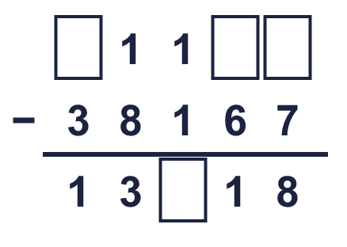
  8 | Write the missing digits in the calculation.

  9 | 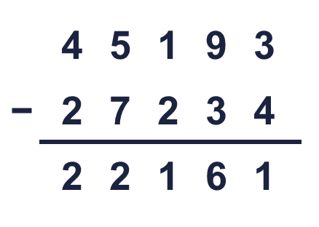  Is Boba correct? Circle yes or no.  Yes / No  What is the correct answer?  Explain Boba’s mistake.
     | 
  9 | Is Boba correct? Circle yes or no.  Yes / No  What is the correct answer?  Explain Boba’s mistake.
  10 | Look at the bar model. Subtract to find the missing part.  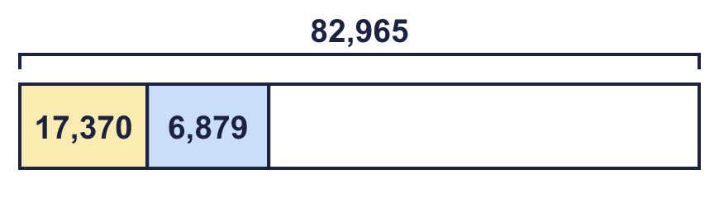
  10 | Look at the bar model. Subtract to find the missing part.
  11 | Teddy and Jack play a computer game. Teddy scores 44,985 points. Jack scores 14,487 fewer points than Teddy.  a) How many points does Jack score?  b) How many points do they score altogether?
  11 | Teddy and Jack play a computer game. Teddy scores 44,985 points. Jack scores 14,487 fewer points than Teddy.  a) How many points does Jack score?  b) How many points do they score altogether?
  12 | 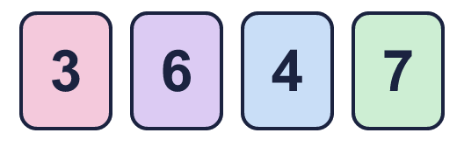  The difference between their numbers is between 1,000 and 3,000.  What numbers could Ron and Eva have made? Write two different pairs.
     | 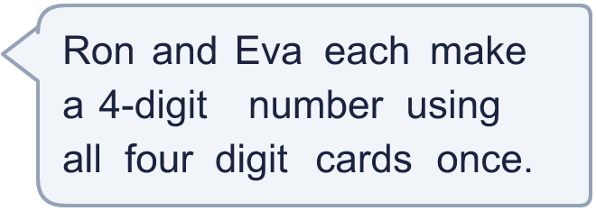
  12 | The difference between their numbers is between 1,000 and 3,000.  What numbers could Ron and Eva have made? Write two different pairs.
  13 | Rosie works out 35,173 − 9,996 by taking away 10,000 first.  a) 35,173 − 10,000 =  c) 35,173 − 9,996 =
    b) | Now she must add back
    to get the answer.
  13 | Rosie works out 35,173 − 9,996 by taking away 10,000 first.  a) 35,173 − 10,000 =  c) 35,173 − 9,996 =
    b) | Now she must add back
    to get the answer.
  14 | Write two different subtractions of two 5-digit numbers with an answer of exactly 20,000.
  14 | Write two different subtractions of two 5-digit numbers with an answer of exactly 20,000.

Year 5 · Addition and subtraction · Step 3
Subtracting large whole numbers
Answers (teacher copy)

  1 | Complete the column subtraction. Write the missing digits in the answer.  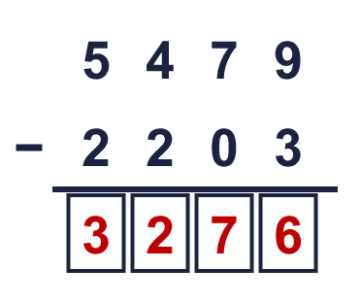  Answer: 3,276
  2 | Use the column method to work out the subtractions.  a) 6,875 − 437 = 6,438  b) 5,940 − 2,968 = 2,972  c) 6,492 − 1,694 = 4,798
  3 | Use the column method to work out the subtractions.  a) 98,320 − 9,455 = 88,865  b) 80,733 − 21,088 = 59,645  c) 331,909 − 44,644 = 287,265
  4 | Use the column method to work out the subtractions. Write the units in your answer.  a) £94,768 − £6,917 = £87,851  b) 93,634 g − 248 g = 93,386 g  c) £36,719 − £26,160 = £10,559
  5 | Work out the subtractions. They all start with 9,589.  a) 9,589 − 1,323 = 8,266  b) 9,589 − 2,694 = 6,895  c) 9,589 − 5,652 = 3,937  d) 9,589 − 611 = 8,978
  6 | Work out the subtractions. Take care with the zeros.  a) 10,009 − 9,993 = 16  b) 10,000 − 9,236 = 764  c) 100,000 − 89,684 = 10,316  d) 80,005 − 9,994 = 70,011
  7 | A family has £25,343 in the bank. They spend £6,800 on a holiday.  a) How much money do they have left? £18,543  Sydney is 10,771 miles from London and 9,997 miles from New York.  b) How much further is Sydney from London than from New York? 774 miles
  8 | Write the missing digits in the calculation.  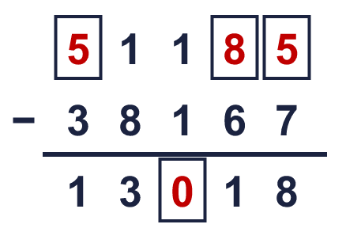  Missing digits, from top to bottom and left to right: 5 8 5 0
  9 | Is Boba correct? Circle yes or no.  Yes / No  What is the correct answer? 17,959  Explain Boba’s mistake.  45,193 − 27,234 = 17,959. Boba took the smaller digit from the bigger digit in every column. When the top digit is smaller, exchange from the next column.
  10 | Look at the bar model. Subtract to find the missing part.  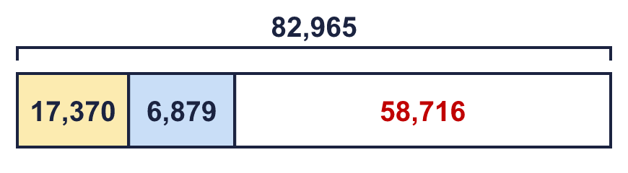  The missing part is 58,716
  11 | Teddy and Jack play a computer game. Teddy scores 44,985 points. Jack scores 14,487 fewer points than Teddy.  a) How many points does Jack score? 30,498  b) How many points do they score altogether? 75,483
  12 | The difference between their numbers is between 1,000 and 3,000.  What numbers could Ron and Eva have made? Write two different pairs.  for example 7,436 and 6,347; 7,364 and 4,736
  13 | Rosie works out 35,173 − 9,996 by taking away 10,000 first.  a) 35,173 − 10,000 = 25,173  b) Now she must add back 4 to get the answer.  c) 35,173 − 9,996 = 25,177
  14 | Write two different subtractions of two 5-digit numbers with an answer of exactly 20,000.  for example 40,000 − 20,000 and 51,000 − 31,000

