  Year 5 · Addition and subtraction · Step 6  Multi-step addition and subtraction problems | 
  Year 5 · Addition and subtraction · Step 6
  Multi-step addition and subtraction problems
  1 | Eva reads a book at bedtime. On Monday she reads 43 pages. On Tuesday she reads 5 more pages than on Monday. The book has 139 pages.  a) How many pages does she read on Tuesday?  b) How many pages does she read on Monday and Tuesday altogether?  c) How many pages does she have left to read?
  1 | Eva reads a book at bedtime. On Monday she reads 43 pages. On Tuesday she reads 5 more pages than on Monday. The book has 139 pages.  a) How many pages does she read on Tuesday?  b) How many pages does she read on Monday and Tuesday altogether?  c) How many pages does she have left to read?
  2 | There are two number cards. One card shows 900. The other card is hidden. The sum of the two numbers is 2,800.  a) What number is on the hidden card?  b) What is the difference between the two numbers?
  2 | There are two number cards. One card shows 900. The other card is hidden. The sum of the two numbers is 2,800.  a) What number is on the hidden card?  b) What is the difference between the two numbers?
  3 | Filip is writing a report. He writes 587 words on Monday and 886 words on Tuesday. The report must have at least 2,400 words.  How many more words does Filip need to write?
  3 | Filip is writing a report. He writes 587 words on Monday and 886 words on Tuesday. The report must have at least 2,400 words.  How many more words does Filip need to write?
  4 | A school has 849 exercise books. It orders 4,236 more. During the year 2,377 books are used.  How many exercise books are left for next year?
  4 | A school has 849 exercise books. It orders 4,236 more. During the year 2,377 books are used.  How many exercise books are left for next year?
  5 | Year 5 and Year 6 go on a trip. There is a bus with 53 seats and a minibus with 15 seats. 42 children go from Year 5 and 44 from Year 6.  How many more seats do they need?
  5 | Year 5 and Year 6 go on a trip. There is a bus with 53 seats and a minibus with 15 seats. 42 children go from Year 5 and 44 from Year 6.  How many more seats do they need?
  6 | There are 18,627 people at a concert. 14,170 of them are adults. The rest are children.  a) How many children are there?  b) How many more adults than children are there?
  6 | There are 18,627 people at a concert. 14,170 of them are adults. The rest are children.  a) How many children are there?  b) How many more adults than children are there?
  7 | Two families each have £1,800. This is what they spend on housing, food and bills.  The Websters: £525 on housing, £380 on food and £100 on bills.  The Changs: £500 on housing, £330 on food and £135 on bills.  b) How much more money do they have left?
    a) | Which family has more money left? The
  7 | Two families each have £1,800. This is what they spend on housing, food and bills.  The Websters: £525 on housing, £380 on food and £100 on bills.  The Changs: £500 on housing, £330 on food and £135 on bills.  b) How much more money do they have left?
    a) | Which family has more money left? The
  8 | Mo has £1,000 to spend. He buys a TV for £389 and a games console for £229. He also wants to buy a phone for £439.  a) How much money does Mo have left after he buys the TV and the console?  b) Can Mo afford the phone as well? Circle yes or no.  Yes / No
  8 | Mo has £1,000 to spend. He buys a TV for £389 and a games console for £229. He also wants to buy a phone for £439.  a) How much money does Mo have left after he buys the TV and the console?  b) Can Mo afford the phone as well? Circle yes or no.  Yes / No

  9 | The bigger number is  The smaller number is
     | 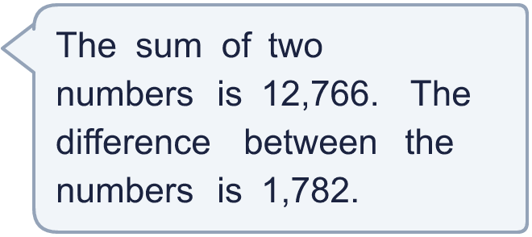
  9 | The bigger number is  The smaller number is
  10 | Jack, Whitney and Amir count their sticker collections. Amir has twice as many stickers as Whitney. Jack has 150 fewer stickers than Whitney. They have 770 stickers altogether.
    Jack has |  | stickers.
    Whitney has |  | stickers.
    Amir has |  | stickers.
  10 | Jack, Whitney and Amir count their sticker collections. Amir has twice as many stickers as Whitney. Jack has 150 fewer stickers than Whitney. They have 770 stickers altogether.
    Jack has |  | stickers.
    Whitney has |  | stickers.
    Amir has |  | stickers.
  11 | Annie opens a book and sees two facing pages. The two page numbers are next to each other and add up to 457.  What is the number of the next page after these two pages?
  11 | Annie opens a book and sees two facing pages. The two page numbers are next to each other and add up to 457.  What is the number of the next page after these two pages?
  12 | A milkman has 690 bottles of milk. He collects 100 more from the dairy. Then he delivers 385 bottles.  Do you agree with Boba? Circle yes or no.  Yes / No  How many bottles does he have left?  Explain Boba’s mistake.
     | 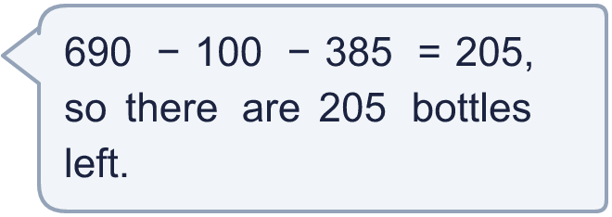
  12 | A milkman has 690 bottles of milk. He collects 100 more from the dairy. Then he delivers 385 bottles.  Do you agree with Boba? Circle yes or no.  Yes / No  How many bottles does he have left?  Explain Boba’s mistake.
  13 | Three 4-digit numbers add up to 9,000. One of the numbers is 2,580.  a) What is the total of the other two numbers?  b) One of the other two numbers cannot be greater than
  13 | Three 4-digit numbers add up to 9,000. One of the numbers is 2,580.  a) What is the total of the other two numbers?  b) One of the other two numbers cannot be greater than
  14 | Three 4-digit numbers add up to 9,000. One of the numbers is 1,660. Write two different pairs of numbers that the other two could be.
  14 | Three 4-digit numbers add up to 9,000. One of the numbers is 1,660. Write two different pairs of numbers that the other two could be.

Year 5 · Addition and subtraction · Step 6
Multi-step addition and subtraction problems
Answers (teacher copy)

  1 | Eva reads a book at bedtime. On Monday she reads 43 pages. On Tuesday she reads 5 more pages than on Monday. The book has 139 pages.  a) How many pages does she read on Tuesday? 48  b) How many pages does she read on Monday and Tuesday altogether? 91  c) How many pages does she have left to read? 48
  2 | There are two number cards. One card shows 900. The other card is hidden. The sum of the two numbers is 2,800.  a) What number is on the hidden card? 1,900  b) What is the difference between the two numbers? 1,000
  3 | Filip is writing a report. He writes 587 words on Monday and 886 words on Tuesday. The report must have at least 2,400 words.  How many more words does Filip need to write? 927
  4 | A school has 849 exercise books. It orders 4,236 more. During the year 2,377 books are used.  How many exercise books are left for next year? 2,708
  5 | Year 5 and Year 6 go on a trip. There is a bus with 53 seats and a minibus with 15 seats. 42 children go from Year 5 and 44 from Year 6.  How many more seats do they need? 18
  6 | There are 18,627 people at a concert. 14,170 of them are adults. The rest are children.  a) How many children are there? 4,457  b) How many more adults than children are there? 9,713
  7 | Two families each have £1,800. This is what they spend on housing, food and bills.  The Websters: £525 on housing, £380 on food and £100 on bills.  The Changs: £500 on housing, £330 on food and £135 on bills.  a) Which family has more money left? The Changs  b) How much more money do they have left? £40
  8 | Mo has £1,000 to spend. He buys a TV for £389 and a games console for £229. He also wants to buy a phone for £439.  a) How much money does Mo have left after he buys the TV and the console? £382  b) Can Mo afford the phone as well? Circle yes or no.  Yes / No
  9 | The bigger number is 7,274  The smaller number is 5,492
  10 | Jack, Whitney and Amir count their sticker collections. Amir has twice as many stickers as Whitney. Jack has 150 fewer stickers than Whitney. They have 770 stickers altogether.  Jack has 80 stickers.  Whitney has 230 stickers.  Amir has 460 stickers.
  11 | Annie opens a book and sees two facing pages. The two page numbers are next to each other and add up to 457.  What is the number of the next page after these two pages? 230
  12 | A milkman has 690 bottles of milk. He collects 100 more from the dairy. Then he delivers 385 bottles.  Do you agree with Boba? Circle yes or no.  Yes / No  How many bottles does he have left? 405  Explain Boba’s mistake.  690 + 100 − 385 = 405. Collecting more bottles adds to the total, so Boba should add 100, not take it away.
  13 | Three 4-digit numbers add up to 9,000. One of the numbers is 2,580.  a) What is the total of the other two numbers? 6,420  b) One of the other two numbers cannot be greater than 5,420
  14 | Three 4-digit numbers add up to 9,000. One of the numbers is 1,660. Write two different pairs of numbers that the other two could be.  for example 2,600 + 4,740 and 3,400 + 3,940

