  Year 5 · Addition and subtraction · Step 2  Adding large whole numbers | 
  Year 5 · Addition and subtraction · Step 2
  Adding large whole numbers
  1 | Complete the column addition. Write the missing digits in the answer.  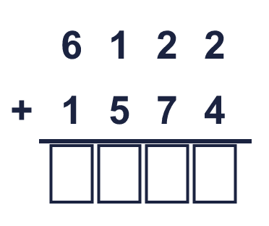
  1 | Complete the column addition. Write the missing digits in the answer.
  2 | Use the column method to work out the additions.  a) 7,097 + 7,948 =  b) 4,211 + 8,229 =  c) 2,958 + 7,060 =
  2 | Use the column method to work out the additions.  a) 7,097 + 7,948 =  b) 4,211 + 8,229 =  c) 2,958 + 7,060 =
  3 | Use the column method to work out the additions.  a) 96,493 + 1,023 =  b) 95,532 + 33,179 =  c) 944,717 + 37,888 =
  3 | Use the column method to work out the additions.  a) 96,493 + 1,023 =  b) 95,532 + 33,179 =  c) 944,717 + 37,888 =
  4 | Use the place value chart in your head: only part of the second number changes each time.  a) 31,850 + 24,411 =  b) 31,850 + 24,418 =  c) 31,850 + 25,191 =
  4 | Use the place value chart in your head: only part of the second number changes each time.  a) 31,850 + 24,411 =  b) 31,850 + 24,418 =  c) 31,850 + 25,191 =
  5 | Write the missing number in each addition.
    a) | 216 + |  | = 1,000
    b) | 1,164 + |  | = 10,000
    c) |  | + 7,340 = 10,000
    d) |  | + 28,745 = 59,975
  5 | Write the missing number in each addition.
    a) | 216 + |  | = 1,000
    b) | 1,164 + |  | = 10,000
    c) |  | + 7,340 = 10,000
    d) |  | + 28,745 = 59,975
  6 | Use the column method to work out the additions. Write the units in your answer.  a) £36,660 + £20,370 =  b) 348 cm + 13,488 cm =  c) 56,818 g + 6,843 g =  d) £12,844 + £8,293 + £24,634 =
  6 | Use the column method to work out the additions. Write the units in your answer.  a) £36,660 + £20,370 =  b) 348 cm + 13,488 cm =  c) 56,818 g + 6,843 g =  d) £12,844 + £8,293 + £24,634 =
  7 | The table shows the number of home and away fans at three football matches.  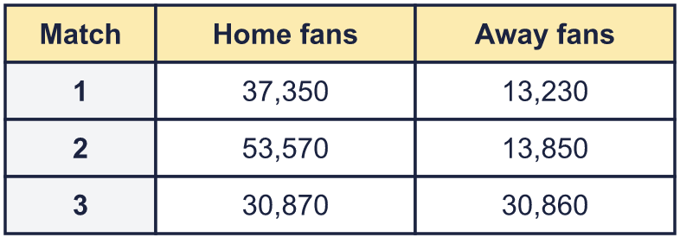  b) How many fans were at that match?
    a) | Which match had the greatest total crowd? Match
  7 | The table shows the number of home and away fans at three football matches.  b) How many fans were at that match?
    a) | Which match had the greatest total crowd? Match
  8 | Write the missing digits in the calculation.  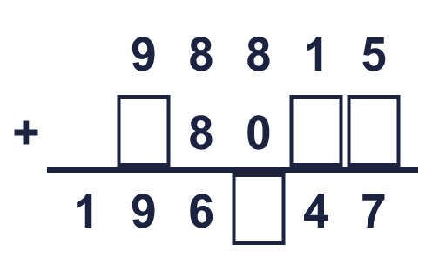
  8 | Write the missing digits in the calculation.

  9 | Work out the three additions.  a) 9,441 + 3,874 =  b) 9,441 + 3,884 =  c) 9,441 + 5,064 =  d) How much greater is the answer to c) than the answer to a)?
     | 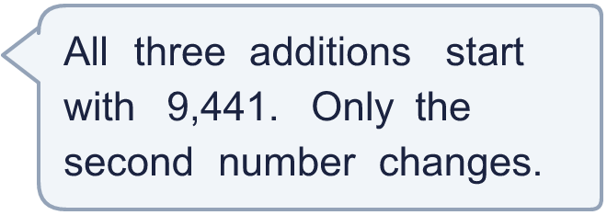
  9 | Work out the three additions.  a) 9,441 + 3,874 =  b) 9,441 + 3,884 =  c) 9,441 + 5,064 =  d) How much greater is the answer to c) than the answer to a)?
  10 | 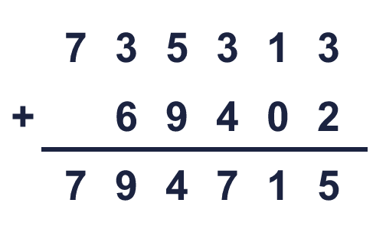  Is Boba correct? Circle yes or no.  Yes / No  What is the correct answer?  Explain Boba’s mistake.
     | 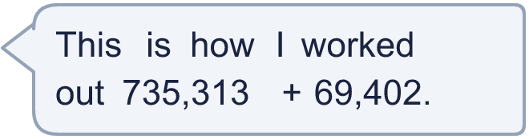
  10 | Is Boba correct? Circle yes or no.  Yes / No  What is the correct answer?  Explain Boba’s mistake.
  11 | Three friends play a computer game. Josh scores 13,637 points, Kim scores 4,415 points and Bobby scores 12,657 points.  a) How many points do they score altogether?  b) How many more points do Josh and Kim score together than Bobby?
  11 | Three friends play a computer game. Josh scores 13,637 points, Kim scores 4,415 points and Bobby scores 12,657 points.  a) How many points do they score altogether?  b) How many more points do Josh and Kim score together than Bobby?
  12 | A factory packs marbles into boxes. A large box holds 79,850 marbles, a medium box holds 20,250 and a small box holds 24,950.  a) How many marbles are in one large box and one small box?  b) How many marbles are in one box of each size?
  12 | A factory packs marbles into boxes. A large box holds 79,850 marbles, a medium box holds 20,250 and a small box holds 24,950.  a) How many marbles are in one large box and one small box?  b) How many marbles are in one box of each size?
  13 | Look at the bar model. Add the parts to find the whole.  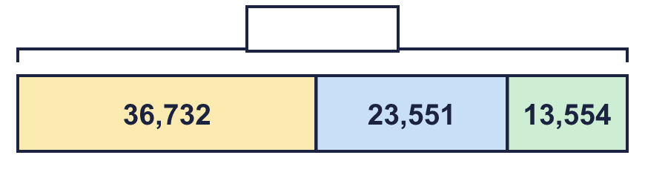
  13 | Look at the bar model. Add the parts to find the whole.
  14 | Write two different additions of two 5-digit numbers that make exactly 100,000.
  14 | Write two different additions of two 5-digit numbers that make exactly 100,000.

Year 5 · Addition and subtraction · Step 2
Adding large whole numbers
Answers (teacher copy)

  1 | Complete the column addition. Write the missing digits in the answer.  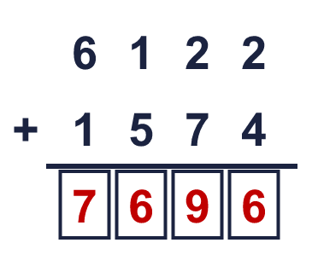  Answer: 7,696
  2 | Use the column method to work out the additions.  a) 7,097 + 7,948 = 15,045  b) 4,211 + 8,229 = 12,440  c) 2,958 + 7,060 = 10,018
  3 | Use the column method to work out the additions.  a) 96,493 + 1,023 = 97,516  b) 95,532 + 33,179 = 128,711  c) 944,717 + 37,888 = 982,605
  4 | Use the place value chart in your head: only part of the second number changes each time.  a) 31,850 + 24,411 = 56,261  b) 31,850 + 24,418 = 56,268  c) 31,850 + 25,191 = 57,041
  5 | Write the missing number in each addition.  a) 216 + 784 = 1,000  b) 1,164 + 8,836 = 10,000  c) 2,660 + 7,340 = 10,000  d) 31,230 + 28,745 = 59,975
  6 | Use the column method to work out the additions. Write the units in your answer.  a) £36,660 + £20,370 = £57,030  b) 348 cm + 13,488 cm = 13,836 cm  c) 56,818 g + 6,843 g = 63,661 g  d) £12,844 + £8,293 + £24,634 = £45,771
  7 | The table shows the number of home and away fans at three football matches.  a) Which match had the greatest total crowd? Match 2  b) How many fans were at that match? 67,420
  8 | Write the missing digits in the calculation.  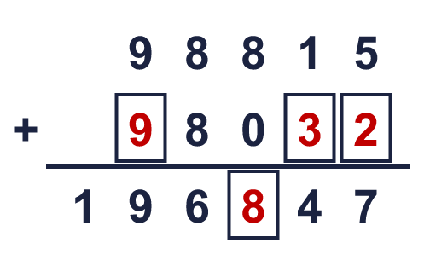  Missing digits, from top to bottom and left to right: 9 3 2 8
  9 | Work out the three additions.  a) 9,441 + 3,874 = 13,315  b) 9,441 + 3,884 = 13,325  c) 9,441 + 5,064 = 14,505  d) How much greater is the answer to c) than the answer to a)? 1,190
  10 | Is Boba correct? Circle yes or no.  Yes / No  What is the correct answer? 804,715  Explain Boba’s mistake.  735,313 + 69,402 = 804,715. Boba did not carry the 1 into the ten thousands column.
  11 | Three friends play a computer game. Josh scores 13,637 points, Kim scores 4,415 points and Bobby scores 12,657 points.  a) How many points do they score altogether? 30,709  b) How many more points do Josh and Kim score together than Bobby? 5,395
  12 | A factory packs marbles into boxes. A large box holds 79,850 marbles, a medium box holds 20,250 and a small box holds 24,950.  a) How many marbles are in one large box and one small box? 104,800  b) How many marbles are in one box of each size? 125,050
  13 | Look at the bar model. Add the parts to find the whole.  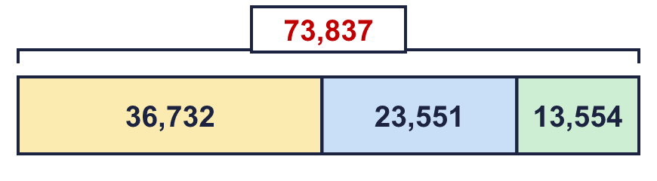  The whole is 73,837
  14 | Write two different additions of two 5-digit numbers that make exactly 100,000.  for example 46,000 + 54,000 and 38,000 + 62,000

