  Year 4 · Time · Step 4  Convert to the 24-hour clock | 
  Year 4 · Time · Step 4
  Convert to the 24-hour clock
  1 | Write the time shown on each clock as a 24-hour clock time.  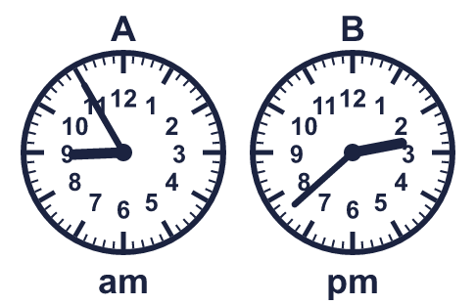
    A:
    B:
  1 | Write the time shown on each clock as a 24-hour clock time.
    A:
    B:
  2 | Write each time as a 24-hour clock time.
    a) 6:05 am =
    b) 11:20 am =
    c) 4:56 am =
  2 | Write each time as a 24-hour clock time.
    a) 6:05 am =
    b) 11:20 am =
    c) 4:56 am =
  3 | Write each time as a 24-hour clock time.
    a) 2:15 am =
    b) 2:15 pm =
    c) 12:15 am =
    d) 12:15 pm =
  3 | Write each time as a 24-hour clock time.
    a) 2:15 am =
    b) 2:15 pm =
    c) 12:15 am =
    d) 12:15 pm =
  4 | Match each time to the same 24-hour clock time. Write the letter.  A: 20:35 B: 23:35 C: 09:00 D: 15:15
    a) 8:35 pm →
    b) 3:15 pm →
    c) 9:00 am →
  4 | Match each time to the same 24-hour clock time. Write the letter.  A: 20:35 B: 23:35 C: 09:00 D: 15:15
    a) 8:35 pm →
    b) 3:15 pm →
    c) 9:00 am →
  5 | Which of these are the same time as 7:33 am? Write the letters.  A: 7:33 pm  B: 19:33  C: 07:33  D: 7:33 am
  5 | Which of these are the same time as 7:33 am? Write the letters.  A: 7:33 pm  B: 19:33  C: 07:33  D: 7:33 am
  6 | The time is 4:25 pm. What time will it be in 1 hour 12 minutes? Write your answer as a 24-hour clock time.
  6 | The time is 4:25 pm. What time will it be in 1 hour 12 minutes? Write your answer as a 24-hour clock time.
  7 | Write each time as a 24-hour clock time.
    a) 4:31 am =
    b) 6:42 am =
    c) 10:48 am =
  7 | Write each time as a 24-hour clock time.
    a) 4:31 am =
    b) 6:42 am =
    c) 10:48 am =
  8 | Use each card once to make the smallest possible 24-hour clock time.
    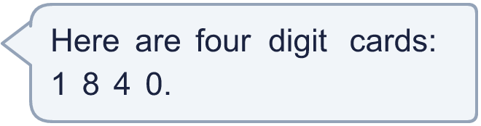
  8 | Use each card once to make the smallest possible 24-hour clock time.

  9 | Is Mo correct? Circle yes or no.  Yes / No  Explain how you know.
     | 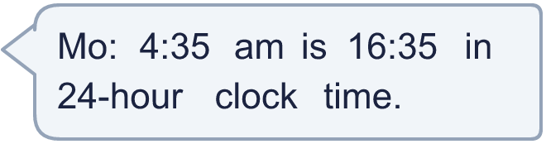
  9 | Is Mo correct? Circle yes or no.  Yes / No  Explain how you know.
  10 | Nijah leaves home at 9:20 am and arrives at her friend's house at 10:10 am. She leaves her friend's house at 11:55 am. The journey home takes the same time.  What time does Nijah get home? Write a 24-hour clock time.
  10 | Nijah leaves home at 9:20 am and arrives at her friend's house at 10:10 am. She leaves her friend's house at 11:55 am. The journey home takes the same time.  What time does Nijah get home? Write a 24-hour clock time.
  11 | Write the next two times in the sequence as 24-hour clock times.
    8:00 am, 8:30 am, 9:00 am,
  11 | Write the next two times in the sequence as 24-hour clock times.
    8:00 am, 8:30 am, 9:00 am,
  12 | Which of these are the same time as 22:41? Write the letters.  A: 10:41 am  B: 22:41  C: 10:41  D: 10:41 pm
  12 | Which of these are the same time as 22:41? Write the letters.  A: 10:41 am  B: 22:41  C: 10:41  D: 10:41 pm
  13 | Is Nina correct? Circle yes or no.  Yes / No  Explain how you know.
     | 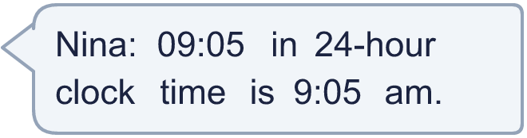
  13 | Is Nina correct? Circle yes or no.  Yes / No  Explain how you know.
  14 | Challenge  He uses each card once to make the smallest possible 24-hour clock time.
    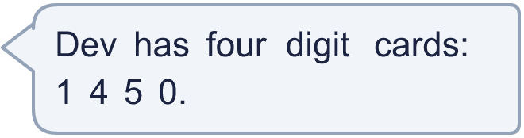
  14 | Challenge  He uses each card once to make the smallest possible 24-hour clock time.

Year 4 · Time · Step 4
Convert to the 24-hour clock
Answers (teacher copy)

  1 | Write the time shown on each clock as a 24-hour clock time.  A: 08:55  B: 14:38
  2 | Write each time as a 24-hour clock time.  a) 6:05 am = 06:05  b) 11:20 am = 11:20  c) 4:56 am = 04:56
  3 | Write each time as a 24-hour clock time.  a) 2:15 am = 02:15  b) 2:15 pm = 14:15  c) 12:15 am = 00:15  d) 12:15 pm = 12:15
  4 | Match each time to the same 24-hour clock time. Write the letter.  A: 20:35 B: 23:35 C: 09:00 D: 15:15  a) 8:35 pm → A  b) 3:15 pm → D  c) 9:00 am → C
  5 | Which of these are the same time as 7:33 am? Write the letters.  A: 7:33 pm  B: 19:33  C: 07:33  D: 7:33 am  C, D
  6 | The time is 4:25 pm. What time will it be in 1 hour 12 minutes? Write your answer as a 24-hour clock time.  17:37
  7 | Write each time as a 24-hour clock time.  a) 4:31 am = 04:31  b) 6:42 am = 06:42  c) 10:48 am = 10:48
  8 | Use each card once to make the smallest possible 24-hour clock time.  01:48
  9 | Is Mo correct? Circle yes or no.  Yes / No  Explain how you know.  No. 4:35 am is 04:35 in 24-hour clock time. A morning time keeps the same hour.
  10 | Nijah leaves home at 9:20 am and arrives at her friend's house at 10:10 am. She leaves her friend's house at 11:55 am. The journey home takes the same time.  What time does Nijah get home? Write a 24-hour clock time. 12:45
  11 | Write the next two times in the sequence as 24-hour clock times.  8:00 am, 8:30 am, 9:00 am, 09:30, 10:00
  12 | Which of these are the same time as 22:41? Write the letters.  A: 10:41 am  B: 22:41  C: 10:41  D: 10:41 pm  B, D
  13 | Is Nina correct? Circle yes or no.  Yes / No  Explain how you know.  Yes. 09:05 is 9:05 am. The times from 00:00 to 11:59 are am times.
  14 | Challenge  He uses each card once to make the smallest possible 24-hour clock time.  01:45

