  Year 4 · Time · Step 3  Convert between analogue and digital times | 
  Year 4 · Time · Step 3
  Convert between analogue and digital times
  1 | Write the time shown on each clock.  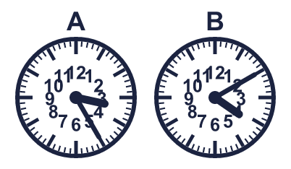
    A:
    B:
  1 | Write the time shown on each clock.
    A:
    B:
  2 | Write the time shown on each clock. Use am or pm.  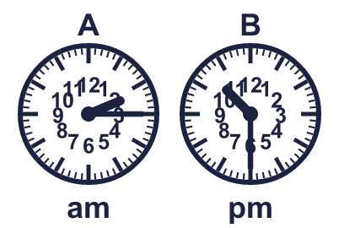
    A:
    B:
  2 | Write the time shown on each clock. Use am or pm.
    A:
    B:
  3 | Which clock shows 7:50 pm? Write the letter.  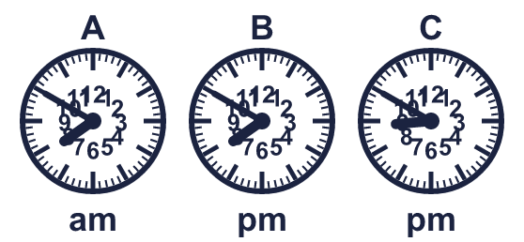
  3 | Which clock shows 7:50 pm? Write the letter.
  4 | Write the new time. Use am or pm.
    a) 4:10 pm + 40 minutes =
  4 | Write the new time. Use am or pm.
    a) 4:10 pm + 40 minutes =
  5 | Is each time in the morning or the afternoon? Write the word.  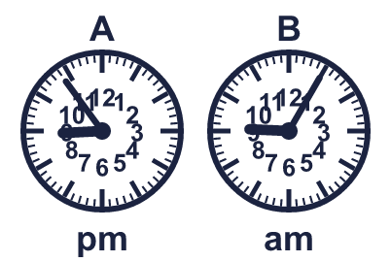
    A:
    B:
  5 | Is each time in the morning or the afternoon? Write the word.
    A:
    B:
  6 | Write each time as a digital time.
    a) quarter past 8:
    b) quarter to 5:
  6 | Write each time as a digital time.
    a) quarter past 8:
    b) quarter to 5:
  7 | How many minutes are there between the two times?
    a) 4:40 pm to 5:30 pm: |  | min
  7 | How many minutes are there between the two times?
    a) 4:40 pm to 5:30 pm: |  | min
  8 | Write the next two times in each sequence.
    a) 4:45 am, 5:05 am, 5:25 am,
  8 | Write the next two times in each sequence.
    a) 4:45 am, 5:05 am, 5:25 am,

  9 | 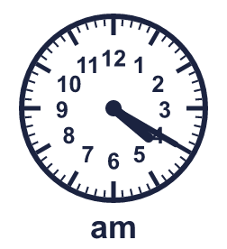  Is Jo correct? Circle yes or no.  Yes / No  Explain how you know.
     | 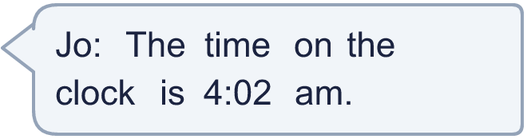
  9 | Is Jo correct? Circle yes or no.  Yes / No  Explain how you know.
  10 | Tia leaves home at the time shown on the clock. The journey takes 2 hours 5 minutes.  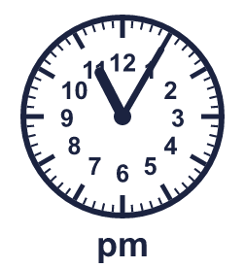
  10 | Tia leaves home at the time shown on the clock. The journey takes 2 hours 5 minutes.
  11 | Buses start running at 6:30 am. A bus arrives every 22 minutes. Alex is ready to leave at 8:22 am.  When does the next bus arrive?
  11 | Buses start running at 6:30 am. A bus arrives every 22 minutes. Alex is ready to leave at 8:22 am.  When does the next bus arrive?
  12 | A film starts at 10:50 am. It lasts 1 hour 25 minutes.
  12 | A film starts at 10:50 am. It lasts 1 hour 25 minutes.
  13 | School starts at 8:55 am. Lunch starts at 12:10 pm.
    How many minutes are there from the start of school to lunch?
    minutes
  13 | School starts at 8:55 am. Lunch starts at 12:10 pm.
    How many minutes are there from the start of school to lunch?
    minutes
  14 | Challenge  A train arrives at 2:20 pm after a journey of 2 hours 50 minutes.  What time did the train leave?
  14 | Challenge  A train arrives at 2:20 pm after a journey of 2 hours 50 minutes.  What time did the train leave?

Year 4 · Time · Step 3
Convert between analogue and digital times
Answers (teacher copy)

  1 | Write the time shown on each clock.  A: 3:25  B: 4:10
  2 | Write the time shown on each clock. Use am or pm.  A: 2:15 am  B: 10:30 pm
  3 | Which clock shows 7:50 pm? Write the letter.  B
  4 | Write the new time. Use am or pm.  a) 4:10 pm + 40 minutes = 4:50 pm
  5 | Is each time in the morning or the afternoon? Write the word.  A: afternoon  B: morning
  6 | Write each time as a digital time.  a) quarter past 8: 8:15  b) quarter to 5: 4:45
  7 | How many minutes are there between the two times?  a) 4:40 pm to 5:30 pm: 50 min
  8 | Write the next two times in each sequence.  a) 4:45 am, 5:05 am, 5:25 am, 5:45 am, 6:05 am
  9 | Is Jo correct? Circle yes or no.  Yes / No  Explain how you know.  No. The hour hand is just past 4 and the minute hand shows 20 minutes, so the time is 4:20 am.
  10 | Tia leaves home at the time shown on the clock. The journey takes 2 hours 5 minutes.  What time does Tia arrive? 1:10 am
  11 | Buses start running at 6:30 am. A bus arrives every 22 minutes. Alex is ready to leave at 8:22 am.  When does the next bus arrive? 8:42 am
  12 | A film starts at 10:50 am. It lasts 1 hour 25 minutes.  What time does the film end? 12:15 pm
  13 | School starts at 8:55 am. Lunch starts at 12:10 pm.  How many minutes are there from the start of school to lunch? 195 minutes
  14 | Challenge  A train arrives at 2:20 pm after a journey of 2 hours 50 minutes.  What time did the train leave? 11:30 am

