  Year 4 · Statistics · Step 3  Interpret line graphs | 
  Year 4 · Statistics · Step 3
  Interpret line graphs
  1 | The graph shows the height of a sunflower at the start of each week.  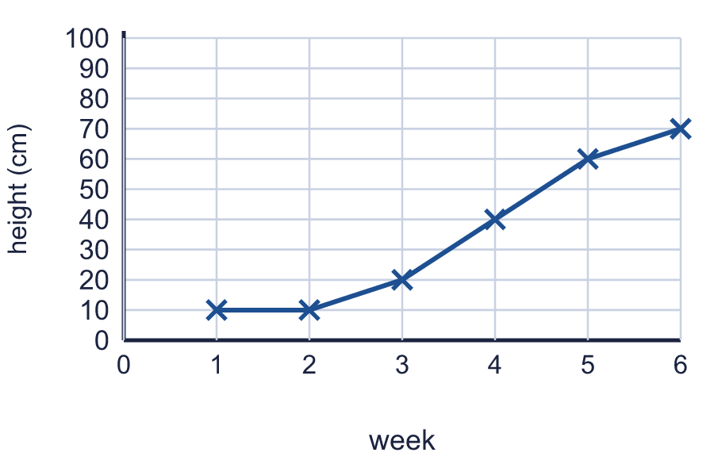
    What was the height at the start of week 2?
    cm
    What was the height at the start of week 6?
    cm
  1 | The graph shows the height of a sunflower at the start of each week.
    What was the height at the start of week 2?
    cm
    What was the height at the start of week 6?
    cm
  2 | The graph shows the height of a sunflower at the start of each week.  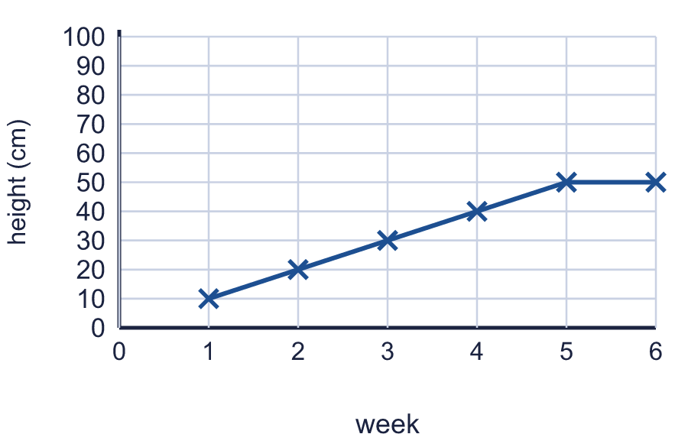
    By how many cm did the sunflower grow from the start of week 2 to the start of week 5?
    cm
  2 | The graph shows the height of a sunflower at the start of each week.
    By how many cm did the sunflower grow from the start of week 2 to the start of week 5?
    cm
  3 | The graph shows the height of a sunflower at the start of each week.  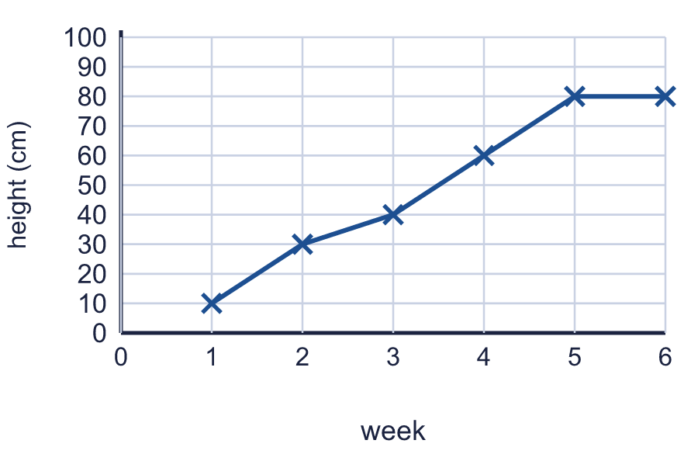
    At the start of which week was the sunflower 60 cm tall? Write the week number.
  3 | The graph shows the height of a sunflower at the start of each week.
    At the start of which week was the sunflower 60 cm tall? Write the week number.
  4 | The graph shows the temperature at different times during the day.  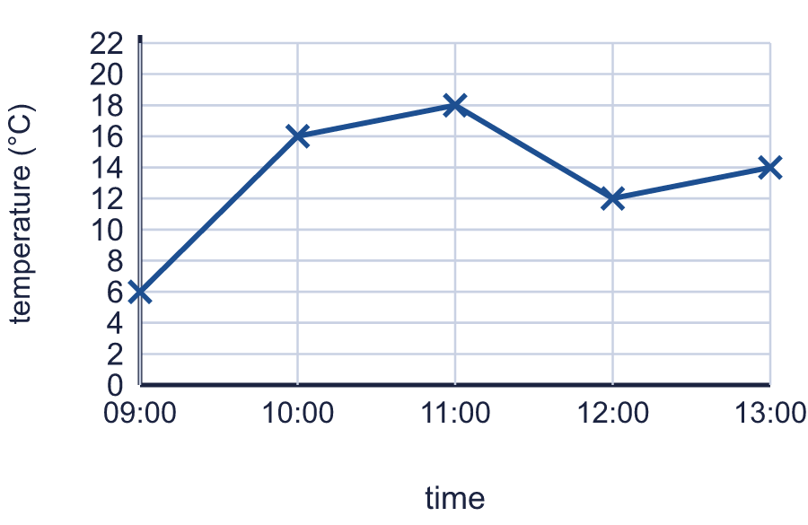
    What is the temperature at 10:00?
    °C
    What is the temperature at 12:00?
    °C
  4 | The graph shows the temperature at different times during the day.
    What is the temperature at 10:00?
    °C
    What is the temperature at 12:00?
    °C
  5 | The graph shows the temperature at different times during the day.  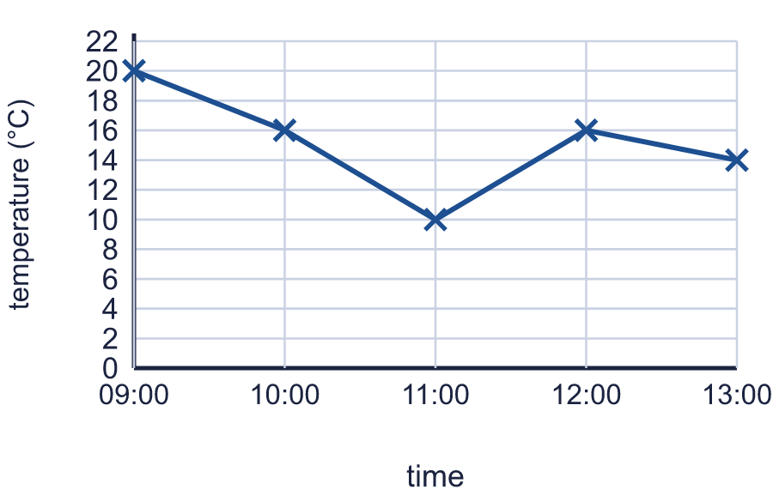
    At what time is the temperature 20 °C?
  5 | The graph shows the temperature at different times during the day.
    At what time is the temperature 20 °C?
  6 | The graph shows the temperature at different times during the day.  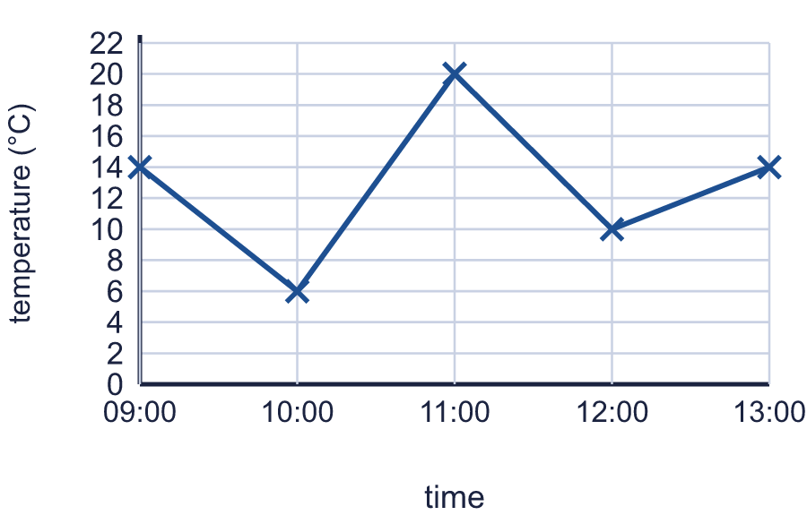
    By how many °C did the temperature rise from 10:00 to 12:00?
    °C
    By how many °C did the temperature fall from 11:00 to 12:00?
    °C
  6 | The graph shows the temperature at different times during the day.
    By how many °C did the temperature rise from 10:00 to 12:00?
    °C
    By how many °C did the temperature fall from 11:00 to 12:00?
    °C
  7 | The graph shows the height of some cress. The points are joined with straight lines.  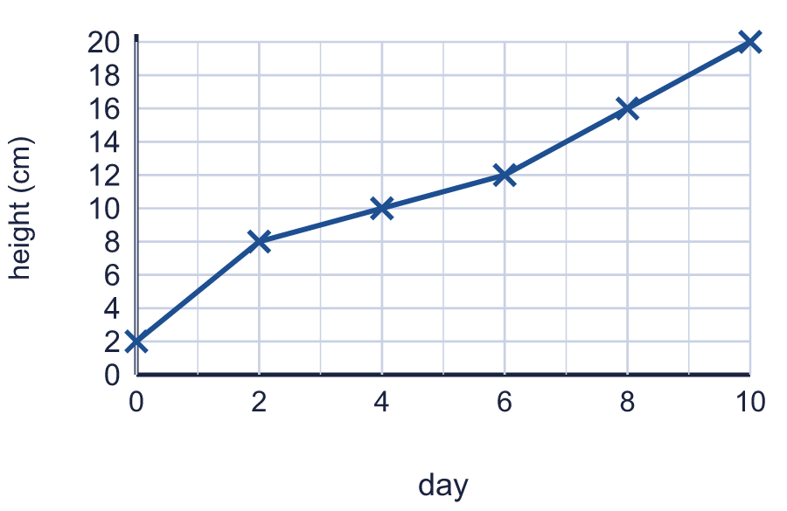
    Estimate the height of the cress on day 5.
    cm
  7 | The graph shows the height of some cress. The points are joined with straight lines.
    Estimate the height of the cress on day 5.
    cm
  8 | The graph shows the height of some cress. The points are joined with straight lines.  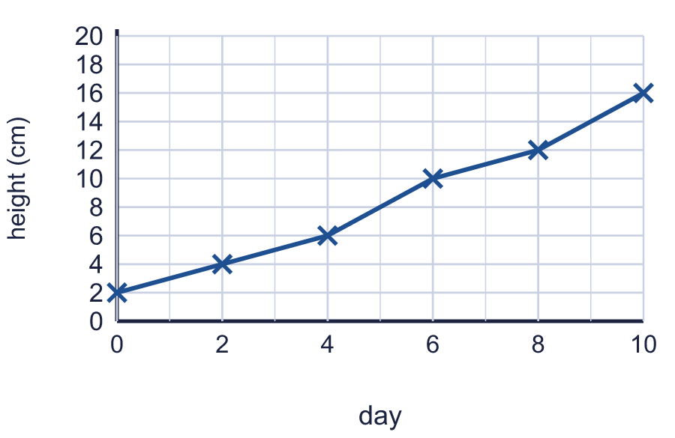
    Estimate on which day the cress reached 8 cm. Write the day.
  8 | The graph shows the height of some cress. The points are joined with straight lines.
    Estimate on which day the cress reached 8 cm. Write the day.

  9 | 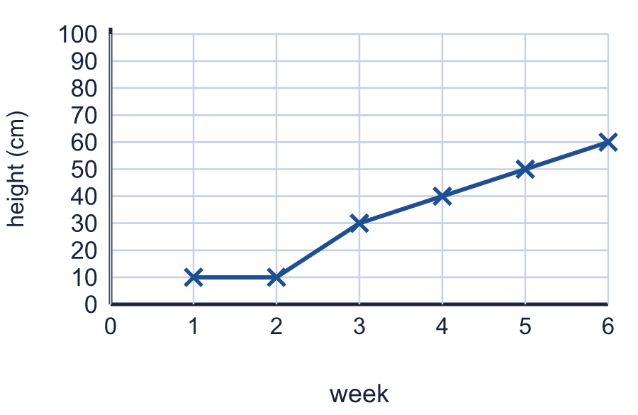  Is Tia correct? Circle yes or no.  Yes / No  Explain how you know.
     | 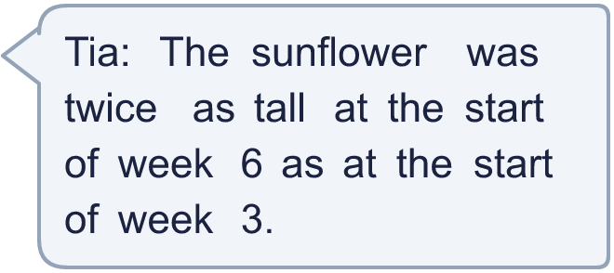
  9 | Is Tia correct? Circle yes or no.  Yes / No  Explain how you know.
  10 | The graph shows the height of a sunflower at the start of each week.  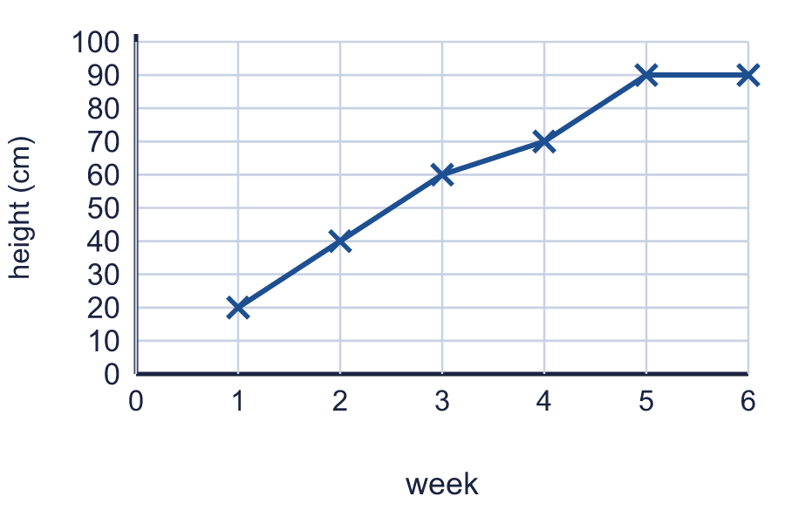
    What is the difference in height between the start of week 1 and the start of week 6?
    cm
  10 | The graph shows the height of a sunflower at the start of each week.
    What is the difference in height between the start of week 1 and the start of week 6?
    cm
  11 | The graph shows the height of a sunflower at the start of each week.  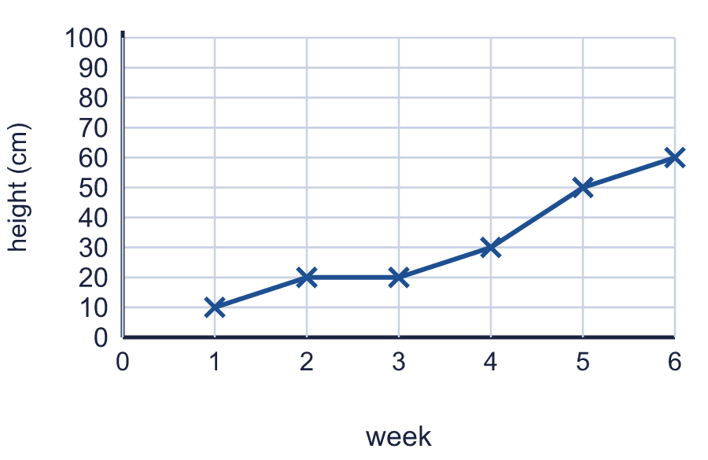
    What was the greatest growth in one week?
    cm
  11 | The graph shows the height of a sunflower at the start of each week.
    What was the greatest growth in one week?
    cm
  12 | The graph shows the temperature at different times during the day.  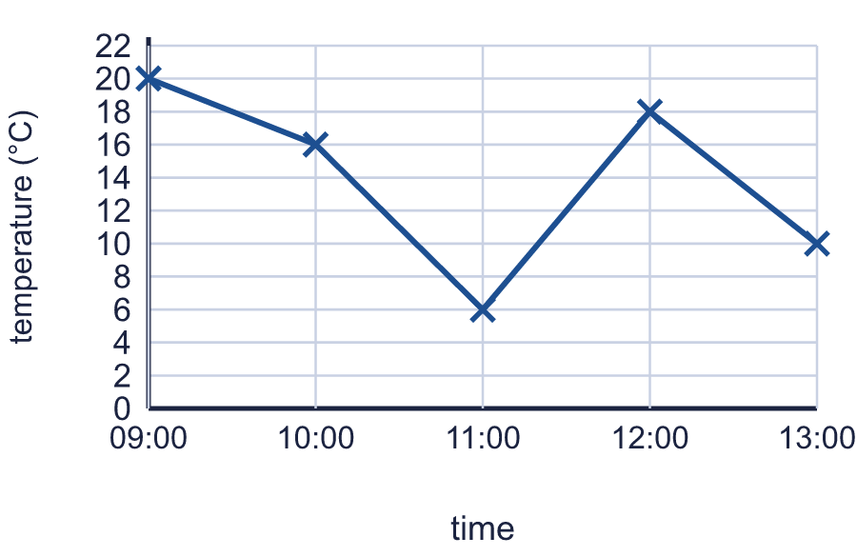
    At what time was it warmest?
    What was the lowest temperature?
    °C
  12 | The graph shows the temperature at different times during the day.
    At what time was it warmest?
    What was the lowest temperature?
    °C
  13 | The graph shows the height of some cress. The line is flat when the cress does not grow.  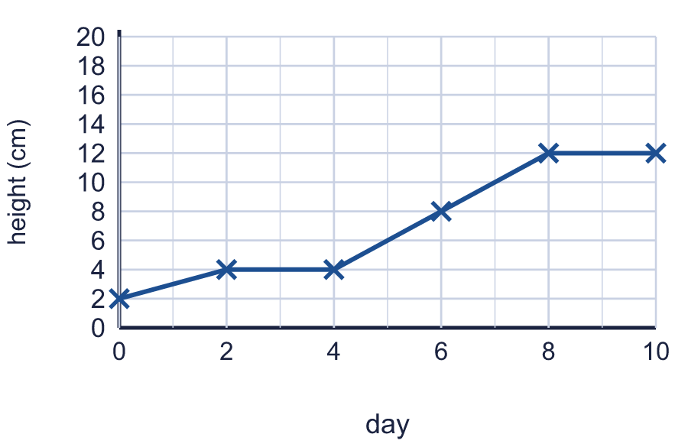
    For how many days did the cress stay the same height?
    days
  13 | The graph shows the height of some cress. The line is flat when the cress does not grow.
    For how many days did the cress stay the same height?
    days
  14 | Challenge  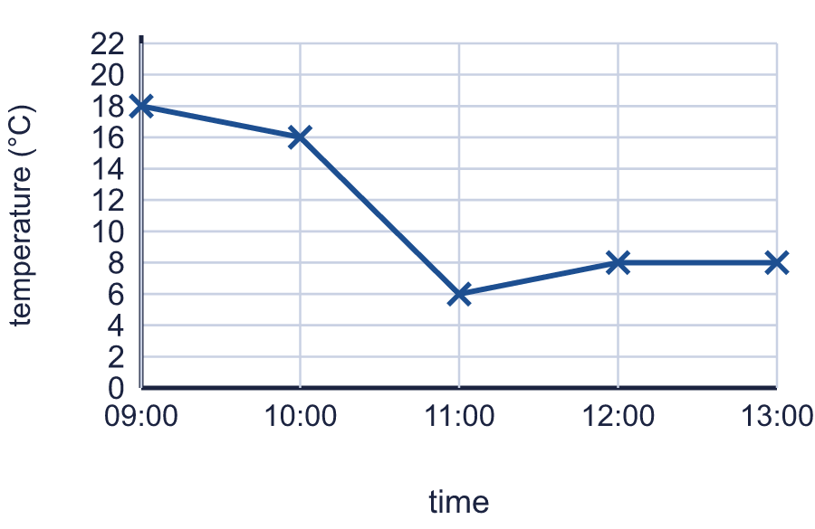
    What is the difference between the temperature at 09:00 and the temperature at 13:00?
    °C
  14 | Challenge
    What is the difference between the temperature at 09:00 and the temperature at 13:00?
    °C

Year 4 · Statistics · Step 3
Interpret line graphs
Answers (teacher copy)

  1 | The graph shows the height of a sunflower at the start of each week.  What was the height at the start of week 2? 10 cm  What was the height at the start of week 6? 70 cm
  2 | The graph shows the height of a sunflower at the start of each week.  By how many cm did the sunflower grow from the start of week 2 to the start of week 5? 30 cm
  3 | The graph shows the height of a sunflower at the start of each week.  At the start of which week was the sunflower 60 cm tall? Write the week number. 4
  4 | The graph shows the temperature at different times during the day.  What is the temperature at 10:00? 16 °C  What is the temperature at 12:00? 12 °C
  5 | The graph shows the temperature at different times during the day.  At what time is the temperature 20 °C? 09:00
  6 | The graph shows the temperature at different times during the day.  By how many °C did the temperature rise from 10:00 to 12:00? 4 °C  By how many °C did the temperature fall from 11:00 to 12:00? 10 °C
  7 | The graph shows the height of some cress. The points are joined with straight lines.  Estimate the height of the cress on day 5. 11 cm
  8 | The graph shows the height of some cress. The points are joined with straight lines.  Estimate on which day the cress reached 8 cm. Write the day. 5
  9 | Is Tia correct? Circle yes or no.  Yes / No  Explain how you know.  Yes. Twice 30 cm is 60 cm, and the sunflower was 60 cm tall in week 6.
  10 | The graph shows the height of a sunflower at the start of each week.  What is the difference in height between the start of week 1 and the start of week 6? 70 cm
  11 | The graph shows the height of a sunflower at the start of each week.  What was the greatest growth in one week? 20 cm
  12 | The graph shows the temperature at different times during the day.  At what time was it warmest? 09:00  What was the lowest temperature? 6 °C
  13 | The graph shows the height of some cress. The line is flat when the cress does not grow.  For how many days did the cress stay the same height? 4 days
  14 | Challenge  What is the difference between the temperature at 09:00 and the temperature at 13:00? 10 °C

