  Year 4 · Statistics · Step 1  Interpret charts | 
  Year 4 · Statistics · Step 1
  Interpret charts
  1 | The pictogram shows how many were counted.  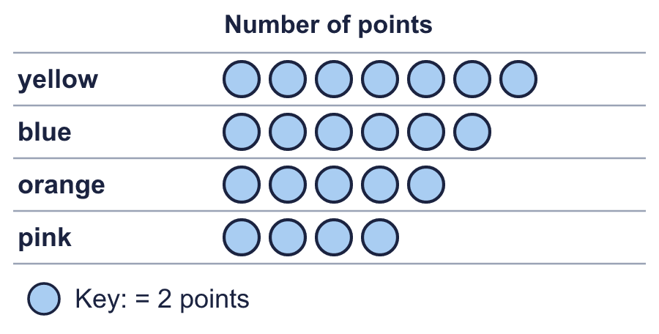
    How many orange?
    How many yellow?
  1 | The pictogram shows how many were counted.
    How many orange?
    How many yellow?
  2 | The pictogram shows how many were counted. Half a symbol is half of the key.  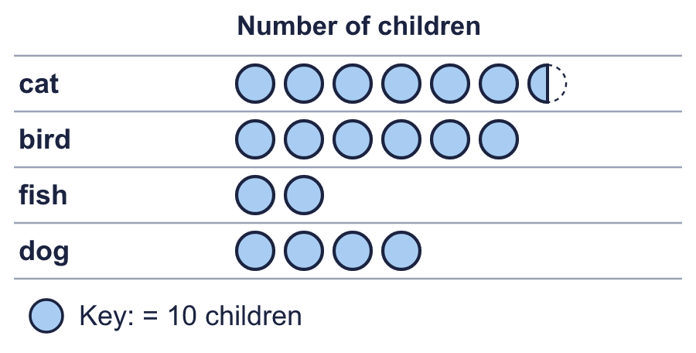
    How many bird?
    How many cat?
  2 | The pictogram shows how many were counted. Half a symbol is half of the key.
    How many bird?
    How many cat?
  3 | Look at the pictogram.  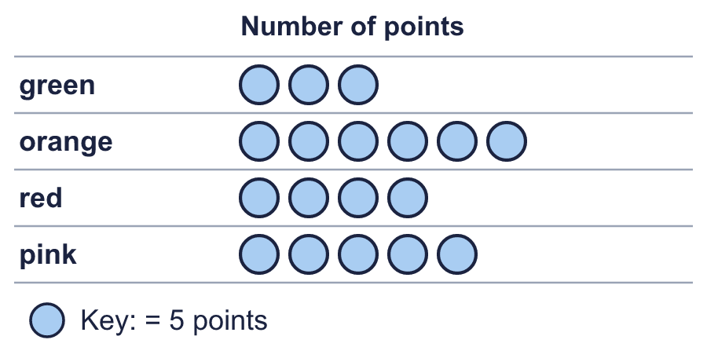
    How many does one symbol stand for?
    How many symbols are in the pink row?
  3 | Look at the pictogram.
    How many does one symbol stand for?
    How many symbols are in the pink row?
  4 | The bar chart shows how many were counted.  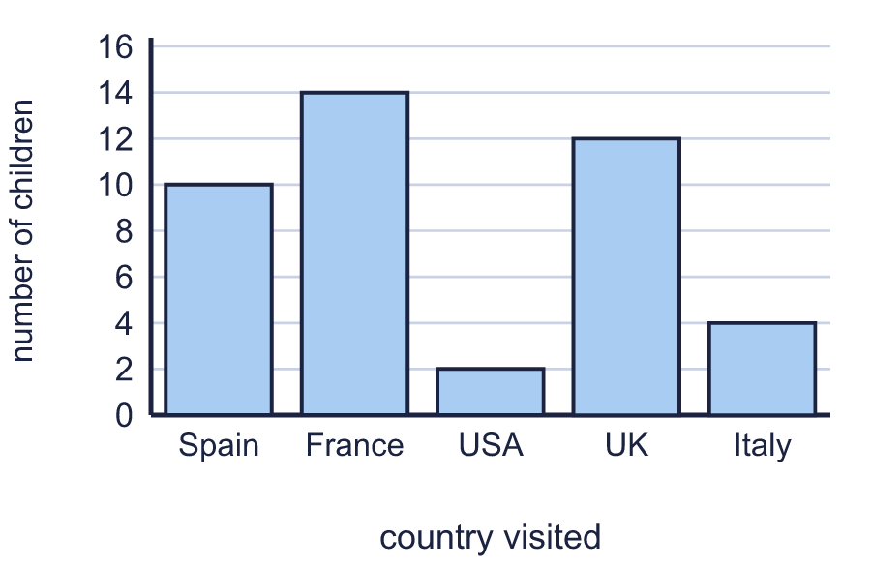
    How many were counted for France?
    How many were counted for UK?
  4 | The bar chart shows how many were counted.
    How many were counted for France?
    How many were counted for UK?
  5 | The bar chart shows how many were counted. The scale goes up in 5s.  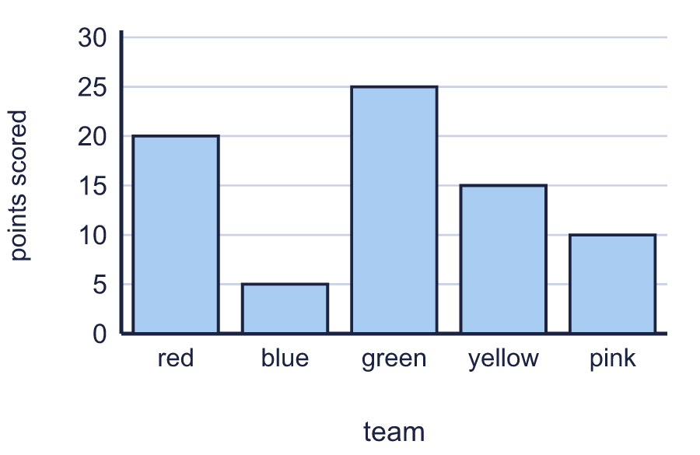
    How many were counted for blue?
    How many were counted for green?
  5 | The bar chart shows how many were counted. The scale goes up in 5s.
    How many were counted for blue?
    How many were counted for green?
  6 | Complete the pictogram to show that 8 children were counted for dog. Draw the symbols in your book.  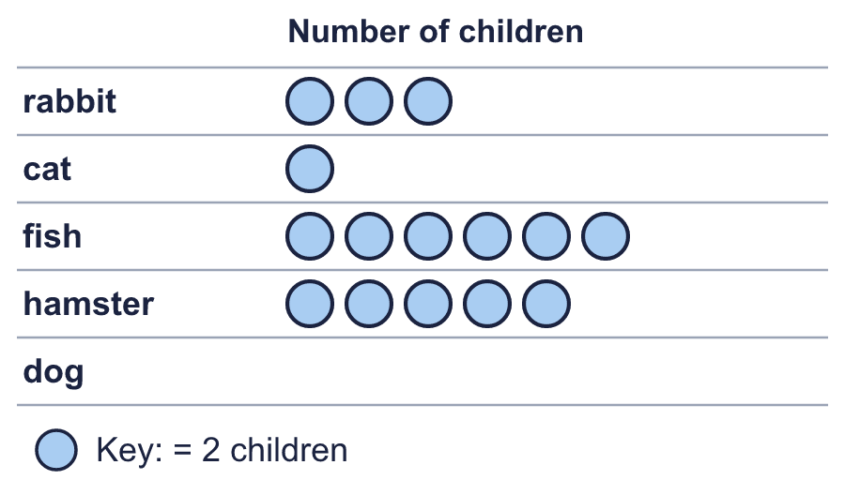
    How many symbols do you draw for dog?
    How many were counted for rabbit?
  6 | Complete the pictogram to show that 8 children were counted for dog. Draw the symbols in your book.
    How many symbols do you draw for dog?
    How many were counted for rabbit?
  7 | Use the bar chart to complete the table.  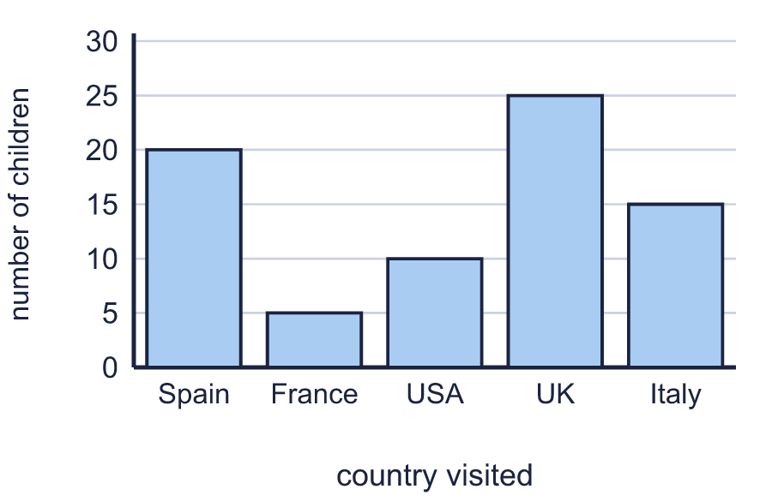
    Spain:
    USA:
    Italy:
  7 | Use the bar chart to complete the table.
    Spain:
    USA:
    Italy:
  8 | Look at the bar chart.  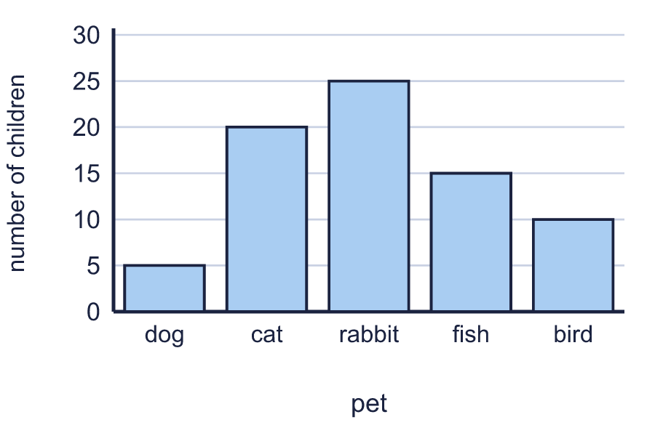
    Which has the most?
    Which has the least?
  8 | Look at the bar chart.
    Which has the most?
    Which has the least?

  9 | 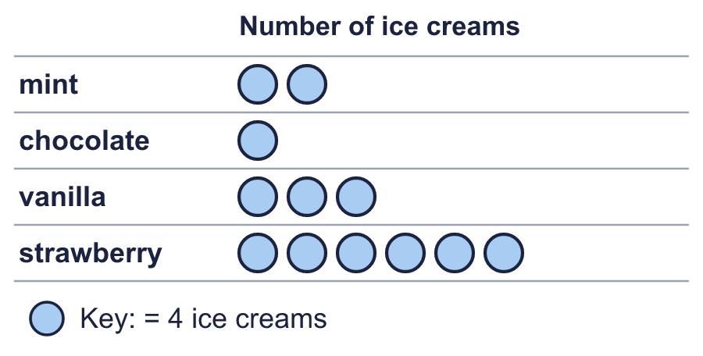  Is Alex correct? Circle yes or no.  Yes / No  Explain how you know.
     | 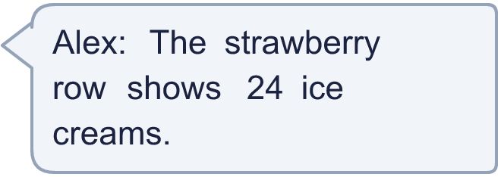
  9 | Is Alex correct? Circle yes or no.  Yes / No  Explain how you know.
  10 | The bar chart shows how many were counted.  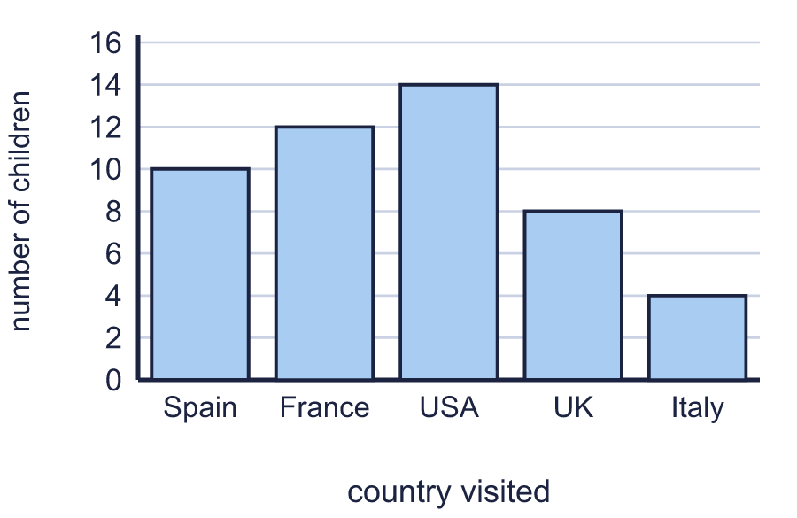
    How many were counted altogether?
  10 | The bar chart shows how many were counted.
    How many were counted altogether?
  11 | 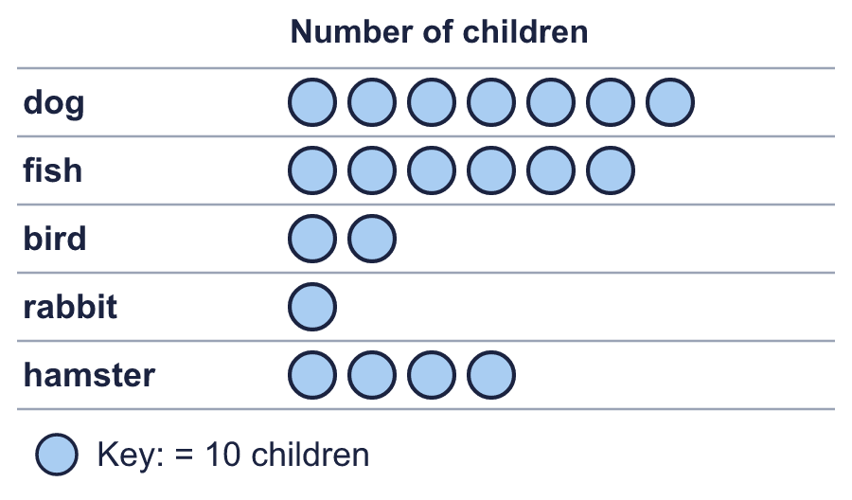
    Which row shows the most?
    Which row shows the least?
  11
    Which row shows the most?
    Which row shows the least?
  12 | 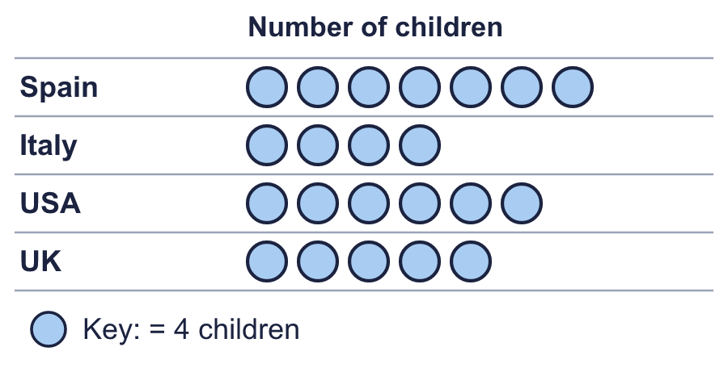  Boba draws the pictogram again. This time one symbol stands for 2 children.
    How many symbols does Boba draw for UK?
  12 | Boba draws the pictogram again. This time one symbol stands for 2 children.
    How many symbols does Boba draw for UK?
  13 | 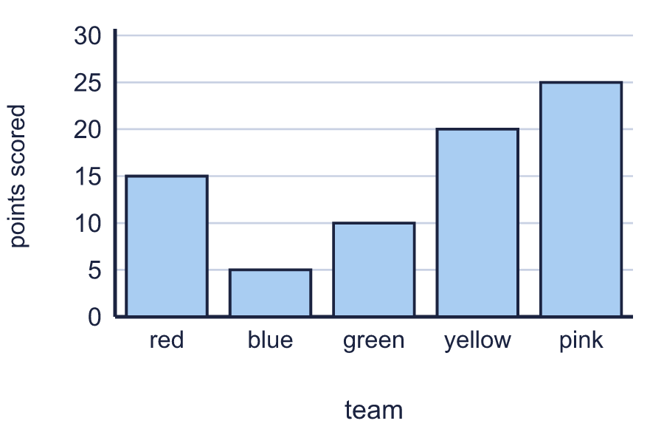
    How many more were counted for pink than for yellow?
  13
    How many more were counted for pink than for yellow?
  14 | Challenge  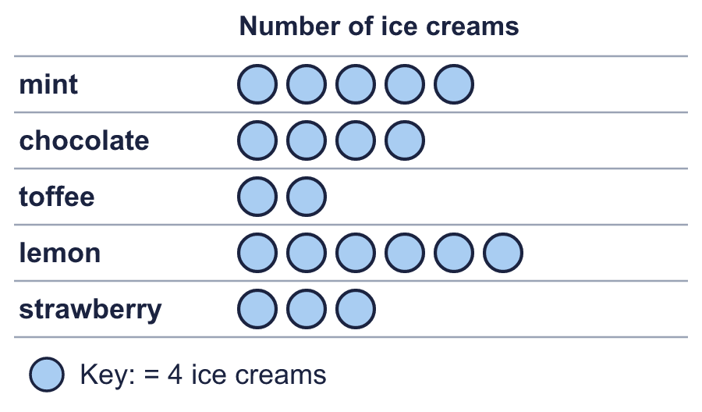
    How many were counted for mint and chocolate together?
  14 | Challenge
    How many were counted for mint and chocolate together?

Year 4 · Statistics · Step 1
Interpret charts
Answers (teacher copy)

  1 | The pictogram shows how many were counted.  How many orange? 10  How many yellow? 14
  2 | The pictogram shows how many were counted. Half a symbol is half of the key.  How many bird? 60  How many cat? 65
  3 | Look at the pictogram.  How many does one symbol stand for? 5  How many symbols are in the pink row? 5
  4 | The bar chart shows how many were counted.  How many were counted for France? 14  How many were counted for UK? 12
  5 | The bar chart shows how many were counted. The scale goes up in 5s.  How many were counted for blue? 5  How many were counted for green? 25
  6 | Complete the pictogram to show that 8 children were counted for dog. Draw the symbols in your book.  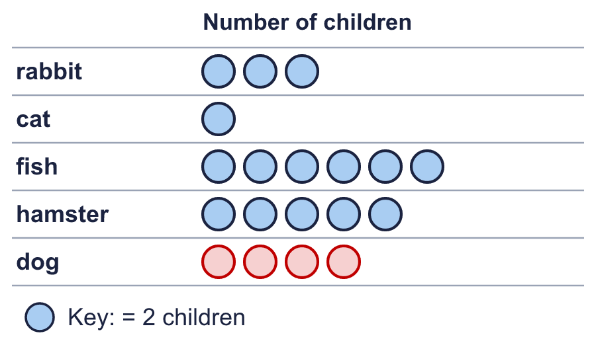  How many symbols do you draw for dog? 4  How many were counted for rabbit? 6
  7 | Use the bar chart to complete the table.  Spain: 20  USA: 10  Italy: 15
  8 | Look at the bar chart.  Which has the most? rabbit  Which has the least? dog
  9 | Is Alex correct? Circle yes or no.  Yes / No  Explain how you know.  Yes. The strawberry row has 6 symbols and each symbol stands for 4, so it shows 24.
  10 | The bar chart shows how many were counted.  How many were counted altogether? 48
  11 | Which row shows the most? dog  Which row shows the least? rabbit
  12 | Boba draws the pictogram again. This time one symbol stands for 2 children.  How many symbols does Boba draw for UK? 10
  13 | How many more were counted for pink than for yellow? 5
  14 | Challenge  How many were counted for mint and chocolate together? 36

