  Year 4 · Statistics · Step 4  Draw line graphs | 
  Year 4 · Statistics · Step 4
  Draw line graphs
  1 | The table shows the mass of a calf at the end of each week. Draw a line graph of the data in your book. Put the weeks along the bottom and the mass up the side.  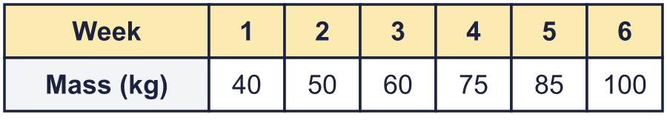
    Use your graph. What was the mass at the end of week 3?
    kg
    By how many kg did the mass go up between week 2 and week 6?
    kg
  1 | The table shows the mass of a calf at the end of each week. Draw a line graph of the data in your book. Put the weeks along the bottom and the mass up the side.
    Use your graph. What was the mass at the end of week 3?
    kg
    By how many kg did the mass go up between week 2 and week 6?
    kg
  2 | The table shows the height of a child at different ages. Draw a line graph of the data in your book.  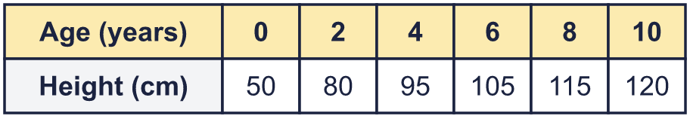
    By how many cm did the child grow between age 2 and age 6?
    cm
    At which age did the child's height first reach more than 100 cm? The age was
    years.
  2 | The table shows the height of a child at different ages. Draw a line graph of the data in your book.
    By how many cm did the child grow between age 2 and age 6?
    cm
    At which age did the child's height first reach more than 100 cm? The age was
    years.
  3 | The graph shows the height of a sunflower at the start of each week.  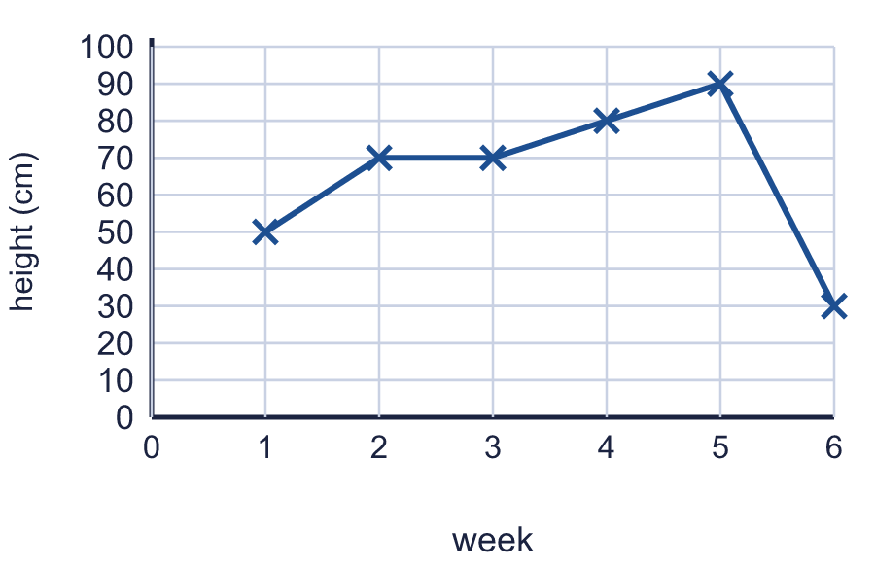
    What was the height at the start of week 3?
    cm
    What was the height at the start of week 5?
    cm
  3 | The graph shows the height of a sunflower at the start of each week.
    What was the height at the start of week 3?
    cm
    What was the height at the start of week 5?
    cm
  4 | The table shows the temperature outside. Draw a line graph in your book. Put the time along the bottom.  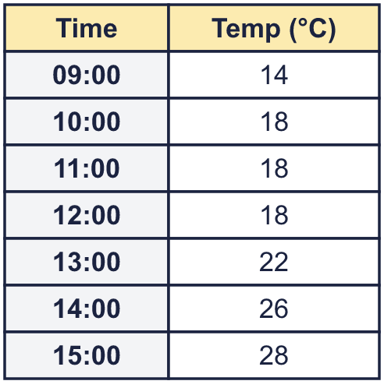
    How much did the temperature change between 11:00 and 12:00?
    °C
  4 | The table shows the temperature outside. Draw a line graph in your book. Put the time along the bottom.
    How much did the temperature change between 11:00 and 12:00?
    °C
  5 | The table shows the height of a plant over six months. Draw a line graph of the data in your book.  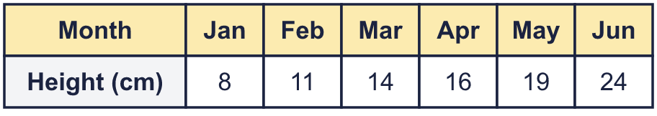
    How many cm did the plant grow between January and June?
    cm
  5 | The table shows the height of a plant over six months. Draw a line graph of the data in your book.
    How many cm did the plant grow between January and June?
    cm
  6 | The greatest value in a table is 167. You draw the vertical axis starting at 0 and going up in 20s.
    What is the smallest number the axis must reach?
    How many gridlines are there above 0?
  6 | The greatest value in a table is 167. You draw the vertical axis starting at 0 and going up in 20s.
    What is the smallest number the axis must reach?
    How many gridlines are there above 0?
  7 | The graph shows the height of a sunflower at the start of each week.  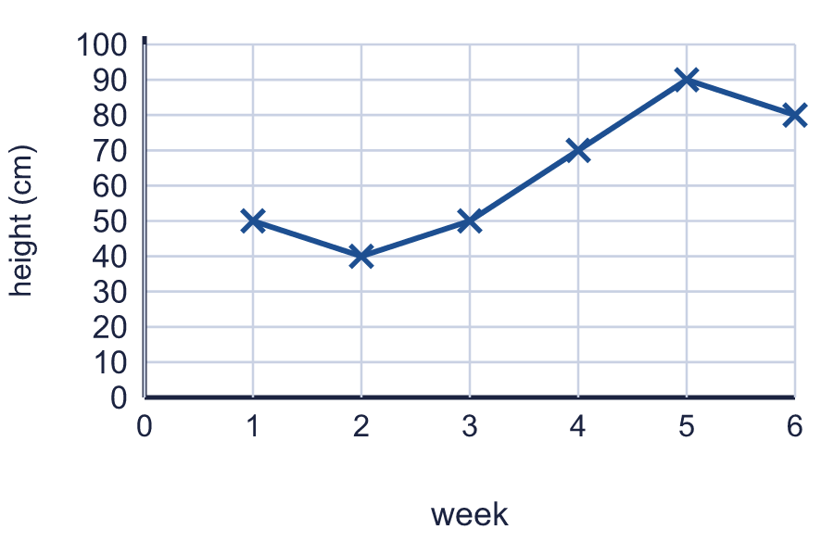
    What is the difference in height between week 3 and week 6?
    cm
  7 | The graph shows the height of a sunflower at the start of each week.
    What is the difference in height between week 3 and week 6?
    cm
  8 | The table shows the height of some cress every 2 days. Draw a line graph in your book. Join the points with a ruler.  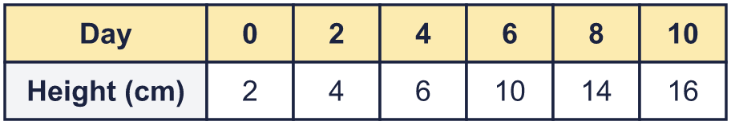
    Use your graph to estimate the height on day 3.
    cm
  8 | The table shows the height of some cress every 2 days. Draw a line graph in your book. Join the points with a ruler.
    Use your graph to estimate the height on day 3.
    cm

  9 | 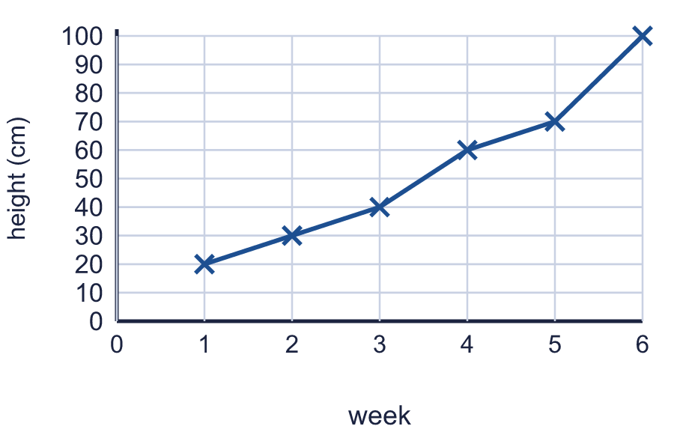  Is Ron correct? Circle yes or no.  Yes / No  Explain how you know.
     | 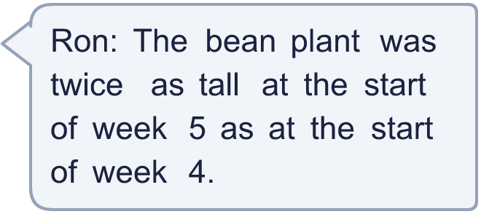
  9 | Is Ron correct? Circle yes or no.  Yes / No  Explain how you know.
  10 | A class measures a bean plant each week. The table shows the results. Draw a line graph in your book. Use a ruler and put the weeks along the bottom.  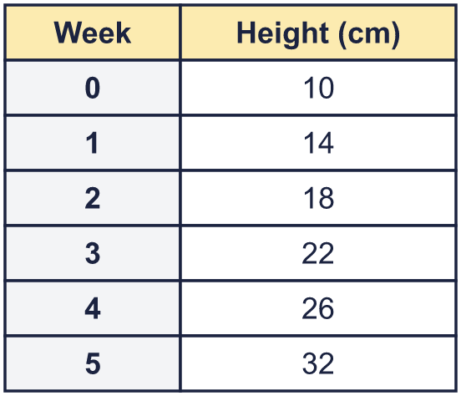
    Use your graph. What was the biggest increase in height in one week?
    cm
    In which week did the plant grow the most? Write the week number.
  10 | A class measures a bean plant each week. The table shows the results. Draw a line graph in your book. Use a ruler and put the weeks along the bottom.
    Use your graph. What was the biggest increase in height in one week?
    cm
    In which week did the plant grow the most? Write the week number.
  11 | The table shows the rain that fell in six months. Draw a line graph in your book.  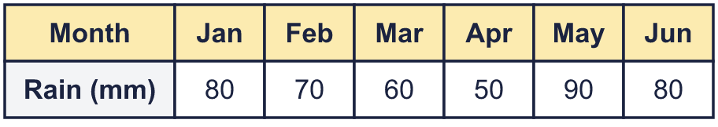
    In which month did the most rain fall?
    In which month did the least rain fall?
  11 | The table shows the rain that fell in six months. Draw a line graph in your book.
    In which month did the most rain fall?
    In which month did the least rain fall?
  12 | The greatest value in a table is 72. You draw the vertical axis starting at 0 and going up in 10s.
    What is the smallest number the axis must reach?
    How many gridlines are there above 0?
  12 | The greatest value in a table is 72. You draw the vertical axis starting at 0 and going up in 10s.
    What is the smallest number the axis must reach?
    How many gridlines are there above 0?
  13 | A weather station measures the temperature every hour. The table shows the readings. Draw a line graph in your book. Put the time along the bottom.  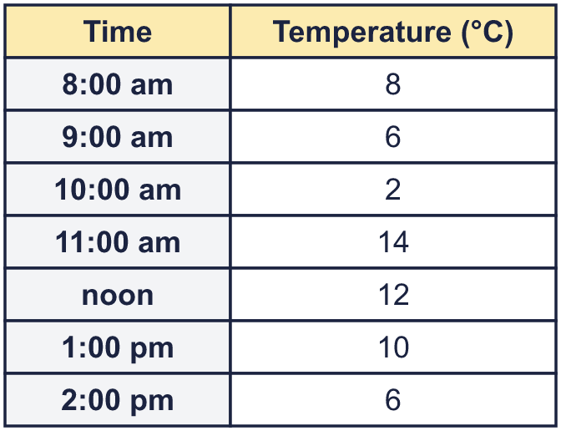
    At what time was it warmest? Write the time.
    At how many of the readings was the temperature higher than 6 °C?
  13 | A weather station measures the temperature every hour. The table shows the readings. Draw a line graph in your book. Put the time along the bottom.
    At what time was it warmest? Write the time.
    At how many of the readings was the temperature higher than 6 °C?
  14 | Challenge  The graph shows the height of a bean plant at the start of each week.  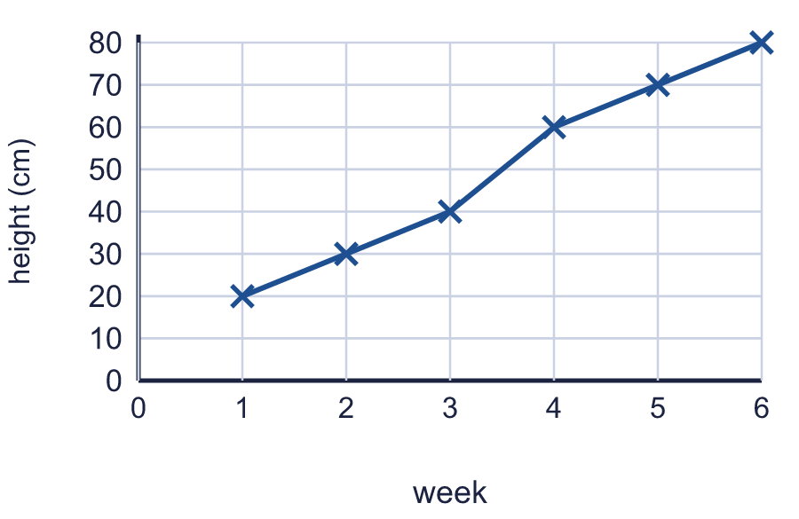
    What was the greatest growth in one week?
    cm
  14 | Challenge  The graph shows the height of a bean plant at the start of each week.
    What was the greatest growth in one week?
    cm

Year 4 · Statistics · Step 4
Draw line graphs
Answers (teacher copy)

  1 | The table shows the mass of a calf at the end of each week. Draw a line graph of the data in your book. Put the weeks along the bottom and the mass up the side.  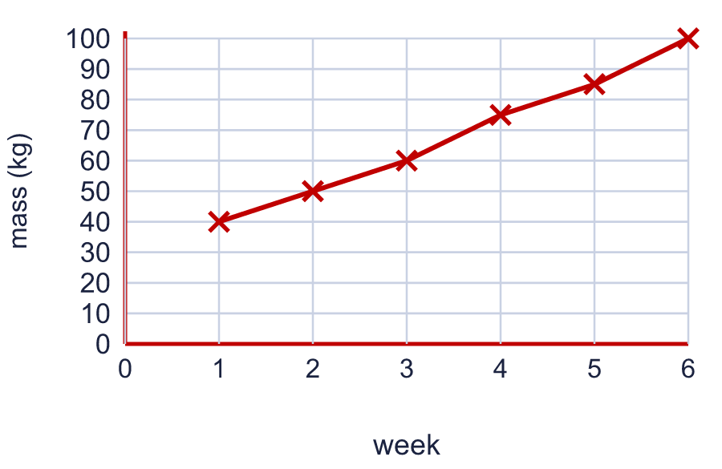  Use your graph. What was the mass at the end of week 3? 60 kg  By how many kg did the mass go up between week 2 and week 6? 50 kg
  2 | The table shows the height of a child at different ages. Draw a line graph of the data in your book.  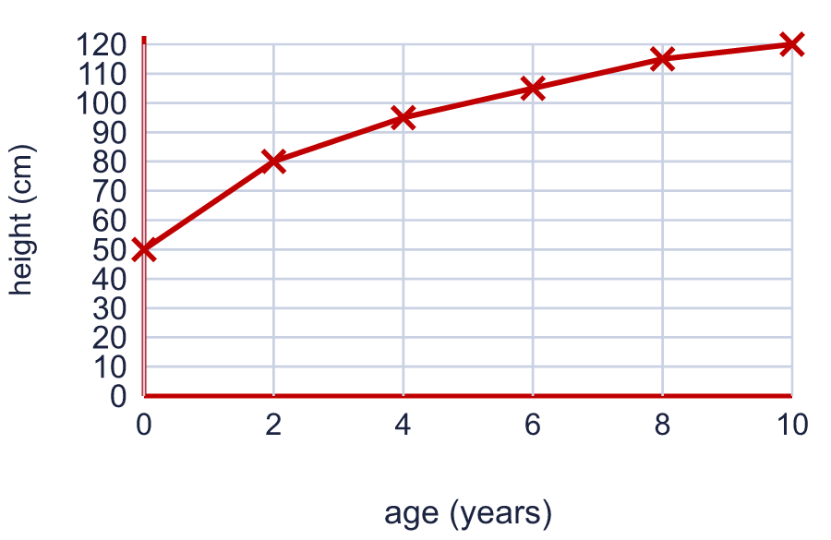  By how many cm did the child grow between age 2 and age 6? 25 cm  At which age did the child's height first reach more than 100 cm? The age was 6 years.
  3 | The graph shows the height of a sunflower at the start of each week.  What was the height at the start of week 3? 70 cm  What was the height at the start of week 5? 90 cm
  4 | The table shows the temperature outside. Draw a line graph in your book. Put the time along the bottom.  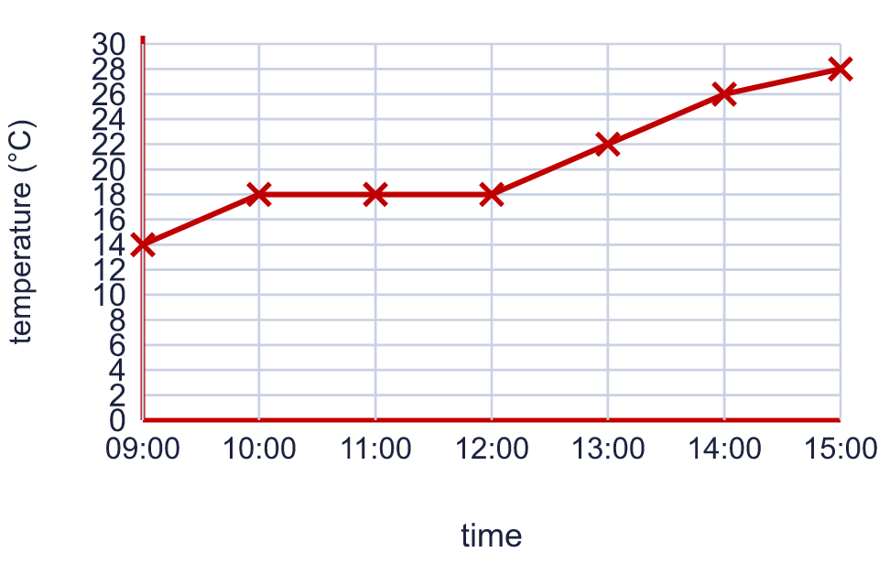  How much did the temperature change between 11:00 and 12:00? 0 °C
  5 | The table shows the height of a plant over six months. Draw a line graph of the data in your book.  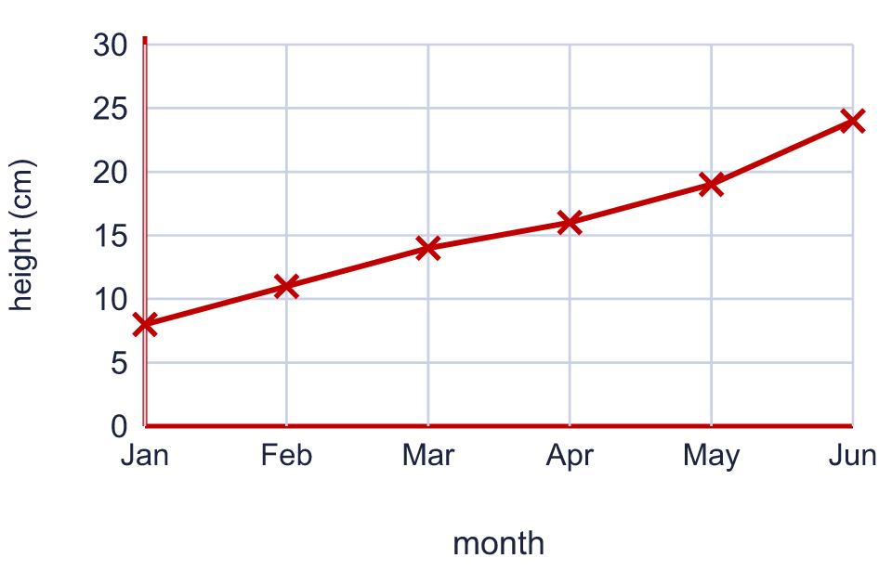  How many cm did the plant grow between January and June? 16 cm
  6 | The greatest value in a table is 167. You draw the vertical axis starting at 0 and going up in 20s.  What is the smallest number the axis must reach? 180  How many gridlines are there above 0? 9
  7 | The graph shows the height of a sunflower at the start of each week.  What is the difference in height between week 3 and week 6? 30 cm
  8 | The table shows the height of some cress every 2 days. Draw a line graph in your book. Join the points with a ruler.  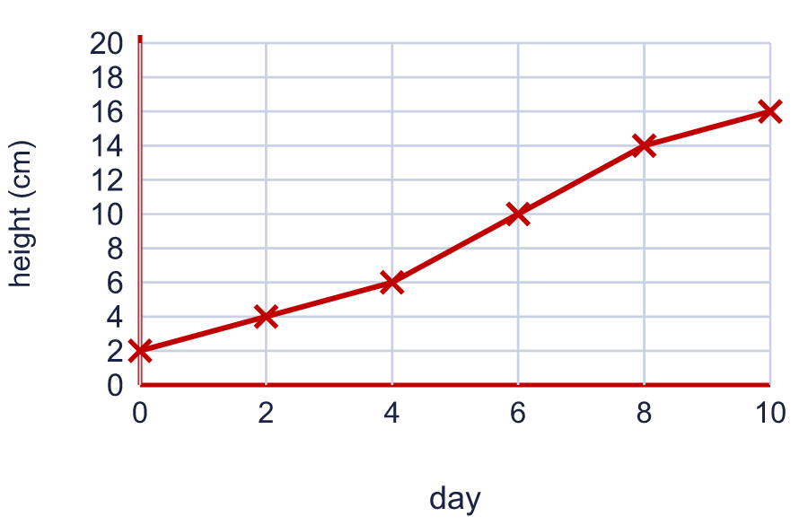  Use your graph to estimate the height on day 3. 5 cm
  9 | Is Ron correct? Circle yes or no.  Yes / No  Explain how you know.  No. Twice 60 cm is 120 cm, but the plant was 70 cm tall in week 5.
  10 | A class measures a bean plant each week. The table shows the results. Draw a line graph in your book. Use a ruler and put the weeks along the bottom.  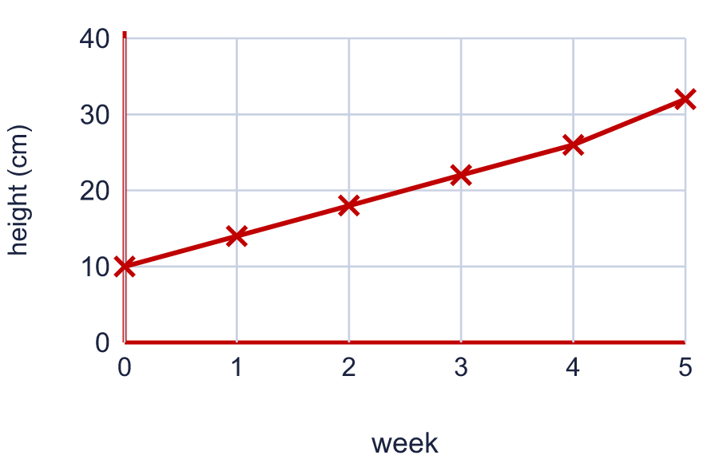  Use your graph. What was the biggest increase in height in one week? 6 cm  In which week did the plant grow the most? Write the week number. 5
  11 | The table shows the rain that fell in six months. Draw a line graph in your book.  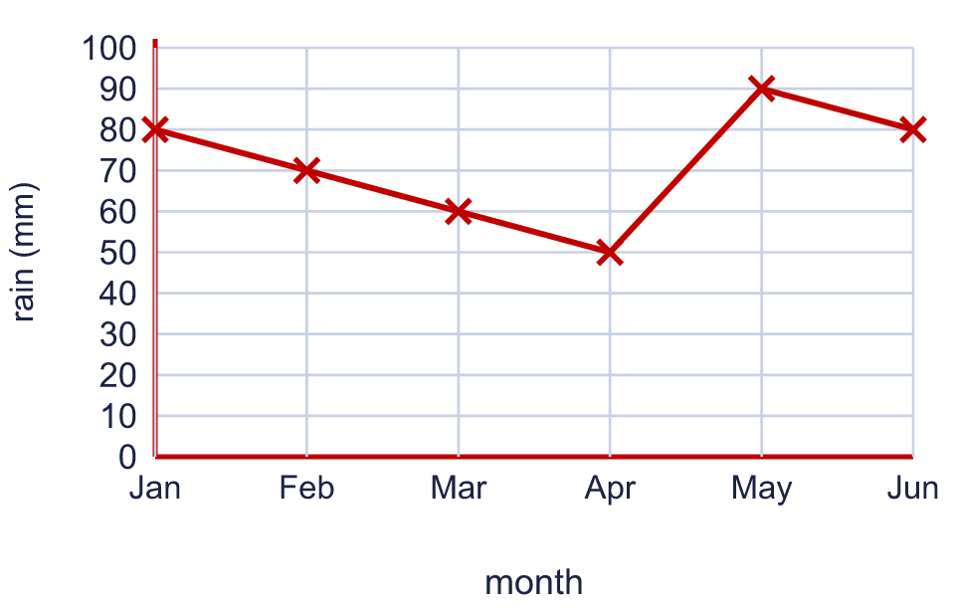  In which month did the most rain fall? May  In which month did the least rain fall? Apr
  12 | The greatest value in a table is 72. You draw the vertical axis starting at 0 and going up in 10s.  What is the smallest number the axis must reach? 80  How many gridlines are there above 0? 8
  13 | A weather station measures the temperature every hour. The table shows the readings. Draw a line graph in your book. Put the time along the bottom.  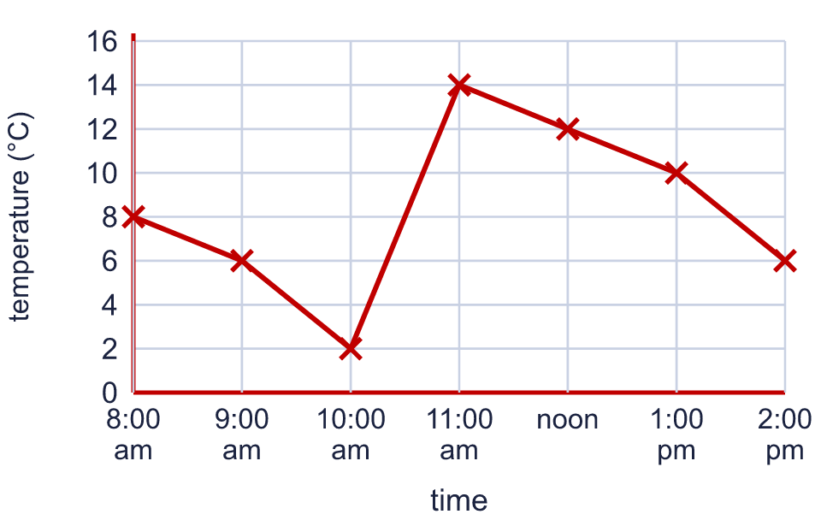  At what time was it warmest? Write the time. 11:00 am  At how many of the readings was the temperature higher than 6 °C? 4
  14 | Challenge  The graph shows the height of a bean plant at the start of each week.  What was the greatest growth in one week? 20 cm

