  Year 4 · Statistics · Step 2  Comparison, sum and difference | 
  Year 4 · Statistics · Step 2
  Comparison, sum and difference
  1 | The pictogram shows how many points each team scored. Write <, > or = in each box.  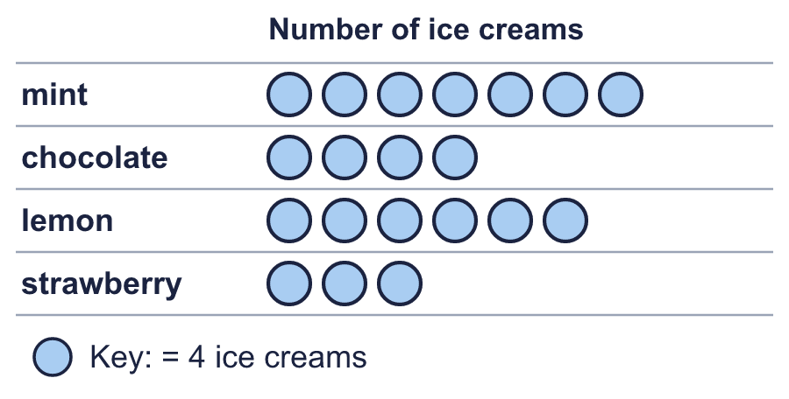
    a) mint |  | strawberry
    b) mint |  | lemon
    c) mint |  | chocolate
  1 | The pictogram shows how many points each team scored. Write <, > or = in each box.
    a) mint |  | strawberry
    b) mint |  | lemon
    c) mint |  | chocolate
  2 | Look at the pictogram.  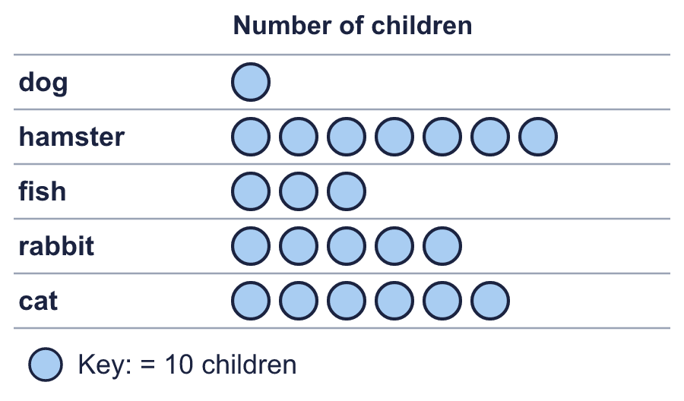
    How many more are there for cat than for fish?
  2 | Look at the pictogram.
    How many more are there for cat than for fish?
  3 | Look at the pictogram.  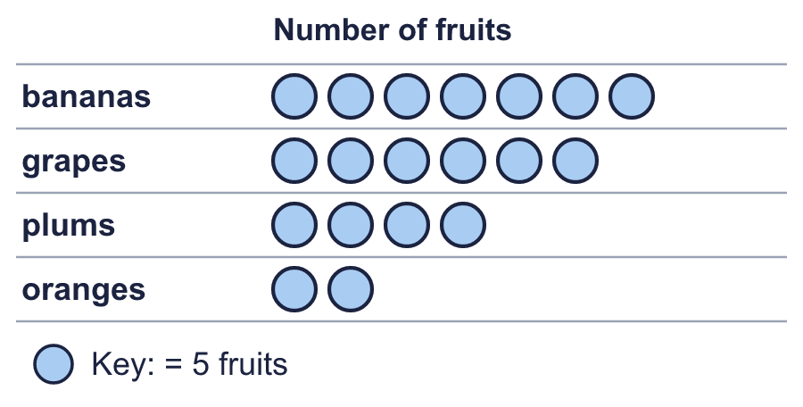
    How many are there altogether?
  3 | Look at the pictogram.
    How many are there altogether?
  4 | The bar chart shows the visitors to a museum.  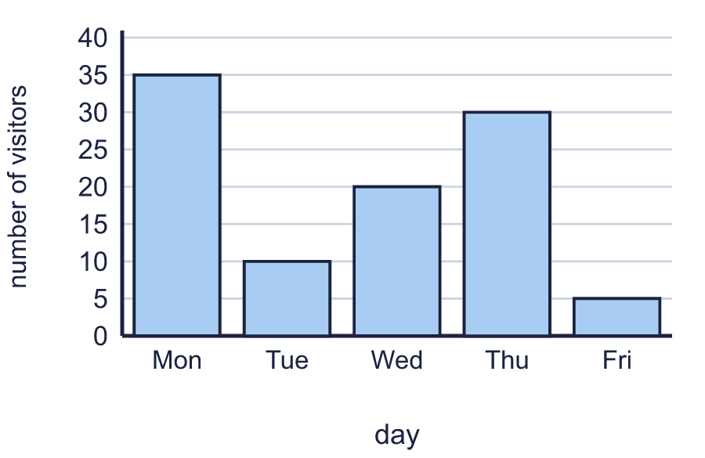
    How many more on Wed than on Tue?
  4 | The bar chart shows the visitors to a museum.
    How many more on Wed than on Tue?
  5 | The bar chart shows the visitors to a museum.  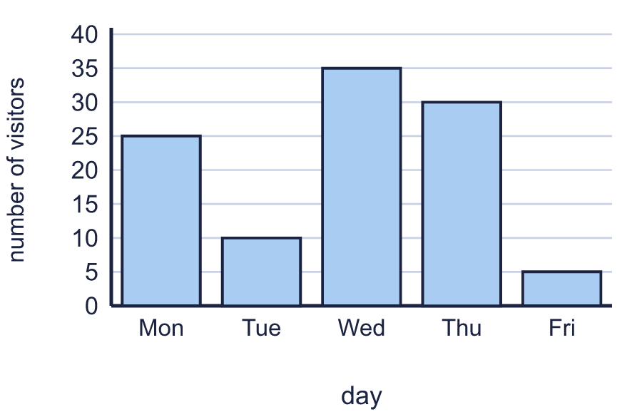
    What is the total for all five bars?
  5 | The bar chart shows the visitors to a museum.
    What is the total for all five bars?
  6 | The bar chart shows the children who visited.  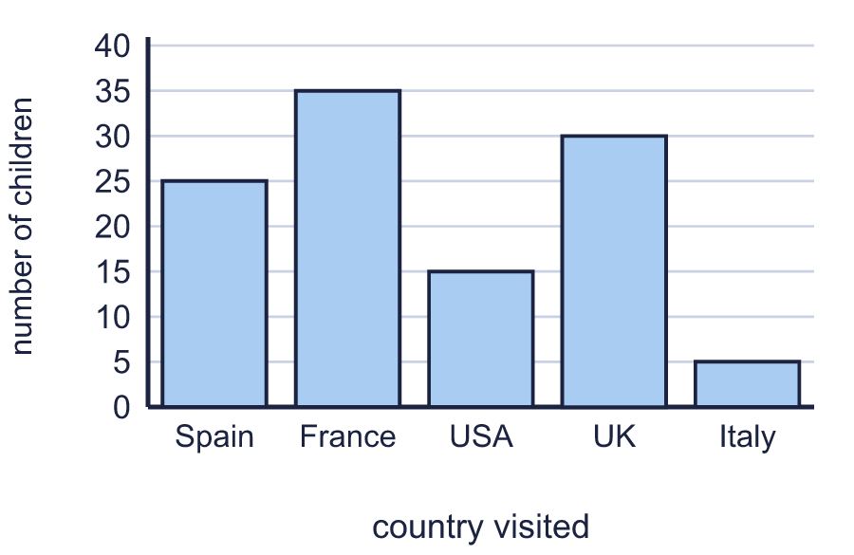
    What is the difference between the greatest and the least?
  6 | The bar chart shows the children who visited.
    What is the difference between the greatest and the least?
  7 | Look at the pictogram.  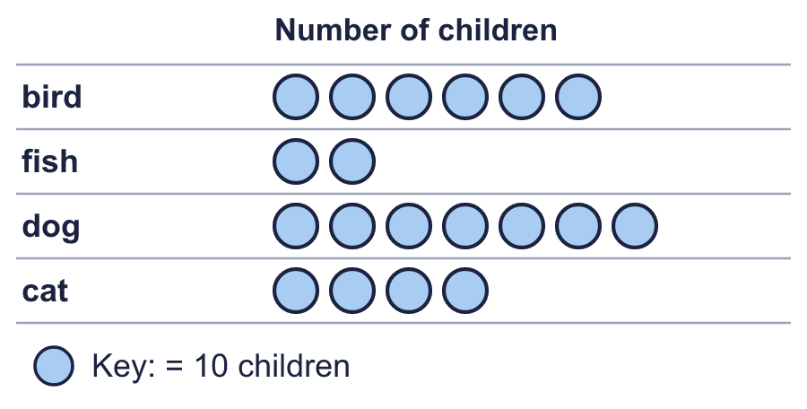
    bird is ___ times as many as fish. Write the number.
  7 | Look at the pictogram.
    bird is ___ times as many as fish. Write the number.
  8 | The bar chart shows the children who visited.  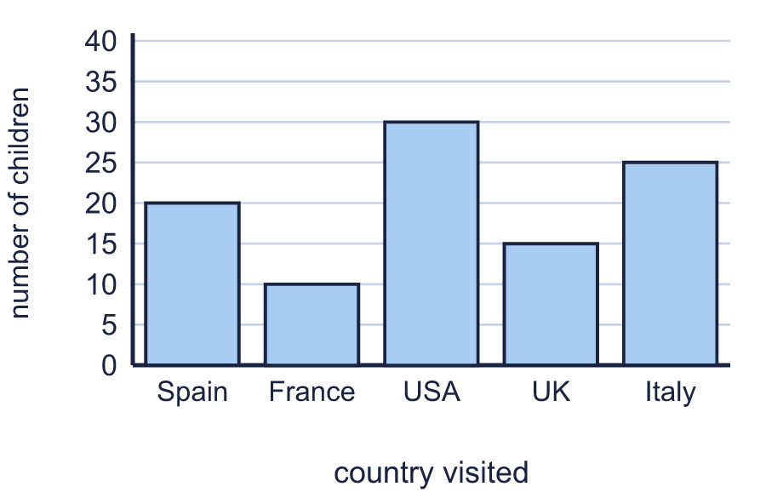
    How many were there on Italy and USA together?
  8 | The bar chart shows the children who visited.
    How many were there on Italy and USA together?

  9 | 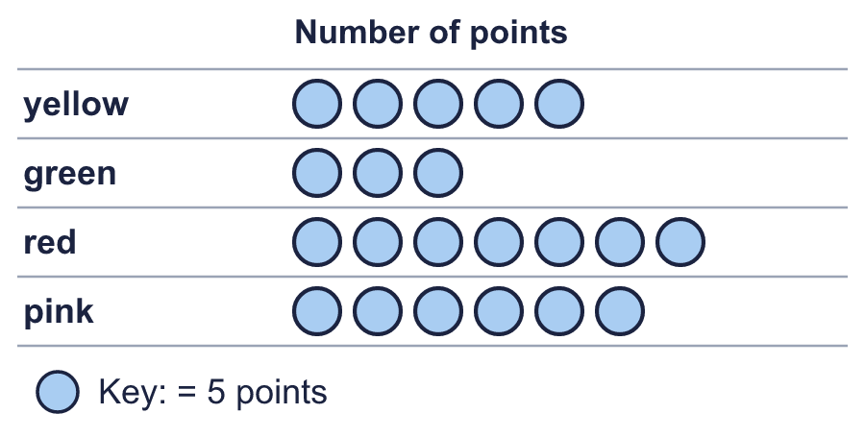  Is Mia correct? Circle yes or no.  Yes / No  Explain how you know.
     | 
  9 | Is Mia correct? Circle yes or no.  Yes / No  Explain how you know.
  10 | 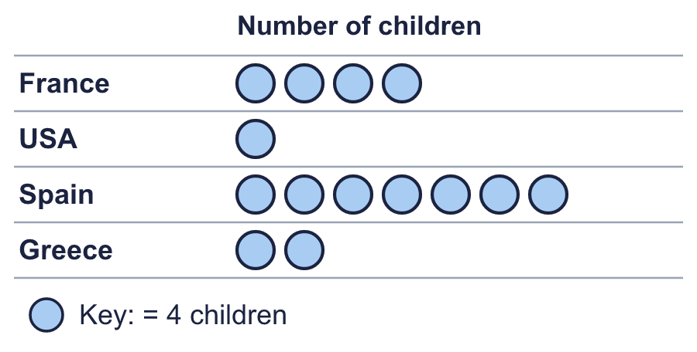  A new row shows half the number that Spain shows.
    How many does the new row show?
  10 | A new row shows half the number that Spain shows.
    How many does the new row show?
  11 | 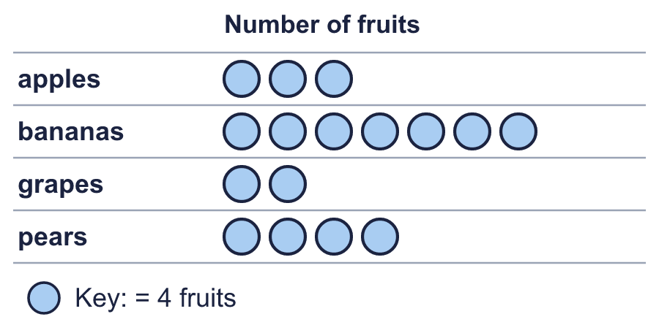  Next week there will be 2 times as many for grapes.
    How many will there be for grapes next week?
  11 | Next week there will be 2 times as many for grapes.
    How many will there be for grapes next week?
  12 | 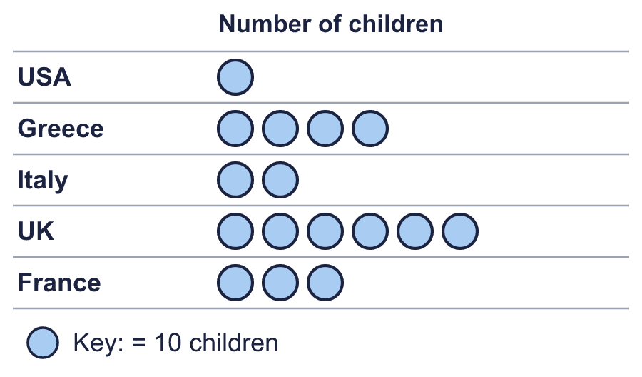
    UK and Greece together has how many more than France?
  12
    UK and Greece together has how many more than France?
  13 | The bar chart shows the goals scored.  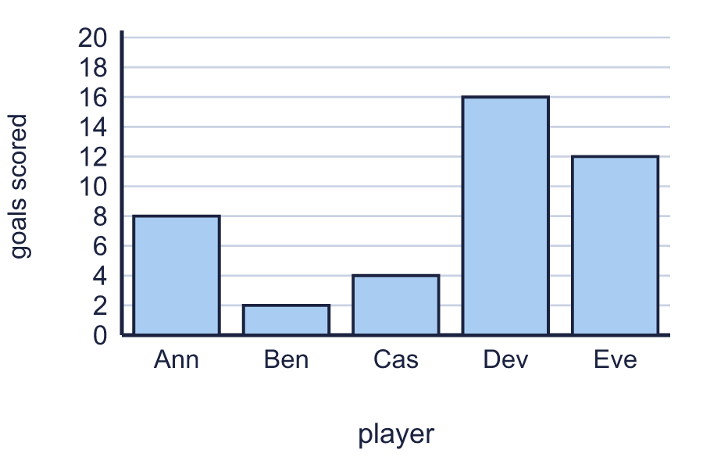
    How many were there on Eve, Ben, Ann altogether?
  13 | The bar chart shows the goals scored.
    How many were there on Eve, Ben, Ann altogether?
  14 | Challenge  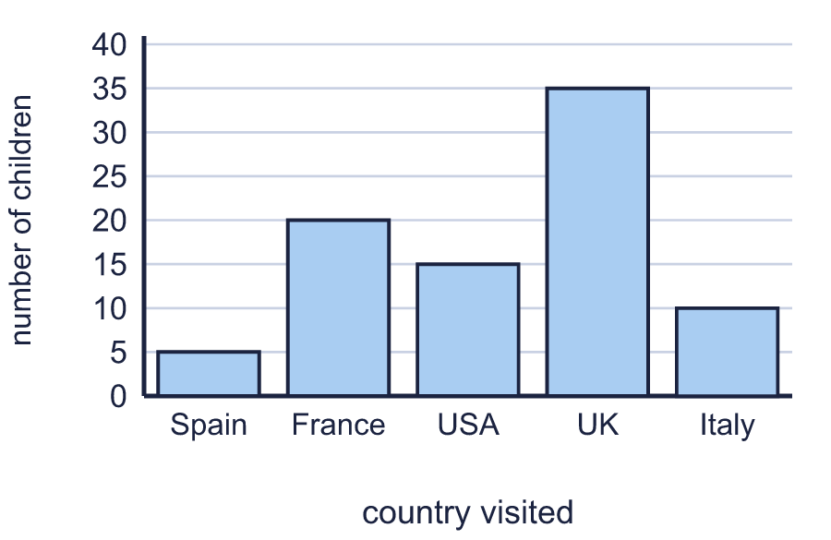
    How many more are there on USA than on Italy?
    How many are there on USA and Italy together?
  14 | Challenge
    How many more are there on USA than on Italy?
    How many are there on USA and Italy together?

Year 4 · Statistics · Step 2
Comparison, sum and difference
Answers (teacher copy)

  1 | The pictogram shows how many points each team scored. Write <, > or = in each box.  a) mint > strawberry  b) mint > lemon  c) mint > chocolate
  2 | Look at the pictogram.  How many more are there for cat than for fish? 30
  3 | Look at the pictogram.  How many are there altogether? 95
  4 | The bar chart shows the visitors to a museum.  How many more on Wed than on Tue? 10
  5 | The bar chart shows the visitors to a museum.  What is the total for all five bars? 105
  6 | The bar chart shows the children who visited.  What is the difference between the greatest and the least? 30
  7 | Look at the pictogram.  bird is ___ times as many as fish. Write the number. 3
  8 | The bar chart shows the children who visited.  How many were there on Italy and USA together? 55
  9 | Is Mia correct? Circle yes or no.  Yes / No  Explain how you know.  No. red shows 35 and pink shows 30, so the difference is 5.
  10 | A new row shows half the number that Spain shows.  How many does the new row show? 14
  11 | Next week there will be 2 times as many for grapes.  How many will there be for grapes next week? 16
  12 | UK and Greece together has how many more than France? 70
  13 | The bar chart shows the goals scored.  How many were there on Eve, Ben, Ann altogether? 22
  14 | Challenge  How many more are there on USA than on Italy? 5  How many are there on USA and Italy together? 25

