  Year 4 · Shape · Step 1  Understand angles as turns | 
  Year 4 · Shape · Step 1
  Understand angles as turns
  1 | The child is facing north. Which way will the child face after each turn?  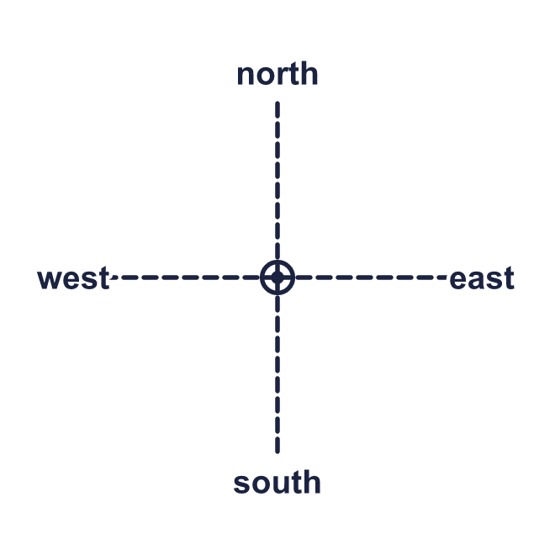  a) a half turn anticlockwise:  b) a quarter turn anticlockwise:  c) a three-quarter turn anticlockwise:
  1 | The child is facing north. Which way will the child face after each turn?  a) a half turn anticlockwise:  b) a quarter turn anticlockwise:  c) a three-quarter turn anticlockwise:
  2 | Look at the picture. Write quarter, half or three-quarter for the size of each turn.  a) west to north, clockwise:  b) east to north, anticlockwise:  c) south to west, clockwise:
  2 | Look at the picture. Write quarter, half or three-quarter for the size of each turn.  a) west to north, clockwise:  b) east to north, anticlockwise:  c) south to west, clockwise:
  3 | Look at the picture. Write clockwise or anticlockwise.  a) a quarter turn from north to east:  b) a quarter turn from east to south:  c) a quarter turn from east to north:
  3 | Look at the picture. Write clockwise or anticlockwise.  a) a quarter turn from north to east:  b) a quarter turn from east to south:  c) a quarter turn from east to north:
  4 | How many quarter turns make each turn?  a) a three-quarter turn:  b) a half turn:  c) a full turn:
  4 | How many quarter turns make each turn?  a) a three-quarter turn:  b) a half turn:  c) a full turn:
  5 | The minute hand of a clock points to a number. It makes a turn. Which number does it point to now?  a) It starts at 12 and makes a quarter turn anticlockwise:  b) It starts at 3 and makes a quarter turn anticlockwise:  c) It starts at 12 and makes a half turn clockwise:
  5 | The minute hand of a clock points to a number. It makes a turn. Which number does it point to now?  a) It starts at 12 and makes a quarter turn anticlockwise:  b) It starts at 3 and makes a quarter turn anticlockwise:  c) It starts at 12 and makes a half turn clockwise:
  6 | Complete the sentences. Write quarter, half or three-quarter.  a) a three-quarter turn anticlockwise is the same as a ___ turn clockwise:  b) a quarter turn anticlockwise is the same as a ___ turn clockwise:
  6 | Complete the sentences. Write quarter, half or three-quarter.  a) a three-quarter turn anticlockwise is the same as a ___ turn clockwise:  b) a quarter turn anticlockwise is the same as a ___ turn clockwise:
  7 | The child is facing north. The child makes a quarter turn anticlockwise and then a quarter turn anticlockwise.  a) Which way is the child facing now?
  7 | The child is facing north. The child makes a quarter turn anticlockwise and then a quarter turn anticlockwise.  a) Which way is the child facing now?
  8 | After a half turn clockwise the child is facing west.  a) Which way was the child facing before the turn?
  8 | After a half turn clockwise the child is facing west.  a) Which way was the child facing before the turn?

  9 | Nina is facing east.  Is Nina correct? Circle yes or no.  Yes / No  Explain how you know.
     | 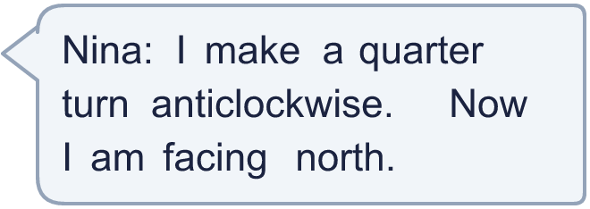
  9 | Nina is facing east.  Is Nina correct? Circle yes or no.  Yes / No  Explain how you know.
  10 | The child is facing south. Which of these turns make the child face the same way as a three-quarter turn clockwise? Write the letters.  A: a quarter turn anticlockwise  B: a three-quarter turn clockwise  C: a half turn clockwise  D: a three-quarter turn anticlockwise
  10 | The child is facing south. Which of these turns make the child face the same way as a three-quarter turn clockwise? Write the letters.  A: a quarter turn anticlockwise  B: a three-quarter turn clockwise  C: a half turn clockwise  D: a three-quarter turn anticlockwise
  11 | The minute hand starts at 3. It makes a quarter turn clockwise and then a quarter turn clockwise.  a) Which number does it point to now?
  11 | The minute hand starts at 3. It makes a quarter turn clockwise and then a quarter turn clockwise.  a) Which number does it point to now?
  12 | Jo is facing east. Jo makes a full turn clockwise and then a half turn clockwise.  a) Which way is Jo facing now?
  12 | Jo is facing east. Jo makes a full turn clockwise and then a half turn clockwise.  a) Which way is Jo facing now?
  13 | A quarter of an hour is a quarter turn of the minute hand. Which number does the minute hand point to?  a) It starts at 12 and makes a three-quarter turn clockwise:  b) It starts at 12 and makes a half turn clockwise:
  13 | A quarter of an hour is a quarter turn of the minute hand. Which number does the minute hand point to?  a) It starts at 12 and makes a three-quarter turn clockwise:  b) It starts at 12 and makes a half turn clockwise:
  14 | Challenge  Eva makes a quarter turn anticlockwise and then a half turn. Eva is now facing west.  a) Which way was Eva facing at the start?
  14 | Challenge  Eva makes a quarter turn anticlockwise and then a half turn. Eva is now facing west.  a) Which way was Eva facing at the start?

Year 4 · Shape · Step 1
Understand angles as turns
Answers (teacher copy)

  1 | The child is facing north. Which way will the child face after each turn?  a) a half turn anticlockwise: south  b) a quarter turn anticlockwise: west  c) a three-quarter turn anticlockwise: east
  2 | Look at the picture. Write quarter, half or three-quarter for the size of each turn.  a) west to north, clockwise: quarter  b) east to north, anticlockwise: quarter  c) south to west, clockwise: quarter
  3 | Look at the picture. Write clockwise or anticlockwise.  a) a quarter turn from north to east: clockwise  b) a quarter turn from east to south: clockwise  c) a quarter turn from east to north: anticlockwise
  4 | How many quarter turns make each turn?  a) a three-quarter turn: 3  b) a half turn: 2  c) a full turn: 4
  5 | The minute hand of a clock points to a number. It makes a turn. Which number does it point to now?  a) It starts at 12 and makes a quarter turn anticlockwise: 9  b) It starts at 3 and makes a quarter turn anticlockwise: 12  c) It starts at 12 and makes a half turn clockwise: 6
  6 | Complete the sentences. Write quarter, half or three-quarter.  a) a three-quarter turn anticlockwise is the same as a ___ turn clockwise: quarter  b) a quarter turn anticlockwise is the same as a ___ turn clockwise: three-quarter
  7 | The child is facing north. The child makes a quarter turn anticlockwise and then a quarter turn anticlockwise.  a) Which way is the child facing now? south
  8 | After a half turn clockwise the child is facing west.  a) Which way was the child facing before the turn? east
  9 | Nina is facing east.  Is Nina correct? Circle yes or no.  Yes / No  Explain how you know.  Yes. After a quarter turn anticlockwise from east the child faces north.
  10 | The child is facing south. Which of these turns make the child face the same way as a three-quarter turn clockwise? Write the letters.  A: a quarter turn anticlockwise  B: a three-quarter turn clockwise  C: a half turn clockwise  D: a three-quarter turn anticlockwise  A, B
  11 | The minute hand starts at 3. It makes a quarter turn clockwise and then a quarter turn clockwise.  a) Which number does it point to now? 9
  12 | Jo is facing east. Jo makes a full turn clockwise and then a half turn clockwise.  a) Which way is Jo facing now? west
  13 | A quarter of an hour is a quarter turn of the minute hand. Which number does the minute hand point to?  a) It starts at 12 and makes a three-quarter turn clockwise: 9  b) It starts at 12 and makes a half turn clockwise: 6
  14 | Challenge  Eva makes a quarter turn anticlockwise and then a half turn. Eva is now facing west.  a) Which way was Eva facing at the start? south

