  Year 4 · Shape · Step 4  Triangles | 
  Year 4 · Shape · Step 4
  Triangles
  1 | The marks on the sides show which sides are the same length. Write equilateral, isosceles or scalene for each triangle.  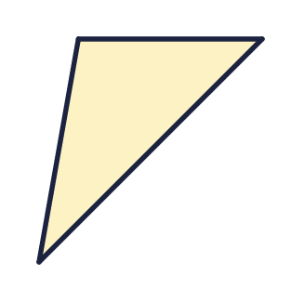  a) Triangle A  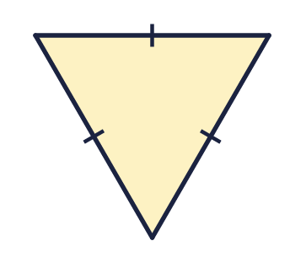  b) Triangle B  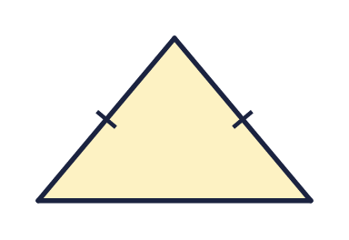  c) Triangle C
  1 | The marks on the sides show which sides are the same length. Write equilateral, isosceles or scalene for each triangle.  a) Triangle A  b) Triangle B  c) Triangle C
  2 | Write how many sides are the same length in each triangle. Write 0 if no sides are the same length.  a) An equilateral triangle has  b) An isosceles triangle has  c) An scalene triangle has
  2 | Write how many sides are the same length in each triangle. Write 0 if no sides are the same length.  a) An equilateral triangle has  b) An isosceles triangle has  c) An scalene triangle has
  3 | How many sides of each triangle are the same length? The marks show the equal sides.  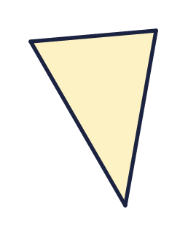  a) Triangle A  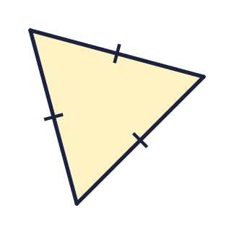  b) Triangle B
  3 | How many sides of each triangle are the same length? The marks show the equal sides.  a) Triangle A  b) Triangle B
  4 | Look at the four triangles. Which are equilateral triangles? Write the letters.  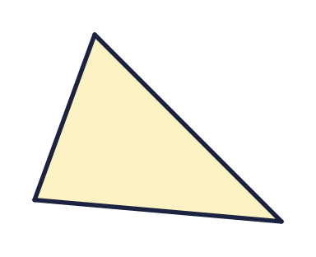  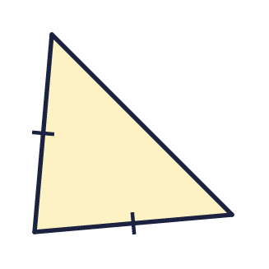  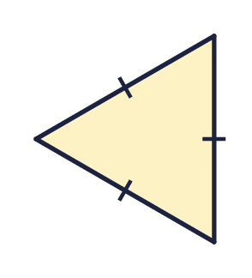  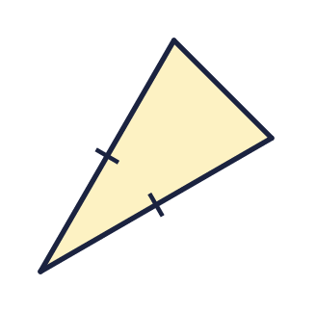
  4 | Look at the four triangles. Which are equilateral triangles? Write the letters.
  5 | Look at the triangle. The right angle is marked with a square if there is one.  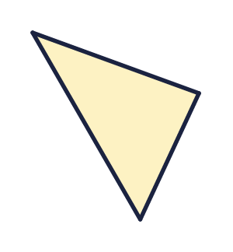  Write right-angled, acute-angled or obtuse-angled.
  5 | Look at the triangle. The right angle is marked with a square if there is one.  Write right-angled, acute-angled or obtuse-angled.
  6 | Is each shape a triangle? Write yes or no.    a) Shape A    b) Shape B
  6 | Is each shape a triangle? Write yes or no.  a) Shape A  b) Shape B
  7 | Which triangle is scalene? Write the letter.  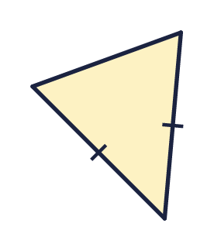  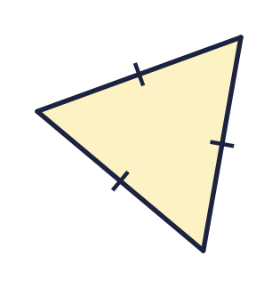  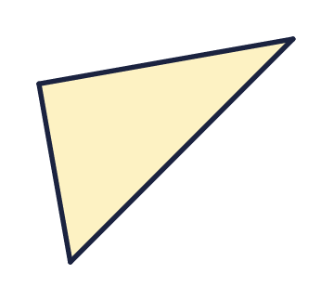
  7 | Which triangle is scalene? Write the letter.
  8 | An equilateral triangle has sides of 6 cm.  a) What is the perimeter of the triangle (in cm)?
  8 | An equilateral triangle has sides of 6 cm.  a) What is the perimeter of the triangle (in cm)?

  9 | 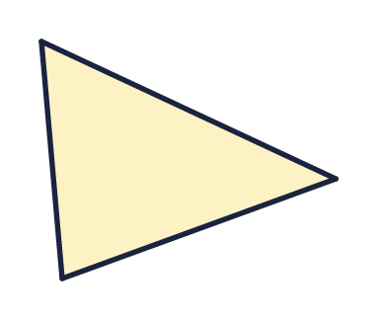  Is Eva correct? Circle yes or no.  Yes / No  Explain how you know.
     | 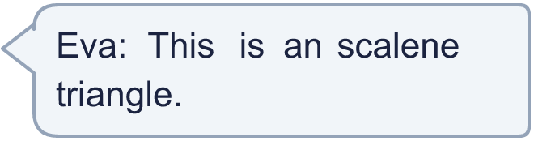
  9 | Is Eva correct? Circle yes or no.  Yes / No  Explain how you know.
  10 | Is the statement always true, sometimes true or never true?  A triangle has four sides.  Write always, sometimes or never.
  10 | Is the statement always true, sometimes true or never true?  A triangle has four sides.  Write always, sometimes or never.
  11 | An isosceles triangle has two sides of 6 cm and one side of 3 cm.  a) What is the perimeter of the triangle (in cm)?
  11 | An isosceles triangle has two sides of 6 cm and one side of 3 cm.  a) What is the perimeter of the triangle (in cm)?
  12 | 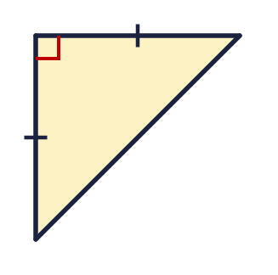  Is Mo correct? Circle yes or no.  Yes / No  Explain how you know.
     | 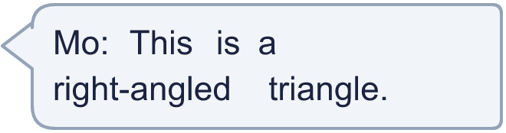
  12 | Is Mo correct? Circle yes or no.  Yes / No  Explain how you know.
  13 | An isosceles triangle has two sides of 5 cm. Its perimeter is 15 cm.  a) How long is the third side (in cm)?
  13 | An isosceles triangle has two sides of 5 cm. Its perimeter is 15 cm.  a) How long is the third side (in cm)?
  14 | Challenge  Look at the four triangles. Which are scalene triangles? Write the letters.  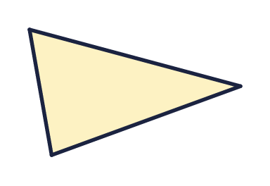  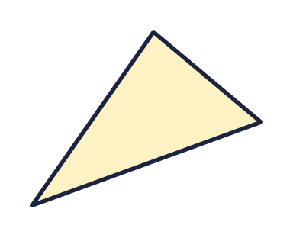  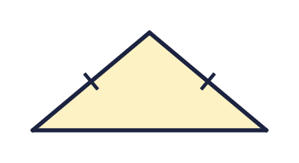
  14 | Challenge  Look at the four triangles. Which are scalene triangles? Write the letters.

Year 4 · Shape · Step 4
Triangles
Answers (teacher copy)

  1 | The marks on the sides show which sides are the same length. Write equilateral, isosceles or scalene for each triangle.  a) Triangle A scalene  b) Triangle B equilateral  c) Triangle C isosceles
  2 | Write how many sides are the same length in each triangle. Write 0 if no sides are the same length.  a) An equilateral triangle has 3  b) An isosceles triangle has 2  c) An scalene triangle has 0
  3 | How many sides of each triangle are the same length? The marks show the equal sides.  a) Triangle A 0  b) Triangle B 3
  4 | Look at the four triangles. Which are equilateral triangles? Write the letters.  C
  5 | Look at the triangle. The right angle is marked with a square if there is one.  Write right-angled, acute-angled or obtuse-angled. acute-angled
  6 | Is each shape a triangle? Write yes or no.  a) Shape A No  b) Shape B No
  7 | Which triangle is scalene? Write the letter.  C
  8 | An equilateral triangle has sides of 6 cm.  a) What is the perimeter of the triangle (in cm)? 18
  9 | Is Eva correct? Circle yes or no.  Yes / No  Explain how you know.  Yes. The marks show that it is a scalene triangle because no sides are the same length.
  10 | Is the statement always true, sometimes true or never true?  A triangle has four sides.  Write always, sometimes or never. never
  11 | An isosceles triangle has two sides of 6 cm and one side of 3 cm.  a) What is the perimeter of the triangle (in cm)? 15
  12 | Is Mo correct? Circle yes or no.  Yes / No  Explain how you know.  Yes. The triangle has a right angle, marked with a square.
  13 | An isosceles triangle has two sides of 5 cm. Its perimeter is 15 cm.  a) How long is the third side (in cm)? 5
  14 | Challenge  Look at the four triangles. Which are scalene triangles? Write the letters.  B, C

