  Year 4 · Shape · Step 5  Quadrilaterals | 
  Year 4 · Shape · Step 5
  Quadrilaterals
  1 | Write the name of each quadrilateral: square, rectangle, rhombus, parallelogram or trapezium.  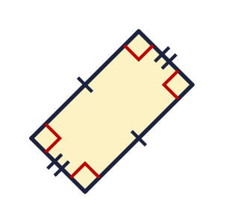  a) Shape A  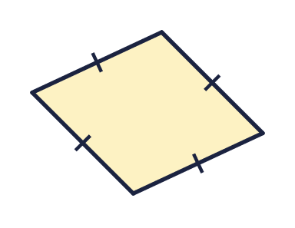  b) Shape B  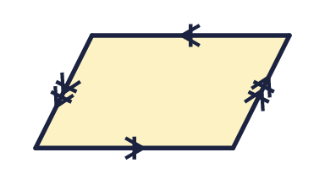  c) Shape C
  1 | Write the name of each quadrilateral: square, rectangle, rhombus, parallelogram or trapezium.  a) Shape A  b) Shape B  c) Shape C
  2 | Write the name of each quadrilateral.  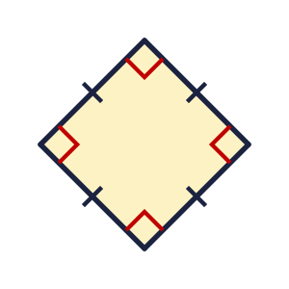  a) Shape A  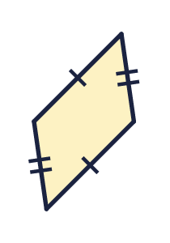  b) Shape B  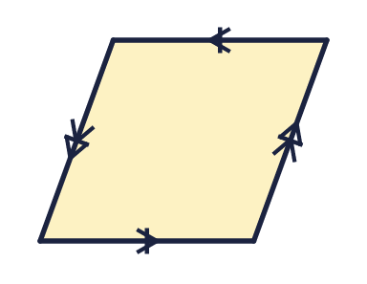  c) Shape C
  2 | Write the name of each quadrilateral.  a) Shape A  b) Shape B  c) Shape C
  3 | How many right angles does each shape have? Right angles are marked with squares.  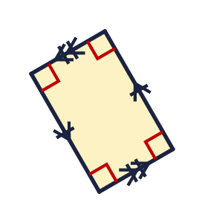  a) Shape A  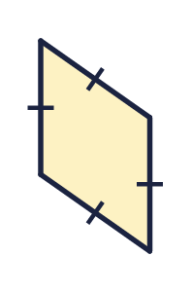  b) Shape B
  3 | How many right angles does each shape have? Right angles are marked with squares.  a) Shape A  b) Shape B
  4 | How many pairs of parallel sides does each shape have?  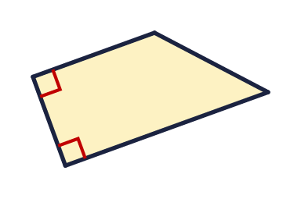  a) Shape A  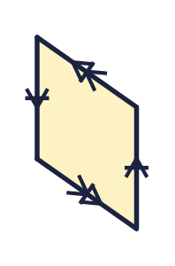  b) Shape B
  4 | How many pairs of parallel sides does each shape have?  a) Shape A  b) Shape B
  5 | Are all four sides the same length? Write yes or no.  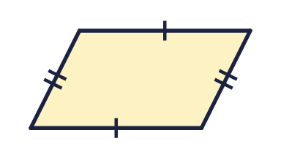  a) Shape A  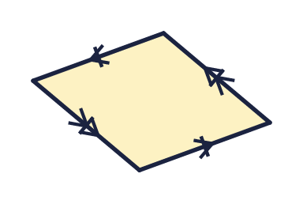  b) Shape B
  5 | Are all four sides the same length? Write yes or no.  a) Shape A  b) Shape B
  6 | Which shape is a square? Write the letter.  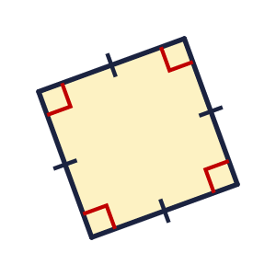  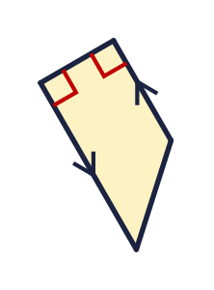
  6 | Which shape is a square? Write the letter.
  7 | Look at the shape.  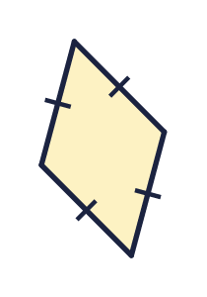  a) How many right angles?  b) How many pairs of parallel sides?  c) Are all four sides equal? Write yes or no.
  7 | Look at the shape.  a) How many right angles?  b) How many pairs of parallel sides?  c) Are all four sides equal? Write yes or no.
  8 | Write the name of the quadrilateral.  a) A quadrilateral with four equal sides and no right angles:  b) A quadrilateral with only one pair of parallel sides:
  8 | Write the name of the quadrilateral.  a) A quadrilateral with four equal sides and no right angles:  b) A quadrilateral with only one pair of parallel sides:

  9 | 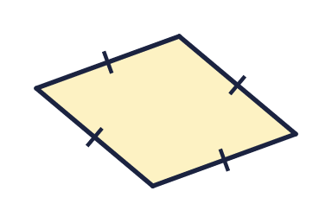  Is Nina correct? Circle yes or no.  Yes / No  Explain how you know.
     | 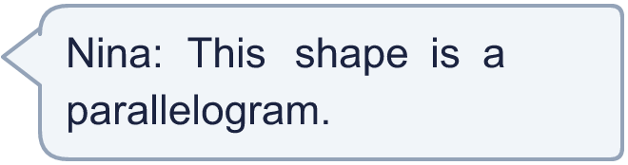
  9 | Is Nina correct? Circle yes or no.  Yes / No  Explain how you know.
  10 | Is the statement always true, sometimes true or never true?  A quadrilateral has four sides.  Write always, sometimes or never.
  10 | Is the statement always true, sometimes true or never true?  A quadrilateral has four sides.  Write always, sometimes or never.
  11 | Look at the four shapes. Which shape has the most right angles? Write the letter.  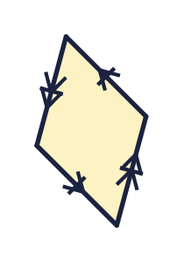  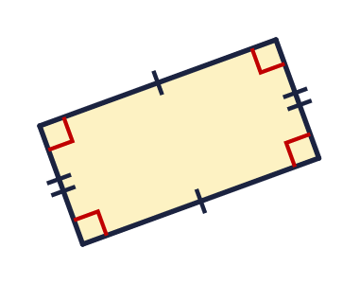  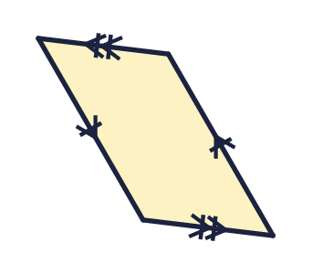  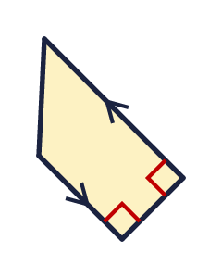
  11 | Look at the four shapes. Which shape has the most right angles? Write the letter.
  12 | Write the name of the quadrilateral.  a) A quadrilateral with two pairs of parallel sides, no right angles and the sides are not all equal:
  12 | Write the name of the quadrilateral.  a) A quadrilateral with two pairs of parallel sides, no right angles and the sides are not all equal:
  13 | A rhombus has sides of 5 cm.  a) What is the perimeter of the shape (in cm)?
  13 | A rhombus has sides of 5 cm.  a) What is the perimeter of the shape (in cm)?
  14 | Challenge  A rectangle is 5 cm long and 4 cm wide.  a) What is the perimeter of the rectangle (in cm)?
  14 | Challenge  A rectangle is 5 cm long and 4 cm wide.  a) What is the perimeter of the rectangle (in cm)?

Year 4 · Shape · Step 5
Quadrilaterals
Answers (teacher copy)

  1 | Write the name of each quadrilateral: square, rectangle, rhombus, parallelogram or trapezium.  a) Shape A rectangle  b) Shape B rhombus  c) Shape C parallelogram
  2 | Write the name of each quadrilateral.  a) Shape A square  b) Shape B parallelogram  c) Shape C rhombus
  3 | How many right angles does each shape have? Right angles are marked with squares.  a) Shape A 4  b) Shape B 0
  4 | How many pairs of parallel sides does each shape have?  a) Shape A 1  b) Shape B 2
  5 | Are all four sides the same length? Write yes or no.  a) Shape A No  b) Shape B Yes
  6 | Which shape is a square? Write the letter.  B
  7 | Look at the shape.  a) How many right angles? 0  b) How many pairs of parallel sides? 2  c) Are all four sides equal? Write yes or no. Yes
  8 | Write the name of the quadrilateral.  a) A quadrilateral with four equal sides and no right angles: rhombus  b) A quadrilateral with only one pair of parallel sides: trapezium
  9 | Is Nina correct? Circle yes or no.  Yes / No  Explain how you know.  No. The shape is a rhombus.
  10 | Is the statement always true, sometimes true or never true?  A quadrilateral has four sides.  Write always, sometimes or never. always
  11 | Look at the four shapes. Which shape has the most right angles? Write the letter.  B
  12 | Write the name of the quadrilateral.  a) A quadrilateral with two pairs of parallel sides, no right angles and the sides are not all equal: parallelogram
  13 | A rhombus has sides of 5 cm.  a) What is the perimeter of the shape (in cm)? 20
  14 | Challenge  A rectangle is 5 cm long and 4 cm wide.  a) What is the perimeter of the rectangle (in cm)? 18

