  Year 4 · Shape · Step 6  Polygons | 
  Year 4 · Shape · Step 6
  Polygons
  1 | One of these triangles is regular. Which one? Write the letter.  Shape A  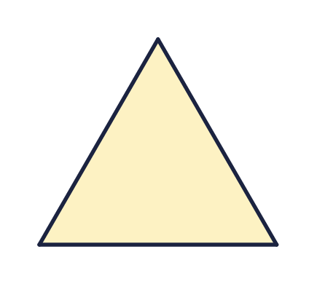  Shape B  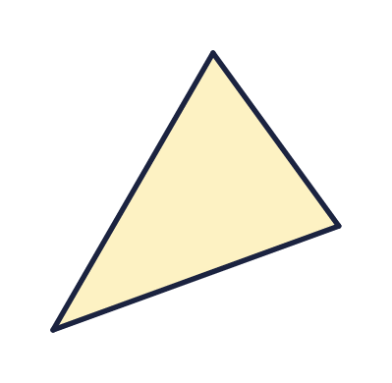  Shape C  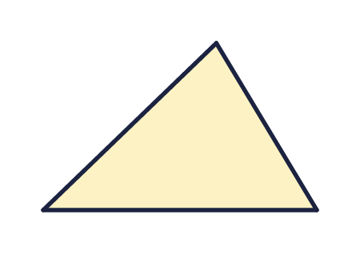  Shape D  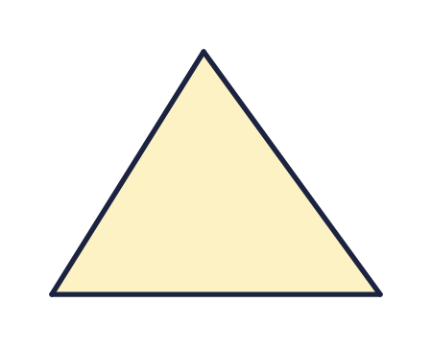
    The regular shape is shape
  1 | One of these triangles is regular. Which one? Write the letter.  Shape A  Shape B  Shape C  Shape D
    The regular shape is shape
  2 | One of these hexagons is regular. Which one? Write the letter.  Shape A  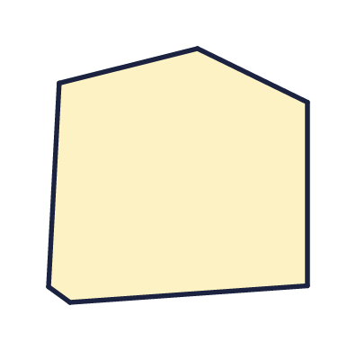  Shape B  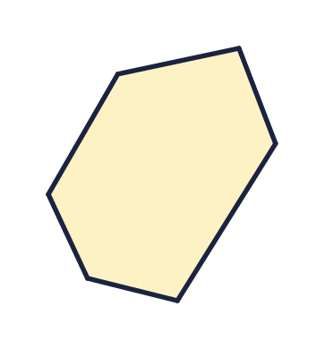  Shape C  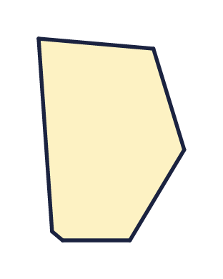  Shape D  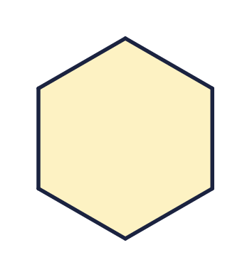
    The regular shape is shape
  2 | One of these hexagons is regular. Which one? Write the letter.  Shape A  Shape B  Shape C  Shape D
    The regular shape is shape
  3 | These are all regular polygons. Write the name of each polygon.  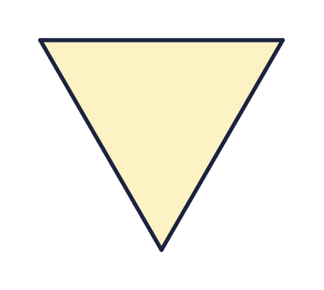  a) Name  b) Name  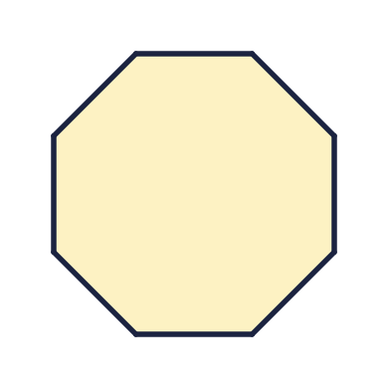  c) Name
  3 | These are all regular polygons. Write the name of each polygon.  a) Name  b) Name  c) Name
  4 | A polygon has 7 straight sides. What is it called?  a) It is a
  4 | A polygon has 7 straight sides. What is it called?  a) It is a
  5 | The marks on the sides show that all the sides are the same length. All the angles are the same size too.  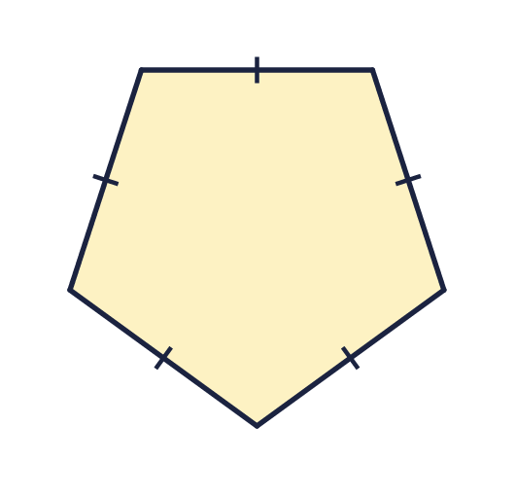  a) Is this polygon regular? Write yes or no.  b) How many sides does it have?
  5 | The marks on the sides show that all the sides are the same length. All the angles are the same size too.  a) Is this polygon regular? Write yes or no.  b) How many sides does it have?
  6 | All four angles of this rectangle are right angles. The sides are not all the same length.  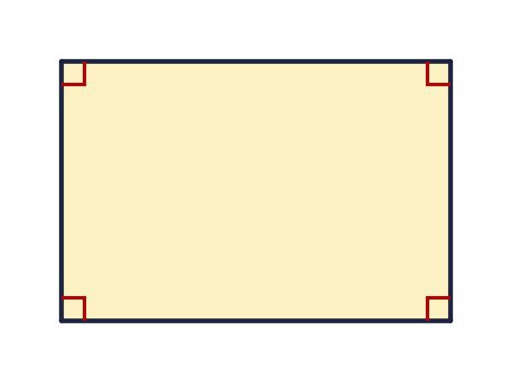  a) Is the rectangle a regular polygon? Write yes or no.
  6 | All four angles of this rectangle are right angles. The sides are not all the same length.  a) Is the rectangle a regular polygon? Write yes or no.
  7 | Look at the four shapes.  Shape A  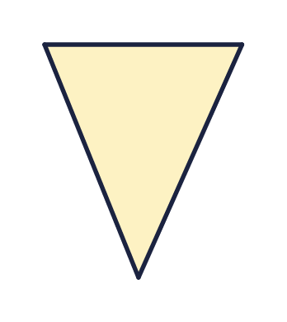  Shape B  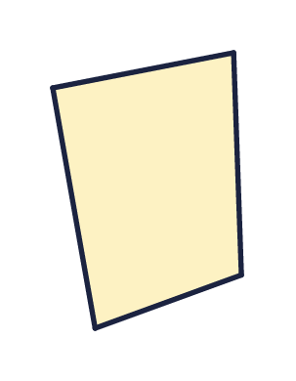  Shape C  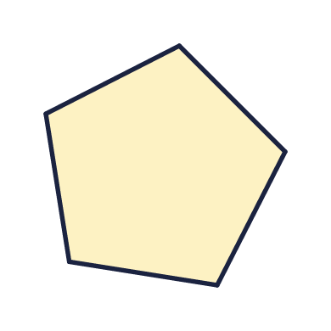  Shape D  a) How many of the shapes are regular?
  7 | Look at the four shapes.  Shape A  Shape B  Shape C  Shape D  a) How many of the shapes are regular?
  8 | A regular pentagon has sides of 8 cm.
    The perimeter is |  | cm
  8 | A regular pentagon has sides of 8 cm.
    The perimeter is |  | cm

  9 | Here is a rhombus. The marks show that all four sides are the same length.  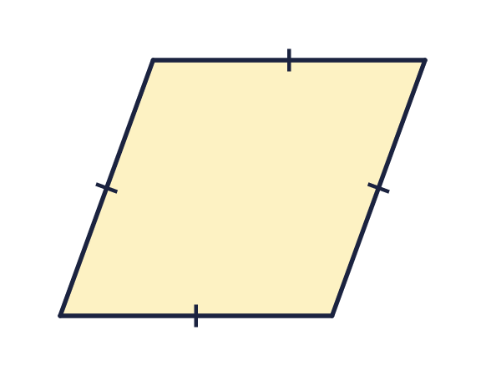  Is Ron correct? Circle yes or no.  Yes / No  Explain how you know.
     | 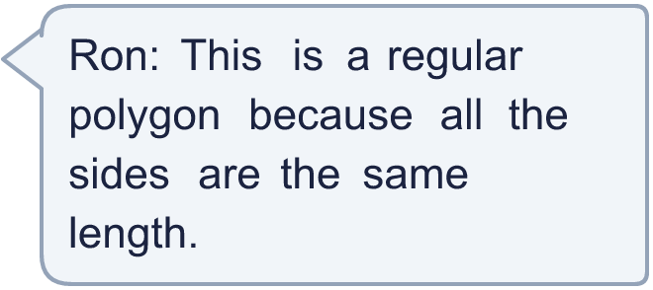
  9 | Here is a rhombus. The marks show that all four sides are the same length.  Is Ron correct? Circle yes or no.  Yes / No  Explain how you know.
  10 | A regular pentagon has sides of 6 cm.  a) What is the perimeter of the polygon (in cm)?
  10 | A regular pentagon has sides of 6 cm.  a) What is the perimeter of the polygon (in cm)?
  11 | Here is a rectangle. All its angles are right angles.  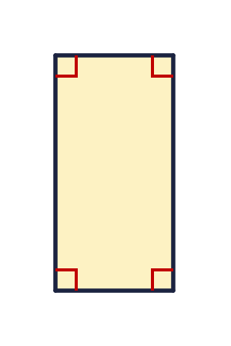  Is Max correct? Circle yes or no.  Yes / No  Explain how you know.
    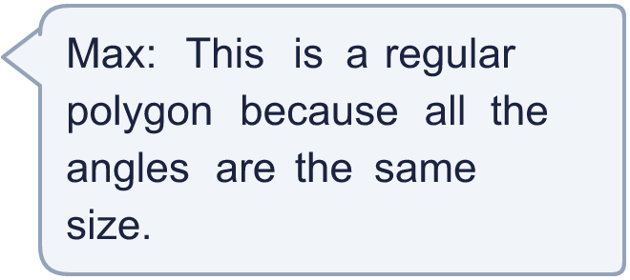
  11 | Here is a rectangle. All its angles are right angles.  Is Max correct? Circle yes or no.  Yes / No  Explain how you know.
  12 | A shape has 8 sides of equal length and 8 equal angles.  a) Is it a regular or an irregular polygon?  b) What is the shape called?
  12 | A shape has 8 sides of equal length and 8 equal angles.  a) Is it a regular or an irregular polygon?  b) What is the shape called?
  13 | Look at the six shapes. Count how many are regular and how many are irregular.  Shape A  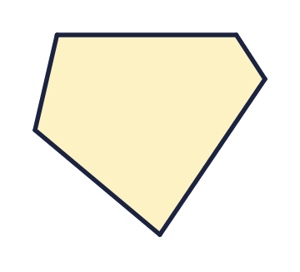  Shape B  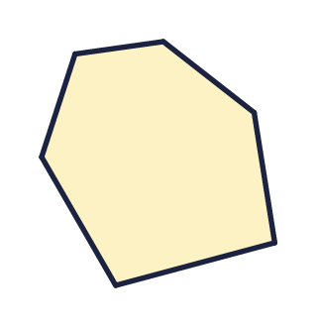  Shape C  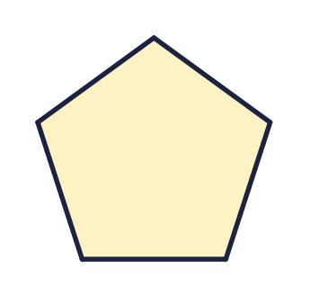  Shape D  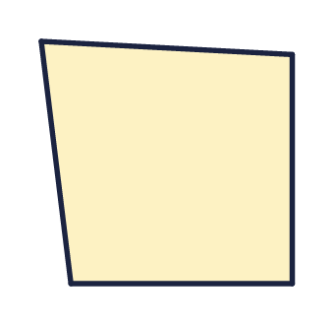  Shape E  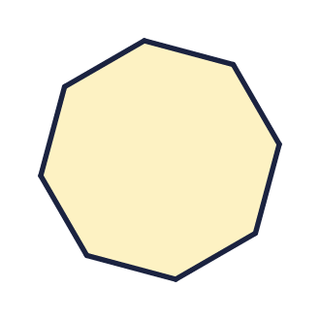  Shape F  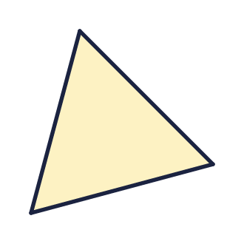  a) Regular shapes  b) Irregular shapes
  13 | Look at the six shapes. Count how many are regular and how many are irregular.  Shape A  Shape B  Shape C  Shape D  Shape E  Shape F  a) Regular shapes  b) Irregular shapes
  14 | Challenge  A regular polygon has a perimeter of 32 cm. Each side is 4 cm long.  a) How many sides does it have?  b) What is the polygon called?
  14 | Challenge  A regular polygon has a perimeter of 32 cm. Each side is 4 cm long.  a) How many sides does it have?  b) What is the polygon called?

Year 4 · Shape · Step 6
Polygons
Answers (teacher copy)

  1 | One of these triangles is regular. Which one? Write the letter.  Shape A  Shape B  Shape C  Shape D  The regular shape is shape A
  2 | One of these hexagons is regular. Which one? Write the letter.  Shape A  Shape B  Shape C  Shape D  The regular shape is shape D
  3 | These are all regular polygons. Write the name of each polygon.  a) Name triangle  b) Name hexagon  c) Name octagon
  4 | A polygon has 7 straight sides. What is it called?  a) It is a heptagon
  5 | The marks on the sides show that all the sides are the same length. All the angles are the same size too.  a) Is this polygon regular? Write yes or no. Yes  b) How many sides does it have? 5
  6 | All four angles of this rectangle are right angles. The sides are not all the same length.  a) Is the rectangle a regular polygon? Write yes or no. No
  7 | Look at the four shapes.  Shape A  Shape B  Shape C  Shape D  a) How many of the shapes are regular? 2
  8 | A regular pentagon has sides of 8 cm.  The perimeter is 40 cm
  9 | Here is a rhombus. The marks show that all four sides are the same length.  Is Ron correct? Circle yes or no.  Yes / No  Explain how you know.  No. A regular polygon needs all its angles to be equal too. The angles of a rhombus are not all the same size, so it is not regular.
  10 | A regular pentagon has sides of 6 cm.  a) What is the perimeter of the polygon (in cm)? 30
  11 | Here is a rectangle. All its angles are right angles.  Is Max correct? Circle yes or no.  Yes / No  Explain how you know.  No. A regular polygon needs all its sides to be equal too. The sides of this rectangle are not all the same length, so it is not regular.
  12 | A shape has 8 sides of equal length and 8 equal angles.  a) Is it a regular or an irregular polygon? regular  b) What is the shape called? octagon
  13 | Look at the six shapes. Count how many are regular and how many are irregular.  Shape A  Shape B  Shape C  Shape D  Shape E  Shape F  a) Regular shapes 3  b) Irregular shapes 3
  14 | Challenge  A regular polygon has a perimeter of 32 cm. Each side is 4 cm long.  a) How many sides does it have? 8  b) What is the polygon called? octagon

