  Year 4 · Shape · Step 7  Lines of symmetry | 
  Year 4 · Shape · Step 7
  Lines of symmetry
  1 | How many lines of symmetry does each shape have?  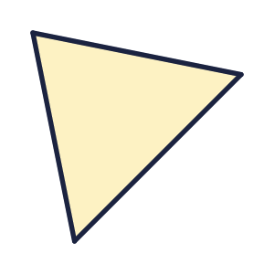  a) Shape A  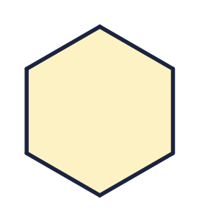  b) Shape B
  1 | How many lines of symmetry does each shape have?  a) Shape A  b) Shape B
  2 | How many lines of symmetry does each shape have? Write 0 if there are none.  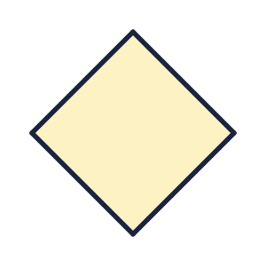  a) Shape A  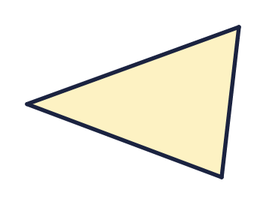  b) Shape B
  2 | How many lines of symmetry does each shape have? Write 0 if there are none.  a) Shape A  b) Shape B
  3 | Which shapes have at least one line of symmetry? Write the letters.  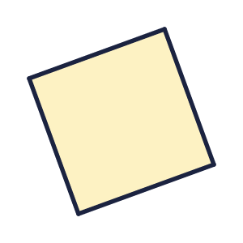    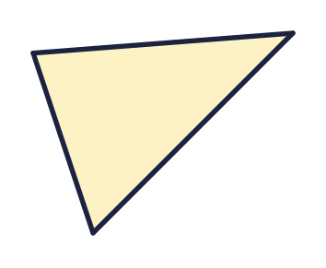  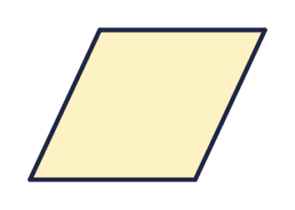
  3 | Which shapes have at least one line of symmetry? Write the letters.
  4 | Which shapes have no lines of symmetry? Write the letters.  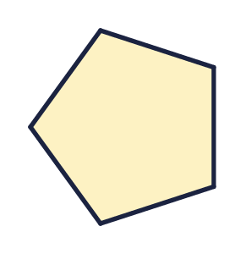  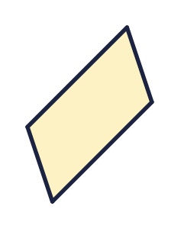  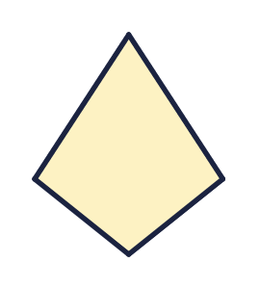  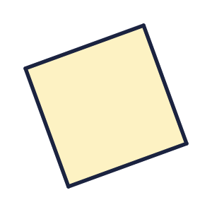
  4 | Which shapes have no lines of symmetry? Write the letters.
  5 | The dashed line is a mirror line. Is it a line of symmetry of the pattern? Write yes or no.  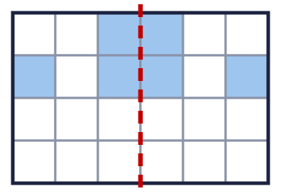
  5 | The dashed line is a mirror line. Is it a line of symmetry of the pattern? Write yes or no.
  6 | Each dashed line is a mirror line. Which patterns are symmetrical? Write the letters.  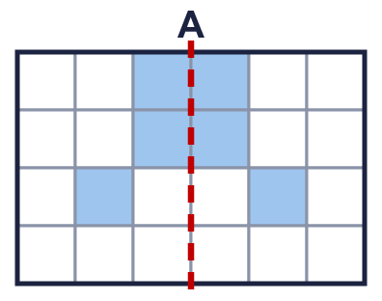  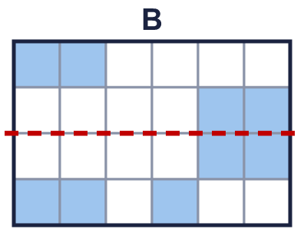  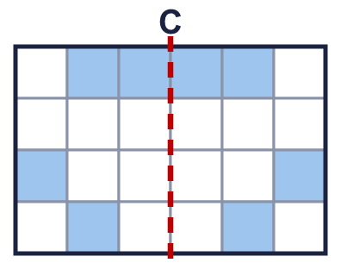
  6 | Each dashed line is a mirror line. Which patterns are symmetrical? Write the letters.
  7 | How many of the four shapes have more than one line of symmetry?  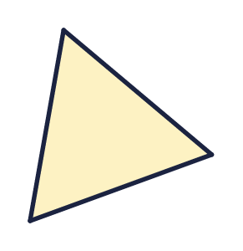  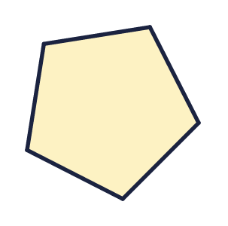  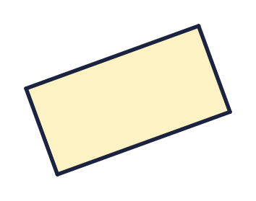  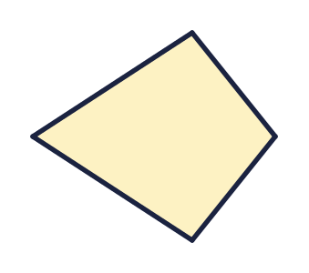  a) Number of shapes
  7 | How many of the four shapes have more than one line of symmetry?  a) Number of shapes
  8 | The dashed line is a mirror line. Is it a line of symmetry of the pattern? Write yes or no.  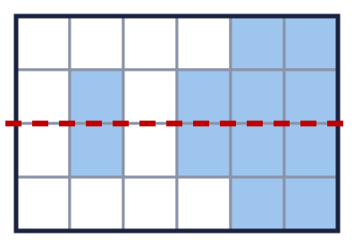
  8 | The dashed line is a mirror line. Is it a line of symmetry of the pattern? Write yes or no.

  9 | Is the statement always true, sometimes true or never true?  A shape with a line of symmetry has two lines of symmetry.  Write always, sometimes or never.
  9 | Is the statement always true, sometimes true or never true?  A shape with a line of symmetry has two lines of symmetry.  Write always, sometimes or never.
  10 | 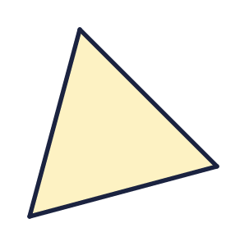  Is Dora correct? Circle yes or no.  Yes / No  Explain how you know.
     | 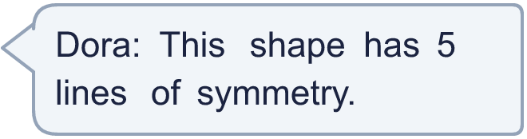
  10 | Is Dora correct? Circle yes or no.  Yes / No  Explain how you know.
  11 | Look at the pattern and the dashed mirror line.  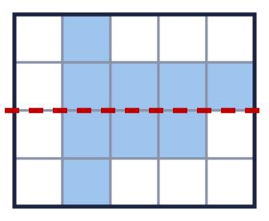  Is the dashed line a line of symmetry? Write yes or no.
  11 | Look at the pattern and the dashed mirror line.  Is the dashed line a line of symmetry? Write yes or no.
  12 | This is a equilateral triangle. How many lines of symmetry does it have?  a) Lines of symmetry
  12 | This is a equilateral triangle. How many lines of symmetry does it have?  a) Lines of symmetry
  13 | Which shapes have more than one line of symmetry? Write the letters.  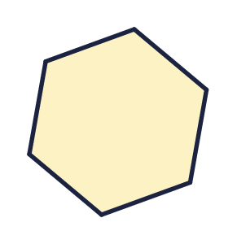  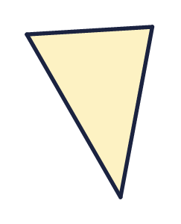  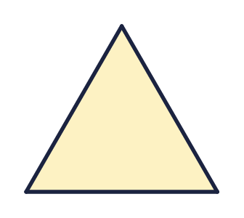
  13 | Which shapes have more than one line of symmetry? Write the letters.
  14 | Challenge  How many lines of symmetry do the two shapes have altogether?  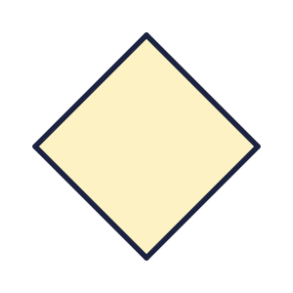  a) Total number of lines of symmetry
  14 | Challenge  How many lines of symmetry do the two shapes have altogether?  a) Total number of lines of symmetry

Year 4 · Shape · Step 7
Lines of symmetry
Answers (teacher copy)

  1 | How many lines of symmetry does each shape have?  a) Shape A 1  b) Shape B 6
  2 | How many lines of symmetry does each shape have? Write 0 if there are none.  a) Shape A 4  b) Shape B 0
  3 | Which shapes have at least one line of symmetry? Write the letters.  A, B, D
  4 | Which shapes have no lines of symmetry? Write the letters.  B
  5 | The dashed line is a mirror line. Is it a line of symmetry of the pattern? Write yes or no.  Yes
  6 | Each dashed line is a mirror line. Which patterns are symmetrical? Write the letters.  A, C
  7 | How many of the four shapes have more than one line of symmetry?  a) Number of shapes 3
  8 | The dashed line is a mirror line. Is it a line of symmetry of the pattern? Write yes or no.  Yes
  9 | Is the statement always true, sometimes true or never true?  A shape with a line of symmetry has two lines of symmetry.  Write always, sometimes or never. sometimes
  10 | Is Dora correct? Circle yes or no.  Yes / No  Explain how you know.  No. The shape has 3 lines of symmetry. Fold it along a line and both halves match.
  11 | Look at the pattern and the dashed mirror line.  Is the dashed line a line of symmetry? Write yes or no.  No
  12 | This is a equilateral triangle. How many lines of symmetry does it have?  a) Lines of symmetry 3
  13 | Which shapes have more than one line of symmetry? Write the letters.  A, B, D
  14 | Challenge  How many lines of symmetry do the two shapes have altogether?  a) Total number of lines of symmetry 10

