  Year 4 · Shape · Step 2  Identify angles | 
  Year 4 · Shape · Step 2
  Identify angles
  1 | Look at the four angles. Write whether each angle is acute, obtuse or right.  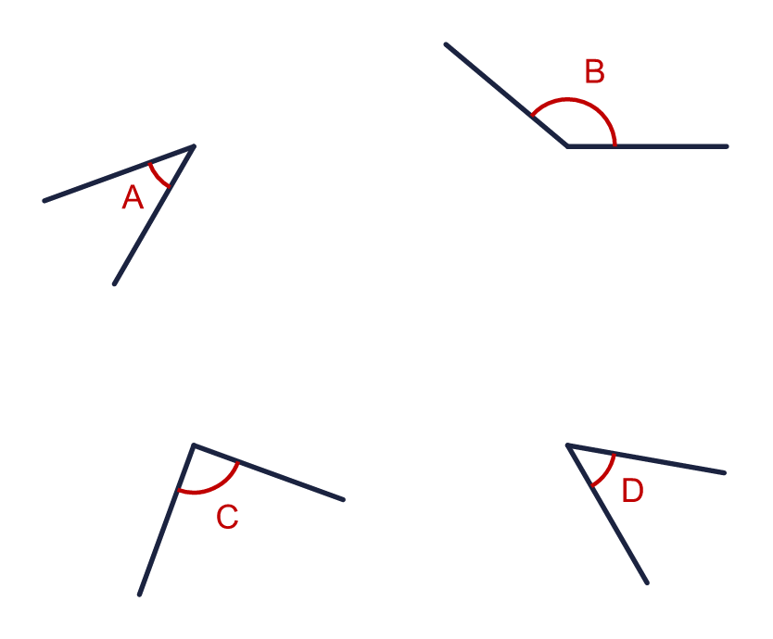  a) Angle A  b) Angle B  c) Angle C  d) Angle D
  1 | Look at the four angles. Write whether each angle is acute, obtuse or right.  a) Angle A  b) Angle B  c) Angle C  d) Angle D
  2 | Complete the sentences. Write quarter or half.  a) A right angle is the same as a ___ turn:  b) An acute angle is less than a ___ turn:  c) An obtuse angle is less than a ___ turn:
  2 | Complete the sentences. Write quarter or half.  a) A right angle is the same as a ___ turn:  b) An acute angle is less than a ___ turn:  c) An obtuse angle is less than a ___ turn:
  3 | Look at the six angles.  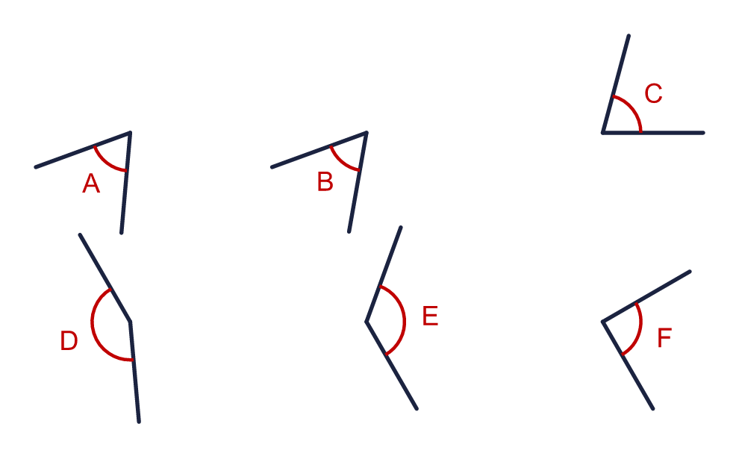  Which angles are acute? Write the letters.
  3 | Look at the six angles.  Which angles are acute? Write the letters.
  4 | Look at the six angles.  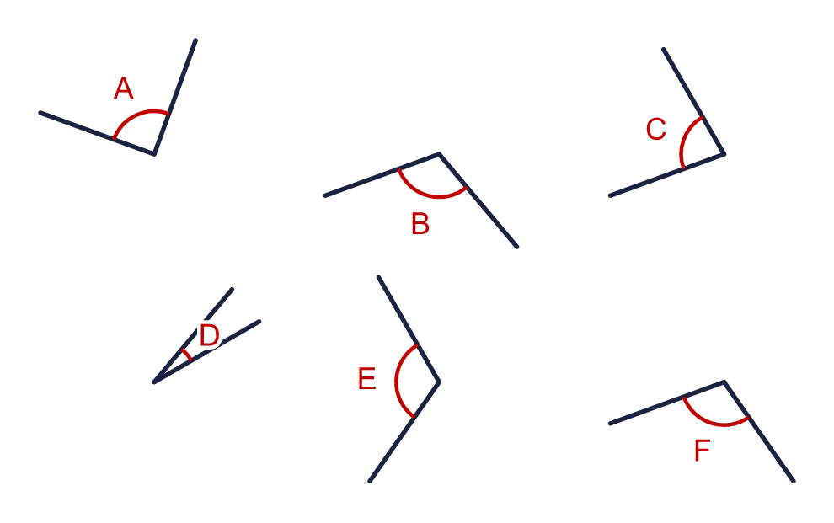  Which angles are obtuse? Write the letters.
  4 | Look at the six angles.  Which angles are obtuse? Write the letters.
  5 | Here are six angles. None of them is a right angle.  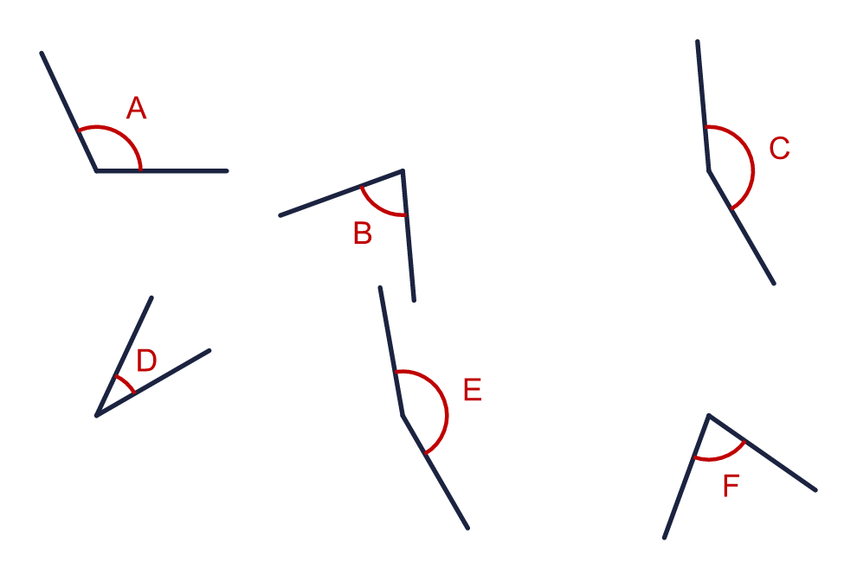  a) How many are less than a right angle?  b) How many are greater than a right angle?
  5 | Here are six angles. None of them is a right angle.  a) How many are less than a right angle?  b) How many are greater than a right angle?
  6 | The right angles are marked with squares.  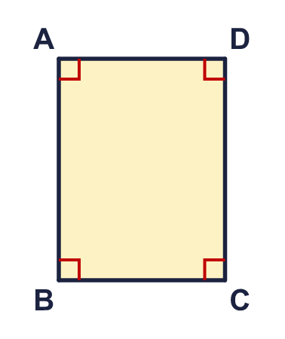  a) How many right angles does the shape have?
  6 | The right angles are marked with squares.  a) How many right angles does the shape have?
  7 | Look at the four angles.  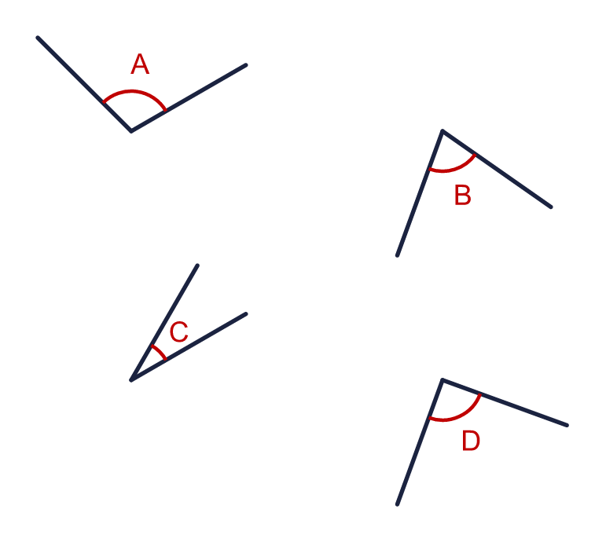  Which angle is a right angle? Write the letter.
  7 | Look at the four angles.  Which angle is a right angle? Write the letter.
  8 | Look at the shape.  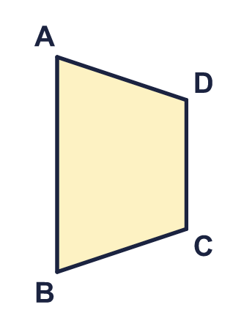  a) How many acute angles does it have?  b) How many obtuse angles does it have?
  8 | Look at the shape.  a) How many acute angles does it have?  b) How many obtuse angles does it have?

  9 | Sam has drawn the angle a.  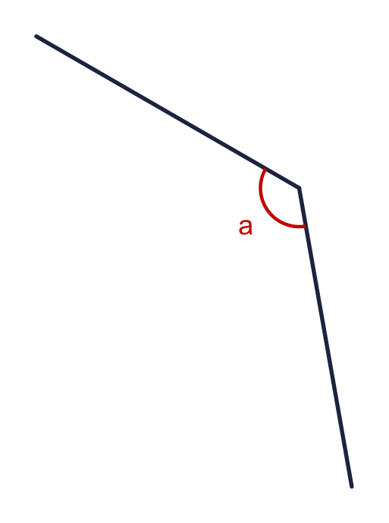  Is Sam correct? Circle yes or no.  Yes / No  Explain how you know.
     | 
  9 | Sam has drawn the angle a.  Is Sam correct? Circle yes or no.  Yes / No  Explain how you know.
  10 | Is the statement always true, sometimes true or never true?  An obtuse angle is a greater turn than an acute angle.  Write always, sometimes or never.
  10 | Is the statement always true, sometimes true or never true?  An obtuse angle is a greater turn than an acute angle.  Write always, sometimes or never.
  11 | The right angles are marked with squares.  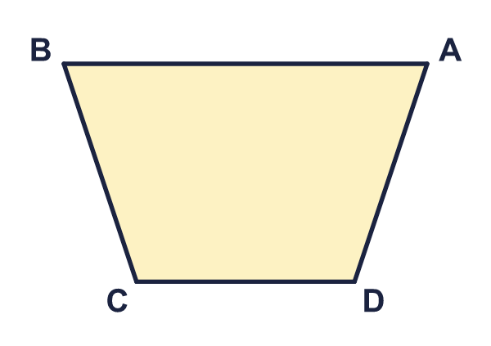  a) How many angles are not right angles?
  11 | The right angles are marked with squares.  a) How many angles are not right angles?
  12 | Look at the six angles.  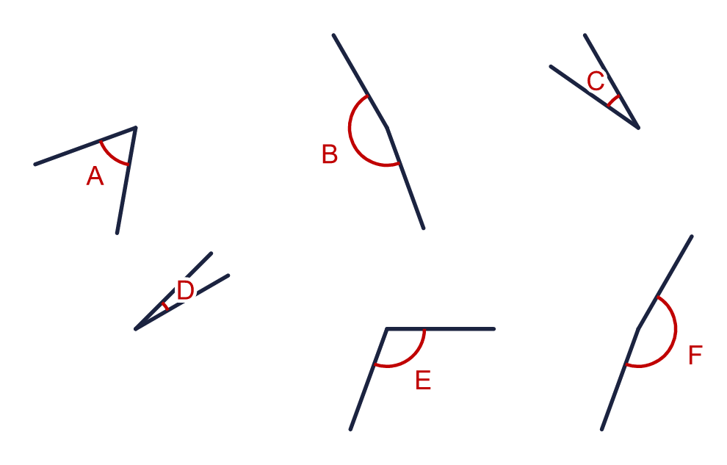  a) How many obtuse angles are there?  b) How many acute angles are there?
  12 | Look at the six angles.  a) How many obtuse angles are there?  b) How many acute angles are there?
  13 | Is the statement always true, sometimes true or never true?  A polygon has a right angle.  Write always, sometimes or never.
  13 | Is the statement always true, sometimes true or never true?  A polygon has a right angle.  Write always, sometimes or never.
  14 | Challenge  Here are six angles. Two of them are right angles.  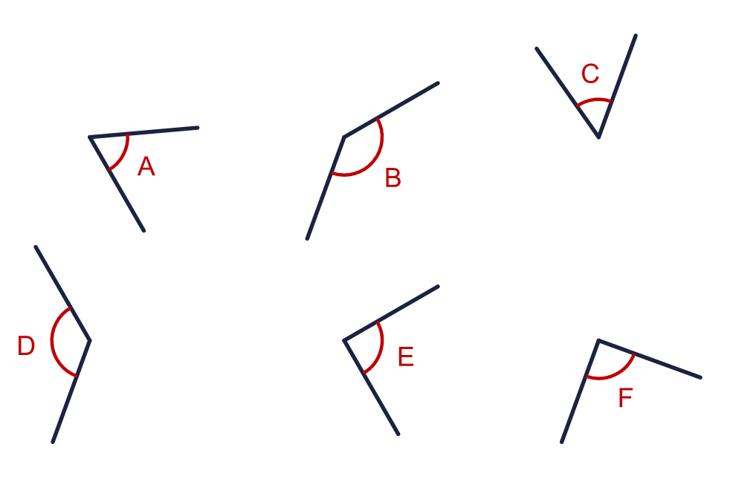  Write the letters of the two right angles.
  14 | Challenge  Here are six angles. Two of them are right angles.  Write the letters of the two right angles.

Year 4 · Shape · Step 2
Identify angles
Answers (teacher copy)

  1 | Look at the four angles. Write whether each angle is acute, obtuse or right.  a) Angle A acute  b) Angle B obtuse  c) Angle C right  d) Angle D acute
  2 | Complete the sentences. Write quarter or half.  a) A right angle is the same as a ___ turn: quarter  b) An acute angle is less than a ___ turn: quarter  c) An obtuse angle is less than a ___ turn: half
  3 | Look at the six angles.  Which angles are acute? Write the letters. A, B, C
  4 | Look at the six angles.  Which angles are obtuse? Write the letters. B, E, F
  5 | Here are six angles. None of them is a right angle.  a) How many are less than a right angle? 3  b) How many are greater than a right angle? 3
  6 | The right angles are marked with squares.  a) How many right angles does the shape have? 4
  7 | Look at the four angles.  Which angle is a right angle? Write the letter. D
  8 | Look at the shape.  a) How many acute angles does it have? 2  b) How many obtuse angles does it have? 2
  9 | Sam has drawn the angle a.  Is Sam correct? Circle yes or no.  Yes / No  Explain how you know.  Yes. Angle a is greater than a right angle, so it is obtuse.
  10 | Is the statement always true, sometimes true or never true?  An obtuse angle is a greater turn than an acute angle.  Write always, sometimes or never. always
  11 | The right angles are marked with squares.  a) How many angles are not right angles? 4
  12 | Look at the six angles.  a) How many obtuse angles are there? 3  b) How many acute angles are there? 3
  13 | Is the statement always true, sometimes true or never true?  A polygon has a right angle.  Write always, sometimes or never. sometimes
  14 | Challenge  Here are six angles. Two of them are right angles.  Write the letters of the two right angles. E, F

