  Year 4 · Shape · Step 8  Complete a symmetric figure | 
  Year 4 · Shape · Step 8
  Complete a symmetric figure
  1 | Shade squares to make the pattern symmetrical about the dashed line. Shade the squares in your book.  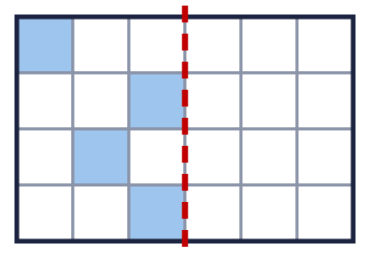  a) How many more squares do you shade?
  1 | Shade squares to make the pattern symmetrical about the dashed line. Shade the squares in your book.  a) How many more squares do you shade?
  2 | Shade squares to make the pattern symmetrical about the dashed line. Shade the squares in your book.  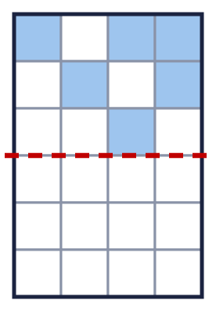  a) How many more squares do you shade?
  2 | Shade squares to make the pattern symmetrical about the dashed line. Shade the squares in your book.  a) How many more squares do you shade?
  3 | Shade squares to make the pattern symmetrical about the dashed line. Shade the squares in your book.  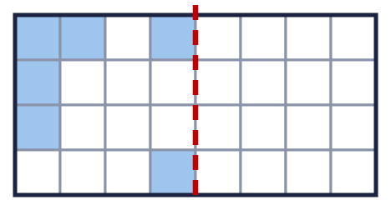  a) How many more squares do you shade?
  3 | Shade squares to make the pattern symmetrical about the dashed line. Shade the squares in your book.  a) How many more squares do you shade?
  4 | Complete the pattern so that it is symmetrical about the dashed line. Shade the squares in your book.  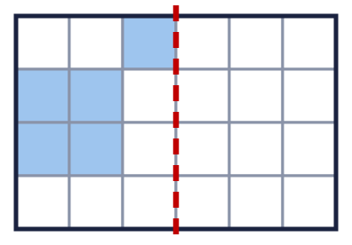  a) How many squares are shaded when the pattern is finished?
  4 | Complete the pattern so that it is symmetrical about the dashed line. Shade the squares in your book.  a) How many squares are shaded when the pattern is finished?
  5 | Shade squares to make the pattern symmetrical about the dashed line. Shade the squares in your book.  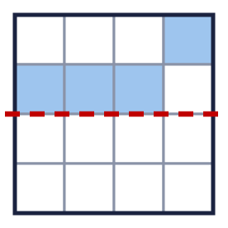  a) How many more squares do you shade?
  5 | Shade squares to make the pattern symmetrical about the dashed line. Shade the squares in your book.  a) How many more squares do you shade?
  6 | Is the pattern symmetrical about the dashed line? Write yes or no.  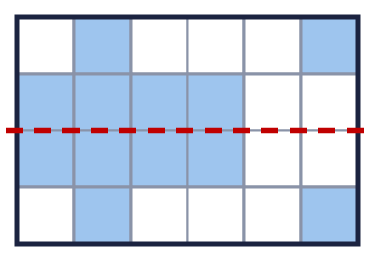
  6 | Is the pattern symmetrical about the dashed line? Write yes or no.
  7 | Which patterns are symmetrical about the dashed line? Write the letters.  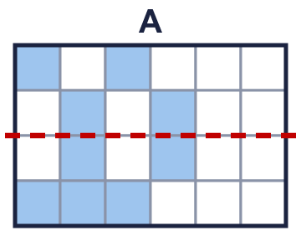  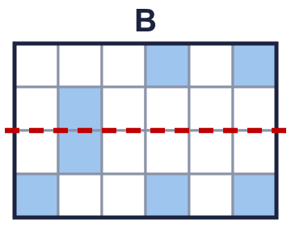  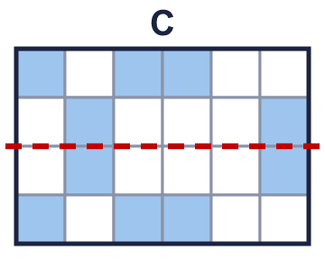
  7 | Which patterns are symmetrical about the dashed line? Write the letters.
  8 | Shade squares to make the pattern symmetrical about the dashed line. Shade the squares in your book.  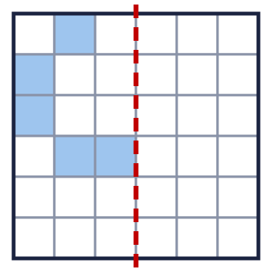  a) How many more squares do you shade?
  8 | Shade squares to make the pattern symmetrical about the dashed line. Shade the squares in your book.  a) How many more squares do you shade?

  9 | 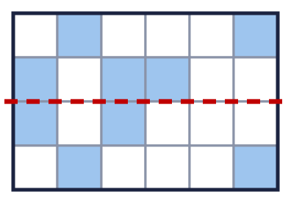  Is Ron correct? Circle yes or no.  Yes / No  Explain how you know.
     | 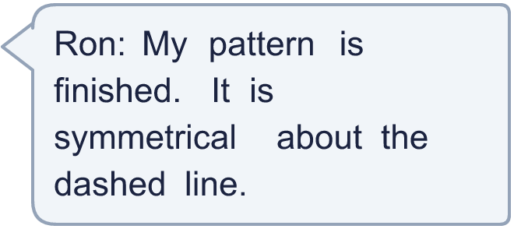
  9 | Is Ron correct? Circle yes or no.  Yes / No  Explain how you know.
  10 | Complete the pattern so that it is symmetrical about the dashed line. Shade the squares in your book.  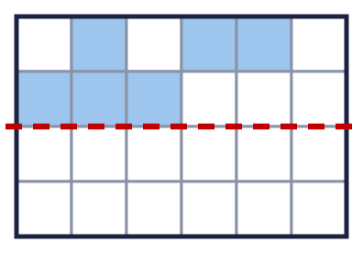  a) How many squares are shaded when the pattern is finished?
  10 | Complete the pattern so that it is symmetrical about the dashed line. Shade the squares in your book.  a) How many squares are shaded when the pattern is finished?
  11 | Complete the pattern so that it is symmetrical about the dashed line. Shade the squares in your book.  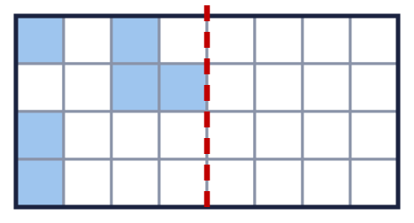  a) How many squares are shaded when the pattern is finished?
  11 | Complete the pattern so that it is symmetrical about the dashed line. Shade the squares in your book.  a) How many squares are shaded when the pattern is finished?
  12 | Which patterns are symmetrical about the dashed line? Write the letters.  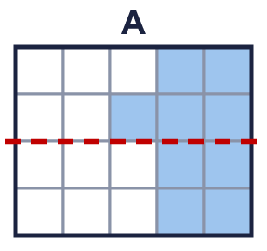  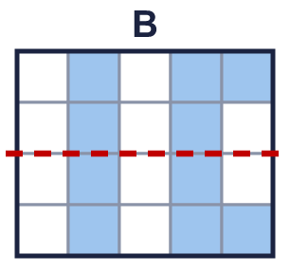  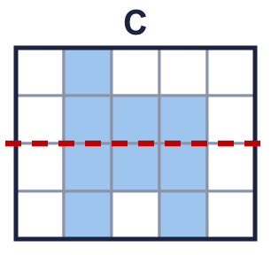  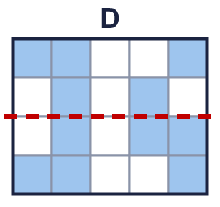
  12 | Which patterns are symmetrical about the dashed line? Write the letters.
  13 | Shade squares to make the pattern symmetrical about the dashed line. Shade the squares in your book.  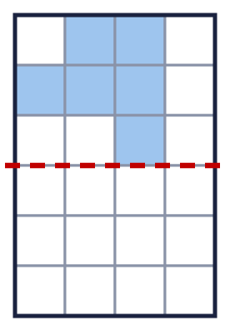  a) How many more squares do you shade?
  13 | Shade squares to make the pattern symmetrical about the dashed line. Shade the squares in your book.  a) How many more squares do you shade?
  14 | Challenge  Tia needs to shade 9 more squares to make the pattern symmetrical about the dashed line.  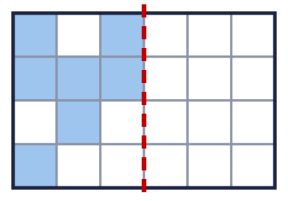  a) How many more squares does Tia need to shade?
  14 | Challenge  Tia needs to shade 9 more squares to make the pattern symmetrical about the dashed line.  a) How many more squares does Tia need to shade?

Year 4 · Shape · Step 8
Complete a symmetric figure
Answers (teacher copy)

  1 | Shade squares to make the pattern symmetrical about the dashed line. Shade the squares in your book.  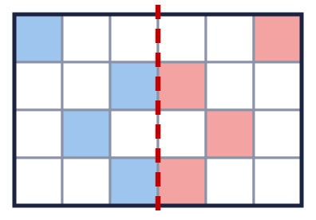  a) How many more squares do you shade? 4
  2 | Shade squares to make the pattern symmetrical about the dashed line. Shade the squares in your book.  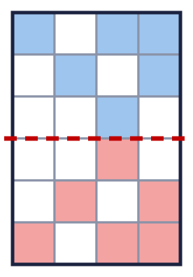  a) How many more squares do you shade? 6
  3 | Shade squares to make the pattern symmetrical about the dashed line. Shade the squares in your book.  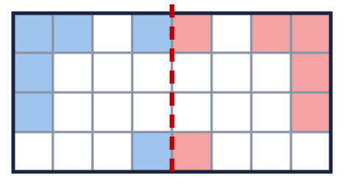  a) How many more squares do you shade? 6
  4 | Complete the pattern so that it is symmetrical about the dashed line. Shade the squares in your book.  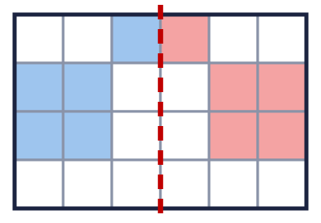  a) How many squares are shaded when the pattern is finished? 10
  5 | Shade squares to make the pattern symmetrical about the dashed line. Shade the squares in your book.  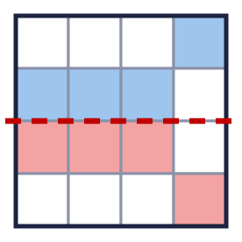  a) How many more squares do you shade? 4
  6 | Is the pattern symmetrical about the dashed line? Write yes or no.  Yes
  7 | Which patterns are symmetrical about the dashed line? Write the letters.  C
  8 | Shade squares to make the pattern symmetrical about the dashed line. Shade the squares in your book.  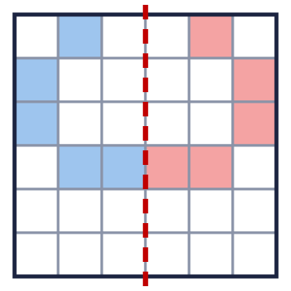  a) How many more squares do you shade? 5
  9 | Is Ron correct? Circle yes or no.  Yes / No  Explain how you know.  No. One shaded square does not have a matching square on the other side of the dashed line.
  10 | Complete the pattern so that it is symmetrical about the dashed line. Shade the squares in your book.  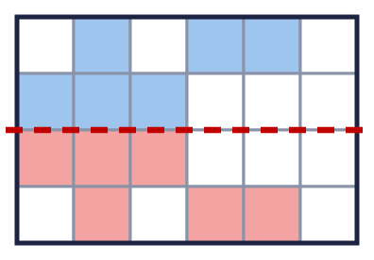  a) How many squares are shaded when the pattern is finished? 12
  11 | Complete the pattern so that it is symmetrical about the dashed line. Shade the squares in your book.  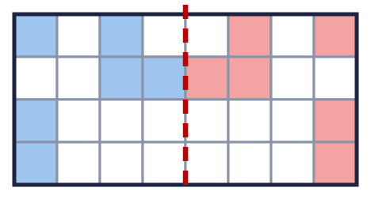  a) How many squares are shaded when the pattern is finished? 12
  12 | Which patterns are symmetrical about the dashed line? Write the letters.  B
  13 | Shade squares to make the pattern symmetrical about the dashed line. Shade the squares in your book.  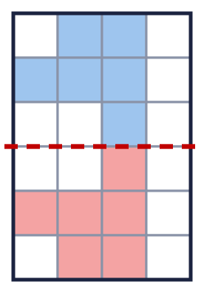  a) How many more squares do you shade? 6
  14 | Challenge  Tia needs to shade 9 more squares to make the pattern symmetrical about the dashed line.  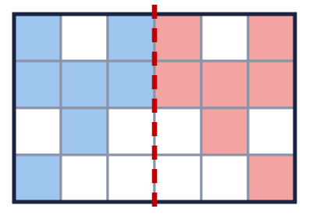  a) How many more squares does Tia need to shade? 7

