  Year 4 · Position and direction · Step 2  Plot coordinates | 
  Year 4 · Position and direction · Step 2
  Plot coordinates
  1 | Plot these points on a coordinate grid in your book. Use the same scale as the grid shown. A (5, 6), B (9, 4), C (2, 3), D (4, 1).  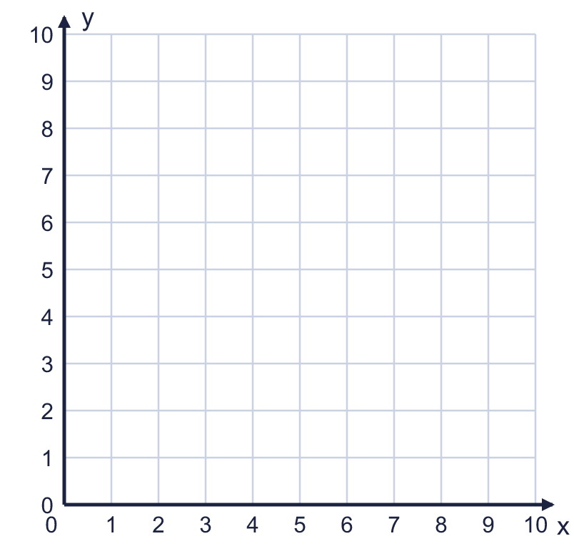  a) Which point is the closest to the x-axis? Write the letter.  b) Which point is the furthest from the y-axis? Write the letter.
  1 | Plot these points on a coordinate grid in your book. Use the same scale as the grid shown. A (5, 6), B (9, 4), C (2, 3), D (4, 1).  a) Which point is the closest to the x-axis? Write the letter.  b) Which point is the furthest from the y-axis? Write the letter.
  2 | Plot these points on a coordinate grid in your book. E (4, 8), F (8, 9), G (3, 5), H (7, 2).  a) Which point is the highest? Write the letter.  b) Which point is the furthest to the left? Write the letter.
  2 | Plot these points on a coordinate grid in your book. E (4, 8), F (8, 9), G (3, 5), H (7, 2).  a) Which point is the highest? Write the letter.  b) Which point is the furthest to the left? Write the letter.
  3 | Plot the points G (0, 5), H (8, 0) on a coordinate grid in your book.  a) Point G is on which axis? Write the x-axis or the y-axis.  b) Point H is on which axis? Write the x-axis or the y-axis.
  3 | Plot the points G (0, 5), H (8, 0) on a coordinate grid in your book.  a) Point G is on which axis? Write the x-axis or the y-axis.  b) Point H is on which axis? Write the x-axis or the y-axis.
  4 | Plot the points X (1, 3), Y (6, 3), Z (8, 3) on a coordinate grid in your book. Join them with a ruler.  a) Is the line horizontal or vertical?  b) Which number is the same in all three points?
  4 | Plot the points X (1, 3), Y (6, 3), Z (8, 3) on a coordinate grid in your book. Join them with a ruler.  a) Is the line horizontal or vertical?  b) Which number is the same in all three points?
  5 | Plot the point A (2, 7) and the point B (7, 2) on a coordinate grid in your book.  a) Which point is higher? Write the letter.  b) Which point is further to the right? Write the letter.
  5 | Plot the point A (2, 7) and the point B (7, 2) on a coordinate grid in your book.  a) Which point is higher? Write the letter.  b) Which point is further to the right? Write the letter.
  6 | Plot the points A (6, 1), B (6, 5), C (1, 5) on a coordinate grid in your book. They are three corners of a rectangle with sides parallel to the axes.
    Write the coordinates of the fourth corner, D.
  6 | Plot the points A (6, 1), B (6, 5), C (1, 5) on a coordinate grid in your book. They are three corners of a rectangle with sides parallel to the axes.
    Write the coordinates of the fourth corner, D.
  7 | The points (3, 3), (4, 5), (5, 7) make a pattern.
    Write the coordinates of the next point.
  7 | The points (3, 3), (4, 5), (5, 7) make a pattern.
    Write the coordinates of the next point.
  8 | Eva plots the point (7, 7). Eva starts at (0, 0), goes along the x-axis to (7, 0) and then goes up.  a) How many squares does Eva go along from (0, 0) to (7, 0)?  b) How many squares does Eva go up from (7, 0) to (7, 7)?
  8 | Eva plots the point (7, 7). Eva starts at (0, 0), goes along the x-axis to (7, 0) and then goes up.  a) How many squares does Eva go along from (0, 0) to (7, 0)?  b) How many squares does Eva go up from (7, 0) to (7, 7)?

  9 | The point P is plotted on the coordinate grid.  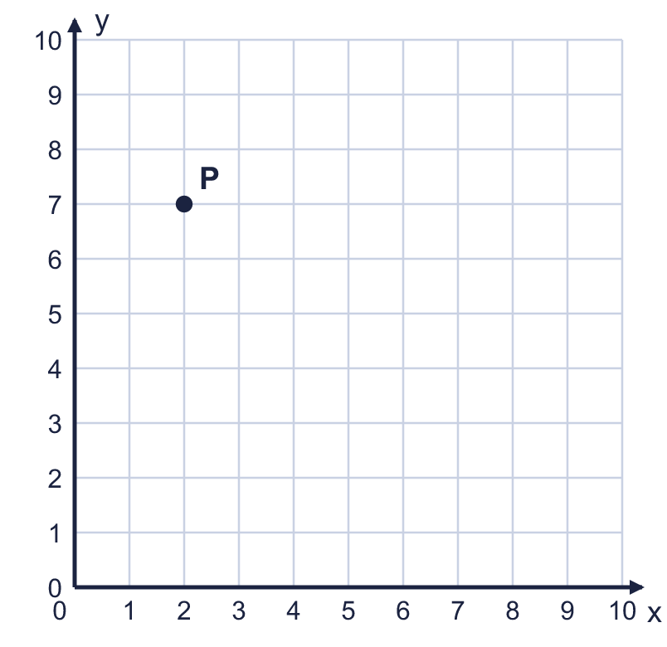  Is Tiny correct? Circle yes or no.  Yes / No  Explain how you know.
     | 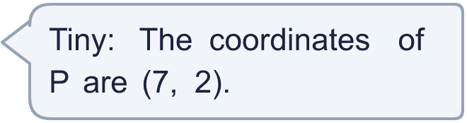
  9 | The point P is plotted on the coordinate grid.  Is Tiny correct? Circle yes or no.  Yes / No  Explain how you know.
  10 | The points (2, 2), (5, 5), (8, 8) make a pattern.
    Write the coordinates of the next two points.
  10 | The points (2, 2), (5, 5), (8, 8) make a pattern.
    Write the coordinates of the next two points.
  11 | The points (8, 3) and (8, 8) are joined with a straight line.  a) Is the line horizontal or vertical?  b) How many squares long is the line?
  11 | The points (8, 3) and (8, 8) are joined with a straight line.  a) Is the line horizontal or vertical?  b) How many squares long is the line?
  12 | Two corners of a square are at (6, 1) and (9, 1). The other two corners are above these two corners.  Write the coordinates of the other two corners.
  12 | Two corners of a square are at (6, 1) and (9, 1). The other two corners are above these two corners.  Write the coordinates of the other two corners.
  13 | I am thinking of a point on a coordinate grid. Both of its coordinates are whole numbers from 0 to 10.  • The y-coordinate is an even number.  • The x-coordinate is greater than 8.  • The coordinates add up to 11.  What are the coordinates of my point?
  13 | I am thinking of a point on a coordinate grid. Both of its coordinates are whole numbers from 0 to 10.  • The y-coordinate is an even number.  • The x-coordinate is greater than 8.  • The coordinates add up to 11.  What are the coordinates of my point?
  14 | Challenge  Plot the points M (6, 0), N (0, 8) on a coordinate grid in your book.  a) Which point is on the x-axis? Write the letter.  b) Which point is on the y-axis? Write the letter.
  14 | Challenge  Plot the points M (6, 0), N (0, 8) on a coordinate grid in your book.  a) Which point is on the x-axis? Write the letter.  b) Which point is on the y-axis? Write the letter.

Year 4 · Position and direction · Step 2
Plot coordinates
Answers (teacher copy)

  1 | Plot these points on a coordinate grid in your book. Use the same scale as the grid shown. A (5, 6), B (9, 4), C (2, 3), D (4, 1).  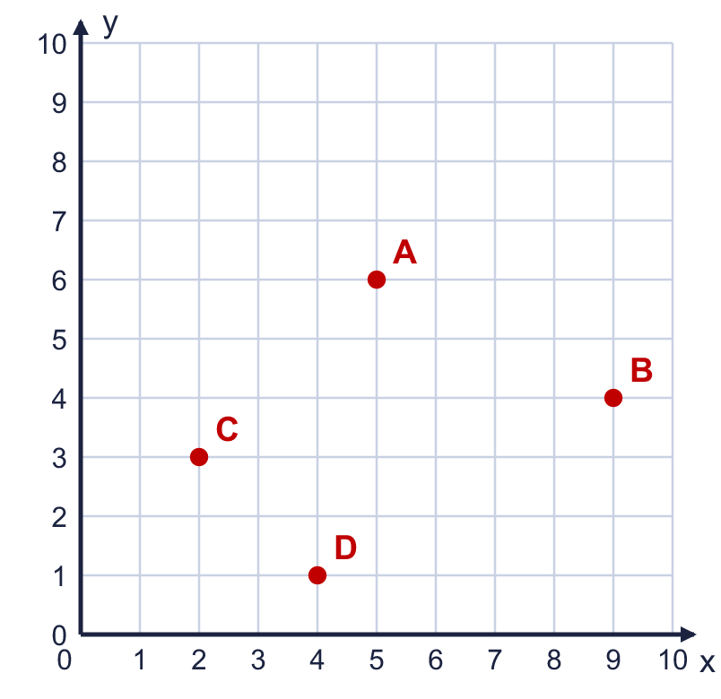  a) Which point is the closest to the x-axis? Write the letter. D  b) Which point is the furthest from the y-axis? Write the letter. B
  2 | Plot these points on a coordinate grid in your book. E (4, 8), F (8, 9), G (3, 5), H (7, 2).  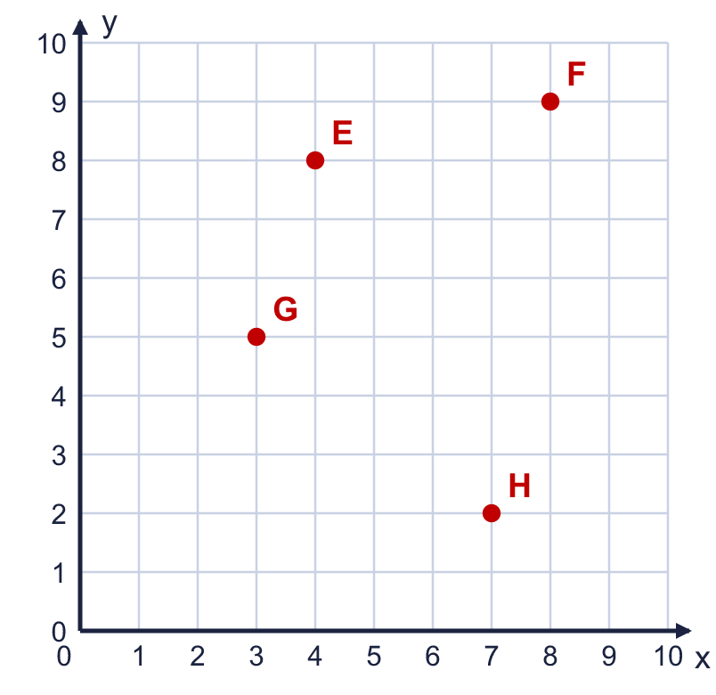  a) Which point is the highest? Write the letter. F  b) Which point is the furthest to the left? Write the letter. G
  3 | Plot the points G (0, 5), H (8, 0) on a coordinate grid in your book.  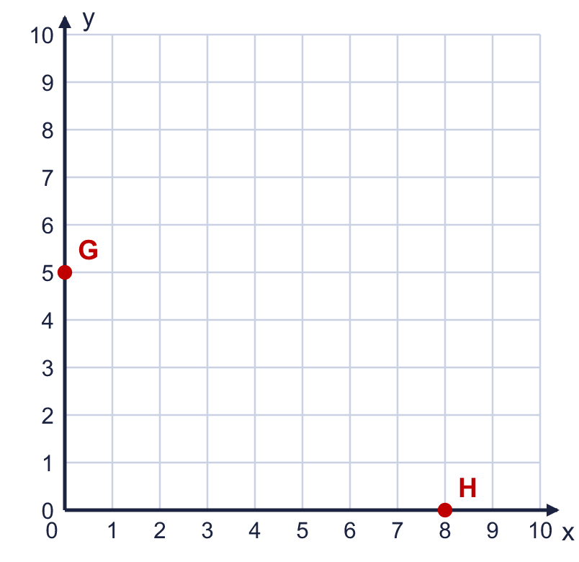  a) Point G is on which axis? Write the x-axis or the y-axis. y-axis  b) Point H is on which axis? Write the x-axis or the y-axis. x-axis
  4 | Plot the points X (1, 3), Y (6, 3), Z (8, 3) on a coordinate grid in your book. Join them with a ruler.  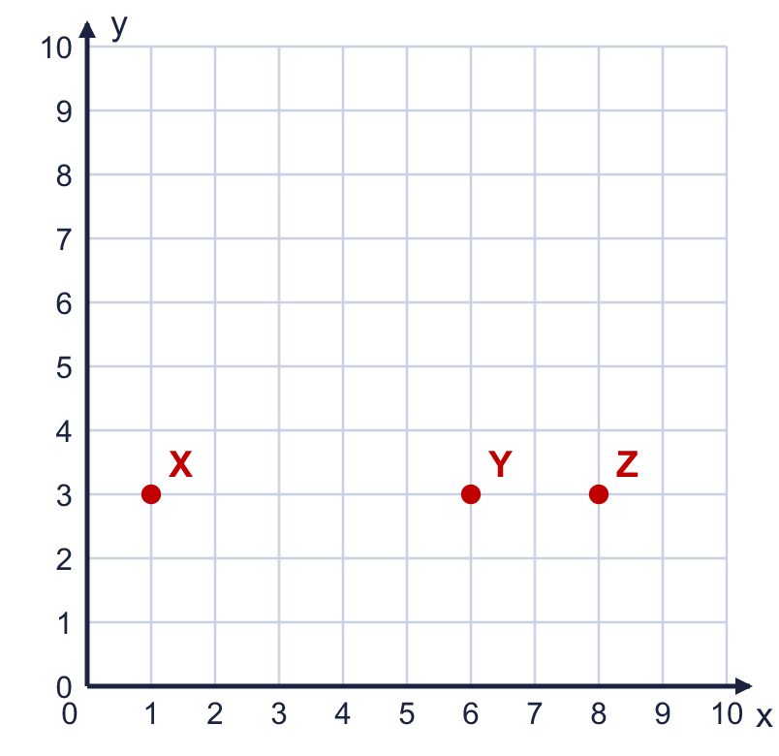  a) Is the line horizontal or vertical? horizontal  b) Which number is the same in all three points? 3
  5 | Plot the point A (2, 7) and the point B (7, 2) on a coordinate grid in your book.  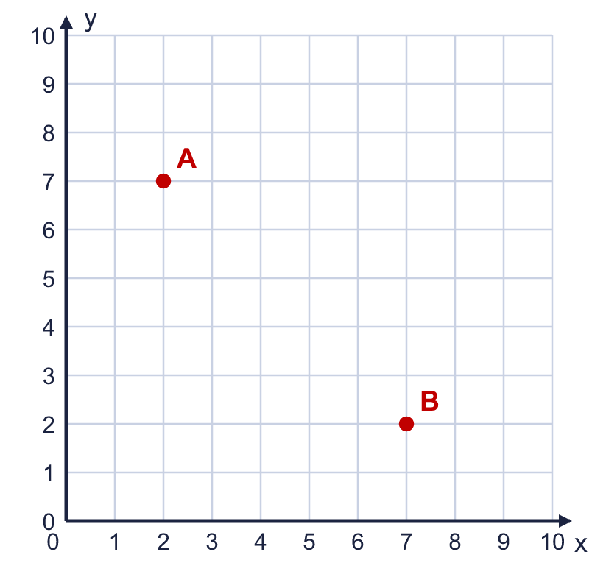  a) Which point is higher? Write the letter. A  b) Which point is further to the right? Write the letter. B
  6 | Plot the points A (6, 1), B (6, 5), C (1, 5) on a coordinate grid in your book. They are three corners of a rectangle with sides parallel to the axes.  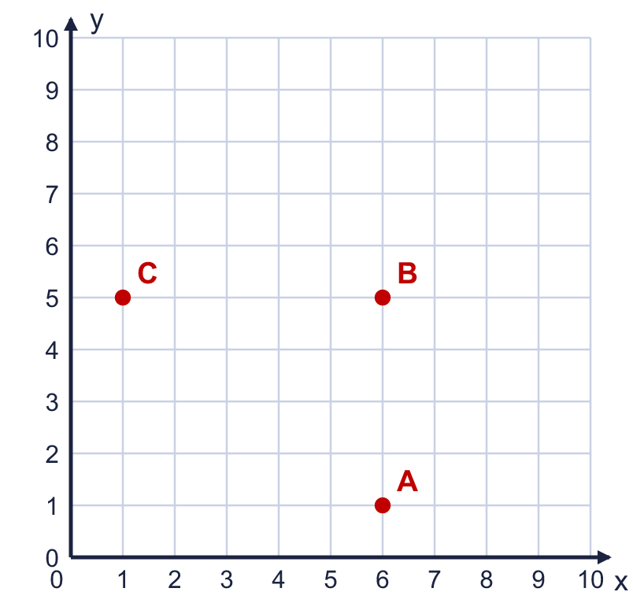  Write the coordinates of the fourth corner, D. (1, 1)
  7 | The points (3, 3), (4, 5), (5, 7) make a pattern.  Write the coordinates of the next point. (6, 9)
  8 | Eva plots the point (7, 7). Eva starts at (0, 0), goes along the x-axis to (7, 0) and then goes up.  a) How many squares does Eva go along from (0, 0) to (7, 0)? 7  b) How many squares does Eva go up from (7, 0) to (7, 7)? 7
  9 | The point P is plotted on the coordinate grid.  Is Tiny correct? Circle yes or no.  Yes / No  Explain how you know.  No. The x-coordinate (across) is written first. P is 2 squares across and 7 squares up, so it is at (2, 7), not (7, 2).
  10 | The points (2, 2), (5, 5), (8, 8) make a pattern.  Write the coordinates of the next two points. (11, 11) and (14, 14)
  11 | The points (8, 3) and (8, 8) are joined with a straight line.  a) Is the line horizontal or vertical? vertical  b) How many squares long is the line? 5
  12 | Two corners of a square are at (6, 1) and (9, 1). The other two corners are above these two corners.  Write the coordinates of the other two corners. (6, 4) and (9, 4)
  13 | I am thinking of a point on a coordinate grid. Both of its coordinates are whole numbers from 0 to 10.  • The y-coordinate is an even number.  • The x-coordinate is greater than 8.  • The coordinates add up to 11.  What are the coordinates of my point? (9, 2)
  14 | Challenge  Plot the points M (6, 0), N (0, 8) on a coordinate grid in your book.  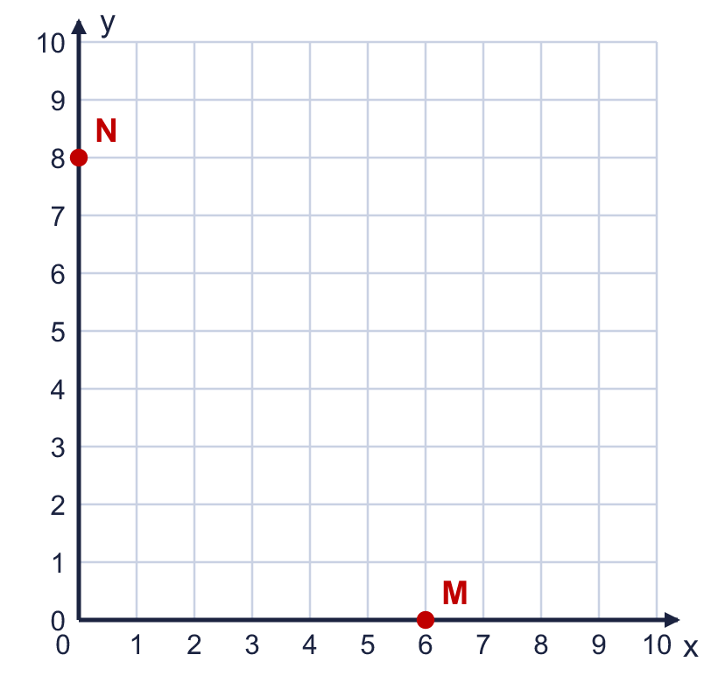  a) Which point is on the x-axis? Write the letter. M  b) Which point is on the y-axis? Write the letter. N

