  Year 4 · Position and direction · Step 3  Draw 2-D shapes on a grid | 
  Year 4 · Position and direction · Step 3
  Draw 2-D shapes on a grid
  1 | A rectangle is drawn on the grid. One corner is at (0, 0) and another is at (7, 7). The sides of the rectangle are parallel to the axes.  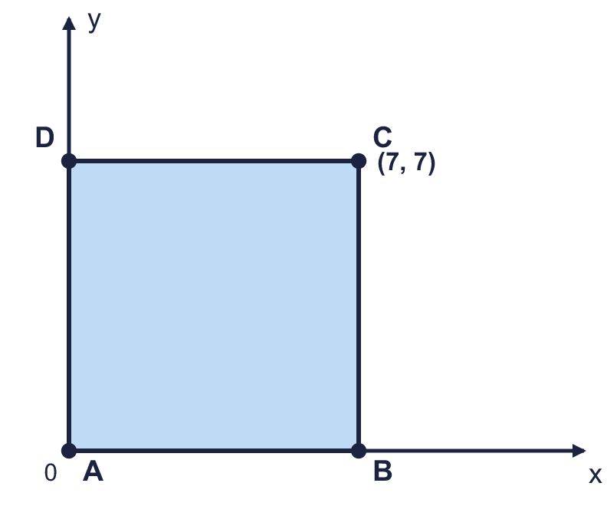  What are the coordinates of the other two corners?  a) Corner B  b) Corner D
  1 | A rectangle is drawn on the grid. One corner is at (0, 0) and another is at (7, 7). The sides of the rectangle are parallel to the axes.  What are the coordinates of the other two corners?  a) Corner B  b) Corner D
  2 | A right-angled triangle is drawn on the grid. Corner Q is at (7, 3). The right angle is at P.  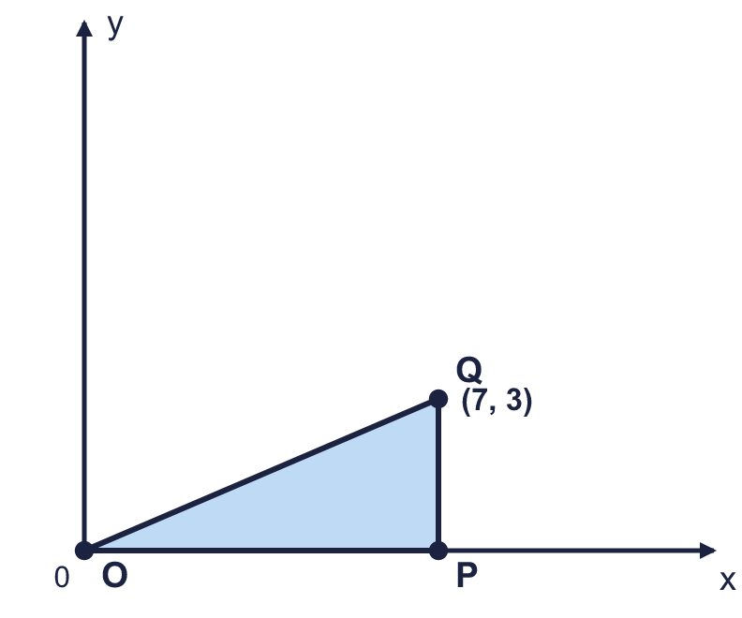  What are the coordinates of the other two corners?  a) Corner O  b) Corner P
  2 | A right-angled triangle is drawn on the grid. Corner Q is at (7, 3). The right angle is at P.  What are the coordinates of the other two corners?  a) Corner O  b) Corner P
  3 | A square is drawn on the grid. Two opposite corners are labelled. The sides of the square are parallel to the axes.  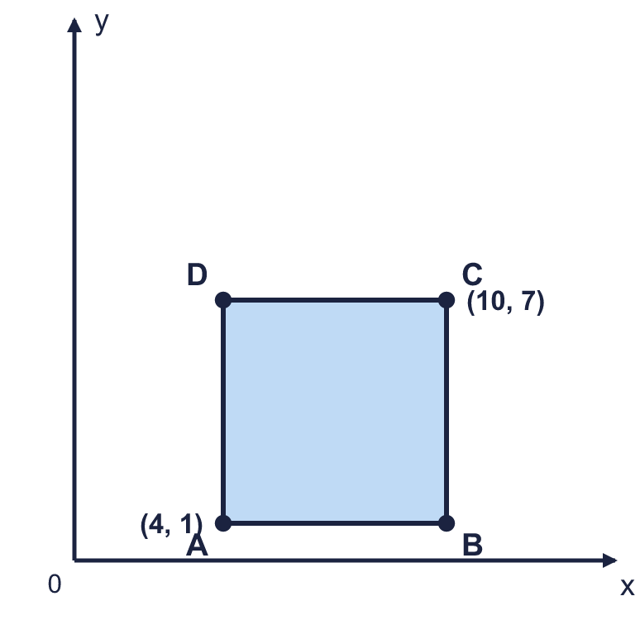  What are the coordinates of the other two corners?  a) Corner B  b) Corner D
  3 | A square is drawn on the grid. Two opposite corners are labelled. The sides of the square are parallel to the axes.  What are the coordinates of the other two corners?  a) Corner B  b) Corner D
  4 | A, B and C are three corners of a rectangle. Write the coordinates of the fourth corner, D.  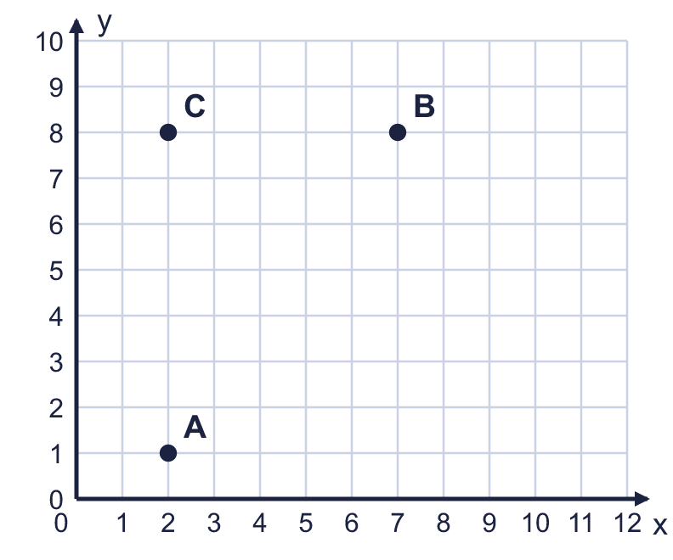
    D =
  4 | A, B and C are three corners of a rectangle. Write the coordinates of the fourth corner, D.
    D =
  5 | Three corners of a rectangle are at (1, 2), (8, 2), (1, 6). The sides are parallel to the axes.  Which of these could be the fourth corner? Circle your answer: (6, 8) (8, 7) (8, 6) (9, 6)
  5 | Three corners of a rectangle are at (1, 2), (8, 2), (1, 6). The sides are parallel to the axes.  Which of these could be the fourth corner? Circle your answer: (6, 8) (8, 7) (8, 6) (9, 6)
  6 | A rectangle has an area of 8 square units. Two of its corners are at (2, 6) and (4, 6). The other two corners are above these two corners.  Write the coordinates of the other two corners.
  6 | A rectangle has an area of 8 square units. Two of its corners are at (2, 6) and (4, 6). The other two corners are above these two corners.  Write the coordinates of the other two corners.
  7 | An isosceles right-angled triangle is drawn on the grid. The right angle is at B. The two equal sides are AB and BM.  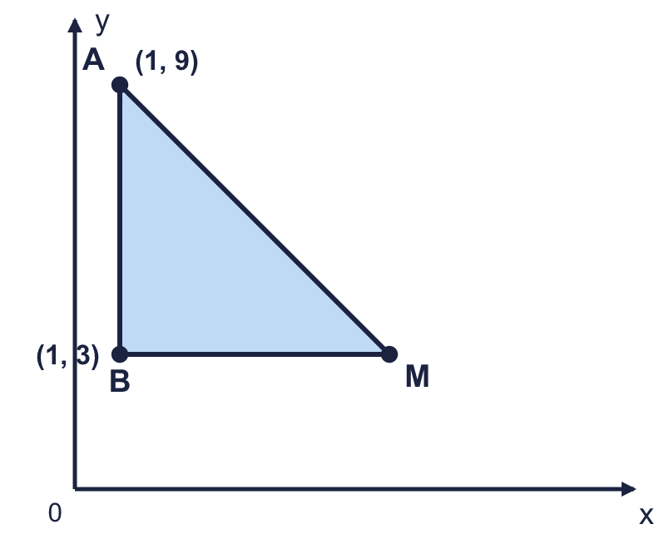
  7 | An isosceles right-angled triangle is drawn on the grid. The right angle is at B. The two equal sides are AB and BM.
  8 | A rectangle is drawn on the grid. Two opposite corners are labelled. The sides are parallel to the axes.  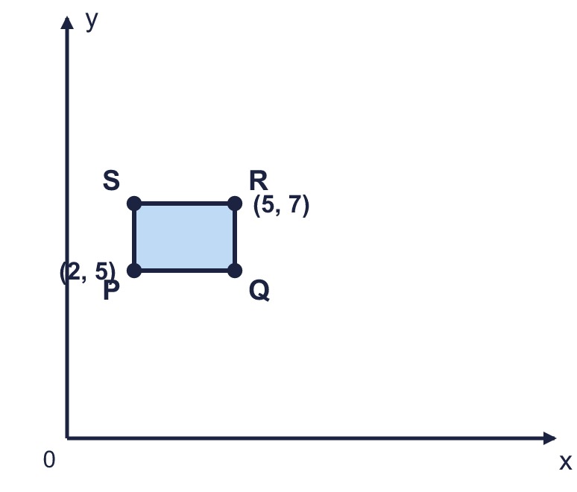  What are the coordinates of the other two corners?  a) Corner Q  b) Corner S
  8 | A rectangle is drawn on the grid. Two opposite corners are labelled. The sides are parallel to the axes.  What are the coordinates of the other two corners?  a) Corner Q  b) Corner S

  9 | ABCD is a square. A is at (2, 2) and B is at (5, 2). D is directly above A.  Is Boba correct? Circle yes or no.  Yes / No  Explain how you know.
     | 
  9 | ABCD is a square. A is at (2, 2) and B is at (5, 2). D is directly above A.  Is Boba correct? Circle yes or no.  Yes / No  Explain how you know.
  10 | A rectangle has a perimeter of 22 units. Two of its corners are at (3, 2) and (8, 2). The other two corners are above these two corners.  Write the coordinates of the other two corners.
  10 | A rectangle has a perimeter of 22 units. Two of its corners are at (3, 2) and (8, 2). The other two corners are above these two corners.  Write the coordinates of the other two corners.
  11 | ABM is an isosceles right-angled triangle with its right angle at B. A is at (2, 8) and B is at (2, 4). M is to the right of B.  a) How long is AB?  b) What are the coordinates of M?
  11 | ABM is an isosceles right-angled triangle with its right angle at B. A is at (2, 8) and B is at (2, 4). M is to the right of B.  a) How long is AB?  b) What are the coordinates of M?
  12 | A rectangle has corners at (3, 5), (9, 5), (9, 11), (3, 11). Its sides are parallel to the axes.  a) What is the length of the rectangle's longer side?  b) The two diagonals cross in the middle of the rectangle. What are the coordinates of the middle?
  12 | A rectangle has corners at (3, 5), (9, 5), (9, 11), (3, 11). Its sides are parallel to the axes.  a) What is the length of the rectangle's longer side?  b) The two diagonals cross in the middle of the rectangle. What are the coordinates of the middle?
  13 | ABC is an isosceles triangle. A is at (2, 6) and B is at (6, 6). C is directly above the middle of AB, at (?, 10).  What is the missing x-coordinate of C?
  13 | ABC is an isosceles triangle. A is at (2, 6) and B is at (6, 6). C is directly above the middle of AB, at (?, 10).  What is the missing x-coordinate of C?
  14 | I am thinking of a point in the first quadrant. Both of its coordinates are whole numbers from 0 to 12.  • The x-coordinate is greater than 0.  • The coordinates add up to 5.  • The y-coordinate is 1 more than the x-coordinate.  What are the coordinates of my point?
  14 | I am thinking of a point in the first quadrant. Both of its coordinates are whole numbers from 0 to 12.  • The x-coordinate is greater than 0.  • The coordinates add up to 5.  • The y-coordinate is 1 more than the x-coordinate.  What are the coordinates of my point?

Year 4 · Position and direction · Step 3
Draw 2-D shapes on a grid
Answers (teacher copy)

  1 | A rectangle is drawn on the grid. One corner is at (0, 0) and another is at (7, 7). The sides of the rectangle are parallel to the axes.  What are the coordinates of the other two corners?  a) Corner B (7, 0)  b) Corner D (0, 7)
  2 | A right-angled triangle is drawn on the grid. Corner Q is at (7, 3). The right angle is at P.  What are the coordinates of the other two corners?  a) Corner O (0, 0)  b) Corner P (7, 0)
  3 | A square is drawn on the grid. Two opposite corners are labelled. The sides of the square are parallel to the axes.  What are the coordinates of the other two corners?  a) Corner B (10, 1)  b) Corner D (4, 7)
  4 | A, B and C are three corners of a rectangle. Write the coordinates of the fourth corner, D.  D = (7, 1)
  5 | Three corners of a rectangle are at (1, 2), (8, 2), (1, 6). The sides are parallel to the axes.  Which of these could be the fourth corner? Circle your answer: (6, 8) (8, 7) (8, 6) (9, 6) (8, 6)
  6 | A rectangle has an area of 8 square units. Two of its corners are at (2, 6) and (4, 6). The other two corners are above these two corners.  Write the coordinates of the other two corners. (2, 10) and (4, 10)
  7 | An isosceles right-angled triangle is drawn on the grid. The right angle is at B. The two equal sides are AB and BM.  Write the coordinates of M. (7, 3)
  8 | A rectangle is drawn on the grid. Two opposite corners are labelled. The sides are parallel to the axes.  What are the coordinates of the other two corners?  a) Corner Q (5, 5)  b) Corner S (2, 7)
  9 | ABCD is a square. A is at (2, 2) and B is at (5, 2). D is directly above A.  Is Boba correct? Circle yes or no.  Yes / No  Explain how you know.  AB is 3 squares long and all the sides of a square are equal, so D is 3 squares above A. D is at (2, 5).
  10 | A rectangle has a perimeter of 22 units. Two of its corners are at (3, 2) and (8, 2). The other two corners are above these two corners.  Write the coordinates of the other two corners. (3, 8) and (8, 8)
  11 | ABM is an isosceles right-angled triangle with its right angle at B. A is at (2, 8) and B is at (2, 4). M is to the right of B.  a) How long is AB? 4  b) What are the coordinates of M? (6, 4)
  12 | A rectangle has corners at (3, 5), (9, 5), (9, 11), (3, 11). Its sides are parallel to the axes.  a) What is the length of the rectangle's longer side? 6  b) The two diagonals cross in the middle of the rectangle. What are the coordinates of the middle? (6, 8)
  13 | ABC is an isosceles triangle. A is at (2, 6) and B is at (6, 6). C is directly above the middle of AB, at (?, 10).  What is the missing x-coordinate of C? 4
  14 | I am thinking of a point in the first quadrant. Both of its coordinates are whole numbers from 0 to 12.  • The x-coordinate is greater than 0.  • The coordinates add up to 5.  • The y-coordinate is 1 more than the x-coordinate.  What are the coordinates of my point? (2, 3)

