  Year 4 · Position and direction · Step 1  Describe position using coordinates | 
  Year 4 · Position and direction · Step 1
  Describe position using coordinates
  1 | Four points are plotted on the coordinate grid. Write the coordinates of each point. Remember: the x-coordinate (across) comes first, then the y-coordinate (up).  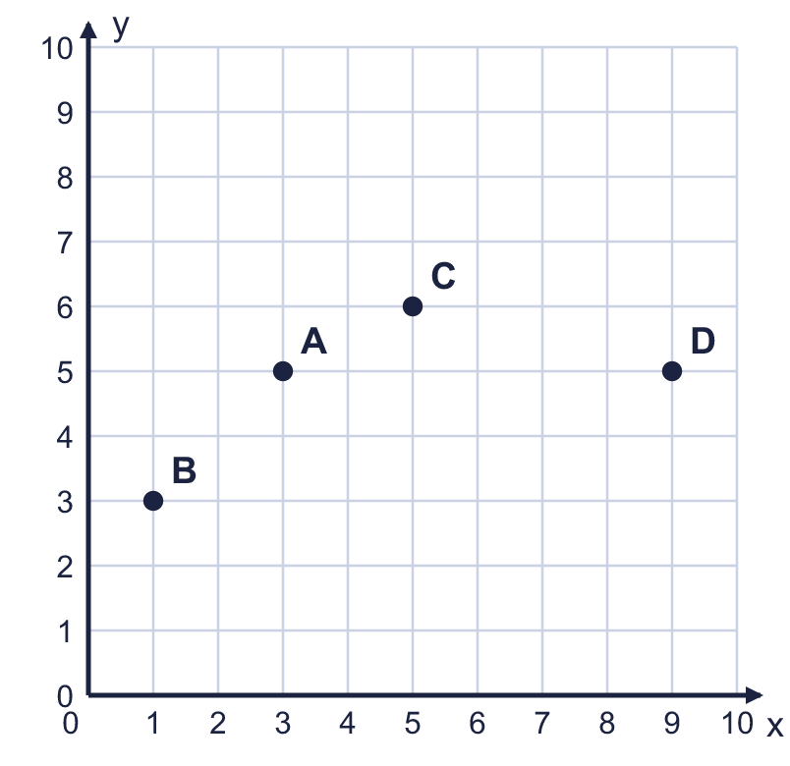  a) Point A  b) Point B  c) Point C  d) Point D
  1 | Four points are plotted on the coordinate grid. Write the coordinates of each point. Remember: the x-coordinate (across) comes first, then the y-coordinate (up).  a) Point A  b) Point B  c) Point C  d) Point D
  2 | Eight points are plotted on the coordinate grid. Two of the points have the same x-coordinate and two have the same y-coordinate.  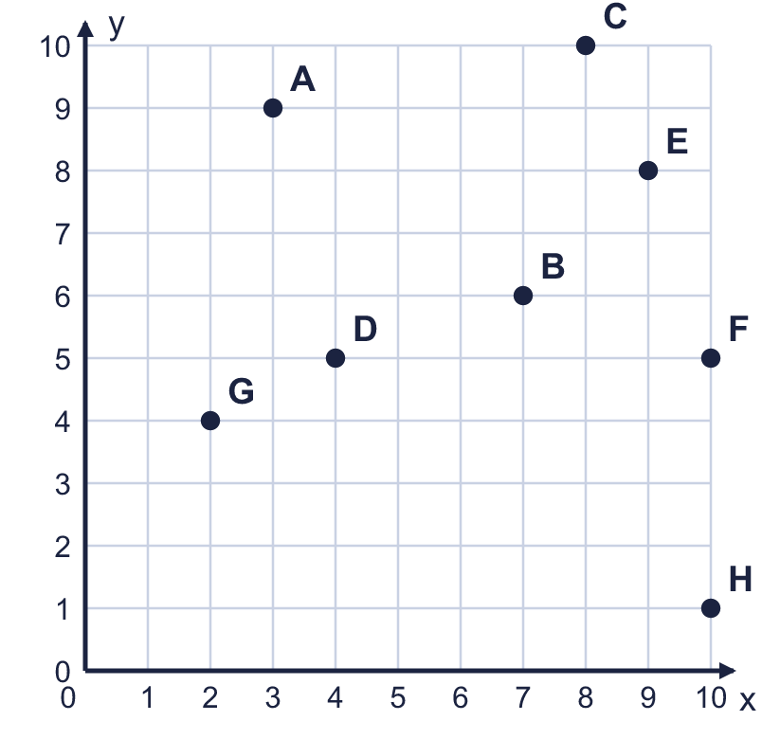  a) Which two points have the same x-coordinate? Write the letters.  b) Which two points have the same y-coordinate? Write the letters.
  2 | Eight points are plotted on the coordinate grid. Two of the points have the same x-coordinate and two have the same y-coordinate.  a) Which two points have the same x-coordinate? Write the letters.  b) Which two points have the same y-coordinate? Write the letters.
  3 | Plot these points on a coordinate grid in your book. Use the same scale as the grid shown. E (3, 2), F (0, 4), G (10, 0), H (8, 9).  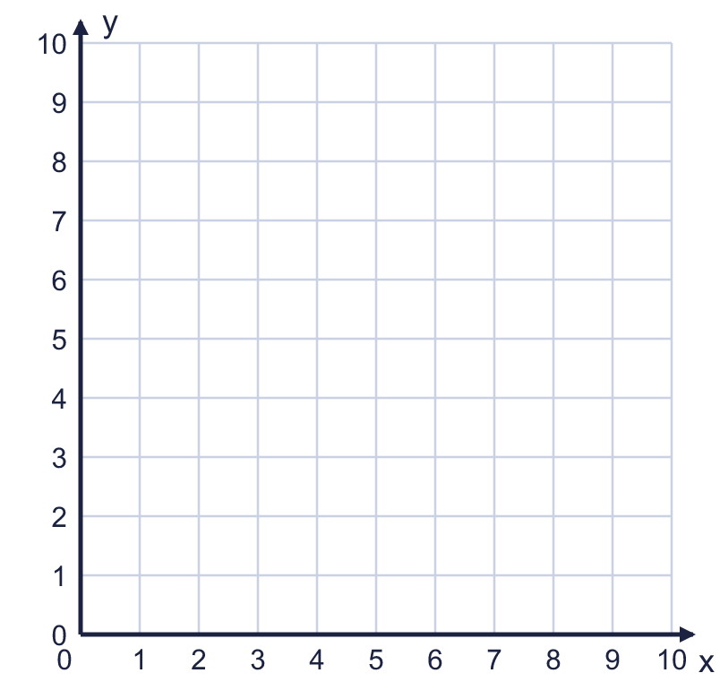  a) Which point is the closest to the x-axis? Write the letter.  b) Which point is the furthest from the y-axis? Write the letter.
  3 | Plot these points on a coordinate grid in your book. Use the same scale as the grid shown. E (3, 2), F (0, 4), G (10, 0), H (8, 9).  a) Which point is the closest to the x-axis? Write the letter.  b) Which point is the furthest from the y-axis? Write the letter.
  4 | Look at the coordinate grid.  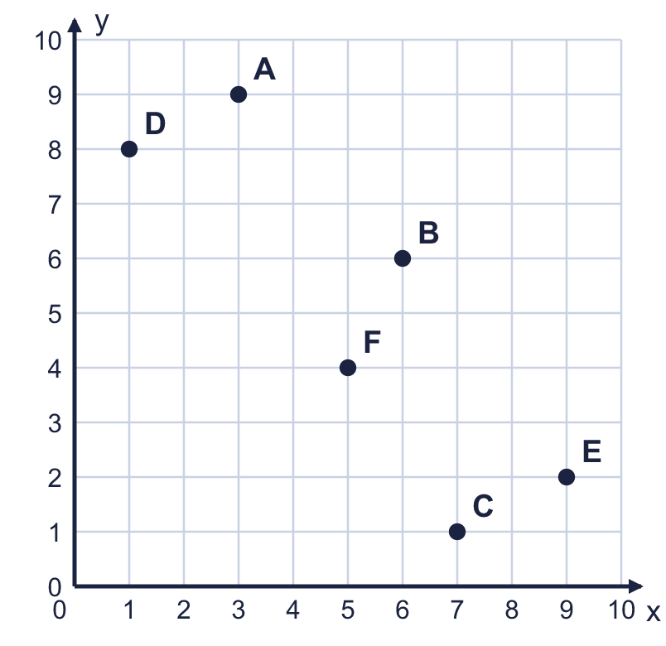  a) Which point is at (6, 6)? Write the letter.  b) Which point is at (1, 8)? Write the letter.
  4 | Look at the coordinate grid.  a) Which point is at (6, 6)? Write the letter.  b) Which point is at (1, 8)? Write the letter.
  5 | A triangle is drawn on the coordinate grid. Write the coordinates of each corner of the triangle.  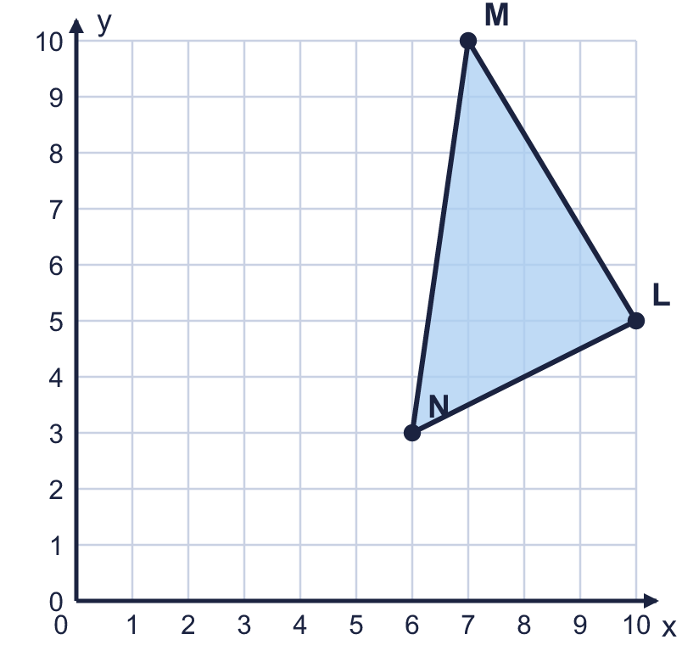  a) Corner L  b) Corner M  c) Corner N
  5 | A triangle is drawn on the coordinate grid. Write the coordinates of each corner of the triangle.  a) Corner L  b) Corner M  c) Corner N
  6 | Look at the coordinate grid. Count the squares along the line from one point to the other.  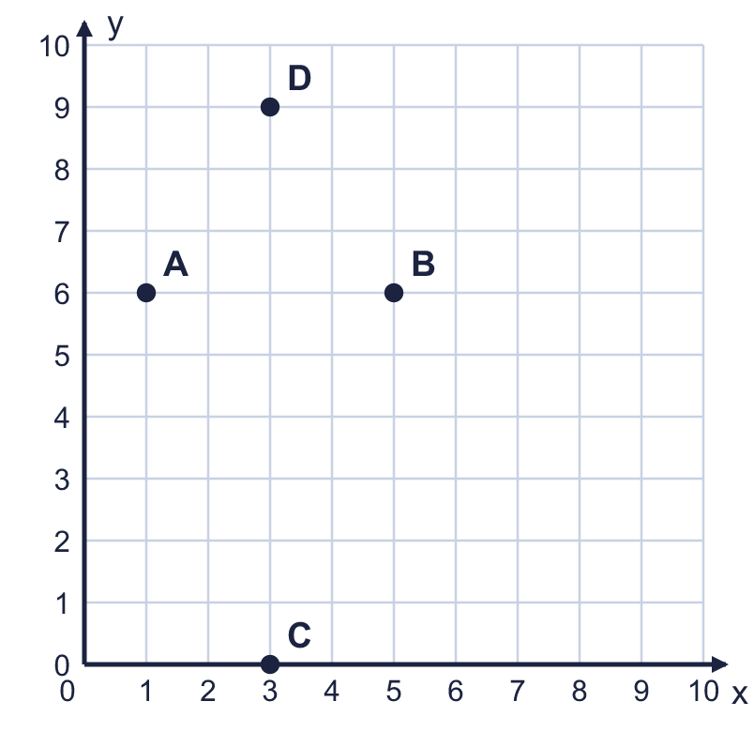  a) How many squares is it from A to B?  b) How many squares is it from C to D?
  6 | Look at the coordinate grid. Count the squares along the line from one point to the other.  a) How many squares is it from A to B?  b) How many squares is it from C to D?
  7 | A, B and C are three corners of a rectangle. Write the coordinates of the fourth corner, D.  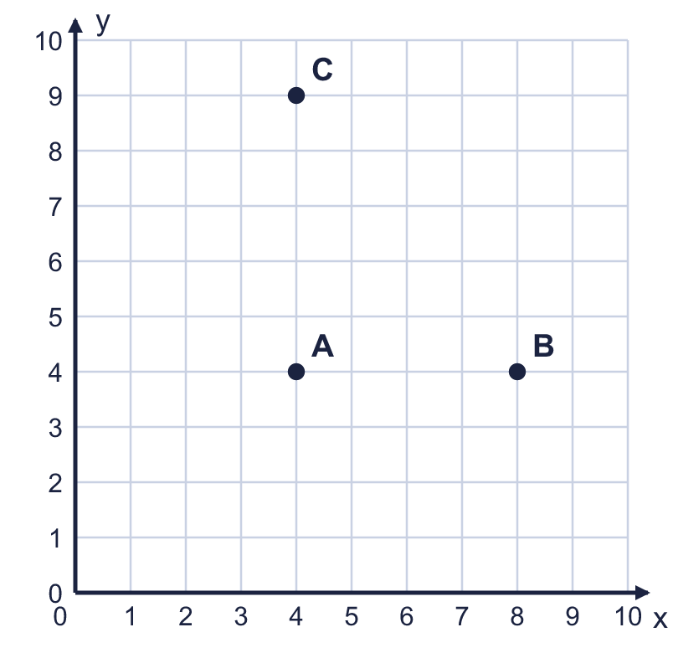
    D =
  7 | A, B and C are three corners of a rectangle. Write the coordinates of the fourth corner, D.
    D =
  8 | The points (5, 6), (6, 6), (9, 6) are in a straight line.  a) Is the line horizontal or vertical?  b) Which number is the same in all three points?
  8 | The points (5, 6), (6, 6), (9, 6) are in a straight line.  a) Is the line horizontal or vertical?  b) Which number is the same in all three points?

  9 | The point P is plotted on the coordinate grid.  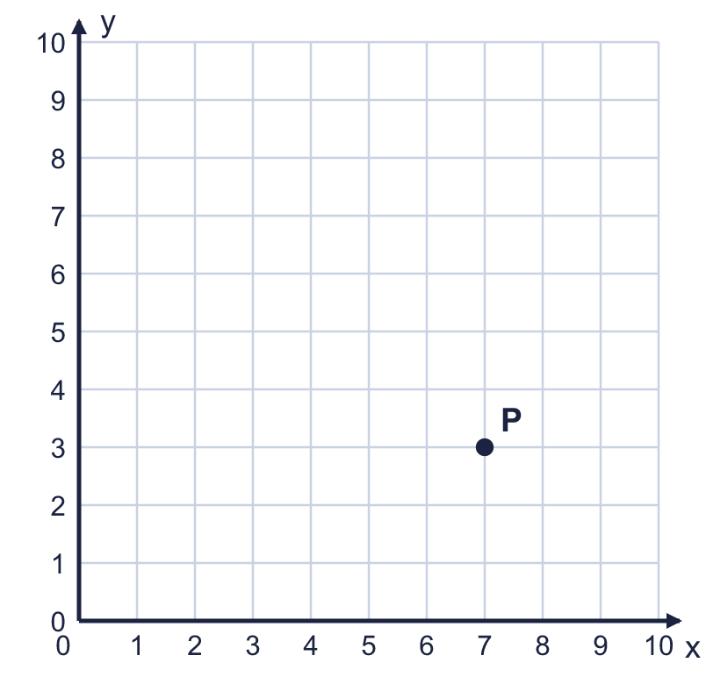  Is Boba correct? Circle yes or no.  Yes / No  Explain how you know.
    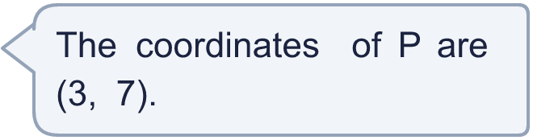
  9 | The point P is plotted on the coordinate grid.  Is Boba correct? Circle yes or no.  Yes / No  Explain how you know.
  10 | The point P is plotted on a coordinate grid. Each square is 2 units long, so the numbers go up in 2s.  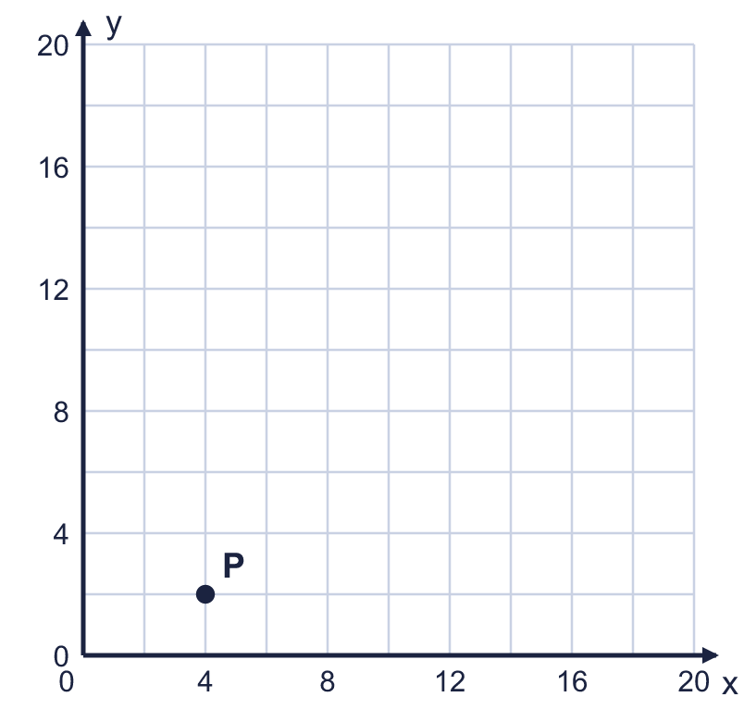  Is Boba correct? Circle yes or no.  Yes / No  Explain how you know.
     | 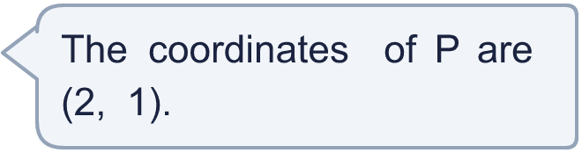
  10 | The point P is plotted on a coordinate grid. Each square is 2 units long, so the numbers go up in 2s.  Is Boba correct? Circle yes or no.  Yes / No  Explain how you know.
  11 | A coordinate grid is drawn on a page of centimetre squares. Three corners of a rectangle are at (1, 3), (4, 8), (1, 8).  a) What are the coordinates of the fourth corner?
    b) | Work out the area of the rectangle.
    cm²
    c) | Work out the perimeter of the rectangle.
    cm
  11 | A coordinate grid is drawn on a page of centimetre squares. Three corners of a rectangle are at (1, 3), (4, 8), (1, 8).  a) What are the coordinates of the fourth corner?
    b) | Work out the area of the rectangle.
    cm²
    c) | Work out the perimeter of the rectangle.
    cm
  12 | Two corners of a square are at (2, 6) and (4, 6). The other two corners are above these two corners.  Write the coordinates of the other two corners.
  12 | Two corners of a square are at (2, 6) and (4, 6). The other two corners are above these two corners.  Write the coordinates of the other two corners.
  13 | Five points are marked on the coordinate grid with a rectangle.  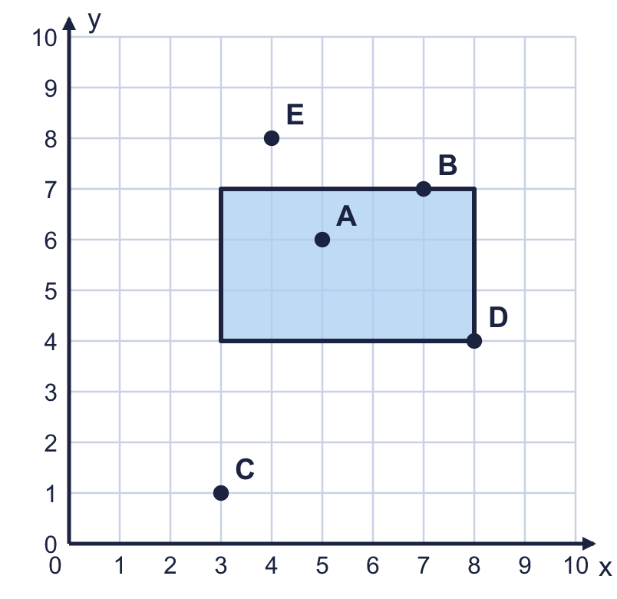  a) Which points are inside the rectangle? Write the letters.  b) Which points are on the edge (the perimeter) of the rectangle? Write the letters.
  13 | Five points are marked on the coordinate grid with a rectangle.  a) Which points are inside the rectangle? Write the letters.  b) Which points are on the edge (the perimeter) of the rectangle? Write the letters.
  14 | I am thinking of a point in the first quadrant. Both of its coordinates are whole numbers from 0 to 10.  • The y-coordinate is 3 more than the x-coordinate.  • The coordinates add up to 15.  • The x-coordinate is greater than 4.  What are the coordinates of my point?
  14 | I am thinking of a point in the first quadrant. Both of its coordinates are whole numbers from 0 to 10.  • The y-coordinate is 3 more than the x-coordinate.  • The coordinates add up to 15.  • The x-coordinate is greater than 4.  What are the coordinates of my point?

Year 4 · Position and direction · Step 1
Describe position using coordinates
Answers (teacher copy)

  1 | Four points are plotted on the coordinate grid. Write the coordinates of each point. Remember: the x-coordinate (across) comes first, then the y-coordinate (up).  a) Point A (3, 5)  b) Point B (1, 3)  c) Point C (5, 6)  d) Point D (9, 5)
  2 | Eight points are plotted on the coordinate grid. Two of the points have the same x-coordinate and two have the same y-coordinate.  a) Which two points have the same x-coordinate? Write the letters. F and H  b) Which two points have the same y-coordinate? Write the letters. D and F
  3 | Plot these points on a coordinate grid in your book. Use the same scale as the grid shown. E (3, 2), F (0, 4), G (10, 0), H (8, 9).  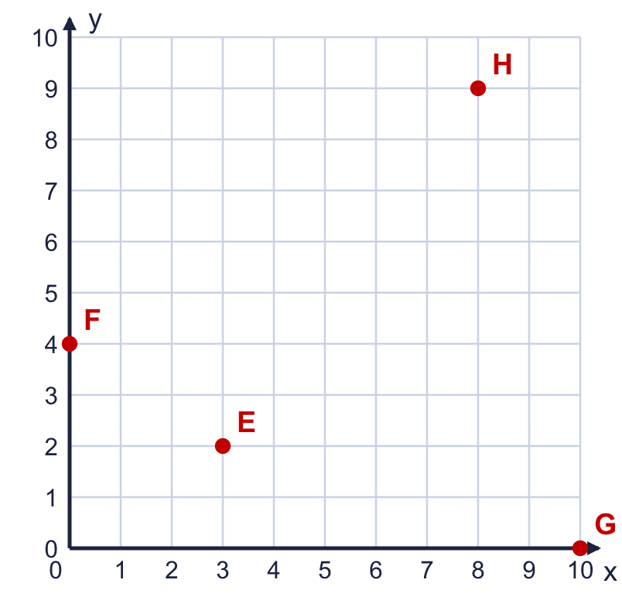  a) Which point is the closest to the x-axis? Write the letter. G  b) Which point is the furthest from the y-axis? Write the letter. G
  4 | Look at the coordinate grid.  a) Which point is at (6, 6)? Write the letter. B  b) Which point is at (1, 8)? Write the letter. D
  5 | A triangle is drawn on the coordinate grid. Write the coordinates of each corner of the triangle.  a) Corner L (10, 5)  b) Corner M (7, 10)  c) Corner N (6, 3)
  6 | Look at the coordinate grid. Count the squares along the line from one point to the other.  a) How many squares is it from A to B? 4  b) How many squares is it from C to D? 9
  7 | A, B and C are three corners of a rectangle. Write the coordinates of the fourth corner, D.  D = (8, 9)
  8 | The points (5, 6), (6, 6), (9, 6) are in a straight line.  a) Is the line horizontal or vertical? horizontal  b) Which number is the same in all three points? 6
  9 | The point P is plotted on the coordinate grid.  Is Boba correct? Circle yes or no.  Yes / No  Explain how you know.  P is 7 squares across and 3 squares up. The x-coordinate (across) is written first, so P is at (7, 3), not (3, 7).
  10 | The point P is plotted on a coordinate grid. Each square is 2 units long, so the numbers go up in 2s.  Is Boba correct? Circle yes or no.  Yes / No  Explain how you know.  Boba counted squares instead of reading the numbers on the axes. P is at 4 on the x-axis and 2 on the y-axis, so it is at (4, 2).
  11 | A coordinate grid is drawn on a page of centimetre squares. Three corners of a rectangle are at (1, 3), (4, 8), (1, 8).  a) What are the coordinates of the fourth corner? (4, 3)  b) Work out the area of the rectangle. 15 cm²  c) Work out the perimeter of the rectangle. 16 cm
  12 | Two corners of a square are at (2, 6) and (4, 6). The other two corners are above these two corners.  Write the coordinates of the other two corners. (2, 8) and (4, 8)
  13 | Five points are marked on the coordinate grid with a rectangle.  a) Which points are inside the rectangle? Write the letters. A  b) Which points are on the edge (the perimeter) of the rectangle? Write the letters. B, D
  14 | I am thinking of a point in the first quadrant. Both of its coordinates are whole numbers from 0 to 10.  • The y-coordinate is 3 more than the x-coordinate.  • The coordinates add up to 15.  • The x-coordinate is greater than 4.  What are the coordinates of my point? (6, 9)

