  Year 4 · Money · Step 1  Write money using decimals | 
  Year 4 · Money · Step 1
  Write money using decimals
  1 | Alex has these coins: £1, 5p, 2p, 2p and 1p.
    How much money does Alex have? £
  1 | Alex has these coins: £1, 5p, 2p, 2p and 1p.
    How much money does Alex have? £
  2 | Leo has these coins: £2, 50p, 50p and 5p.
    How many pence is that in total?
    p
  2 | Leo has these coins: £2, 50p, 50p and 5p.
    How many pence is that in total?
    p
  3 | Write each amount as a decimal.
    a) £2 and 3p = £
    b) £8 and 8p = £
    c) £6 and 87p = £
  3 | Write each amount as a decimal.
    a) £2 and 3p = £
    b) £8 and 8p = £
    c) £6 and 87p = £
  4 | Write each amount in pounds.
    a) 120p = £
    b) 525p = £
    c) 715p = £
  4 | Write each amount in pounds.
    a) 120p = £
    b) 525p = £
    c) 715p = £
  5 | The hundred square is worth £1. Each small square is worth 1p.  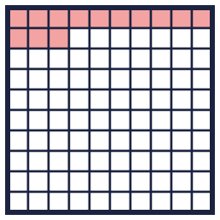
    How many pence are shaded?
    p As a decimal: £
  5 | The hundred square is worth £1. Each small square is worth 1p.
    How many pence are shaded?
    p As a decimal: £
  6 | Write the number of pounds and the number of pence in each amount.
    a) £4.02: |  | pounds |  | pence
    b) £9.75: |  | pounds |  | pence
    c) £2.51: |  | pounds |  | pence
  6 | Write the number of pounds and the number of pence in each amount.
    a) £4.02: |  | pounds |  | pence
    b) £9.75: |  | pounds |  | pence
    c) £2.51: |  | pounds |  | pence
  7 | Nina has these coins: £1, 10p, 10p and 1p.
    How much money is that? £
  7 | Nina has these coins: £1, 10p, 10p and 1p.
    How much money is that? £
  8 | Which of these are equal to £4.06? Write the letters.  A: 406p  B: £4.60  C: £4.06  D: £4 + 6p
  8 | Which of these are equal to £4.06? Write the letters.  A: 406p  B: £4.60  C: £4.06  D: £4 + 6p

  9 | Is Mia correct? Circle yes or no.  Yes / No  Explain how you know.
     | 
  9 | Is Mia correct? Circle yes or no.  Yes / No  Explain how you know.
  10 | Kim has 4 coins. They add up to £2.32.  Write 4 coins Kim could have.
  10 | Kim has 4 coins. They add up to £2.32.  Write 4 coins Kim could have.
  11 | Alex has £6.05. Rosie has £1.28.
    How much money do they have altogether?
  11 | Alex has £6.05. Rosie has £1.28.
    How much money do they have altogether?
  12 | He uses all three cards to make an amount of money like £_.__ Write the smallest amount he can make.
    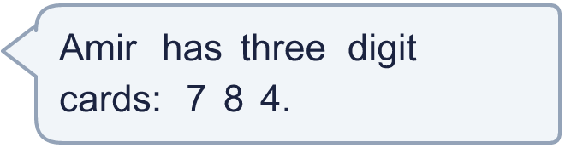
  12 | He uses all three cards to make an amount of money like £_.__ Write the smallest amount he can make.
  13 | Is Sam correct? Circle yes or no.  Yes / No  Explain how you know.
     | 
  13 | Is Sam correct? Circle yes or no.  Yes / No  Explain how you know.
  14 | Challenge  Zach has 5 coins. They add up to £2.34. Write 5 coins Zach could have.
  14 | Challenge  Zach has 5 coins. They add up to £2.34. Write 5 coins Zach could have.

Year 4 · Money · Step 1
Write money using decimals
Answers (teacher copy)

  1 | Alex has these coins: £1, 5p, 2p, 2p and 1p.  How much money does Alex have? £ 1.10
  2 | Leo has these coins: £2, 50p, 50p and 5p.  How many pence is that in total? 305 p
  3 | Write each amount as a decimal.  a) £2 and 3p = £ 2.03  b) £8 and 8p = £ 8.08  c) £6 and 87p = £ 6.87
  4 | Write each amount in pounds.  a) 120p = £ 1.20  b) 525p = £ 5.25  c) 715p = £ 7.15
  5 | The hundred square is worth £1. Each small square is worth 1p.  How many pence are shaded? 13 p As a decimal: £ 0.13
  6 | Write the number of pounds and the number of pence in each amount.  a) £4.02: 4 pounds 2 pence  b) £9.75: 9 pounds 75 pence  c) £2.51: 2 pounds 51 pence
  7 | Nina has these coins: £1, 10p, 10p and 1p.  How much money is that? £ 1.21
  8 | Which of these are equal to £4.06? Write the letters.  A: 406p  B: £4.60  C: £4.06  D: £4 + 6p  A, C, D
  9 | Is Mia correct? Circle yes or no.  Yes / No  Explain how you know.  No. £5 and 2p is £5.02. The 2p must go in the hundredths place.
  10 | Kim has 4 coins. They add up to £2.32.  Write 4 coins Kim could have.  £2, 20p, 10p and 2p
  11 | Alex has £6.05. Rosie has £1.28.  How much money do they have altogether? £7.33
  12 | He uses all three cards to make an amount of money like £_.__ Write the smallest amount he can make.  £4.78
  13 | Is Sam correct? Circle yes or no.  Yes / No  Explain how you know.  No. 478p is 4 pounds and 78 pence, which is £4.78.
  14 | Challenge  Zach has 5 coins. They add up to £2.34. Write 5 coins Zach could have.  £2, 20p, 10p, 2p and 2p

