  Year 4 · Money · Step 6  Solve problems with money | 
  Year 4 · Money · Step 6
  Solve problems with money
  1 | At the cinema a child's ticket costs £3.88 and an adult's ticket costs £5.63.  How much more does an adult's ticket cost?
  1 | At the cinema a child's ticket costs £3.88 and an adult's ticket costs £5.63.  How much more does an adult's ticket cost?
  2 | A child's ticket costs £3.31 and an adult's ticket costs £4.31.  How much for 1 adult and 3 children?
  2 | A child's ticket costs £3.31 and an adult's ticket costs £4.31.  How much for 1 adult and 3 children?
  3 | Jo has £9. Jo shares it equally between 3 friends.  How much does each friend get?
  3 | Jo has £9. Jo shares it equally between 3 friends.  How much does each friend get?
  4 | Rosie has £9. Rosie's friend has 2 times as much.  How much does the friend have?
  4 | Rosie has £9. Rosie's friend has 2 times as much.  How much does the friend have?
  5 | Eva buys 3 sets of headphones. Each set costs £7.67. Eva has a voucher for £5 off the total.
  5 | Eva buys 3 sets of headphones. Each set costs £7.67. Eva has a voucher for £5 off the total.
  6 | Eva buys a cap for £4.34 and some marbles for £3.07. Tom buys a book for £2.98.  How much more does Eva spend than Tom?
  6 | Eva buys a cap for £4.34 and some marbles for £3.07. Tom buys a book for £2.98.  How much more does Eva spend than Tom?
  7 | A skate park ticket costs £13.02 and a scooter hire costs £14.53.  What is the total of the two prices?
  7 | A skate park ticket costs £13.02 and a scooter hire costs £14.53.  What is the total of the two prices?
  8 | Leo spends £18.66 and pays with a £20 note.  How much change does Leo get?
  8 | Leo spends £18.66 and pays with a £20 note.  How much change does Leo get?

  9 | Is Tia correct? Circle yes or no.  Yes / No  Explain how you know.
     | 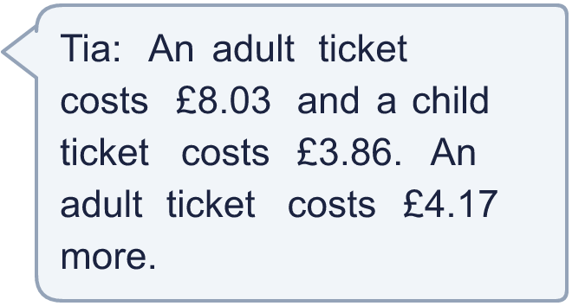
  9 | Is Tia correct? Circle yes or no.  Yes / No  Explain how you know.
  10 | At a theme park, the Galaxy ride costs £16. The Frenzy ride costs one quarter of the price of Galaxy.
  10 | At a theme park, the Galaxy ride costs £16. The Frenzy ride costs one quarter of the price of Galaxy.
  11 | Galaxy and Up 'n' Down cost £14.83 together. Galaxy costs £12.25.  How much does Up 'n' Down cost?
  11 | Galaxy and Up 'n' Down cost £14.83 together. Galaxy costs £12.25.  How much does Up 'n' Down cost?
  12 | Up 'n' Down costs £2.39. Speedster costs double the price of Up 'n' Down.  How much does Speedster cost?
  12 | Up 'n' Down costs £2.39. Speedster costs double the price of Up 'n' Down.  How much does Speedster cost?
  13 | Zach spends £9.68 altogether on a hat, a scarf and gloves. The hat costs £2.32 and the scarf costs £4.44.
  13 | Zach spends £9.68 altogether on a hat, a scarf and gloves. The hat costs £2.32 and the scarf costs £4.44.
  14 | Challenge  Amir has £10. Amir buys a book for £5.94. Pens cost 25p each. Amir spends as much of the rest as possible on pens.
  14 | Challenge  Amir has £10. Amir buys a book for £5.94. Pens cost 25p each. Amir spends as much of the rest as possible on pens.

Year 4 · Money · Step 6
Solve problems with money
Answers (teacher copy)

  1 | At the cinema a child's ticket costs £3.88 and an adult's ticket costs £5.63.  How much more does an adult's ticket cost? £1.75
  2 | A child's ticket costs £3.31 and an adult's ticket costs £4.31.  How much for 1 adult and 3 children? £14.24
  3 | Jo has £9. Jo shares it equally between 3 friends.  How much does each friend get? £3
  4 | Rosie has £9. Rosie's friend has 2 times as much.  How much does the friend have? £18
  5 | Eva buys 3 sets of headphones. Each set costs £7.67. Eva has a voucher for £5 off the total.  How much does Eva pay? £18.01
  6 | Eva buys a cap for £4.34 and some marbles for £3.07. Tom buys a book for £2.98.  How much more does Eva spend than Tom? £4.43
  7 | A skate park ticket costs £13.02 and a scooter hire costs £14.53.  What is the total of the two prices? £27.55
  8 | Leo spends £18.66 and pays with a £20 note.  How much change does Leo get? £1.34
  9 | Is Tia correct? Circle yes or no.  Yes / No  Explain how you know.  Yes. £8.03 − £3.86 = £4.17. To find how much more, take away the smaller amount.
  10 | At a theme park, the Galaxy ride costs £16. The Frenzy ride costs one quarter of the price of Galaxy.  How much does Frenzy cost? £4
  11 | Galaxy and Up 'n' Down cost £14.83 together. Galaxy costs £12.25.  How much does Up 'n' Down cost? £2.58
  12 | Up 'n' Down costs £2.39. Speedster costs double the price of Up 'n' Down.  How much does Speedster cost? £4.78
  13 | Zach spends £9.68 altogether on a hat, a scarf and gloves. The hat costs £2.32 and the scarf costs £4.44.  How much do the gloves cost? £2.92
  14 | Challenge  Amir has £10. Amir buys a book for £5.94. Pens cost 25p each. Amir spends as much of the rest as possible on pens.  How many pens does Amir buy? 16

