  Year 4 · Money · Step 3  Compare amounts of money | 
  Year 4 · Money · Step 3
  Compare amounts of money
  1 | What is the value of the digit in each amount?
    a) the digit 1 in 5,701p:
    b) the digit 7 in £8.71:
    c) the digit 7 in £75.13:
    d) the digit 4 in £83.42:
  1 | What is the value of the digit in each amount?
    a) the digit 1 in 5,701p:
    b) the digit 7 in £8.71:
    c) the digit 7 in £75.13:
    d) the digit 4 in £83.42:
  2 | Write <, > or = in each box.
    a) 907p |  | 970p
    b) £7.24 |  | £7.42
    c) 434p |  | 443p
    d) £5.09 |  | £5.90
  2 | Write <, > or = in each box.
    a) 907p |  | 970p
    b) £7.24 |  | £7.42
    c) 434p |  | 443p
    d) £5.09 |  | £5.90
  3 | Write <, > or = in each box.
    a) 258p |  | £3.48
    b) 416p |  | £4.61
    c) £2.39 |  | 149p
    d) 677p |  | £7.67
  3 | Write <, > or = in each box.
    a) 258p |  | £3.48
    b) 416p |  | £4.61
    c) £2.39 |  | 149p
    d) 677p |  | £7.67
  4 | Write the amounts in order, starting with the smallest.  405p £6.96 838p £7.42
  4 | Write the amounts in order, starting with the smallest.  405p £6.96 838p £7.42
  5 | Write the amounts in order, starting with the largest.  £9.95 493p £4.19 944p
  5 | Write the amounts in order, starting with the largest.  £9.95 493p £4.19 944p
  6 | Mia has £3.81. Tia has 658p. Zach has £6.77.  Who has the least money? Write the name.
  6 | Mia has £3.81. Tia has 658p. Zach has £6.77.  Who has the least money? Write the name.
  7 | Write <, > or = in each box.
    a) 1,671p |  | £16.71
    b) 4,373p |  | £47.33
  7 | Write <, > or = in each box.
    a) 1,671p |  | £16.71
    b) 4,373p |  | £47.33
  8 | Write an amount of money that is greater than £6.06 and less than £6.16.
  8 | Write an amount of money that is greater than £6.06 and less than £6.16.

  9 | Nina wants to complete the statement using < or >.  565p > £5.56  Is Nina's statement correct? Circle yes or no.  Yes / No  Explain how you know.
     | 
  9 | Nina wants to complete the statement using < or >.  565p > £5.56  Is Nina's statement correct? Circle yes or no.  Yes / No  Explain how you know.
  10 | He uses all three cards to make an amount of money like £_.__ Write the smallest amount he can make.
    
  10 | He uses all three cards to make an amount of money like £_.__ Write the smallest amount he can make.
  11 | Alex has £6.11 and Zach has 629p. Mia has more money than Alex, but less than Zach.  How much money could Mia have?
  11 | Alex has £6.11 and Zach has 629p. Mia has more money than Alex, but less than Zach.  How much money could Mia have?
  12 | Which of these amounts are greater than £4.75? Write the letters.  A: 480p  B: 470p  C: £4.25  D: £5.25
  12 | Which of these amounts are greater than £4.75? Write the letters.  A: 480p  B: 470p  C: £4.25  D: £5.25
  13 | Three of these amounts are equal. Write the letter of the amount that is different.  A: 781p  B: £8.71  C: £7.81  D: £7 + 81p
  13 | Three of these amounts are equal. Write the letter of the amount that is different.  A: 781p  B: £8.71  C: £7.81  D: £7 + 81p
  14 | Challenge  Is Dora's statement correct? Circle yes or no.  Yes / No  Explain.
     | 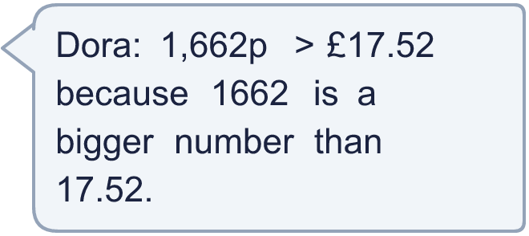
  14 | Challenge  Is Dora's statement correct? Circle yes or no.  Yes / No  Explain.

Year 4 · Money · Step 3
Compare amounts of money
Answers (teacher copy)

  1 | What is the value of the digit in each amount?  a) the digit 1 in 5,701p: 1p  b) the digit 7 in £8.71: 70p  c) the digit 7 in £75.13: £70  d) the digit 4 in £83.42: 40p
  2 | Write <, > or = in each box.  a) 907p < 970p  b) £7.24 < £7.42  c) 434p < 443p  d) £5.09 < £5.90
  3 | Write <, > or = in each box.  a) 258p < £3.48  b) 416p < £4.61  c) £2.39 > 149p  d) 677p < £7.67
  4 | Write the amounts in order, starting with the smallest.  405p £6.96 838p £7.42  405p, £6.96, £7.42, 838p
  5 | Write the amounts in order, starting with the largest.  £9.95 493p £4.19 944p  £9.95, 944p, 493p, £4.19
  6 | Mia has £3.81. Tia has 658p. Zach has £6.77.  Who has the least money? Write the name. Mia
  7 | Write <, > or = in each box.  a) 1,671p = £16.71  b) 4,373p < £47.33
  8 | Write an amount of money that is greater than £6.06 and less than £6.16.  £6.11
  9 | Nina wants to complete the statement using < or >.  565p > £5.56  Is Nina's statement correct? Circle yes or no.  Yes / No  Explain how you know.  Yes. £5.65 is the bigger amount. Change both amounts to pence or to pounds to compare.
  10 | He uses all three cards to make an amount of money like £_.__ Write the smallest amount he can make.  £1.27
  11 | Alex has £6.11 and Zach has 629p. Mia has more money than Alex, but less than Zach.  How much money could Mia have? £6.12
  12 | Which of these amounts are greater than £4.75? Write the letters.  A: 480p  B: 470p  C: £4.25  D: £5.25  A, D
  13 | Three of these amounts are equal. Write the letter of the amount that is different.  A: 781p  B: £8.71  C: £7.81  D: £7 + 81p  B
  14 | Challenge  Is Dora's statement correct? Circle yes or no.  Yes / No  Explain.  No. 1,662p is £16.62 and the other amount is £17.52.

