  Year 4 · Decimals B · Step 7  Round to the nearest whole number | 
  Year 4 · Decimals B · Step 7
  Round to the nearest whole number
  1 | Write the two whole numbers each decimal lies between.
    a) 11.9 is between |  | and
    b) 14.9 is between |  | and
    c) 11.5 is between |  | and
  1 | Write the two whole numbers each decimal lies between.
    a) 11.9 is between |  | and
    b) 14.9 is between |  | and
    c) 11.5 is between |  | and
  2 | Round each number to the nearest whole number.
    a) 30.6 →
    b) 35.9 →
    c) 70.5 →
  2 | Round each number to the nearest whole number.
    a) 30.6 →
    b) 35.9 →
    c) 70.5 →
  3 | Round each number to the nearest whole number.
    a) 8.5 →
    b) 0.2 →
    c) 0.8 →
  3 | Round each number to the nearest whole number.
    a) 8.5 →
    b) 0.2 →
    c) 0.8 →
  4 | The number line is split into 10 equal steps. Write the number each arrow points to.  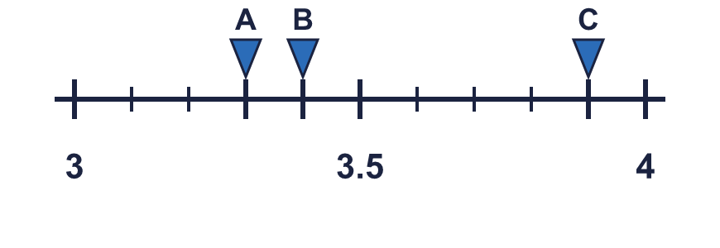
    A = |  | B = |  | C =
  4 | The number line is split into 10 equal steps. Write the number each arrow points to.
    A = |  | B = |  | C =
  5 | Which of these numbers round to 28 to the nearest whole number? Write the letters.  A: 28.5  B: 28.4  C: 27.5  D: 27.4
  5 | Which of these numbers round to 28 to the nearest whole number? Write the letters.  A: 28.5  B: 28.4  C: 27.5  D: 27.4
  6 | Round each measurement to the nearest whole number.
    a) 3.6 kg →
    b) 18.2 cm →
    c) 2.6 litres →
  6 | Round each measurement to the nearest whole number.
    a) 3.6 kg →
    b) 18.2 cm →
    c) 2.6 litres →
  7 | Round each number to the nearest whole number. Think about where it is on a number line between 2 and 3.
    a) 2.3 →
    b) 2.7 →
  7 | Round each number to the nearest whole number. Think about where it is on a number line between 2 and 3.
    a) 2.3 →
    b) 2.7 →
  8 | Round each number to the nearest whole number.
    a) 45.6 →
    b) 37.3 →
  8 | Round each number to the nearest whole number.
    a) 45.6 →
    b) 37.3 →

  9 | Is Amir correct? Circle yes or no.  Yes / No  Explain how you know.
     | 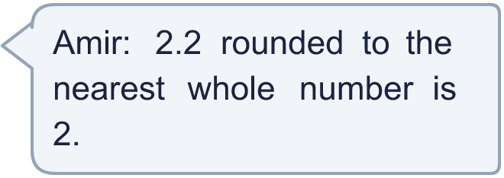
  9 | Is Amir correct? Circle yes or no.  Yes / No  Explain how you know.
  10 | A: 42.6  B: 41.5  C: 42.4  D: 41.4
    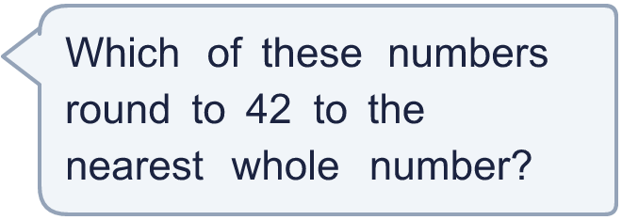
  10 | A: 42.6  B: 41.5  C: 42.4  D: 41.4
  11 | A number with one decimal place rounds to 39 to the nearest whole number.
    The smallest it could be:
    The largest it could be:
  11 | A number with one decimal place rounds to 39 to the nearest whole number.
    The smallest it could be:
    The largest it could be:
  12 | How many numbers with one decimal place round to 41 to the nearest whole number?
  12 | How many numbers with one decimal place round to 41 to the nearest whole number?
  13 | a) A farmer walks 11.3 km. Round this to the nearest whole number.  b) A jug holds 9.5 litres. Round this to the nearest whole number.
  13 | a) A farmer walks 11.3 km. Round this to the nearest whole number.  b) A jug holds 9.5 litres. Round this to the nearest whole number.
  14 | Challenge  Tommy is thinking of a number with 1 decimal place. It rounds to 27 to the nearest whole number. Write a number Tommy could be thinking of.
  14 | Challenge  Tommy is thinking of a number with 1 decimal place. It rounds to 27 to the nearest whole number. Write a number Tommy could be thinking of.

Year 4 · Decimals B · Step 7
Round to the nearest whole number
Answers (teacher copy)

  1 | Write the two whole numbers each decimal lies between.  a) 11.9 is between 11 and 12  b) 14.9 is between 14 and 15  c) 11.5 is between 11 and 12
  2 | Round each number to the nearest whole number.  a) 30.6 → 31  b) 35.9 → 36  c) 70.5 → 71
  3 | Round each number to the nearest whole number.  a) 8.5 → 9  b) 0.2 → 0  c) 0.8 → 1
  4 | The number line is split into 10 equal steps. Write the number each arrow points to.  A = 3.3 B = 3.4 C = 3.9
  5 | Which of these numbers round to 28 to the nearest whole number? Write the letters.  A: 28.5  B: 28.4  C: 27.5  D: 27.4  B, C
  6 | Round each measurement to the nearest whole number.  a) 3.6 kg → 4  b) 18.2 cm → 18  c) 2.6 litres → 3
  7 | Round each number to the nearest whole number. Think about where it is on a number line between 2 and 3.  a) 2.3 → 2  b) 2.7 → 3
  8 | Round each number to the nearest whole number.  a) 45.6 → 46  b) 37.3 → 37
  9 | Is Amir correct? Circle yes or no.  Yes / No  Explain how you know.  Yes. The tenths digit of 2.2 is 2, so it rounds to 2.
  10 | A: 42.6  B: 41.5  C: 42.4  D: 41.4  Write the letters: B, C
  11 | A number with one decimal place rounds to 39 to the nearest whole number.  The smallest it could be: 38.5 The largest it could be: 39.4
  12 | How many numbers with one decimal place round to 41 to the nearest whole number?  10
  13 | a) A farmer walks 11.3 km. Round this to the nearest whole number.  11 km  b) A jug holds 9.5 litres. Round this to the nearest whole number.  10 litres
  14 | Challenge  Tommy is thinking of a number with 1 decimal place. It rounds to 27 to the nearest whole number. Write a number Tommy could be thinking of.  27.2

