  Year 4 · Decimals B · Step 3  Partition decimals | 
  Year 4 · Decimals B · Step 3
  Partition decimals
  1 | Write the number shown on each place value chart.  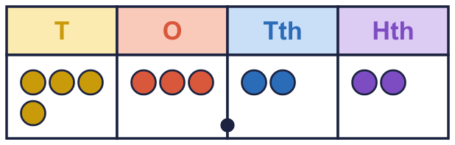
    a) The number is
  1 | Write the number shown on each place value chart.
    a) The number is
  2 | What is the value of the digit in each number?
    a) the digit 8 in 52.18:
    b) the digit 4 in 43.81:
    c) the digit 5 in 47.35:
    d) the digit 3 in 37.21:
  2 | What is the value of the digit in each number?
    a) the digit 8 in 52.18:
    b) the digit 4 in 43.81:
    c) the digit 5 in 47.35:
    d) the digit 3 in 37.21:
  3 | Write the missing number.
    a) 2.46 = 2 + 0.4 +
    b) 1.16 = 1 + |  | + 0.06
    c) 3.91 = 3 + 0.9 +
  3 | Write the missing number.
    a) 2.46 = 2 + 0.4 +
    b) 1.16 = 1 + |  | + 0.06
    c) 3.91 = 3 + 0.9 +
  4 | Write each number as one decimal.
    a) 40 + 2 + 0.2 + 0.07 =
    b) 50 + 4 + 0.1 + 0.07 =
    c) 40 + 5 + 0.7 + 0.04 =
  4 | Write each number as one decimal.
    a) 40 + 2 + 0.2 + 0.07 =
    b) 50 + 4 + 0.1 + 0.07 =
    c) 40 + 5 + 0.7 + 0.04 =
  5 | Use counters to make each number. Write how many counters go in each column. Remember the zeros.  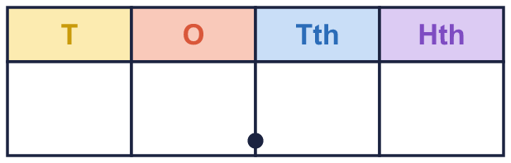
    a) 40.75:
  5 | Use counters to make each number. Write how many counters go in each column. Remember the zeros.
    a) 40.75:
  6 | Write each number as a decimal.
    a) 1 one, 1 tenth and 9 hundredths:
    b) 4 ones, 4 tenths and 1 hundredth:
    c) 2 ones, 2 tenths and 6 hundredths:
  6 | Write each number as a decimal.
    a) 1 one, 1 tenth and 9 hundredths:
    b) 4 ones, 4 tenths and 1 hundredth:
    c) 2 ones, 2 tenths and 6 hundredths:
  7 | Write < or > in each box.
    a) 5.83 |  | 9.94
    b) 2.53 |  | 1.51
    c) 6.42 |  | 5.79
    d) 9.43 |  | 7.27
  7 | Write < or > in each box.
    a) 5.83 |  | 9.94
    b) 2.53 |  | 1.51
    c) 6.42 |  | 5.79
    d) 9.43 |  | 7.27
  8 | Write the missing number.
    a) 36.01 = 30 + 6 +
    b) 26.02 = 20 + 6 +
  8 | Write the missing number.
    a) 36.01 = 30 + 6 +
    b) 26.02 = 20 + 6 +

  9 | 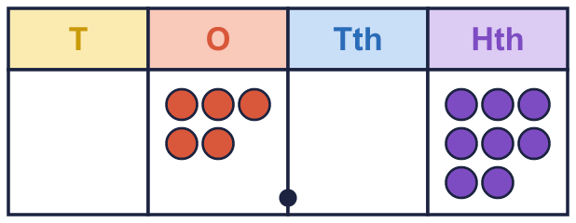  Is Mo correct? Circle yes or no.  Yes / No  Explain how you know.
     | 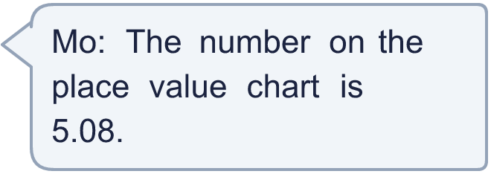
  9 | Is Mo correct? Circle yes or no.  Yes / No  Explain how you know.
  10 | He uses all four cards to make a number like __.__ Write the smallest number he can make.
    
  10 | He uses all four cards to make a number like __.__ Write the smallest number he can make.
  11 | Which of these are equal to 3.62? Write the letters.  A: 3 + 0.6 + 0.02  B: 362 ÷ 100  C: 3 + 0.2 + 0.06  D: 3.6 + 0.02
  11 | Which of these are equal to 3.62? Write the letters.  A: 3 + 0.6 + 0.02  B: 362 ÷ 100  C: 3 + 0.2 + 0.06  D: 3.6 + 0.02
  12 | Write the missing number.
    a) 3.96 = 3 + 0.9 +
  12 | Write the missing number.
    a) 3.96 = 3 + 0.9 +
  13 | Is Zach correct? Circle yes or no.  Yes / No  Explain how you know.
     | 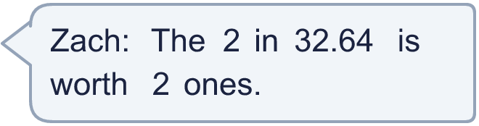
  13 | Is Zach correct? Circle yes or no.  Yes / No  Explain how you know.
  14 | Write a decimal with 2 decimal places that is between 6.1 and 6.2.
  14 | Write a decimal with 2 decimal places that is between 6.1 and 6.2.

Year 4 · Decimals B · Step 3
Partition decimals
Answers (teacher copy)

  1 | Write the number shown on each place value chart.  a) The number is 43.22
  2 | What is the value of the digit in each number?  a) the digit 8 in 52.18: 0.08  b) the digit 4 in 43.81: 40  c) the digit 5 in 47.35: 0.05  d) the digit 3 in 37.21: 30
  3 | Write the missing number.  a) 2.46 = 2 + 0.4 + 0.06  b) 1.16 = 1 + 0.1 + 0.06  c) 3.91 = 3 + 0.9 + 0.01
  4 | Write each number as one decimal.  a) 40 + 2 + 0.2 + 0.07 = 42.27  b) 50 + 4 + 0.1 + 0.07 = 54.17  c) 40 + 5 + 0.7 + 0.04 = 45.74
  5 | Use counters to make each number. Write how many counters go in each column. Remember the zeros.  a) 40.75: 4 0 7 5
  6 | Write each number as a decimal.  a) 1 one, 1 tenth and 9 hundredths: 1.19  b) 4 ones, 4 tenths and 1 hundredth: 4.41  c) 2 ones, 2 tenths and 6 hundredths: 2.26
  7 | Write < or > in each box.  a) 5.83 < 9.94  b) 2.53 > 1.51  c) 6.42 > 5.79  d) 9.43 > 7.27
  8 | Write the missing number.  a) 36.01 = 30 + 6 + 0.01  b) 26.02 = 20 + 6 + 0.02
  9 | Is Mo correct? Circle yes or no.  Yes / No  Explain how you know.  Yes. The chart shows 5 ones, no tenths and 8 hundredths, so the number is 5.08.
  10 | He uses all four cards to make a number like __.__ Write the smallest number he can make.  16.78
  11 | Which of these are equal to 3.62? Write the letters.  A: 3 + 0.6 + 0.02  B: 362 ÷ 100  C: 3 + 0.2 + 0.06  D: 3.6 + 0.02  A, B, D
  12 | Write the missing number.  a) 3.96 = 3 + 0.9 + 0.06
  13 | Is Zach correct? Circle yes or no.  Yes / No  Explain how you know.  Yes. In 32.64 the 2 is in the ones column, so it is worth 2 ones.
  14 | Write a decimal with 2 decimal places that is between 6.1 and 6.2.  6.15

