  Year 4 · Decimals B · Step 6  Order decimals | 
  Year 4 · Decimals B · Step 6
  Order decimals
  1 | Write these decimals in order, starting with the smallest.  8.3 2.7 7.6 6.7
  1 | Write these decimals in order, starting with the smallest.  8.3 2.7 7.6 6.7
  2 | Write these decimals in order, starting with the largest.  1.4 5.1 5.8 9.4
  2 | Write these decimals in order, starting with the largest.  1.4 5.1 5.8 9.4
  3 | Write these decimals in order, starting with the smallest.  3.95 3.88 1.84 1.22
  3 | Write these decimals in order, starting with the smallest.  3.95 3.88 1.84 1.22
  4 | Write these decimals in order, starting with the largest.  0.46 0.67 0.47 0.37
  4 | Write these decimals in order, starting with the largest.  0.46 0.67 0.47 0.37
  5 | These numbers have the same ones. Write them in order, starting with the smallest.  4.14 4.47 4.68 4.71
  5 | These numbers have the same ones. Write them in order, starting with the smallest.  4.14 4.47 4.68 4.71
  6 | Write these decimals in order, starting with the smallest.  3.31 3.01 2.46 1.71 1.1
  6 | Write these decimals in order, starting with the smallest.  3.31 3.01 2.46 1.71 1.1
  7 | The children measure their heights.  Ron: 1.32 m  Mo: 1.52 m  Jack: 1.48 m  Write the names in order, from the shortest to the tallest.
  7 | The children measure their heights.  Ron: 1.32 m  Mo: 1.52 m  Jack: 1.48 m  Write the names in order, from the shortest to the tallest.
  8 | Write the distances in order, starting with the shortest.  1.66 km 1.98 km 2.42 km 1.78 km 1.27 km
  8 | Write the distances in order, starting with the shortest.  1.66 km 1.98 km 2.42 km 1.78 km 1.27 km

  9 | 8.02 8.8 9 8.87  Write them in the correct order:
    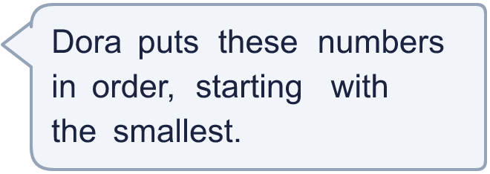
  9 | 8.02 8.8 9 8.87  Write them in the correct order:
  10 | She uses all three cards to make a number like _.__ Write the smallest number she can make.
    
  10 | She uses all three cards to make a number like _.__ Write the smallest number she can make.
  11 | Write a decimal with 2 decimal places that is greater than 0.58 and less than 0.63.
  11 | Write a decimal with 2 decimal places that is greater than 0.58 and less than 0.63.
  12 | Kim has these three numbers: 0.42 0.32 0.36.  Which number is in the middle when they are in order?
  12 | Kim has these three numbers: 0.42 0.32 0.36.  Which number is in the middle when they are in order?
  13 | Write the number that is 1 tenth (0.1) more and the number that is 1 tenth less than 6.76.
    a) 6.76 + 0.1 =
    b) 6.76 − 0.1 =
  13 | Write the number that is 1 tenth (0.1) more and the number that is 1 tenth less than 6.76.
    a) 6.76 + 0.1 =
    b) 6.76 − 0.1 =
  14 | Is Ron correct? Circle yes or no.  Yes / No  Explain how you know.
     | 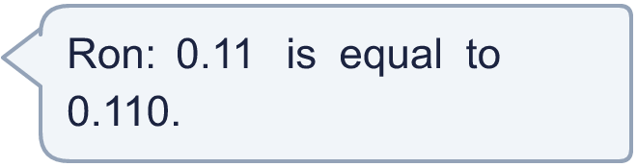
  14 | Is Ron correct? Circle yes or no.  Yes / No  Explain how you know.

Year 4 · Decimals B · Step 6
Order decimals
Answers (teacher copy)

  1 | Write these decimals in order, starting with the smallest.  8.3 2.7 7.6 6.7  2.7, 6.7, 7.6, 8.3
  2 | Write these decimals in order, starting with the largest.  1.4 5.1 5.8 9.4  9.4, 5.8, 5.1, 1.4
  3 | Write these decimals in order, starting with the smallest.  3.95 3.88 1.84 1.22  1.22, 1.84, 3.88, 3.95
  4 | Write these decimals in order, starting with the largest.  0.46 0.67 0.47 0.37  0.67, 0.47, 0.46, 0.37
  5 | These numbers have the same ones. Write them in order, starting with the smallest.  4.14 4.47 4.68 4.71  4.14, 4.47, 4.68, 4.71
  6 | Write these decimals in order, starting with the smallest.  3.31 3.01 2.46 1.71 1.1  1.1, 1.71, 2.46, 3.01, 3.31
  7 | The children measure their heights.  Ron: 1.32 m  Mo: 1.52 m  Jack: 1.48 m  Write the names in order, from the shortest to the tallest. Ron, Jack, Mo
  8 | Write the distances in order, starting with the shortest.  1.66 km 1.98 km 2.42 km 1.78 km 1.27 km  1.27 km, 1.66 km, 1.78 km, 1.98 km, 2.42 km
  9 | 8.02 8.8 9 8.87  Write them in the correct order: 8.02, 8.8, 8.87, 9
  10 | She uses all three cards to make a number like _.__ Write the smallest number she can make.  1.67
  11 | Write a decimal with 2 decimal places that is greater than 0.58 and less than 0.63.  0.6
  12 | Kim has these three numbers: 0.42 0.32 0.36.  Which number is in the middle when they are in order? 0.36
  13 | Write the number that is 1 tenth (0.1) more and the number that is 1 tenth less than 6.76.  a) 6.76 + 0.1 = 6.86  b) 6.76 − 0.1 = 6.66
  14 | Is Ron correct? Circle yes or no.  Yes / No  Explain how you know.  Yes. 0.11 = 0.11 and 0.110 = 0.11, so they are equal.

