  Year 4 · Decimals B · Step 8  Halves and quarters as decimals | 
  Year 4 · Decimals B · Step 8
  Halves and quarters as decimals
  1 | One quarter of the hundred square is shaded. How many hundredths are shaded? Write it as a decimal.  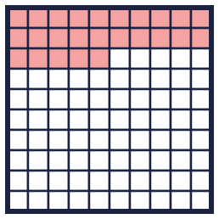
    Hundredths shaded: |  | decimal:
  1 | One quarter of the hundred square is shaded. How many hundredths are shaded? Write it as a decimal.
    Hundredths shaded: |  | decimal:
  2 | Write each fraction as a decimal.
    a) ¹⁄₂ =
    b) ¹⁄₄ =
  2 | Write each fraction as a decimal.
    a) ¹⁄₂ =
    b) ¹⁄₄ =
  3 | Write each decimal as a fraction in its simplest form.
    a) 0.75 =
    b) 0.5 =
  3 | Write each decimal as a fraction in its simplest form.
    a) 0.75 =
    b) 0.5 =
  4 | Complete the equivalent fraction and the decimal.
    a) ¹⁄₄ = |  | /100 =
    b) ³⁄₄ = |  | /100 =
  4 | Complete the equivalent fraction and the decimal.
    a) ¹⁄₄ = |  | /100 =
    b) ³⁄₄ = |  | /100 =
  5 | Complete the equivalent fractions.
    a) ¹⁄₂ = |  | /10
    b) ¹⁄₄ = |  | /100
  5 | Complete the equivalent fractions.
    a) ¹⁄₂ = |  | /10
    b) ¹⁄₄ = |  | /100
  6 | The number line from 0 to 1 is split into 4 equal steps. Write the decimal each arrow points to.  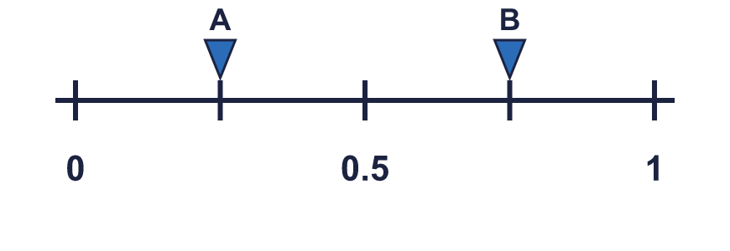
    A = |  | B =
  6 | The number line from 0 to 1 is split into 4 equal steps. Write the decimal each arrow points to.
    A = |  | B =
  7 | Write < or > in each box.
    a) ¹⁄₄ |  | 0.6
    b) ³⁄₄ |  | 0.7
    c) ¹⁄₂ |  | 0.6
  7 | Write < or > in each box.
    a) ¹⁄₄ |  | 0.6
    b) ³⁄₄ |  | 0.7
    c) ¹⁄₂ |  | 0.6
  8 | Write these in order, starting with the smallest.  ³⁄₄ 0.15 0.1 ¹⁄₂
  8 | Write these in order, starting with the smallest.  ³⁄₄ 0.15 0.1 ¹⁄₂

  9 | Is Dora correct? Circle yes or no.  Yes / No  Explain how you know.
     | 
  9 | Is Dora correct? Circle yes or no.  Yes / No  Explain how you know.
  10 | Which of these are equal to 0.25? Write the letters.  A: ¹⁄₄  B: 0.25  C: 0.025  D: ²⁵⁄₁₀₀
  10 | Which of these are equal to 0.25? Write the letters.  A: ¹⁄₄  B: 0.25  C: 0.025  D: ²⁵⁄₁₀₀
  11 | Match each fraction to the equal decimal. Write the letter.  A: 0.5 B: 0.25 C: 0.65 D: 0.75
    a) ¹⁄₄ →
    b) ³⁄₄ →
    c) ¹⁄₂ →
  11 | Match each fraction to the equal decimal. Write the letter.  A: 0.5 B: 0.25 C: 0.65 D: 0.75
    a) ¹⁄₄ →
    b) ³⁄₄ →
    c) ¹⁄₂ →
  12 | Jo drinks ¹⁄₄ litre of juice. Zach drinks 0.5 litre of juice.  How many litres do they drink altogether? Write a decimal.
  12 | Jo drinks ¹⁄₄ litre of juice. Zach drinks 0.5 litre of juice.  How many litres do they drink altogether? Write a decimal.
  13 | Write the decimal each arrow points to. The line is split into 10 equal steps.  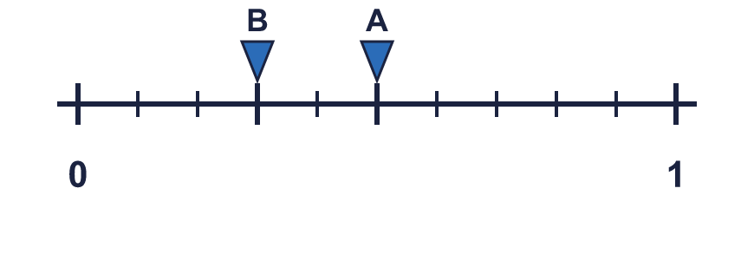
    A = |  | B =
  13 | Write the decimal each arrow points to. The line is split into 10 equal steps.
    A = |  | B =
  14 | Write a decimal that is between ¹⁄₄ and ¹⁄₂.
  14 | Write a decimal that is between ¹⁄₄ and ¹⁄₂.

Year 4 · Decimals B · Step 8
Halves and quarters as decimals
Answers (teacher copy)

  1 | One quarter of the hundred square is shaded. How many hundredths are shaded? Write it as a decimal.  Hundredths shaded: 25 decimal: 0.25
  2 | Write each fraction as a decimal.  a) ¹⁄₂ = 0.5  b) ¹⁄₄ = 0.25
  3 | Write each decimal as a fraction in its simplest form.  a) 0.75 = ³⁄₄  b) 0.5 = ¹⁄₂
  4 | Complete the equivalent fraction and the decimal.  a) ¹⁄₄ = 25 /100 = 0.25  b) ³⁄₄ = 75 /100 = 0.75
  5 | Complete the equivalent fractions.  a) ¹⁄₂ = 5 /10  b) ¹⁄₄ = 25 /100
  6 | The number line from 0 to 1 is split into 4 equal steps. Write the decimal each arrow points to.  A = 0.25 B = 0.75
  7 | Write < or > in each box.  a) ¹⁄₄ < 0.6  b) ³⁄₄ > 0.7  c) ¹⁄₂ < 0.6
  8 | Write these in order, starting with the smallest.  ³⁄₄ 0.15 0.1 ¹⁄₂  0.1, 0.15, ¹⁄₂, ³⁄₄
  9 | Is Dora correct? Circle yes or no.  Yes / No  Explain how you know.  No. ¹⁄₄ = 0.25 and 0.1 = 0.1, so they are not equal.
  10 | Which of these are equal to 0.25? Write the letters.  A: ¹⁄₄  B: 0.25  C: 0.025  D: ²⁵⁄₁₀₀  A, B, D
  11 | Match each fraction to the equal decimal. Write the letter.  A: 0.5 B: 0.25 C: 0.65 D: 0.75  a) ¹⁄₄ → B  b) ³⁄₄ → D  c) ¹⁄₂ → A
  12 | Jo drinks ¹⁄₄ litre of juice. Zach drinks 0.5 litre of juice.  How many litres do they drink altogether? Write a decimal. 0.75
  13 | Write the decimal each arrow points to. The line is split into 10 equal steps.  A = 0.5 B = 0.3
  14 | Write a decimal that is between ¹⁄₄ and ¹⁄₂.  0.3

