  Year 4 · Decimals B · Step 5  Compare decimals | 
  Year 4 · Decimals B · Step 5
  Compare decimals
  1 | Write < or > in each box.
    a) 6.3 |  | 4.4
    b) 1.5 |  | 6.6
    c) 5.1 |  | 2.4
  1 | Write < or > in each box.
    a) 6.3 |  | 4.4
    b) 1.5 |  | 6.6
    c) 5.1 |  | 2.4
  2 | Write < or > in each box.
    a) 6.31 |  | 3.06
    b) 8.82 |  | 4.73
    c) 3.76 |  | 8.28
    d) 5.69 |  | 9.38
  2 | Write < or > in each box.
    a) 6.31 |  | 3.06
    b) 8.82 |  | 4.73
    c) 3.76 |  | 8.28
    d) 5.69 |  | 9.38
  3 | Write < or > in each box.
    a) 1.7 |  | 7.84
    b) 5.79 |  | 1.6
    c) 3.21 |  | 8.6
    d) 8.23 |  | 3.3
  3 | Write < or > in each box.
    a) 1.7 |  | 7.84
    b) 5.79 |  | 1.6
    c) 3.21 |  | 8.6
    d) 8.23 |  | 3.3
  4 | Write <, > or = in each box.
    a) 5.6 |  | 5.60
    b) 0.6 |  | 0.06
    c) 1.20 |  | 1.2
  4 | Write <, > or = in each box.
    a) 5.6 |  | 5.60
    b) 0.6 |  | 0.06
    c) 1.20 |  | 1.2
  5 | A bag of flour has a mass of 0.86 kg. A bag of sugar has a mass of 0.51 kg.  Which bag has the smaller mass? Write flour or sugar.
  5 | A bag of flour has a mass of 0.86 kg. A bag of sugar has a mass of 0.51 kg.  Which bag has the smaller mass? Write flour or sugar.
  6 | Write < or > in each box.
    a) ⁵⁄₁₀ |  | 0.84
    b) ⁹⁄₁₀ |  | 0.99
    c) ¹⁄₁₀ |  | 0.76
  6 | Write < or > in each box.
    a) ⁵⁄₁₀ |  | 0.84
    b) ⁹⁄₁₀ |  | 0.99
    c) ¹⁄₁₀ |  | 0.76
  7 | The children measure their heights.  Mo: 1.32 m  Teddy: 1.42 m  Amir: 1.44 m  Who is the tallest? Write the name.
  7 | The children measure their heights.  Mo: 1.32 m  Teddy: 1.42 m  Amir: 1.44 m  Who is the tallest? Write the name.
  8 | Write < or > in each box.
    a) 1 + 0.5 + 0.05 |  | 7.72
    b) 7 + 0.9 + 0.08 |  | 5.44
    c) 7 + 0.5 + 0.02 |  | 2.88
  8 | Write < or > in each box.
    a) 1 + 0.5 + 0.05 |  | 7.72
    b) 7 + 0.9 + 0.08 |  | 5.44
    c) 7 + 0.5 + 0.02 |  | 2.88

  9 | Amir wants to complete the statement using < or >.  0.56 > 0.54  Is Amir’s statement correct? Circle yes or no.  Yes / No  Explain. Then write the correct symbol.
     | 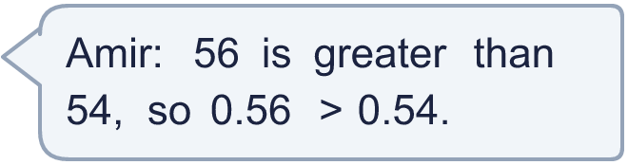
  9 | Amir wants to complete the statement using < or >.  0.56 > 0.54  Is Amir’s statement correct? Circle yes or no.  Yes / No  Explain. Then write the correct symbol.
  10 | Use each card once to make the largest decimal of the form 0.___.
    
  10 | Use each card once to make the largest decimal of the form 0.___.
  11 | Three of these numbers are equal. Write the letter of the number that is different.  A: 0.10  B: 0.1  C: 0.100  D: 0.01
  11 | Three of these numbers are equal. Write the letter of the number that is different.  A: 0.10  B: 0.1  C: 0.100  D: 0.01
  12 | Write a decimal with 2 decimal places that is greater than 0.47 and less than 0.52.
  12 | Write a decimal with 2 decimal places that is greater than 0.47 and less than 0.52.
  13 | Mia wants to complete the statement using < or >.  0.9 < 0.82  Is Mia’s statement correct? Circle yes or no.  Yes / No  Explain. Then write the correct symbol.
     | 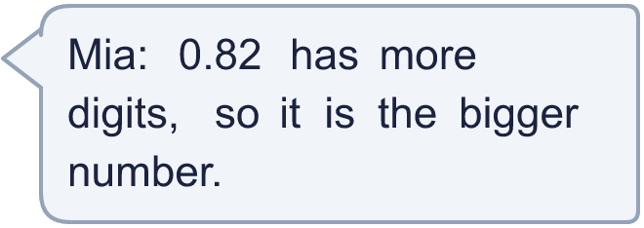
  13 | Mia wants to complete the statement using < or >.  0.9 < 0.82  Is Mia’s statement correct? Circle yes or no.  Yes / No  Explain. Then write the correct symbol.
  14 | Is Sam correct? Circle yes or no.  Yes / No  Explain how you know.
    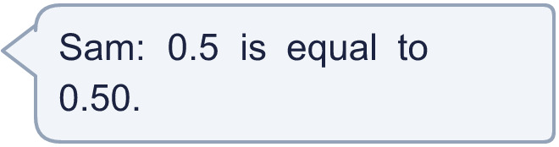
  14 | Is Sam correct? Circle yes or no.  Yes / No  Explain how you know.

Year 4 · Decimals B · Step 5
Compare decimals
Answers (teacher copy)

  1 | Write < or > in each box.  a) 6.3 > 4.4  b) 1.5 < 6.6  c) 5.1 > 2.4
  2 | Write < or > in each box.  a) 6.31 > 3.06  b) 8.82 > 4.73  c) 3.76 < 8.28  d) 5.69 < 9.38
  3 | Write < or > in each box.  a) 1.7 < 7.84  b) 5.79 > 1.6  c) 3.21 < 8.6  d) 8.23 > 3.3
  4 | Write <, > or = in each box.  a) 5.6 = 5.60  b) 0.6 > 0.06  c) 1.20 = 1.2
  5 | A bag of flour has a mass of 0.86 kg. A bag of sugar has a mass of 0.51 kg.  Which bag has the smaller mass? Write flour or sugar. sugar
  6 | Write < or > in each box.  a) ⁵⁄₁₀ < 0.84  b) ⁹⁄₁₀ < 0.99  c) ¹⁄₁₀ < 0.76
  7 | The children measure their heights.  Mo: 1.32 m  Teddy: 1.42 m  Amir: 1.44 m  Who is the tallest? Write the name. Amir
  8 | Write < or > in each box.  a) 1 + 0.5 + 0.05 < 7.72  b) 7 + 0.9 + 0.08 > 5.44  c) 7 + 0.5 + 0.02 > 2.88
  9 | Amir wants to complete the statement using < or >.  0.56 > 0.54  Is Amir’s statement correct? Circle yes or no.  Yes / No  Explain. Then write the correct symbol.  0.56 is more than 0.54. Compare the tenths first, then the hundredths.  >
  10 | Use each card once to make the largest decimal of the form 0.___.  0.743
  11 | Three of these numbers are equal. Write the letter of the number that is different.  A: 0.10  B: 0.1  C: 0.100  D: 0.01  D
  12 | Write a decimal with 2 decimal places that is greater than 0.47 and less than 0.52.  0.49
  13 | Mia wants to complete the statement using < or >.  0.9 < 0.82  Is Mia’s statement correct? Circle yes or no.  Yes / No  Explain. Then write the correct symbol.  0.9 is more than 0.82. Having more digits does not make a decimal bigger. Compare the tenths first.  >
  14 | Is Sam correct? Circle yes or no.  Yes / No  Explain how you know.  Yes. 0.5 = 0.5 and 0.50 = 0.5, so they are equal.

