  Year 4 · Multiplication and division B · Step 2  Use factor pairs | 
  Year 4 · Multiplication and division B · Step 2
  Use factor pairs
  1 | 8 has the factor pair 2 and 4. Work out the three multiplications.  a) 9 × 8 =  b) 9 × 2 × 4 =  c) 18 × 4 =
  1 | 8 has the factor pair 2 and 4. Work out the three multiplications.  a) 9 × 8 =  b) 9 × 2 × 4 =  c) 18 × 4 =
  2 | Use the factor pair 2 and 5 to work out 8 × 10. Complete the working.
    8 × 10 = 8 × 2 × 5 = |  | × 5 =
  2 | Use the factor pair 2 and 5 to work out 8 × 10. Complete the working.
    8 × 10 = 8 × 2 × 5 = |  | × 5 =
  3 | Dani works out 14 × 6 using the factor pair 2 and 3. Complete the multiplication.
    14 × 6 = 14 × 2 × 3 = | 28 × 3 =
  3 | Dani works out 14 × 6 using the factor pair 2 and 3. Complete the multiplication.
    14 × 6 = 14 × 2 × 3 = | 28 × 3 =
  4 | Use factor pairs to work out the multiplications. Show your working.  a) 18 × 7  b) 14 × 5
  4 | Use factor pairs to work out the multiplications. Show your working.  a) 18 × 7  b) 14 × 5
  5 | A box of crayons contains 12 crayons.
    How many crayons are there in 9 boxes?
  5 | A box of crayons contains 12 crayons.
    How many crayons are there in 9 boxes?
  6 | Write the missing number in each multiplication.
    a) | 5 × 12 = 5 × |  | × 6
    b) | 12 × 5 = |  | × 2 × 5
  6 | Write the missing number in each multiplication.
    a) | 5 × 12 = 5 × |  | × 6
    b) | 12 × 5 = |  | × 2 × 5
  7 | Work out the multiplications. Choose the order that is easiest for you.  a) 12 × 3 × 2 =  b) 3 × 12 × 2 =  c) 2 × 3 × 12 =
  7 | Work out the multiplications. Choose the order that is easiest for you.  a) 12 × 3 × 2 =  b) 3 × 12 × 2 =  c) 2 × 3 × 12 =
  8 | Use the factor pair 2 and 3 to work out 9 × 6. Complete the working.
    9 × 6 = 9 × 2 × 3 = |  | × 3 =
  8 | Use the factor pair 2 and 3 to work out 9 × 6. Complete the working.
    9 × 6 = 9 × 2 × 3 = |  | × 3 =

  9 | a) What mistake has Tiny made?
     | 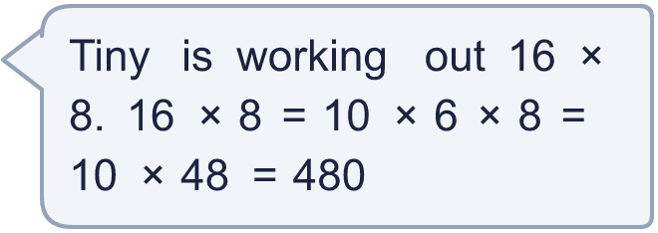
    b) | Use a factor pair to work out 16 × 8:
  9 | a) What mistake has Tiny made?
    b) | Use a factor pair to work out 16 × 8:
  10 | Write two different multiplications of two numbers that I could have been working out.
     | 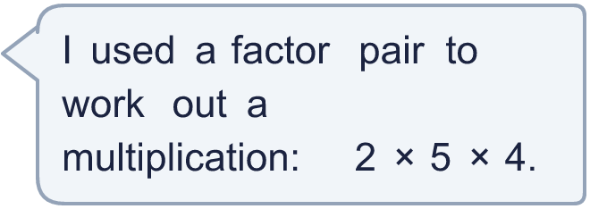
  10 | Write two different multiplications of two numbers that I could have been working out.
  11 | Sam is working out 24 × 5. Sam knows that 12 × 10 = 120.  Use factor pairs to show how Sam can use this fact to work out 24 × 5.
  11 | Sam is working out 24 × 5. Sam knows that 12 × 10 = 120.  Use factor pairs to show how Sam can use this fact to work out 24 × 5.
  12 | Is Boba correct? Circle yes or no.  Yes / No  Explain how you know.
     | 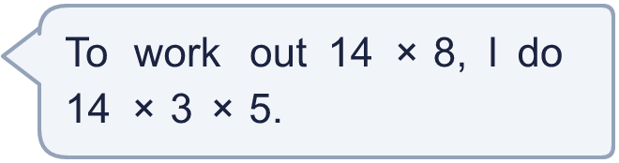
  12 | Is Boba correct? Circle yes or no.  Yes / No  Explain how you know.
  13 | a) How many buns is that?  b) 32 buns are sold. How many buns are left?
    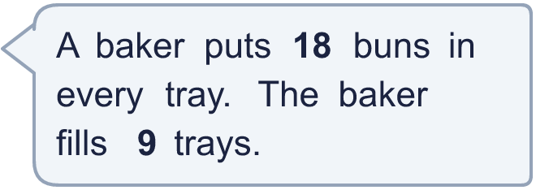
  13 | a) How many buns is that?  b) 32 buns are sold. How many buns are left?
  14 | Is Dexter correct? Circle yes or no.  Yes / No  Explain how you know.
    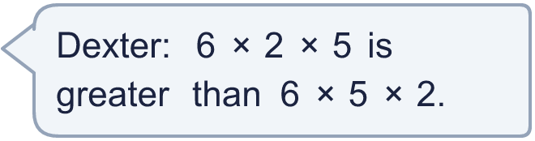
  14 | Is Dexter correct? Circle yes or no.  Yes / No  Explain how you know.

Year 4 · Multiplication and division B · Step 2
Use factor pairs
Answers (teacher copy)

  1 | 8 has the factor pair 2 and 4. Work out the three multiplications.  a) 9 × 8 = 72  b) 9 × 2 × 4 = 72  c) 18 × 4 = 72
  2 | Use the factor pair 2 and 5 to work out 8 × 10. Complete the working.  8 × 10 = 8 × 2 × 5 = 16 × 5 = 80
  3 | Dani works out 14 × 6 using the factor pair 2 and 3. Complete the multiplication.  14 × 6 = 14 × 2 × 3 = 28 × 3 = 84
  4 | Use factor pairs to work out the multiplications. Show your working.  a) 18 × 7  for example 18 × 7 = 2 × 9 × 7 = 2 × 63 = 126  b) 14 × 5  for example 14 × 5 = 2 × 7 × 5 = 2 × 35 = 70
  5 | A box of crayons contains 12 crayons.  How many crayons are there in 9 boxes? 108
  6 | Write the missing number in each multiplication.  a) 5 × 12 = 5 × 2 × 6  b) 12 × 5 = 6 × 2 × 5
  7 | Work out the multiplications. Choose the order that is easiest for you.  a) 12 × 3 × 2 = 72  b) 3 × 12 × 2 = 72  c) 2 × 3 × 12 = 72
  8 | Use the factor pair 2 and 3 to work out 9 × 6. Complete the working.  9 × 6 = 9 × 2 × 3 = 18 × 3 = 54
  9 | a) What mistake has Tiny made?  Tiny has split 16 into 10 + 6 and multiplied the parts, instead of using a factor pair of 16. 10 × 6 is not 16.  b) Use a factor pair to work out 16 × 8: 128
  10 | Write two different multiplications of two numbers that I could have been working out.  for example 10 × 4; 8 × 5; 20 × 2
  11 | Sam is working out 24 × 5. Sam knows that 12 × 10 = 120.  Use factor pairs to show how Sam can use this fact to work out 24 × 5.  for example 24 × 5 = 12 × 2 × 5 = 12 × 10 = 120
  12 | Is Boba correct? Circle yes or no.  Yes / No  Explain how you know.  No. 3 × 5 = 15, not 8, so 3 and 5 are not a factor pair of 8.
  13 | a) How many buns is that? 162  b) 32 buns are sold. How many buns are left? 130
  14 | Is Dexter correct? Circle yes or no.  Yes / No  Explain how you know.  No. 6 × 2 × 5 = 60 and 6 × 5 × 2 = 60, so they are equal.

