  Year 4 · Multiplication and division B · Step 7  Related facts (multiplication and division) | 
  Year 4 · Multiplication and division B · Step 7
  Related facts (multiplication and division)
  1 | Use the first fact to help you with the others.  a) 8 × 9 =  b) 8 × 90 =  c) 8 × 900 =
  1 | Use the first fact to help you with the others.  a) 8 × 9 =  b) 8 × 90 =  c) 8 × 900 =
  2 | Complete the number sentences.
    a) | 3 × 4 hundreds = |  | hundreds
    =
    b) | 5 × 6 tens = |  | tens
    =
  2 | Complete the number sentences.
    a) | 3 × 4 hundreds = |  | hundreds
    =
    b) | 5 × 6 tens = |  | tens
    =
  3 | Use the first fact to help you with the others.  a) 56 ÷ 7 =  b) 560 ÷ 7 =  c) 5,600 ÷ 7 =
  3 | Use the first fact to help you with the others.  a) 56 ÷ 7 =  b) 560 ÷ 7 =  c) 5,600 ÷ 7 =
  4 | Complete the number sentences.
    a) | 48 tens ÷ 8 = |  | tens
    =
    b) | 64 tens ÷ 8 = |  | tens
    =
  4 | Complete the number sentences.
    a) | 48 tens ÷ 8 = |  | tens
    =
    b) | 64 tens ÷ 8 = |  | tens
    =
  5 | Work out the multiplications.  a) 9 × 9 =  b) 90 × 9 =  c) 900 × 9 =  d) 9 × 90 =
  5 | Work out the multiplications.  a) 9 × 9 =  b) 90 × 9 =  c) 900 × 9 =  d) 9 × 90 =
  6
    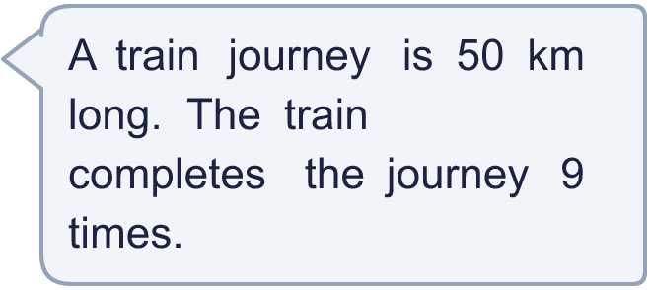
    How far (in km) has the train travelled in total?
  6
    How far (in km) has the train travelled in total?
  7 | A school raises £3,000 at a fundraiser. They share the money equally between 6 charities.
    How much does each charity receive?
  7 | A school raises £3,000 at a fundraiser. They share the money equally between 6 charities.
    How much does each charity receive?
  8 | Write <, > or = in each box.
    a) | 700 × 4 |  | 7 × 400
    b) | 5 × 300 |  | 500 × 3
    c) | 350 ÷ 5 |  | 3,500 ÷ 5
    d) | 3,500 ÷ 7 |  | 3,500 ÷ 8
  8 | Write <, > or = in each box.
    a) | 700 × 4 |  | 7 × 400
    b) | 5 × 300 |  | 500 × 3
    c) | 350 ÷ 5 |  | 3,500 ÷ 5
    d) | 3,500 ÷ 7 |  | 3,500 ÷ 8

  9 | Is Boba correct? Circle yes or no.  Yes / No  Explain how you know.
     | 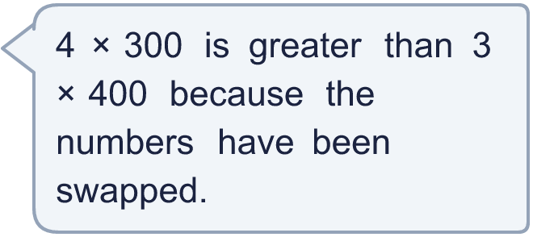
  9 | Is Boba correct? Circle yes or no.  Yes / No  Explain how you know.
  10 | 6 × 3 = 18. Write four other facts that you can work out from this number sentence.
  10 | 6 × 3 = 18. Write four other facts that you can work out from this number sentence.
  11 | There are 5 machines making toys in a factory. Each machine makes 400 toys in a day. The toys are packed equally into 2 containers.
    How many toys are in each container?
  11 | There are 5 machines making toys in a factory. Each machine makes 400 toys in a day. The toys are packed equally into 2 containers.
    How many toys are in each container?
  12 | Write the missing number in each calculation.
    a) | 4 × |  | = 3,600
    b) |  | ÷ 8 = 300
    c) |  | × 3 = 900
  12 | Write the missing number in each calculation.
    a) | 4 × |  | = 3,600
    b) |  | ÷ 8 = 300
    c) |  | × 3 = 900
  13 | Is Boba correct? Circle yes or no.  Yes / No  Explain how you know.
     | 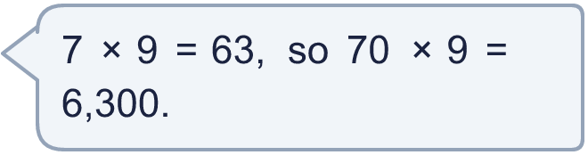
  13 | Is Boba correct? Circle yes or no.  Yes / No  Explain how you know.
  14 | Write three different multiplications that each make 2,800. Use a single-digit number and a multiple of 100.
  14 | Write three different multiplications that each make 2,800. Use a single-digit number and a multiple of 100.

Year 4 · Multiplication and division B · Step 7
Related facts (multiplication and division)
Answers (teacher copy)

  1 | Use the first fact to help you with the others.  a) 8 × 9 = 72  b) 8 × 90 = 720  c) 8 × 900 = 7,200
  2 | Complete the number sentences.  a) 3 × 4 hundreds = 12 hundreds = 1,200  b) 5 × 6 tens = 30 tens = 300
  3 | Use the first fact to help you with the others.  a) 56 ÷ 7 = 8  b) 560 ÷ 7 = 80  c) 5,600 ÷ 7 = 800
  4 | Complete the number sentences.  a) 48 tens ÷ 8 = 6 tens = 60  b) 64 tens ÷ 8 = 8 tens = 80
  5 | Work out the multiplications.  a) 9 × 9 = 81  b) 90 × 9 = 810  c) 900 × 9 = 8,100  d) 9 × 90 = 810
  6 | How far (in km) has the train travelled in total? 450
  7 | A school raises £3,000 at a fundraiser. They share the money equally between 6 charities.  How much does each charity receive? £500
  8 | Write <, > or = in each box.  a) 700 × 4 = 7 × 400  b) 5 × 300 = 500 × 3  c) 350 ÷ 5 < 3,500 ÷ 5  d) 3,500 ÷ 7 > 3,500 ÷ 8
  9 | Is Boba correct? Circle yes or no.  Yes / No  Explain how you know.  No. 4 × 300 = 1,200 and 3 × 400 = 1,200, so they are equal.
  10 | 6 × 3 = 18. Write four other facts that you can work out from this number sentence.  for example 18 ÷ 6 = 3; 18 ÷ 3 = 6; 3 × 6 = 18; 60 × 3 = 180
  11 | There are 5 machines making toys in a factory. Each machine makes 400 toys in a day. The toys are packed equally into 2 containers.  How many toys are in each container? 1,000
  12 | Write the missing number in each calculation.  a) 4 × 900 = 3,600  b) 2,400 ÷ 8 = 300  c) 300 × 3 = 900
  13 | Is Boba correct? Circle yes or no.  Yes / No  Explain how you know.  No. 70 × 9 = 630, not 6,300.
  14 | Write three different multiplications that each make 2,800. Use a single-digit number and a multiple of 100.  for example 2 × 1400; 4 × 700; 7 × 400

