  Year 4 · Multiplication and division B · Step 8  Multiply a 3-digit number by a 1-digit number | 
  Year 4 · Multiplication and division B · Step 8
  Multiply a 3-digit number by a 1-digit number
  1 | Multiply. There is no exchange to make.  a) 43 × 2 =  b) 212 × 4 =  c) 212 × 3 =
  1 | Multiply. There is no exchange to make.  a) 43 × 2 =  b) 212 × 4 =  c) 212 × 3 =
  2 | Write the missing digits in the multiplication 629 × 5.  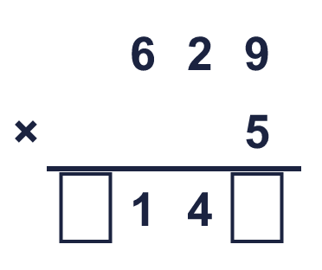  Missing digits, from top to bottom and left to right:
  2 | Write the missing digits in the multiplication 629 × 5.  Missing digits, from top to bottom and left to right:
  3 | Work out the multiplications. Use the column method.  a) 97 × 9 =  b) 549 × 4 =  c) 729 × 9 =
  3 | Work out the multiplications. Use the column method.  a) 97 × 9 =  b) 549 × 4 =  c) 729 × 9 =
  4 | Work out the multiplications. Watch the zeros.  a) 704 × 9 =  b) 203 × 2 =
  4 | Work out the multiplications. Watch the zeros.  a) 704 × 9 =  b) 203 × 2 =
  5 | Estimate 178 × 9 by rounding each number to its first digit (1 significant figure).  Estimate:
  5 | Estimate 178 × 9 by rounding each number to its first digit (1 significant figure).  Estimate:
  6 | A bus carries 321 children. There are 7 buses.  How many children are there?
  6 | A bus carries 321 children. There are 7 buses.  How many children are there?
  7 | One ticket costs £3.70. A family buys 7 tickets.  How much do the tickets cost altogether?
  7 | One ticket costs £3.70. A family buys 7 tickets.  How much do the tickets cost altogether?
  8 | Look at this calculation: 889 × 6. Without working it out, which of these could be the answer? Use the ones digit and an estimate.  5,340 5,334 533
  8 | Look at this calculation: 889 × 6. Without working it out, which of these could be the answer? Use the ones digit and an estimate.  5,340 5,334 533

  9 | Is Boba correct? Circle yes or no.  Yes / No  Explain how you know.
     | 
  9 | Is Boba correct? Circle yes or no.  Yes / No  Explain how you know.
  10 | 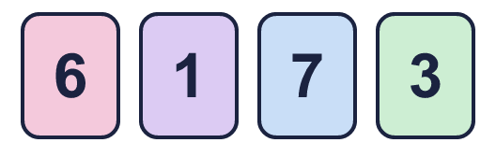  a) What is the greatest product you can make?  b) What is the smallest product you can make?
    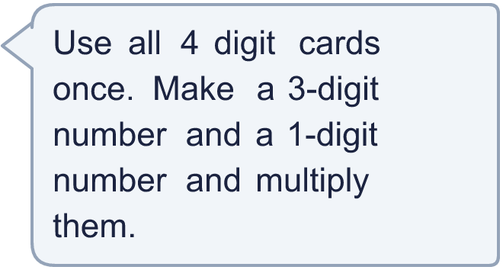
  10 | a) What is the greatest product you can make?  b) What is the smallest product you can make?
  11 | What number did I start with?
     | 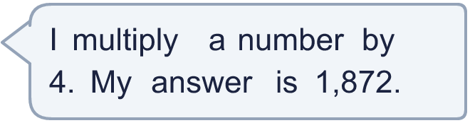
  11 | What number did I start with?
  12 | a) How many points does Amir score altogether?  b) How many points does Whitney score altogether?  c) How many more points does the higher scorer have?
     | 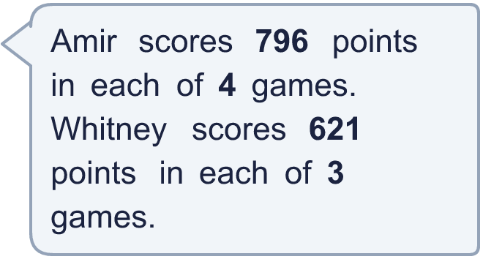
  12 | a) How many points does Amir score altogether?  b) How many points does Whitney score altogether?  c) How many more points does the higher scorer have?
  13 | Use this fact to work out the other multiplications. You do not need the column method.  a) 199 × 5 =  b) 199 × 7 =  c) 200 × 6 =
    
  13 | Use this fact to work out the other multiplications. You do not need the column method.  a) 199 × 5 =  b) 199 × 7 =  c) 200 × 6 =
  14 | Write a 3-digit number and a 1-digit number that multiply to give an answer between 1,000 and 2,000.
  14 | Write a 3-digit number and a 1-digit number that multiply to give an answer between 1,000 and 2,000.

Year 4 · Multiplication and division B · Step 8
Multiply a 3-digit number by a 1-digit number
Answers (teacher copy)

  1 | Multiply. There is no exchange to make.  a) 43 × 2 = 86  b) 212 × 4 = 848  c) 212 × 3 = 636
  2 | Write the missing digits in the multiplication 629 × 5.  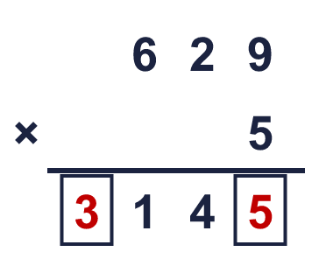  Missing digits, from top to bottom and left to right: 3 5
  3 | Work out the multiplications. Use the column method.  a) 97 × 9 = 873  b) 549 × 4 = 2,196  c) 729 × 9 = 6,561
  4 | Work out the multiplications. Watch the zeros.  a) 704 × 9 = 6,336  b) 203 × 2 = 406
  5 | Estimate 178 × 9 by rounding each number to its first digit (1 significant figure).  Estimate: 1,800
  6 | A bus carries 321 children. There are 7 buses.  How many children are there? 2,247
  7 | One ticket costs £3.70. A family buys 7 tickets.  How much do the tickets cost altogether? £25.90
  8 | Look at this calculation: 889 × 6. Without working it out, which of these could be the answer? Use the ones digit and an estimate.  5,340 5,334 533  5,334
  9 | Is Boba correct? Circle yes or no.  Yes / No  Explain how you know.  0 × 2 = 0, so the answer must end in 0. The correct answer is 590 × 2 = 1,180, not 1,190.
  10 | a) What is the greatest product you can make? 4,417  b) What is the smallest product you can make? 367
  11 | What number did I start with? 468
  12 | a) How many points does Amir score altogether? 3,184  b) How many points does Whitney score altogether? 1,863  c) How many more points does the higher scorer have? 1,321
  13 | Use this fact to work out the other multiplications. You do not need the column method.  a) 199 × 5 = 995  b) 199 × 7 = 1,393  c) 200 × 6 = 1,200
  14 | Write a 3-digit number and a 1-digit number that multiply to give an answer between 1,000 and 2,000.  Any 3-digit × 1-digit multiplication with a product between 1,000 and 2,000, for example 341 × 4 or 834 × 2

