  Year 4 · Multiplication and division B · Step 7  Multiply a 2-digit number by a 1-digit number | 
  Year 4 · Multiplication and division B · Step 7
  Multiply a 2-digit number by a 1-digit number
  1 | Multiply. There is no exchange to make.  a) 12 × 4 =  b) 22 × 4 =  c) 11 × 4 =
  1 | Multiply. There is no exchange to make.  a) 12 × 4 =  b) 22 × 4 =  c) 11 × 4 =
  2 | Write the missing digits in the multiplication 38 × 2.  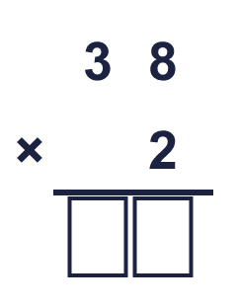  Missing digits, from top to bottom and left to right:
  2 | Write the missing digits in the multiplication 38 × 2.  Missing digits, from top to bottom and left to right:
  3 | Work out the multiplications. Use the column method.  a) 93 × 3 =  b) 79 × 8 =  c) 47 × 8 =
  3 | Work out the multiplications. Use the column method.  a) 93 × 3 =  b) 79 × 8 =  c) 47 × 8 =
  4 | Work out the multiplications. Watch the zeros.  a) 90 × 4 =  b) 401 × 4 =
  4 | Work out the multiplications. Watch the zeros.  a) 90 × 4 =  b) 401 × 4 =
  5 | Estimate 47 × 8 by rounding each number to its first digit (1 significant figure).  Estimate:
  5 | Estimate 47 × 8 by rounding each number to its first digit (1 significant figure).  Estimate:
  6 | A bus carries 21 children. There are 7 buses.  How many children are there?
  6 | A bus carries 21 children. There are 7 buses.  How many children are there?
  7 | One ticket costs £6.99. A family buys 7 tickets.  How much do the tickets cost altogether?
  7 | One ticket costs £6.99. A family buys 7 tickets.  How much do the tickets cost altogether?
  8 | Look at this calculation: 22 × 6. Without working it out, which of these could be the answer? Use the ones digit and an estimate.  132 135 13
  8 | Look at this calculation: 22 × 6. Without working it out, which of these could be the answer? Use the ones digit and an estimate.  132 135 13

  9 | Is Boba correct? Circle yes or no.  Yes / No  Explain how you know.
     | 
  9 | Is Boba correct? Circle yes or no.  Yes / No  Explain how you know.
  10 | 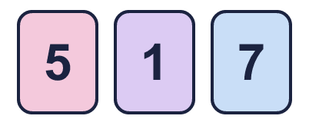  a) What is the greatest product you can make?  b) What is the smallest product you can make?
    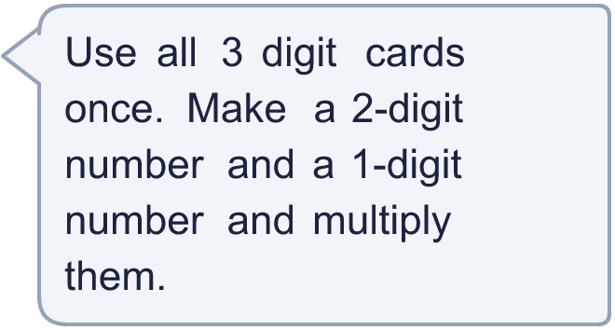
  10 | a) What is the greatest product you can make?  b) What is the smallest product you can make?
  11 | What number did I start with?
     | 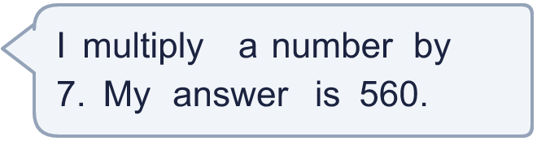
  11 | What number did I start with?
  12 | a) How many points does Amir score altogether?  b) How many points does Whitney score altogether?  c) How many more points does the higher scorer have?
     | 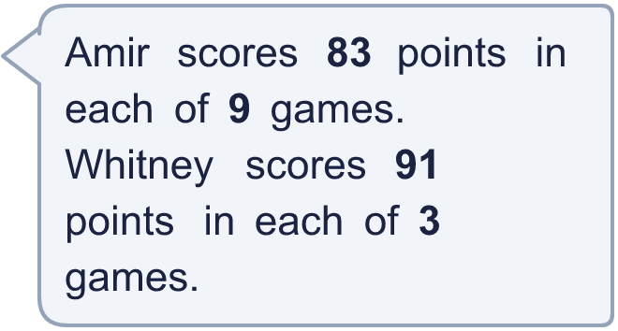
  12 | a) How many points does Amir score altogether?  b) How many points does Whitney score altogether?  c) How many more points does the higher scorer have?
  13 | Use this fact to work out the other multiplications. You do not need the column method.  a) 22 × 6 =  b) 22 × 8 =  c) 23 × 7 =
    
  13 | Use this fact to work out the other multiplications. You do not need the column method.  a) 22 × 6 =  b) 22 × 8 =  c) 23 × 7 =
  14 | Write a 2-digit number and a 1-digit number that multiply to give an answer between 80 and 90.
  14 | Write a 2-digit number and a 1-digit number that multiply to give an answer between 80 and 90.

Year 4 · Multiplication and division B · Step 7
Multiply a 2-digit number by a 1-digit number
Answers (teacher copy)

  1 | Multiply. There is no exchange to make.  a) 12 × 4 = 48  b) 22 × 4 = 88  c) 11 × 4 = 44
  2 | Write the missing digits in the multiplication 38 × 2.  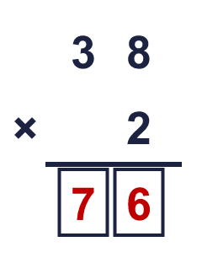  Missing digits, from top to bottom and left to right: 7 6
  3 | Work out the multiplications. Use the column method.  a) 93 × 3 = 279  b) 79 × 8 = 632  c) 47 × 8 = 376
  4 | Work out the multiplications. Watch the zeros.  a) 90 × 4 = 360  b) 401 × 4 = 1,604
  5 | Estimate 47 × 8 by rounding each number to its first digit (1 significant figure).  Estimate: 400
  6 | A bus carries 21 children. There are 7 buses.  How many children are there? 147
  7 | One ticket costs £6.99. A family buys 7 tickets.  How much do the tickets cost altogether? £48.93
  8 | Look at this calculation: 22 × 6. Without working it out, which of these could be the answer? Use the ones digit and an estimate.  132 135 13  132
  9 | Is Boba correct? Circle yes or no.  Yes / No  Explain how you know.  3 × 9 = 27, so the answer must end in 7. The correct answer is 53 × 9 = 477, not 487.
  10 | a) What is the greatest product you can make? 357  b) What is the smallest product you can make? 57
  11 | What number did I start with? 80
  12 | a) How many points does Amir score altogether? 747  b) How many points does Whitney score altogether? 273  c) How many more points does the higher scorer have? 474
  13 | Use this fact to work out the other multiplications. You do not need the column method.  a) 22 × 6 = 132  b) 22 × 8 = 176  c) 23 × 7 = 161
  14 | Write a 2-digit number and a 1-digit number that multiply to give an answer between 80 and 90.  Any 2-digit × 1-digit multiplication with a product between 80 and 90, for example 85 × 1 or 87 × 1

