  Year 4 · Multiplication and division B · Step 8  Informal written methods for multiplication | 
  Year 4 · Multiplication and division B · Step 8
  Informal written methods for multiplication
  1 | Complete the area model for 33 × 9.  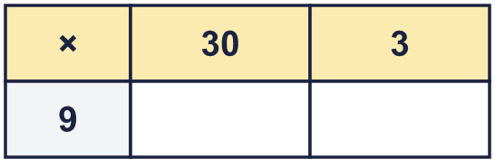  So 33 × 9 =
  1 | Complete the area model for 33 × 9.  So 33 × 9 =
  2 | Use partitioning to work out 85 × 5.  a) 80 × 5 =  b) 5 × 5 =  c) 85 × 5 =
  2 | Use partitioning to work out 85 × 5.  a) 80 × 5 =  b) 5 × 5 =  c) 85 × 5 =
  3 | Work out the multiplications. Use any method you like.  a) 47 × 3 =  b) 88 × 8 =  c) 77 × 6 =
  3 | Work out the multiplications. Use any method you like.  a) 47 × 3 =  b) 88 × 8 =  c) 77 × 6 =
  4 | The area model shows 16 × 3 = 48. Write the missing number.  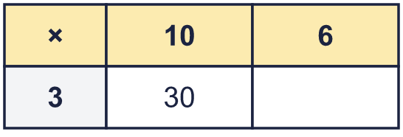  Missing number:
  4 | The area model shows 16 × 3 = 48. Write the missing number.  Missing number:
  5 | Write the missing number.
    a) | 18 × |  | = | 108
    b) |  | × 6 | = | 108
  5 | Write the missing number.
    a) | 18 × |  | = | 108
    b) |  | × 6 | = | 108
  6 | A baker makes 9 trays of buns. Each tray has 24 buns.  a) How many buns are there?  b) 7 buns are eaten. How many buns are left?
  6 | A baker makes 9 trays of buns. Each tray has 24 buns.  a) How many buns are there?  b) 7 buns are eaten. How many buns are left?
  7 | Use partitioning to work out 36 × 8.  a) 30 × 8 =  b) 6 × 8 =  c) 36 × 8 =
  7 | Use partitioning to work out 36 × 8.  a) 30 × 8 =  b) 6 × 8 =  c) 36 × 8 =
  8 | Work out the multiplications. Use any method you like.  a) 36 × 7 =  b) 28 × 9 =  c) 58 × 5 =
  8 | Work out the multiplications. Use any method you like.  a) 36 × 7 =  b) 28 × 9 =  c) 58 × 5 =

  9 | Is Boba correct? Circle yes or no.  Yes / No  What is the correct answer?  Explain Boba’s mistake.
    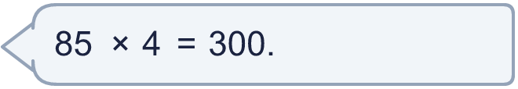
  9 | Is Boba correct? Circle yes or no.  Yes / No  What is the correct answer?  Explain Boba’s mistake.
  10 | a) How long is the yellow ribbon?  b) How much longer is the yellow ribbon than the red ribbon?
     | 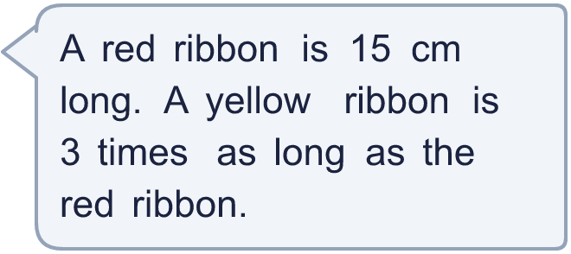
  10 | a) How long is the yellow ribbon?  b) How much longer is the yellow ribbon than the red ribbon?
  11 | The area model shows 45 × 5 = 225. Write the missing number.  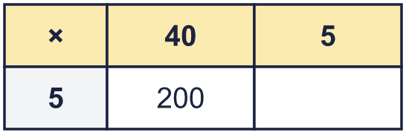  Missing number:
  11 | The area model shows 45 × 5 = 225. Write the missing number.  Missing number:
  12 | Write the missing number.
    a) | 44 × |  | = | 132
    b) |  | × 3 | = | 132
  12 | Write the missing number.
    a) | 44 × |  | = | 132
    b) |  | × 3 | = | 132
  13 | There are 12 players in a team. 6 teams have signed up for a tournament.  a) How many players have signed up?  b) The tournament needs 96 players. How many more teams are needed?
  13 | There are 12 players in a team. 6 teams have signed up for a tournament.  a) How many players have signed up?  b) The tournament needs 96 players. How many more teams are needed?
  14 | Is Boba correct? Circle yes or no.  Yes / No  What is the correct answer?  Explain Boba’s mistake.
    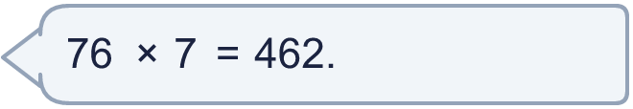
  14 | Is Boba correct? Circle yes or no.  Yes / No  What is the correct answer?  Explain Boba’s mistake.

Year 4 · Multiplication and division B · Step 8
Informal written methods for multiplication
Answers (teacher copy)

  1 | Complete the area model for 33 × 9.  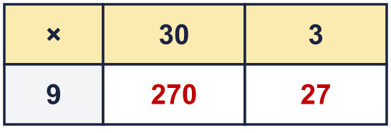  So 33 × 9 = 297
  2 | Use partitioning to work out 85 × 5.  a) 80 × 5 = 400  b) 5 × 5 = 25  c) 85 × 5 = 425
  3 | Work out the multiplications. Use any method you like.  a) 47 × 3 = 141  b) 88 × 8 = 704  c) 77 × 6 = 462
  4 | The area model shows 16 × 3 = 48. Write the missing number.  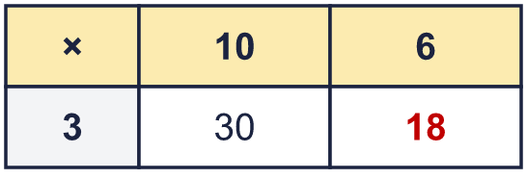  Missing number: 18
  5 | Write the missing number.  a) 18 × 6 = 108  b) 18 × 6 = 108
  6 | A baker makes 9 trays of buns. Each tray has 24 buns.  a) How many buns are there? 216  b) 7 buns are eaten. How many buns are left? 209
  7 | Use partitioning to work out 36 × 8.  a) 30 × 8 = 240  b) 6 × 8 = 48  c) 36 × 8 = 288
  8 | Work out the multiplications. Use any method you like.  a) 36 × 7 = 252  b) 28 × 9 = 252  c) 58 × 5 = 290
  9 | Is Boba correct? Circle yes or no.  Yes / No  What is the correct answer? 340  Explain Boba’s mistake.  85 × 4: 80 × 4 = 320 and 5 × 4 = 20, so the answer is 340. Boba did not count all of the tens.
  10 | a) How long is the yellow ribbon? 45 cm  b) How much longer is the yellow ribbon than the red ribbon? 30 cm
  11 | The area model shows 45 × 5 = 225. Write the missing number.  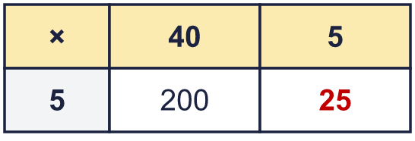  Missing number: 25
  12 | Write the missing number.  a) 44 × 3 = 132  b) 44 × 3 = 132
  13 | There are 12 players in a team. 6 teams have signed up for a tournament.  a) How many players have signed up? 72  b) The tournament needs 96 players. How many more teams are needed? 2
  14 | Is Boba correct? Circle yes or no.  Yes / No  What is the correct answer? 532  Explain Boba’s mistake.  76 × 7: 70 × 7 = 490 and 6 × 7 = 42, so the answer is 532. Boba did not count all of the tens.

