  Year 4 · Multiplication and division B · Step 1  Identify and use factor pairs | 
  Year 4 · Multiplication and division B · Step 1
  Identify and use factor pairs
  1 | Complete the factor pairs of 20.
    a) | 1 × |  | = 20
    b) | 2 × |  | = 20
    c) | 4 × |  | = 20
    d) | 5 × |  | = 20
  1 | Complete the factor pairs of 20.
    a) | 1 × |  | = 20
    b) | 2 × |  | = 20
    c) | 4 × |  | = 20
    d) | 5 × |  | = 20
  2 | Write all the factors of each number.  a) 18:  b) 32:
  2 | Write all the factors of each number.  a) 18:  b) 32:
  3 | Circle the factors of 48. Write them below.  12 3 39 9 32 47 16 6
  3 | Circle the factors of 48. Write them below.  12 3 39 9 32 47 16 6
  4 | Is the first number a factor of the second? Write yes or no.  a) Is 6 a factor of 54?  b) Is 8 a factor of 48?  c) Is 5 a factor of 46?
  4 | Is the first number a factor of the second? Write yes or no.  a) Is 6 a factor of 54?  b) Is 8 a factor of 48?  c) Is 5 a factor of 46?
  5 | Write how many factors each number has.  a) 9:  b) 28:  c) 20:
  5 | Write how many factors each number has.  a) 9:  b) 28:  c) 20:
  6 | Which number has more factors? Write the number.  16 18
  6 | Which number has more factors? Write the number.  16 18
  7 | Whitney bakes 40 cakes. Boxes can hold 2, 3, 4, 5, 6, 8 or 10 cakes. She wants to fill every box.  Which boxes could she use with no cakes left over?
  7 | Whitney bakes 40 cakes. Boxes can hold 2, 3, 4, 5, 6, 8 or 10 cakes. She wants to fill every box.  Which boxes could she use with no cakes left over?
  8 | Complete the factor pairs of 12.
    a) | 1 × |  | = 12
    b) | 2 × |  | = 12
    c) | 3 × |  | = 12
    d) | 4 × |  | = 12
  8 | Complete the factor pairs of 12.
    a) | 1 × |  | = 12
    b) | 2 × |  | = 12
    c) | 3 × |  | = 12
    d) | 4 × |  | = 12

  9 | Is Boba correct? Circle yes or no.  Yes / No  Explain your answer.
     | 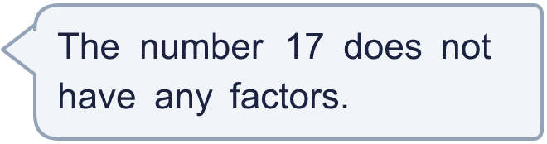
  9 | Is Boba correct? Circle yes or no.  Yes / No  Explain your answer.
  10 | What number am I thinking of?
    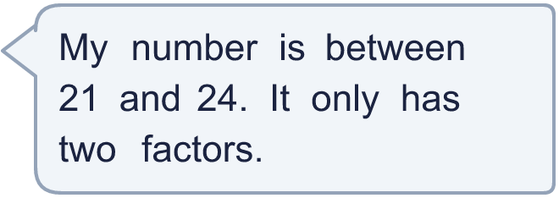
  10 | What number am I thinking of?
  11 | Is Boba correct? Circle yes or no.  Yes / No  Explain the mistake.
     | 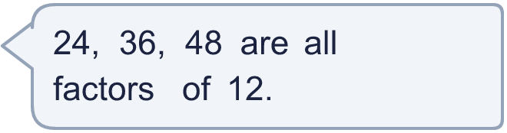
  11 | Is Boba correct? Circle yes or no.  Yes / No  Explain the mistake.
  12 | Is the statement always, sometimes or never true?  Numbers have an even number of factors, because factors come in pairs.  Always, sometimes or never?  Explain your answer.
  12 | Is the statement always, sometimes or never true?  Numbers have an even number of factors, because factors come in pairs.  Always, sometimes or never?  Explain your answer.
  13 | Whitney bakes 30 cakes. Boxes can hold 2, 3, 4, 5, 6, 8 or 10 cakes. She wants to fill every box.  Which boxes could she use with no cakes left over?
  13 | Whitney bakes 30 cakes. Boxes can hold 2, 3, 4, 5, 6, 8 or 10 cakes. She wants to fill every box.  Which boxes could she use with no cakes left over?
  14 | Write three different numbers between 30 and 60 that have exactly 4 factors.
  14 | Write three different numbers between 30 and 60 that have exactly 4 factors.

Year 4 · Multiplication and division B · Step 1
Identify and use factor pairs
Answers (teacher copy)

  1 | Complete the factor pairs of 20.  a) 1 × 20 = 20  b) 2 × 10 = 20  c) 4 × 5 = 20  d) 5 × 4 = 20
  2 | Write all the factors of each number.  a) 18: 1, 2, 3, 6, 9, 18  b) 32: 1, 2, 4, 8, 16, 32
  3 | Circle the factors of 48. Write them below.  12 3 39 9 32 47 16 6  3, 6, 12, 16
  4 | Is the first number a factor of the second? Write yes or no.  a) Is 6 a factor of 54? Yes  b) Is 8 a factor of 48? Yes  c) Is 5 a factor of 46? No
  5 | Write how many factors each number has.  a) 9: 3  b) 28: 6  c) 20: 6
  6 | Which number has more factors? Write the number.  16 18  18
  7 | Whitney bakes 40 cakes. Boxes can hold 2, 3, 4, 5, 6, 8 or 10 cakes. She wants to fill every box.  Which boxes could she use with no cakes left over? 2, 4, 5, 8, 10
  8 | Complete the factor pairs of 12.  a) 1 × 12 = 12  b) 2 × 6 = 12  c) 3 × 4 = 12  d) 4 × 3 = 12
  9 | Is Boba correct? Circle yes or no.  Yes / No  Explain your answer.  17 has the factors 1 and 17. Every number has at least these two factors.
  10 | What number am I thinking of? 23
  11 | Is Boba correct? Circle yes or no.  Yes / No  Explain the mistake.  24, 36, 48 are multiples of 12, not factors. The factors of 12 are 1, 2, 3, 4, 6, 12.
  12 | Is the statement always, sometimes or never true?  Numbers have an even number of factors, because factors come in pairs.  Always, sometimes or never? Sometimes  Explain your answer.  6 has 4 factors, which is even. But 9 has 3 factors (1, 3 and 9), which is odd, because 3 × 3 is one pair that counts once.
  13 | Whitney bakes 30 cakes. Boxes can hold 2, 3, 4, 5, 6, 8 or 10 cakes. She wants to fill every box.  Which boxes could she use with no cakes left over? 2, 3, 5, 6, 10
  14 | Write three different numbers between 30 and 60 that have exactly 4 factors.  for example 39, 46, 58

