  Year 4 · Multiplication and division B · Step 15  Formal division with two exchanges and no remainder | 
  Year 4 · Multiplication and division B · Step 15
  Formal division with two exchanges and no remainder
  1 | Work out the divisions.  a) 292 ÷ 4 =  b) 744 ÷ 3 =  c) 275 ÷ 5 =
  1 | Work out the divisions.  a) 292 ÷ 4 =  b) 744 ÷ 3 =  c) 275 ÷ 5 =
  2 | Work out the divisions. Watch for the zeros.  a) 920 ÷ 5 =  b) 828 ÷ 9 =  c) 308 ÷ 7 =
  2 | Work out the divisions. Watch for the zeros.  a) 920 ÷ 5 =  b) 828 ÷ 9 =  c) 308 ÷ 7 =
  3 | Write the missing number.
    a) |  | ÷ 3 | = | 251
    b) |  | ÷ 2 | = | 360
  3 | Write the missing number.
    a) |  | ÷ 3 | = | 251
    b) |  | ÷ 2 | = | 360
  4 | Write <, > or = in each box.
    a) | 736 ÷ 8 |  | 518 ÷ 7
    b) | 117 ÷ 3 |  | 141 ÷ 3
  4 | Write <, > or = in each box.
    a) | 736 ÷ 8 |  | 518 ÷ 7
    b) | 117 ÷ 3 |  | 141 ÷ 3
  5 | 318 sweets are shared equally between 6 schools.  How many sweets does each school get?
  5 | 318 sweets are shared equally between 6 schools.  How many sweets does each school get?
  6 | Work out the divisions.  a) 312 ÷ 6 =  b) 280 ÷ 5 =
  6 | Work out the divisions.  a) 312 ÷ 6 =  b) 280 ÷ 5 =
  7 | £49.70 is shared equally between 7 children.  How much does each child get?
  7 | £49.70 is shared equally between 7 children.  How much does each child get?
  8 | 12 ÷ 4 = 3. Use this fact to work out the divisions.  a) 120 ÷ 4 =  b) 1,200 ÷ 4 =  c) 1,200 ÷ 40 =
  8 | 12 ÷ 4 = 3. Use this fact to work out the divisions.  a) 120 ÷ 4 =  b) 1,200 ÷ 4 =  c) 1,200 ÷ 40 =

  9 | Is Boba correct? Circle yes or no.  Yes / No  Explain how you know.
     | 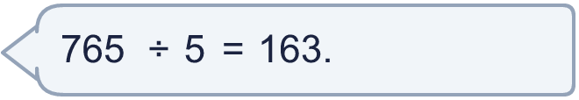
  9 | Is Boba correct? Circle yes or no.  Yes / No  Explain how you know.
  10 | What number did I start with?
     | 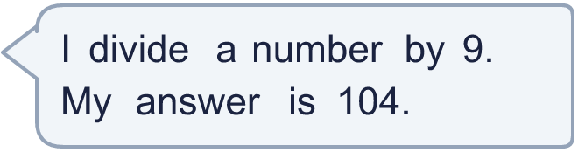
  10 | What number did I start with?
  11 | a) How many trays are filled?  b) How much money does the farm get for all the trays?
     | 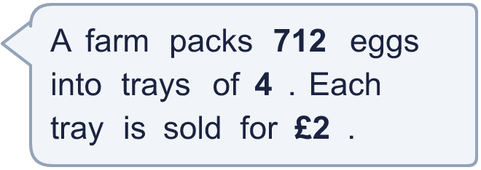
  11 | a) How many trays are filled?  b) How much money does the farm get for all the trays?
  12 | Which is greater: 132 ÷ 6 or 776 ÷ 8?  Write a or b. (a is the first calculation.)
  12 | Which is greater: 132 ÷ 6 or 776 ÷ 8?  Write a or b. (a is the first calculation.)
  13 | How many books does each library have now?
    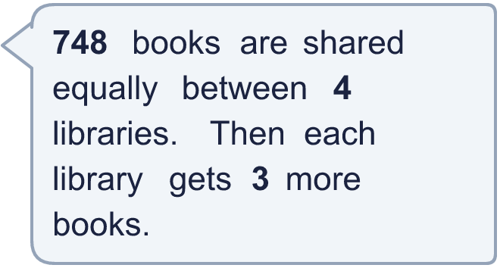
  13 | How many books does each library have now?
  14 | Write three different 3-digit numbers that can be divided by 4 with no remainder.
  14 | Write three different 3-digit numbers that can be divided by 4 with no remainder.

Year 4 · Multiplication and division B · Step 15
Formal division with two exchanges and no remainder
Answers (teacher copy)

  1 | Work out the divisions.  a) 292 ÷ 4 = 73  b) 744 ÷ 3 = 248  c) 275 ÷ 5 = 55
  2 | Work out the divisions. Watch for the zeros.  a) 920 ÷ 5 = 184  b) 828 ÷ 9 = 92  c) 308 ÷ 7 = 44
  3 | Write the missing number.  a) 753 ÷ 3 = 251  b) 720 ÷ 2 = 360
  4 | Write <, > or = in each box.  a) 736 ÷ 8 > 518 ÷ 7  b) 117 ÷ 3 < 141 ÷ 3
  5 | 318 sweets are shared equally between 6 schools.  How many sweets does each school get? 53
  6 | Work out the divisions.  a) 312 ÷ 6 = 52  b) 280 ÷ 5 = 56
  7 | £49.70 is shared equally between 7 children.  How much does each child get? £7.10
  8 | 12 ÷ 4 = 3. Use this fact to work out the divisions.  a) 120 ÷ 4 = 30  b) 1,200 ÷ 4 = 300  c) 1,200 ÷ 40 = 30
  9 | Is Boba correct? Circle yes or no.  Yes / No  Explain how you know.  163 × 5 = 815, not 765. The correct answer is 765 ÷ 5 = 153.
  10 | What number did I start with? 936
  11 | a) How many trays are filled? 178  b) How much money does the farm get for all the trays? £356
  12 | Which is greater: 132 ÷ 6 or 776 ÷ 8?  Write a or b. (a is the first calculation.) b
  13 | How many books does each library have now? 190
  14 | Write three different 3-digit numbers that can be divided by 4 with no remainder.  Any three 3-digit numbers with remainder 0 when divided by 4, for example 324, 548, 772

