  Year 4 · Multiplication and division B · Step 16  Formal division with two exchanges and a remainder | 
  Year 4 · Multiplication and division B · Step 16
  Formal division with two exchanges and a remainder
  1 | Work out the divisions. Write any remainder like this: 56 r 3.  a) 719 ÷ 8 =  b) 595 ÷ 6 =  c) 561 ÷ 6 =
  1 | Work out the divisions. Write any remainder like this: 56 r 3.  a) 719 ÷ 8 =  b) 595 ÷ 6 =  c) 561 ÷ 6 =
  2 | Work out the divisions. Write any remainder.  a) 856 ÷ 9 =  b) 115 ÷ 2 =  c) 145 ÷ 8 =
  2 | Work out the divisions. Write any remainder.  a) 856 ÷ 9 =  b) 115 ÷ 2 =  c) 145 ÷ 8 =
  3 | Write the remainder for each division. You do not need the whole answer.  a) 322 ÷ 5: remainder  b) 348 ÷ 5: remainder  c) 331 ÷ 9: remainder
  3 | Write the remainder for each division. You do not need the whole answer.  a) 322 ÷ 5: remainder  b) 348 ÷ 5: remainder  c) 331 ÷ 9: remainder
  4 | Which is greater: 218 ÷ 6 or 934 ÷ 4?  Write a or b. (a is the first calculation.)
  4 | Which is greater: 218 ÷ 6 or 934 ÷ 4?  Write a or b. (a is the first calculation.)
  5 | Pencils are packed in boxes of 5. There are 813 pencils.  a) How many full boxes can be made?  b) How many pencils are left over?
  5 | Pencils are packed in boxes of 5. There are 813 pencils.  a) How many full boxes can be made?  b) How many pencils are left over?
  6 | Work out the divisions.  a) 774 ÷ 4 =  b) 761 ÷ 8 =
  6 | Work out the divisions.  a) 774 ÷ 4 =  b) 761 ÷ 8 =
  7 | Each minibus seats 8 people. 273 people want to go on a trip.  How many minibuses are needed?
  7 | Each minibus seats 8 people. 273 people want to go on a trip.  How many minibuses are needed?
  8 | 20 ÷ 5 = 4. Use this fact to work out the divisions.  a) 200 ÷ 5 =  b) 2,000 ÷ 5 =  c) 2,000 ÷ 50 =
  8 | 20 ÷ 5 = 4. Use this fact to work out the divisions.  a) 200 ÷ 5 =  b) 2,000 ÷ 5 =  c) 2,000 ÷ 50 =

  9 | Is Boba correct? Circle yes or no.  Yes / No  Explain how you know.
     | 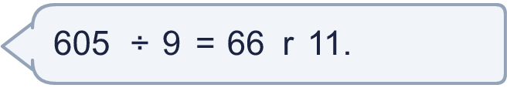
  9 | Is Boba correct? Circle yes or no.  Yes / No  Explain how you know.
  10 | What number did I start with?
     | 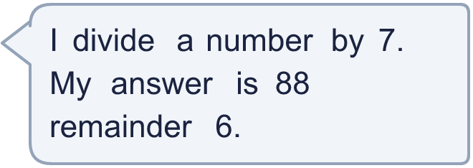
  10 | What number did I start with?
  11 | a) How many times must the ride go round so that everyone rides once?  b) How many people are on the last ride?
     | 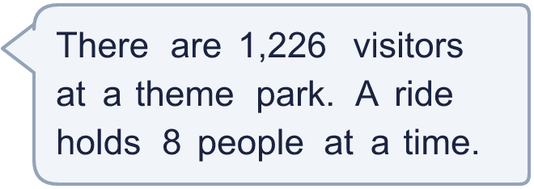
  11 | a) How many times must the ride go round so that everyone rides once?  b) How many people are on the last ride?
  12 | Write the remainder when 510 is divided by each number.  ÷ 2, ÷ 3, ÷ 4, ÷ 5, ÷ 6:
  12 | Write the remainder when 510 is divided by each number.  ÷ 2, ÷ 3, ÷ 4, ÷ 5, ÷ 6:
  13 | a) How many stickers does each friend get?  b) How many stickers does Dani keep?
    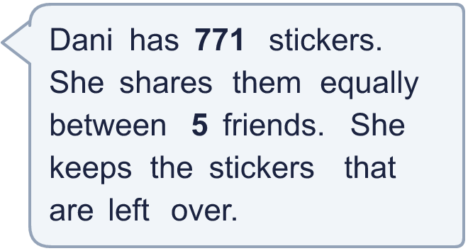
  13 | a) How many stickers does each friend get?  b) How many stickers does Dani keep?
  14 | Write three different 3-digit numbers that leave a remainder of 2 when divided by 7.
  14 | Write three different 3-digit numbers that leave a remainder of 2 when divided by 7.

Year 4 · Multiplication and division B · Step 16
Formal division with two exchanges and a remainder
Answers (teacher copy)

  1 | Work out the divisions. Write any remainder like this: 56 r 3.  a) 719 ÷ 8 = 89 r 7  b) 595 ÷ 6 = 99 r 1  c) 561 ÷ 6 = 93 r 3
  2 | Work out the divisions. Write any remainder.  a) 856 ÷ 9 = 95 r 1  b) 115 ÷ 2 = 57 r 1  c) 145 ÷ 8 = 18 r 1
  3 | Write the remainder for each division. You do not need the whole answer.  a) 322 ÷ 5: remainder 2  b) 348 ÷ 5: remainder 3  c) 331 ÷ 9: remainder 7
  4 | Which is greater: 218 ÷ 6 or 934 ÷ 4?  Write a or b. (a is the first calculation.) b
  5 | Pencils are packed in boxes of 5. There are 813 pencils.  a) How many full boxes can be made? 162  b) How many pencils are left over? 3
  6 | Work out the divisions.  a) 774 ÷ 4 = 193 r 2  b) 761 ÷ 8 = 95 r 1
  7 | Each minibus seats 8 people. 273 people want to go on a trip.  How many minibuses are needed? 35
  8 | 20 ÷ 5 = 4. Use this fact to work out the divisions.  a) 200 ÷ 5 = 40  b) 2,000 ÷ 5 = 400  c) 2,000 ÷ 50 = 40
  9 | Is Boba correct? Circle yes or no.  Yes / No  Explain how you know.  The remainder 11 is bigger than 9, so another group of 9 can be made. 605 ÷ 9 = 67 r 2.
  10 | What number did I start with? 622
  11 | a) How many times must the ride go round so that everyone rides once? 154  b) How many people are on the last ride? 2
  12 | Write the remainder when 510 is divided by each number.  ÷ 2, ÷ 3, ÷ 4, ÷ 5, ÷ 6: 0, 0, 2, 0, 0
  13 | a) How many stickers does each friend get? 154  b) How many stickers does Dani keep? 1
  14 | Write three different 3-digit numbers that leave a remainder of 2 when divided by 7.  Any three 3-digit numbers with remainder 2 when divided by 7, for example 324, 548, 772

