  Year 4 · Multiplication and division B · Step 14  Formal division with one exchange and no remainder | 
  Year 4 · Multiplication and division B · Step 14
  Formal division with one exchange and no remainder
  1 | Work out the divisions.  a) 848 ÷ 8 =  b) 963 ÷ 9 =  c) 408 ÷ 8 =
  1 | Work out the divisions.  a) 848 ÷ 8 =  b) 963 ÷ 9 =  c) 408 ÷ 8 =
  2 | Work out the divisions. Watch for the zeros.  a) 963 ÷ 9 =  b) 545 ÷ 5 =  c) 945 ÷ 9 =
  2 | Work out the divisions. Watch for the zeros.  a) 963 ÷ 9 =  b) 545 ÷ 5 =  c) 945 ÷ 9 =
  3 | Write the missing number.
    a) |  | ÷ 7 | = | 11
    b) |  | ÷ 9 | = | 42
  3 | Write the missing number.
    a) |  | ÷ 7 | = | 11
    b) |  | ÷ 9 | = | 42
  4 | Write <, > or = in each box.
    a) | 700 ÷ 5 |  | 832 ÷ 4
    b) | 896 ÷ 4 |  | 248 ÷ 8
  4 | Write <, > or = in each box.
    a) | 700 ÷ 5 |  | 832 ÷ 4
    b) | 896 ÷ 4 |  | 248 ÷ 8
  5 | 168 sweets are shared equally between 8 schools.  How many sweets does each school get?
  5 | 168 sweets are shared equally between 8 schools.  How many sweets does each school get?
  6 | Work out the divisions.  a) 856 ÷ 4 =  b) 120 ÷ 4 =
  6 | Work out the divisions.  a) 856 ÷ 4 =  b) 120 ÷ 4 =
  7 | £26.40 is shared equally between 8 children.  How much does each child get?
  7 | £26.40 is shared equally between 8 children.  How much does each child get?
  8 | 9 ÷ 3 = 3. Use this fact to work out the divisions.  a) 90 ÷ 3 =  b) 900 ÷ 3 =  c) 900 ÷ 30 =
  8 | 9 ÷ 3 = 3. Use this fact to work out the divisions.  a) 90 ÷ 3 =  b) 900 ÷ 3 =  c) 900 ÷ 30 =

  9 | Is Boba correct? Circle yes or no.  Yes / No  Explain how you know.
     | 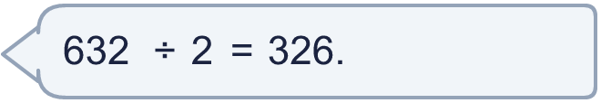
  9 | Is Boba correct? Circle yes or no.  Yes / No  Explain how you know.
  10 | What number did I start with?
     | 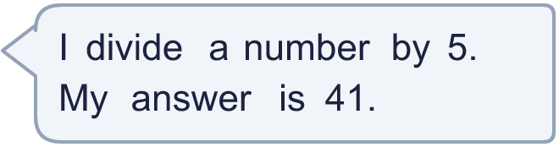
  10 | What number did I start with?
  11 | a) How many trays are filled?  b) How much money does the farm get for all the trays?
     | 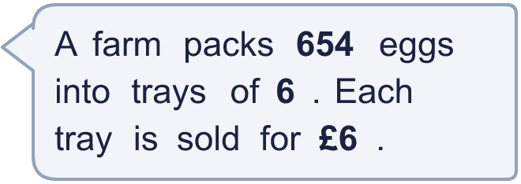
  11 | a) How many trays are filled?  b) How much money does the farm get for all the trays?
  12 | Which is greater: 420 ÷ 6 or 240 ÷ 3?  Write a or b. (a is the first calculation.)
  12 | Which is greater: 420 ÷ 6 or 240 ÷ 3?  Write a or b. (a is the first calculation.)
  13 | How many books does each library have now?
    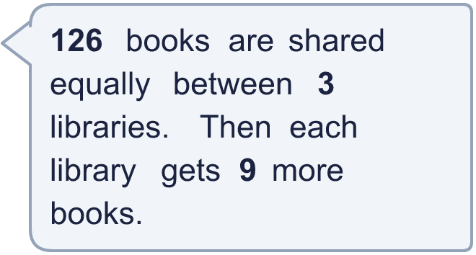
  13 | How many books does each library have now?
  14 | Write three different 3-digit numbers that can be divided by 5 with no remainder.
  14 | Write three different 3-digit numbers that can be divided by 5 with no remainder.

Year 4 · Multiplication and division B · Step 14
Formal division with one exchange and no remainder
Answers (teacher copy)

  1 | Work out the divisions.  a) 848 ÷ 8 = 106  b) 963 ÷ 9 = 107  c) 408 ÷ 8 = 51
  2 | Work out the divisions. Watch for the zeros.  a) 963 ÷ 9 = 107  b) 545 ÷ 5 = 109  c) 945 ÷ 9 = 105
  3 | Write the missing number.  a) 77 ÷ 7 = 11  b) 378 ÷ 9 = 42
  4 | Write <, > or = in each box.  a) 700 ÷ 5 < 832 ÷ 4  b) 896 ÷ 4 > 248 ÷ 8
  5 | 168 sweets are shared equally between 8 schools.  How many sweets does each school get? 21
  6 | Work out the divisions.  a) 856 ÷ 4 = 214  b) 120 ÷ 4 = 30
  7 | £26.40 is shared equally between 8 children.  How much does each child get? £3.30
  8 | 9 ÷ 3 = 3. Use this fact to work out the divisions.  a) 90 ÷ 3 = 30  b) 900 ÷ 3 = 300  c) 900 ÷ 30 = 30
  9 | Is Boba correct? Circle yes or no.  Yes / No  Explain how you know.  326 × 2 = 652, not 632. The correct answer is 632 ÷ 2 = 316.
  10 | What number did I start with? 205
  11 | a) How many trays are filled? 109  b) How much money does the farm get for all the trays? £654
  12 | Which is greater: 420 ÷ 6 or 240 ÷ 3?  Write a or b. (a is the first calculation.) b
  13 | How many books does each library have now? 51
  14 | Write three different 3-digit numbers that can be divided by 5 with no remainder.  Any three 3-digit numbers with remainder 0 when divided by 5, for example 320, 545, 770

