  Year 4 · Multiplication and division B · Step 12  Formal division with no exchange and no remainder | 
  Year 4 · Multiplication and division B · Step 12
  Formal division with no exchange and no remainder
  1 | Work out the divisions.  a) 440 ÷ 4 =  b) 500 ÷ 5 =  c) 208 ÷ 2 =
  1 | Work out the divisions.  a) 440 ÷ 4 =  b) 500 ÷ 5 =  c) 208 ÷ 2 =
  2 | Work out the divisions. Watch for the zeros.  a) 204 ÷ 2 =  b) 240 ÷ 2 =  c) 800 ÷ 8 =
  2 | Work out the divisions. Watch for the zeros.  a) 204 ÷ 2 =  b) 240 ÷ 2 =  c) 800 ÷ 8 =
  3 | Write the missing number.
    a) |  | ÷ 8 | = | 113
    b) |  | ÷ 4 | = | 177
  3 | Write the missing number.
    a) |  | ÷ 8 | = | 113
    b) |  | ÷ 4 | = | 177
  4 | Write <, > or = in each box.
    a) | 480 ÷ 4 |  | 707 ÷ 7
    b) | 696 ÷ 3 |  | 777 ÷ 7
  4 | Write <, > or = in each box.
    a) | 480 ÷ 4 |  | 707 ÷ 7
    b) | 696 ÷ 3 |  | 777 ÷ 7
  5 | 990 sweets are shared equally between 3 schools.  How many sweets does each school get?
  5 | 990 sweets are shared equally between 3 schools.  How many sweets does each school get?
  6 | Work out the divisions.  a) 990 ÷ 9 =  b) 909 ÷ 9 =
  6 | Work out the divisions.  a) 990 ÷ 9 =  b) 909 ÷ 9 =
  7 | £44.10 is shared equally between 9 children.  How much does each child get?
  7 | £44.10 is shared equally between 9 children.  How much does each child get?
  8 | 21 ÷ 7 = 3. Use this fact to work out the divisions.  a) 210 ÷ 7 =  b) 2,100 ÷ 7 =  c) 2,100 ÷ 70 =
  8 | 21 ÷ 7 = 3. Use this fact to work out the divisions.  a) 210 ÷ 7 =  b) 2,100 ÷ 7 =  c) 2,100 ÷ 70 =

  9 | Is Boba correct? Circle yes or no.  Yes / No  Explain how you know.
     | 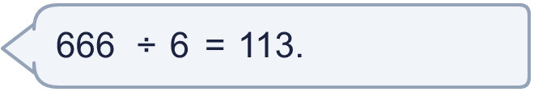
  9 | Is Boba correct? Circle yes or no.  Yes / No  Explain how you know.
  10 | What number did I start with?
     | 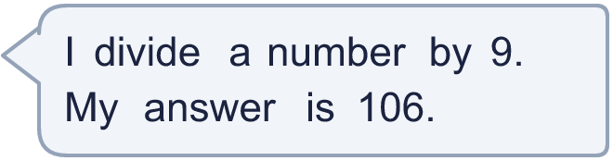
  10 | What number did I start with?
  11 | a) How many trays are filled?  b) How much money does the farm get for all the trays?
     | 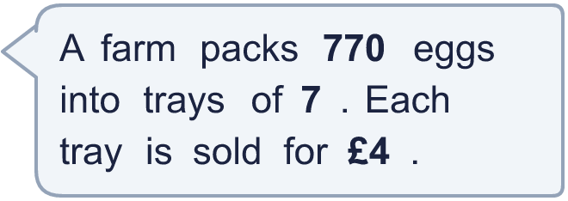
  11 | a) How many trays are filled?  b) How much money does the farm get for all the trays?
  12 | Which is greater: 660 ÷ 6 or 606 ÷ 2?  Write a or b. (a is the first calculation.)
  12 | Which is greater: 660 ÷ 6 or 606 ÷ 2?  Write a or b. (a is the first calculation.)
  13 | How many books does each library have now?
    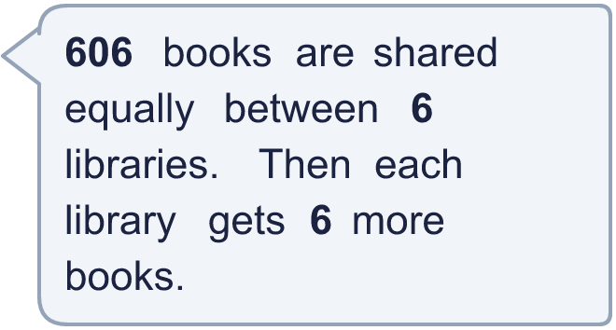
  13 | How many books does each library have now?
  14 | Write three different 3-digit numbers that can be divided by 4 with no remainder.
  14 | Write three different 3-digit numbers that can be divided by 4 with no remainder.

Year 4 · Multiplication and division B · Step 12
Formal division with no exchange and no remainder
Answers (teacher copy)

  1 | Work out the divisions.  a) 440 ÷ 4 = 110  b) 500 ÷ 5 = 100  c) 208 ÷ 2 = 104
  2 | Work out the divisions. Watch for the zeros.  a) 204 ÷ 2 = 102  b) 240 ÷ 2 = 120  c) 800 ÷ 8 = 100
  3 | Write the missing number.  a) 904 ÷ 8 = 113  b) 708 ÷ 4 = 177
  4 | Write <, > or = in each box.  a) 480 ÷ 4 > 707 ÷ 7  b) 696 ÷ 3 > 777 ÷ 7
  5 | 990 sweets are shared equally between 3 schools.  How many sweets does each school get? 330
  6 | Work out the divisions.  a) 990 ÷ 9 = 110  b) 909 ÷ 9 = 101
  7 | £44.10 is shared equally between 9 children.  How much does each child get? £4.90
  8 | 21 ÷ 7 = 3. Use this fact to work out the divisions.  a) 210 ÷ 7 = 30  b) 2,100 ÷ 7 = 300  c) 2,100 ÷ 70 = 30
  9 | Is Boba correct? Circle yes or no.  Yes / No  Explain how you know.  113 × 6 = 678, not 666. The correct answer is 666 ÷ 6 = 111.
  10 | What number did I start with? 954
  11 | a) How many trays are filled? 110  b) How much money does the farm get for all the trays? £440
  12 | Which is greater: 660 ÷ 6 or 606 ÷ 2?  Write a or b. (a is the first calculation.) b
  13 | How many books does each library have now? 107
  14 | Write three different 3-digit numbers that can be divided by 4 with no remainder.  Any three 3-digit numbers with remainder 0 when divided by 4, for example 324, 548, 772

