  Year 4 · Multiplication and division B · Step 13  Formal division with no exchange and a remainder | 
  Year 4 · Multiplication and division B · Step 13
  Formal division with no exchange and a remainder
  1 | Work out the divisions. Write any remainder like this: 56 r 3.  a) 602 ÷ 6 =  b) 502 ÷ 5 =  c) 968 ÷ 3 =
  1 | Work out the divisions. Write any remainder like this: 56 r 3.  a) 602 ÷ 6 =  b) 502 ÷ 5 =  c) 968 ÷ 3 =
  2 | Work out the divisions. Write any remainder.  a) 409 ÷ 4 =  b) 809 ÷ 8 =  c) 441 ÷ 4 =
  2 | Work out the divisions. Write any remainder.  a) 409 ÷ 4 =  b) 809 ÷ 8 =  c) 441 ÷ 4 =
  3 | Write the remainder for each division. You do not need the whole answer.  a) 801 ÷ 8: remainder  b) 996 ÷ 9: remainder  c) 507 ÷ 5: remainder
  3 | Write the remainder for each division. You do not need the whole answer.  a) 801 ÷ 8: remainder  b) 996 ÷ 9: remainder  c) 507 ÷ 5: remainder
  4 | Which is greater: 887 ÷ 4 or 692 ÷ 3?  Write a or b. (a is the first calculation.)
  4 | Which is greater: 887 ÷ 4 or 692 ÷ 3?  Write a or b. (a is the first calculation.)
  5 | Pencils are packed in boxes of 9. There are 992 pencils.  a) How many full boxes can be made?  b) How many pencils are left over?
  5 | Pencils are packed in boxes of 9. There are 992 pencils.  a) How many full boxes can be made?  b) How many pencils are left over?
  6 | Work out the divisions.  a) 485 ÷ 2 =  b) 776 ÷ 7 =
  6 | Work out the divisions.  a) 485 ÷ 2 =  b) 776 ÷ 7 =
  7 | Each minibus seats 8 people. 697 people want to go on a trip.  How many minibuses are needed?
  7 | Each minibus seats 8 people. 697 people want to go on a trip.  How many minibuses are needed?
  8 | 24 ÷ 4 = 6. Use this fact to work out the divisions.  a) 240 ÷ 4 =  b) 2,400 ÷ 4 =  c) 2,400 ÷ 40 =
  8 | 24 ÷ 4 = 6. Use this fact to work out the divisions.  a) 240 ÷ 4 =  b) 2,400 ÷ 4 =  c) 2,400 ÷ 40 =

  9 | Is Boba correct? Circle yes or no.  Yes / No  Explain how you know.
     | 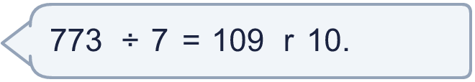
  9 | Is Boba correct? Circle yes or no.  Yes / No  Explain how you know.
  10 | What number did I start with?
     | 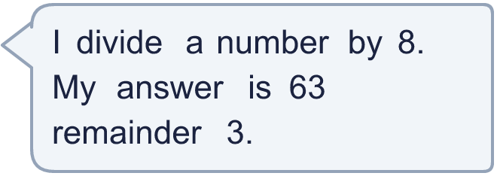
  10 | What number did I start with?
  11 | a) How many times must the ride go round so that everyone rides once?  b) How many people are on the last ride?
     | 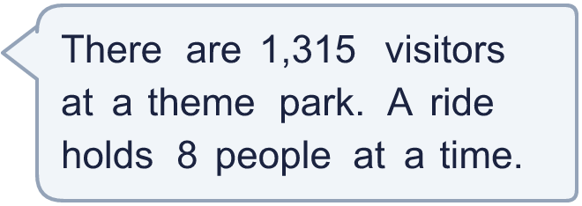
  11 | a) How many times must the ride go round so that everyone rides once?  b) How many people are on the last ride?
  12 | Write the remainder when 957 is divided by each number.  ÷ 2, ÷ 3, ÷ 4, ÷ 5, ÷ 6:
  12 | Write the remainder when 957 is divided by each number.  ÷ 2, ÷ 3, ÷ 4, ÷ 5, ÷ 6:
  13 | a) How many stickers does each friend get?  b) How many stickers does Dani keep?
    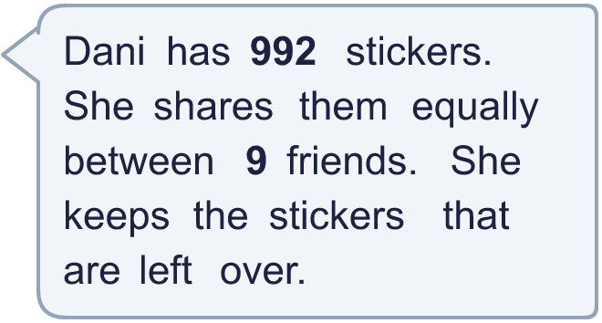
  13 | a) How many stickers does each friend get?  b) How many stickers does Dani keep?
  14 | Write three different 3-digit numbers that leave a remainder of 3 when divided by 4.
  14 | Write three different 3-digit numbers that leave a remainder of 3 when divided by 4.

Year 4 · Multiplication and division B · Step 13
Formal division with no exchange and a remainder
Answers (teacher copy)

  1 | Work out the divisions. Write any remainder like this: 56 r 3.  a) 602 ÷ 6 = 100 r 2  b) 502 ÷ 5 = 100 r 2  c) 968 ÷ 3 = 322 r 2
  2 | Work out the divisions. Write any remainder.  a) 409 ÷ 4 = 102 r 1  b) 809 ÷ 8 = 101 r 1  c) 441 ÷ 4 = 110 r 1
  3 | Write the remainder for each division. You do not need the whole answer.  a) 801 ÷ 8: remainder 1  b) 996 ÷ 9: remainder 6  c) 507 ÷ 5: remainder 2
  4 | Which is greater: 887 ÷ 4 or 692 ÷ 3?  Write a or b. (a is the first calculation.) b
  5 | Pencils are packed in boxes of 9. There are 992 pencils.  a) How many full boxes can be made? 110  b) How many pencils are left over? 2
  6 | Work out the divisions.  a) 485 ÷ 2 = 242 r 1  b) 776 ÷ 7 = 110 r 6
  7 | Each minibus seats 8 people. 697 people want to go on a trip.  How many minibuses are needed? 88
  8 | 24 ÷ 4 = 6. Use this fact to work out the divisions.  a) 240 ÷ 4 = 60  b) 2,400 ÷ 4 = 600  c) 2,400 ÷ 40 = 60
  9 | Is Boba correct? Circle yes or no.  Yes / No  Explain how you know.  The remainder 10 is bigger than 7, so another group of 7 can be made. 773 ÷ 7 = 110 r 3.
  10 | What number did I start with? 507
  11 | a) How many times must the ride go round so that everyone rides once? 165  b) How many people are on the last ride? 3
  12 | Write the remainder when 957 is divided by each number.  ÷ 2, ÷ 3, ÷ 4, ÷ 5, ÷ 6: 1, 0, 1, 2, 3
  13 | a) How many stickers does each friend get? 110  b) How many stickers does Dani keep? 2
  14 | Write three different 3-digit numbers that leave a remainder of 3 when divided by 4.  Any three 3-digit numbers with remainder 3 when divided by 4, for example 327, 551, 775

