  Year 4 · Multiplication and division B · Step 15  Efficient multiplication | 
  Year 4 · Multiplication and division B · Step 15
  Efficient multiplication
  1 | Two ways to work out 44 × 6. Work them out.  a) 40 × 6 + 4 × 6 =  b) 44 × 6 =
  1 | Two ways to work out 44 × 6. Work them out.  a) 40 × 6 + 4 × 6 =  b) 44 × 6 =
  2 | To multiply by 4, double and then double again. Work out the calculations.  a) 23 × 2 =  b) 46 × 2 =  c) 23 × 4 =
  2 | To multiply by 4, double and then double again. Work out the calculations.  a) 23 × 2 =  b) 46 × 2 =  c) 23 × 4 =
  3 | To multiply by 5, multiply by 10 and then halve. Work out the calculations.  a) 176 × 10 =  b) 1,760 ÷ 2 =  c) 176 × 5 =
  3 | To multiply by 5, multiply by 10 and then halve. Work out the calculations.  a) 176 × 10 =  b) 1,760 ÷ 2 =  c) 176 × 5 =
  4 | To multiply by 9, multiply by 10 and then subtract the number once. Work out the calculations.  a) 27 × 10 =  b) 270 − 27 =  c) 27 × 9 =
  4 | To multiply by 9, multiply by 10 and then subtract the number once. Work out the calculations.  a) 27 × 10 =  b) 270 − 27 =  c) 27 × 9 =
  5 | Use the quick way to multiply by 5.  a) 85 × 5 =  b) 38 × 5 =  c) 62 × 5 =
  5 | Use the quick way to multiply by 5.  a) 85 × 5 =  b) 38 × 5 =  c) 62 × 5 =
  6 | Three ways to work out 25 × 8. Work them out.  a) 25 × 10 − 25 × 2 =  b) 400 ÷ 2 =  c) 25 × 8 =
  6 | Three ways to work out 25 × 8. Work them out.  a) 25 × 10 − 25 × 2 =  b) 400 ÷ 2 =  c) 25 × 8 =
  7 | a) How many pencils does she buy?  b) She then buys 3 more boxes. How many pencils does she have now?
    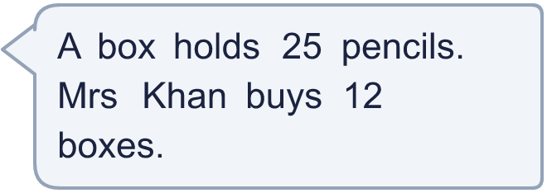
  7 | a) How many pencils does she buy?  b) She then buys 3 more boxes. How many pencils does she have now?
  8 | Work out the multiplications. Use the first one to help you with the second.  a) 23 × 10 − 23 =  b) 23 × 9 =  c) 47 × 100 − 47 =  d) 47 × 99 =
  8 | Work out the multiplications. Use the first one to help you with the second.  a) 23 × 10 − 23 =  b) 23 × 9 =  c) 47 × 100 − 47 =  d) 47 × 99 =

  9 | Is Boba correct? Circle yes or no.  Yes / No  Explain Boba’s mistake.
     | 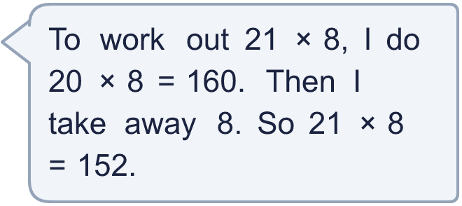
  9 | Is Boba correct? Circle yes or no.  Yes / No  Explain Boba’s mistake.
  10 | Ron, Amir and Annie all work out 20 × 8 in different ways. Work out each method to show that they are all correct.  a) 15 × 8 + 5 × 8 =  b) 20 × 2 × 4 =  c) 5 × 8 × 4 =  d) 20 × 8 =
  10 | Ron, Amir and Annie all work out 20 × 8 in different ways. Work out each method to show that they are all correct.  a) 15 × 8 + 5 × 8 =  b) 20 × 2 × 4 =  c) 5 × 8 × 4 =  d) 20 × 8 =
  11 | Is Dora correct? Circle yes or no.  Yes / No  Explain how you know.
     | 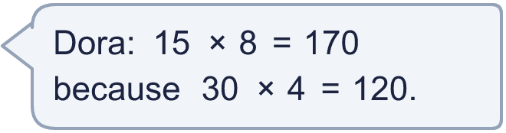
  11 | Is Dora correct? Circle yes or no.  Yes / No  Explain how you know.
  12 | A baker makes 25 cakes every hour for 6 hours. She sells 40 cakes.
    How many cakes are left?
  12 | A baker makes 25 cakes every hour for 6 hours. She sells 40 cakes.
    How many cakes are left?
  13 | Write three different calculations that you could use to work out 31 × 5. Each must make 155.
  13 | Write three different calculations that you could use to work out 31 × 5. Each must make 155.
  14 | Write <, > or = in each box.
    a) | 36 × 9 |  | 36 × 10 − 36
    b) | 48 × 5 |  | 480 ÷ 2 + 4
    c) | 36 × 99 |  | 36 × 100 − 72
  14 | Write <, > or = in each box.
    a) | 36 × 9 |  | 36 × 10 − 36
    b) | 48 × 5 |  | 480 ÷ 2 + 4
    c) | 36 × 99 |  | 36 × 100 − 72

Year 4 · Multiplication and division B · Step 15
Efficient multiplication
Answers (teacher copy)

  1 | Two ways to work out 44 × 6. Work them out.  a) 40 × 6 + 4 × 6 = 264  b) 44 × 6 = 264
  2 | To multiply by 4, double and then double again. Work out the calculations.  a) 23 × 2 = 46  b) 46 × 2 = 92  c) 23 × 4 = 92
  3 | To multiply by 5, multiply by 10 and then halve. Work out the calculations.  a) 176 × 10 = 1,760  b) 1,760 ÷ 2 = 880  c) 176 × 5 = 880
  4 | To multiply by 9, multiply by 10 and then subtract the number once. Work out the calculations.  a) 27 × 10 = 270  b) 270 − 27 = 243  c) 27 × 9 = 243
  5 | Use the quick way to multiply by 5.  a) 85 × 5 = 425  b) 38 × 5 = 190  c) 62 × 5 = 310
  6 | Three ways to work out 25 × 8. Work them out.  a) 25 × 10 − 25 × 2 = 200  b) 400 ÷ 2 = 200  c) 25 × 8 = 200
  7 | a) How many pencils does she buy? 300  b) She then buys 3 more boxes. How many pencils does she have now? 375
  8 | Work out the multiplications. Use the first one to help you with the second.  a) 23 × 10 − 23 = 207  b) 23 × 9 = 207  c) 47 × 100 − 47 = 4,653  d) 47 × 99 = 4,653
  9 | Is Boba correct? Circle yes or no.  Yes / No  Explain Boba’s mistake.  No. 21 is one more than 20, so Boba should add 8, not take it away. 21 × 8 = 168.
  10 | Ron, Amir and Annie all work out 20 × 8 in different ways. Work out each method to show that they are all correct.  a) 15 × 8 + 5 × 8 = 160  b) 20 × 2 × 4 = 160  c) 5 × 8 × 4 = 160  d) 20 × 8 = 160
  11 | Is Dora correct? Circle yes or no.  Yes / No  Explain how you know.  No. 15 × 8 = 120.
  12 | A baker makes 25 cakes every hour for 6 hours. She sells 40 cakes.  How many cakes are left? 110
  13 | Write three different calculations that you could use to work out 31 × 5. Each must make 155.  for example 31 × 10 ÷ 2; 30 × 5 + 1 × 5; 31 × 100 ÷ 20
  14 | Write <, > or = in each box.  a) 36 × 9 = 36 × 10 − 36  b) 48 × 5 < 480 ÷ 2 + 4  c) 36 × 99 > 36 × 100 − 72

