  Year 4 · Multiplication and division B · Step 11  Divide a 3-digit number by a 1-digit number | 
  Year 4 · Multiplication and division B · Step 11
  Divide a 3-digit number by a 1-digit number
  1 | Work out the divisions.  a) 889 ÷ 7 =  b) 704 ÷ 8 =  c) 456 ÷ 2 =
  1 | Work out the divisions.  a) 889 ÷ 7 =  b) 704 ÷ 8 =  c) 456 ÷ 2 =
  2 | Work out the divisions. Watch for the zeros.  a) 480 ÷ 8 =  b) 676 ÷ 4 =  c) 408 ÷ 2 =
  2 | Work out the divisions. Watch for the zeros.  a) 480 ÷ 8 =  b) 676 ÷ 4 =  c) 408 ÷ 2 =
  3 | Write the missing number.
    a) |  | ÷ 5 | = | 46
    b) |  | ÷ 9 | = | 49
  3 | Write the missing number.
    a) |  | ÷ 5 | = | 46
    b) |  | ÷ 9 | = | 49
  4 | Write <, > or = in each box.
    a) | 484 ÷ 4 |  | 248 ÷ 8
    b) | 156 ÷ 3 |  | 860 ÷ 5
  4 | Write <, > or = in each box.
    a) | 484 ÷ 4 |  | 248 ÷ 8
    b) | 156 ÷ 3 |  | 860 ÷ 5
  5 | 910 sweets are shared equally between 7 schools.  How many sweets does each school get?
  5 | 910 sweets are shared equally between 7 schools.  How many sweets does each school get?
  6 | Work out the divisions.  a) 905 ÷ 5 =  b) 480 ÷ 8 =
  6 | Work out the divisions.  a) 905 ÷ 5 =  b) 480 ÷ 8 =
  7 | £86.40 is shared equally between 9 children.  How much does each child get?
  7 | £86.40 is shared equally between 9 children.  How much does each child get?
  8 | 10 ÷ 5 = 2. Use this fact to work out the divisions.  a) 100 ÷ 5 =  b) 1,000 ÷ 5 =  c) 1,000 ÷ 50 =
  8 | 10 ÷ 5 = 2. Use this fact to work out the divisions.  a) 100 ÷ 5 =  b) 1,000 ÷ 5 =  c) 1,000 ÷ 50 =

  9 | Is Boba correct? Circle yes or no.  Yes / No  Explain how you know.
     | 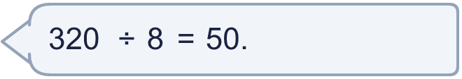
  9 | Is Boba correct? Circle yes or no.  Yes / No  Explain how you know.
  10 | What number did I start with?
     | 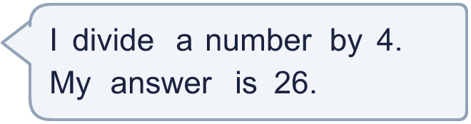
  10 | What number did I start with?
  11 | a) How many trays are filled?  b) How much money does the farm get for all the trays?
     | 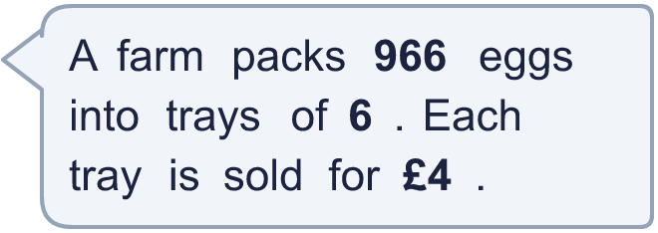
  11 | a) How many trays are filled?  b) How much money does the farm get for all the trays?
  12 | Which is greater: 573 ÷ 3 or 432 ÷ 8?  Write a or b. (a is the first calculation.)
  12 | Which is greater: 573 ÷ 3 or 432 ÷ 8?  Write a or b. (a is the first calculation.)
  13 | How many books does each library have now?
    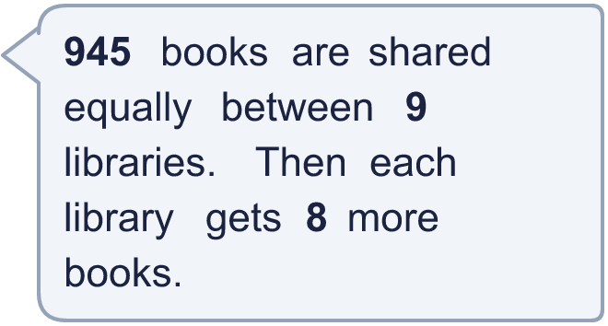
  13 | How many books does each library have now?
  14 | Write three different 3-digit numbers that can be divided by 3 with no remainder.
  14 | Write three different 3-digit numbers that can be divided by 3 with no remainder.

Year 4 · Multiplication and division B · Step 11
Divide a 3-digit number by a 1-digit number
Answers (teacher copy)

  1 | Work out the divisions.  a) 889 ÷ 7 = 127  b) 704 ÷ 8 = 88  c) 456 ÷ 2 = 228
  2 | Work out the divisions. Watch for the zeros.  a) 480 ÷ 8 = 60  b) 676 ÷ 4 = 169  c) 408 ÷ 2 = 204
  3 | Write the missing number.  a) 230 ÷ 5 = 46  b) 441 ÷ 9 = 49
  4 | Write <, > or = in each box.  a) 484 ÷ 4 > 248 ÷ 8  b) 156 ÷ 3 < 860 ÷ 5
  5 | 910 sweets are shared equally between 7 schools.  How many sweets does each school get? 130
  6 | Work out the divisions.  a) 905 ÷ 5 = 181  b) 480 ÷ 8 = 60
  7 | £86.40 is shared equally between 9 children.  How much does each child get? £9.60
  8 | 10 ÷ 5 = 2. Use this fact to work out the divisions.  a) 100 ÷ 5 = 20  b) 1,000 ÷ 5 = 200  c) 1,000 ÷ 50 = 20
  9 | Is Boba correct? Circle yes or no.  Yes / No  Explain how you know.  50 × 8 = 400, not 320. The correct answer is 320 ÷ 8 = 40.
  10 | What number did I start with? 104
  11 | a) How many trays are filled? 161  b) How much money does the farm get for all the trays? £644
  12 | Which is greater: 573 ÷ 3 or 432 ÷ 8?  Write a or b. (a is the first calculation.) a
  13 | How many books does each library have now? 113
  14 | Write three different 3-digit numbers that can be divided by 3 with no remainder.  Any three 3-digit numbers with remainder 0 when divided by 3, for example 324, 549, 774

