  Year 4 · Multiplication and division B · Step 9  Divide a 2-digit number by a 1-digit number | 
  Year 4 · Multiplication and division B · Step 9
  Divide a 2-digit number by a 1-digit number
  1 | Work out the divisions.  a) 52 ÷ 4 =  b) 12 ÷ 3 =  c) 42 ÷ 7 =
  1 | Work out the divisions.  a) 52 ÷ 4 =  b) 12 ÷ 3 =  c) 42 ÷ 7 =
  2 | Work out the divisions. Watch for the zeros.  a) 90 ÷ 9 =  b) 54 ÷ 3 =  c) 80 ÷ 8 =
  2 | Work out the divisions. Watch for the zeros.  a) 90 ÷ 9 =  b) 54 ÷ 3 =  c) 80 ÷ 8 =
  3 | Write the missing number.
    a) |  | ÷ 2 | = | 9
    b) |  | ÷ 4 | = | 3
  3 | Write the missing number.
    a) |  | ÷ 2 | = | 9
    b) |  | ÷ 4 | = | 3
  4 | Write <, > or = in each box.
    a) | 36 ÷ 6 |  | 68 ÷ 4
    b) | 72 ÷ 8 |  | 32 ÷ 8
  4 | Write <, > or = in each box.
    a) | 36 ÷ 6 |  | 68 ÷ 4
    b) | 72 ÷ 8 |  | 32 ÷ 8
  5 | 90 sweets are shared equally between 5 schools.  How many sweets does each school get?
  5 | 90 sweets are shared equally between 5 schools.  How many sweets does each school get?
  6 | Work out the divisions.  a) 45 ÷ 9 =  b) 60 ÷ 6 =
  6 | Work out the divisions.  a) 45 ÷ 9 =  b) 60 ÷ 6 =
  7 | £28.00 is shared equally between 7 children.  How much does each child get?
  7 | £28.00 is shared equally between 7 children.  How much does each child get?
  8 | 24 ÷ 8 = 3. Use this fact to work out the divisions.  a) 240 ÷ 8 =  b) 2,400 ÷ 8 =  c) 2,400 ÷ 80 =
  8 | 24 ÷ 8 = 3. Use this fact to work out the divisions.  a) 240 ÷ 8 =  b) 2,400 ÷ 8 =  c) 2,400 ÷ 80 =

  9 | Is Boba correct? Circle yes or no.  Yes / No  Explain how you know.
     | 
  9 | Is Boba correct? Circle yes or no.  Yes / No  Explain how you know.
  10 | What number did I start with?
     | 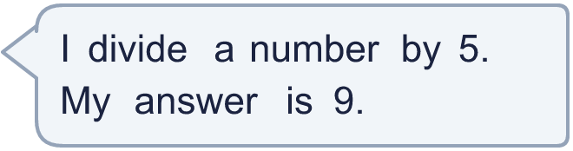
  10 | What number did I start with?
  11 | a) How many trays are filled?  b) How much money does the farm get for all the trays?
     | 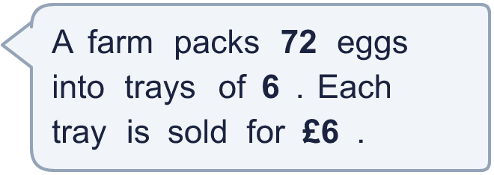
  11 | a) How many trays are filled?  b) How much money does the farm get for all the trays?
  12 | Which is greater: 80 ÷ 8 or 49 ÷ 7?  Write a or b. (a is the first calculation.)
  12 | Which is greater: 80 ÷ 8 or 49 ÷ 7?  Write a or b. (a is the first calculation.)
  13 | How many books does each library have now?
    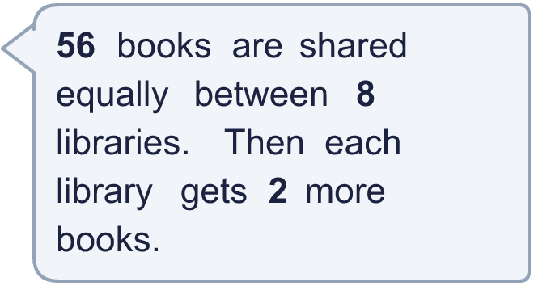
  13 | How many books does each library have now?
  14 | Write three different 2-digit numbers that can be divided by 7 with no remainder.
  14 | Write three different 2-digit numbers that can be divided by 7 with no remainder.

Year 4 · Multiplication and division B · Step 9
Divide a 2-digit number by a 1-digit number
Answers (teacher copy)

  1 | Work out the divisions.  a) 52 ÷ 4 = 13  b) 12 ÷ 3 = 4  c) 42 ÷ 7 = 6
  2 | Work out the divisions. Watch for the zeros.  a) 90 ÷ 9 = 10  b) 54 ÷ 3 = 18  c) 80 ÷ 8 = 10
  3 | Write the missing number.  a) 18 ÷ 2 = 9  b) 12 ÷ 4 = 3
  4 | Write <, > or = in each box.  a) 36 ÷ 6 < 68 ÷ 4  b) 72 ÷ 8 > 32 ÷ 8
  5 | 90 sweets are shared equally between 5 schools.  How many sweets does each school get? 18
  6 | Work out the divisions.  a) 45 ÷ 9 = 5  b) 60 ÷ 6 = 10
  7 | £28.00 is shared equally between 7 children.  How much does each child get? £4.00
  8 | 24 ÷ 8 = 3. Use this fact to work out the divisions.  a) 240 ÷ 8 = 30  b) 2,400 ÷ 8 = 300  c) 2,400 ÷ 80 = 30
  9 | Is Boba correct? Circle yes or no.  Yes / No  Explain how you know.  8 × 3 = 24, not 18. The correct answer is 18 ÷ 3 = 6.
  10 | What number did I start with? 45
  11 | a) How many trays are filled? 12  b) How much money does the farm get for all the trays? £72
  12 | Which is greater: 80 ÷ 8 or 49 ÷ 7?  Write a or b. (a is the first calculation.) a
  13 | How many books does each library have now? 9
  14 | Write three different 2-digit numbers that can be divided by 7 with no remainder.  Any three 2-digit numbers with remainder 0 when divided by 7, for example 35, 56, 77

