  Year 4 · Multiplication and division B · Step 10  Divide a 2-digit number by a 1-digit number with remainders | 
  Year 4 · Multiplication and division B · Step 10
  Divide a 2-digit number by a 1-digit number with remainders
  1 | Work out the divisions. Write any remainder like this: 56 r 3.  a) 58 ÷ 4 =  b) 53 ÷ 5 =  c) 11 ÷ 4 =
  1 | Work out the divisions. Write any remainder like this: 56 r 3.  a) 58 ÷ 4 =  b) 53 ÷ 5 =  c) 11 ÷ 4 =
  2 | Work out the divisions. Write any remainder.  a) 41 ÷ 2 =  b) 88 ÷ 5 =  c) 86 ÷ 8 =
  2 | Work out the divisions. Write any remainder.  a) 41 ÷ 2 =  b) 88 ÷ 5 =  c) 86 ÷ 8 =
  3 | Write the remainder for each division. You do not need the whole answer.  a) 80 ÷ 7: remainder  b) 75 ÷ 7: remainder  c) 28 ÷ 8: remainder
  3 | Write the remainder for each division. You do not need the whole answer.  a) 80 ÷ 7: remainder  b) 75 ÷ 7: remainder  c) 28 ÷ 8: remainder
  4 | Which is greater: 35 ÷ 6 or 61 ÷ 6?  Write a or b. (a is the first calculation.)
  4 | Which is greater: 35 ÷ 6 or 61 ÷ 6?  Write a or b. (a is the first calculation.)
  5 | Pencils are packed in boxes of 5. There are 42 pencils.  a) How many full boxes can be made?  b) How many pencils are left over?
  5 | Pencils are packed in boxes of 5. There are 42 pencils.  a) How many full boxes can be made?  b) How many pencils are left over?
  6 | Work out the divisions.  a) 65 ÷ 2 =  b) 92 ÷ 3 =
  6 | Work out the divisions.  a) 65 ÷ 2 =  b) 92 ÷ 3 =
  7 | Each minibus seats 5 people. 354 people want to go on a trip.  How many minibuses are needed?
  7 | Each minibus seats 5 people. 354 people want to go on a trip.  How many minibuses are needed?
  8 | 36 ÷ 9 = 4. Use this fact to work out the divisions.  a) 360 ÷ 9 =  b) 3,600 ÷ 9 =  c) 3,600 ÷ 90 =
  8 | 36 ÷ 9 = 4. Use this fact to work out the divisions.  a) 360 ÷ 9 =  b) 3,600 ÷ 9 =  c) 3,600 ÷ 90 =

  9 | Is Boba correct? Circle yes or no.  Yes / No  Explain how you know.
     | 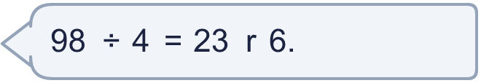
  9 | Is Boba correct? Circle yes or no.  Yes / No  Explain how you know.
  10 | What number did I start with?
     | 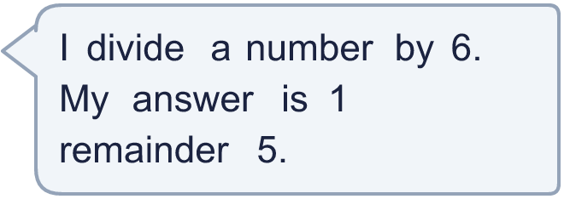
  10 | What number did I start with?
  11 | a) How many times must the ride go round so that everyone rides once?  b) How many people are on the last ride?
     | 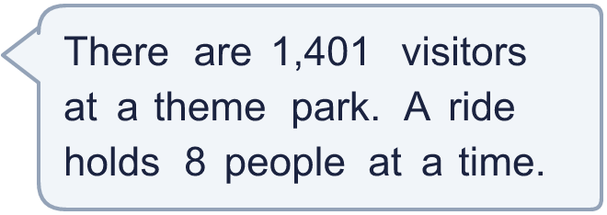
  11 | a) How many times must the ride go round so that everyone rides once?  b) How many people are on the last ride?
  12 | Write the remainder when 57 is divided by each number.  ÷ 2, ÷ 3, ÷ 4, ÷ 5, ÷ 6:
  12 | Write the remainder when 57 is divided by each number.  ÷ 2, ÷ 3, ÷ 4, ÷ 5, ÷ 6:
  13 | a) How many stickers does each friend get?  b) How many stickers does Dani keep?
    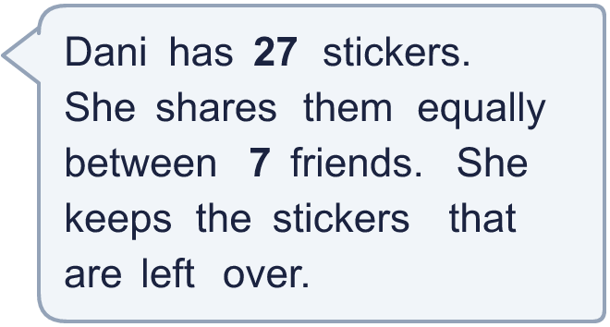
  13 | a) How many stickers does each friend get?  b) How many stickers does Dani keep?
  14 | Write three different 2-digit numbers that leave a remainder of 7 when divided by 8.
  14 | Write three different 2-digit numbers that leave a remainder of 7 when divided by 8.

Year 4 · Multiplication and division B · Step 10
Divide a 2-digit number by a 1-digit number with remainders
Answers (teacher copy)

  1 | Work out the divisions. Write any remainder like this: 56 r 3.  a) 58 ÷ 4 = 14 r 2  b) 53 ÷ 5 = 10 r 3  c) 11 ÷ 4 = 2 r 3
  2 | Work out the divisions. Write any remainder.  a) 41 ÷ 2 = 20 r 1  b) 88 ÷ 5 = 17 r 3  c) 86 ÷ 8 = 10 r 6
  3 | Write the remainder for each division. You do not need the whole answer.  a) 80 ÷ 7: remainder 3  b) 75 ÷ 7: remainder 5  c) 28 ÷ 8: remainder 4
  4 | Which is greater: 35 ÷ 6 or 61 ÷ 6?  Write a or b. (a is the first calculation.) b
  5 | Pencils are packed in boxes of 5. There are 42 pencils.  a) How many full boxes can be made? 8  b) How many pencils are left over? 2
  6 | Work out the divisions.  a) 65 ÷ 2 = 32 r 1  b) 92 ÷ 3 = 30 r 2
  7 | Each minibus seats 5 people. 354 people want to go on a trip.  How many minibuses are needed? 71
  8 | 36 ÷ 9 = 4. Use this fact to work out the divisions.  a) 360 ÷ 9 = 40  b) 3,600 ÷ 9 = 400  c) 3,600 ÷ 90 = 40
  9 | Is Boba correct? Circle yes or no.  Yes / No  Explain how you know.  The remainder 6 is bigger than 4, so another group of 4 can be made. 98 ÷ 4 = 24 r 2.
  10 | What number did I start with? 11
  11 | a) How many times must the ride go round so that everyone rides once? 176  b) How many people are on the last ride? 1
  12 | Write the remainder when 57 is divided by each number.  ÷ 2, ÷ 3, ÷ 4, ÷ 5, ÷ 6: 1, 0, 1, 2, 3
  13 | a) How many stickers does each friend get? 3  b) How many stickers does Dani keep? 6
  14 | Write three different 2-digit numbers that leave a remainder of 7 when divided by 8.  Any three 2-digit numbers with remainder 7 when divided by 8, for example 39, 55, 71

